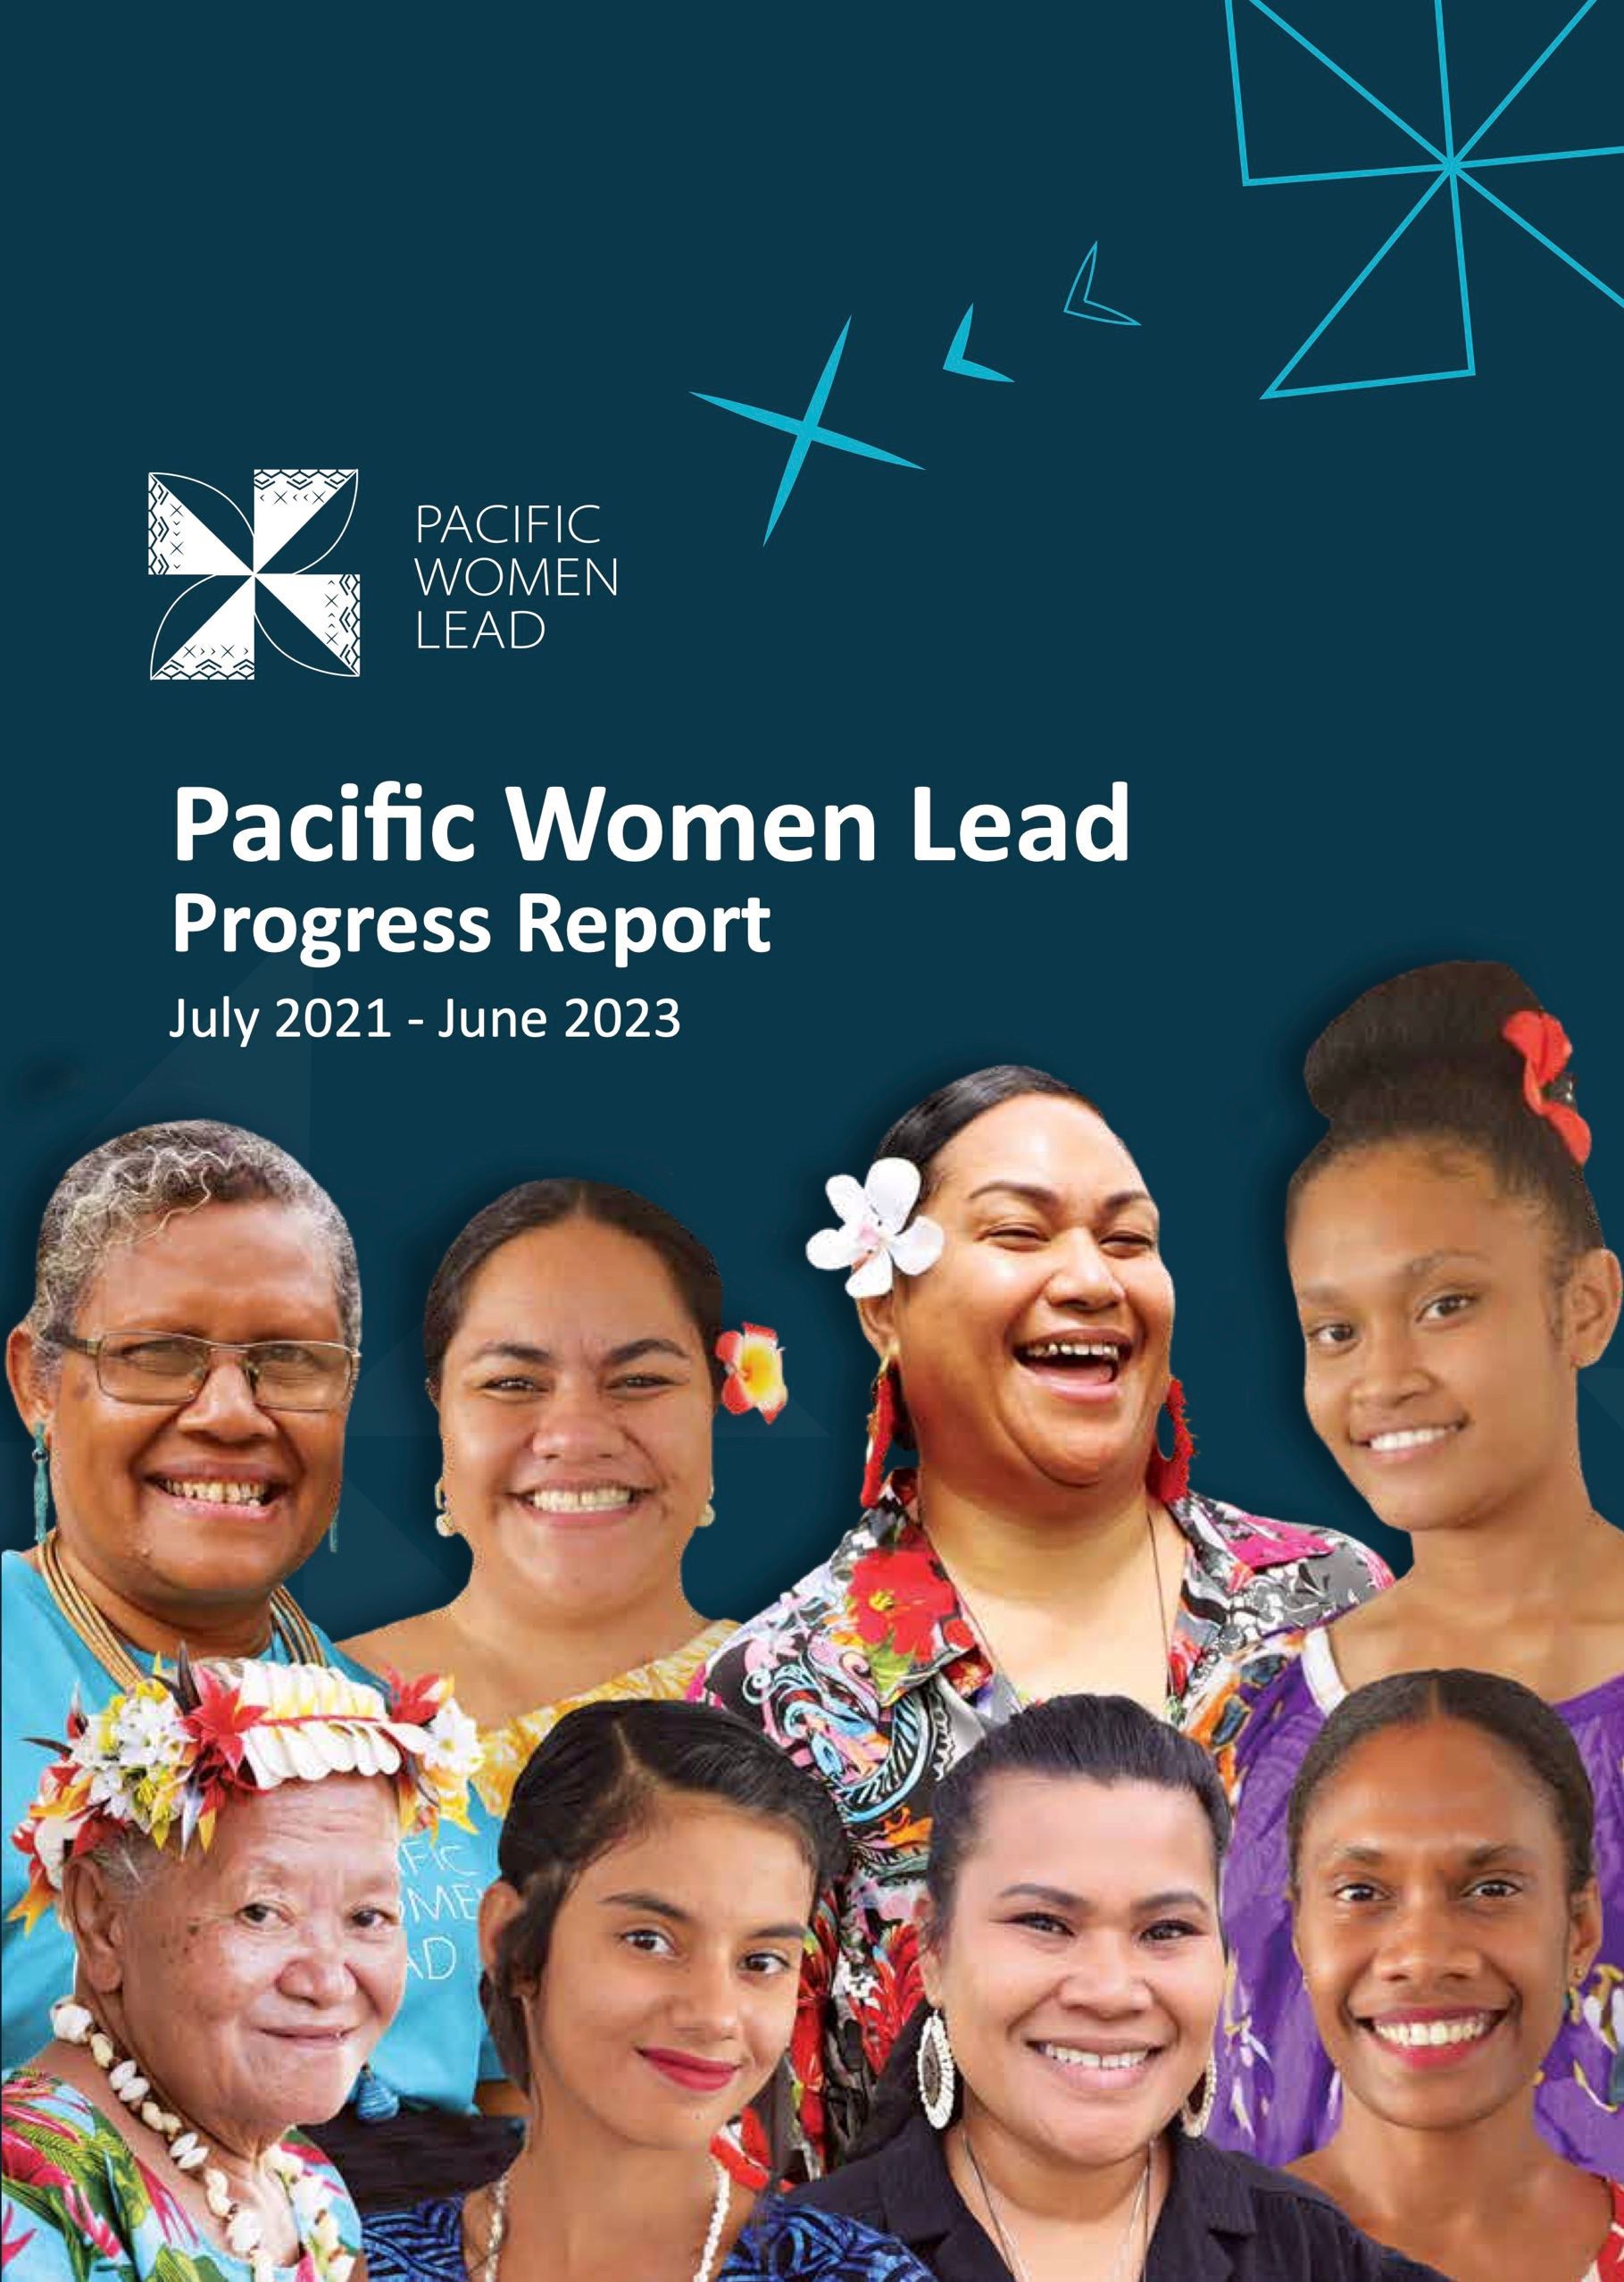

Preferred citation: Pacific Women Lead Progress Report (July 2021 - June 2023) For further information please contact:
Joanne Choe
Contractor Representative DT Global Asia Pacific
+613 91004145
Joanne.Choe@dt-global.com

Document History
Version Effective Date Revision Prepared by Reviewed by

1 29 September
2023
Original Emily Miller/Junita Ngai
Angela Lenn/Joanne Kunatuba

This document is produced by DT Global Asia Pacific Pty Ltd (DT Global), solely for the benefit and use by the client in accordance with the terms of the engagement. DT Global does not and shall not assume any responsibility or liability whatsoever to any third party arising out of any use or reliance by any third party on the content of this document.
This publication has been funded by the Australian Government through the Department of Foreign Affairs and Trade. The views expressed in this publication are the author’s alone and are not necessarily the views of the Australian Government.
Pacific Women Lead Enabling Services is supported by the Australian Government and implemented by DT Global.

© Copyright 2023 Commonwealth of Australia as represented by the Department of Foreign Affairs and Trade (Licensor)
The Licensor hereby grants you a worldwide, royalty-free, non-sublicensable, non-exclusive, irrevocable license to use, reproduce, modify and share the licensed material in whole or in part, for scientific, educational or research purposes, provided that:
- the source document, author and Licensor are properly acknowledged;
- photos, artwork and any imagery contained in the licensed material are not altered or separately published without the prior written consent of the Licensor.
Where a third party holds copyright in material presented in this publication, the copyright ownership remains with that party. Their permission may be required to use the material. All reasonable efforts have been made to clearly label material where the copyright is owned by a third party, and to ensure that the copyright owner has consented to their material being presented in this publication. To the extent possible, the Licensor excludes all liability for any losses, costs, expenses or damages arising out of this license or use of the material contained in this publication.
Contents
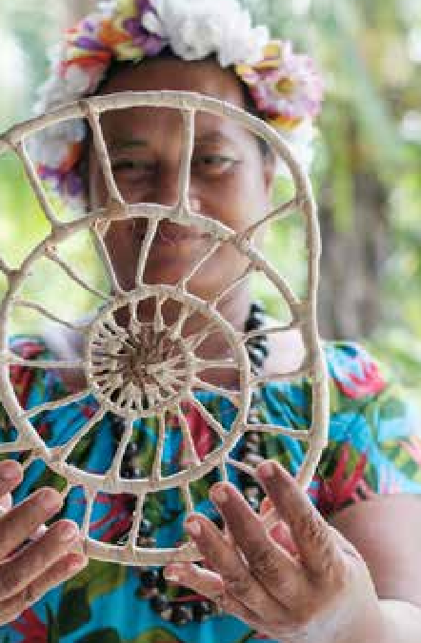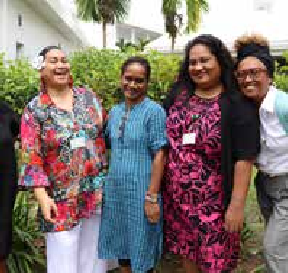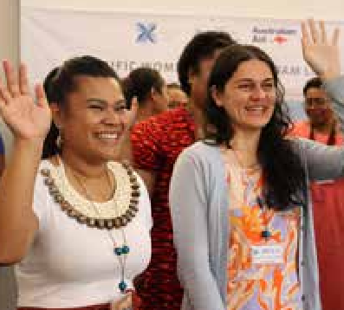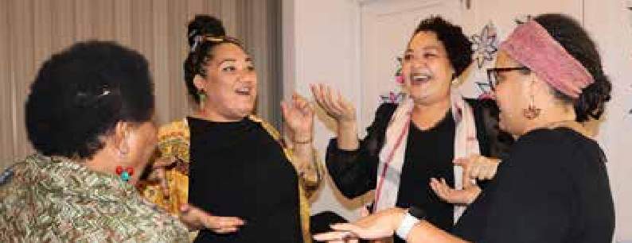

2 3
Report Overview
Pacific Women Lead
Background…………………..10
4
Pacific Women Lead Facts and Figures……………17
4.1 Where we work…………………………………………….19
4.2 Who we have reached….………………………………21
13
3.1 Methodology used for
reflection and analysis …………14

1
Executive Summary 5

- What Has Changed in the Operating Context?
How Should the Program Respond?...................................................................................... 23
  - National elections 24
  - Pacific labour mobility schemes 24
  - Natural Disasters 25
  - Global gender and anti-rights backlash 25
  - COVID-19 25
- Program Effectiveness and Recommendations for the Coming Year……….………………..……….26
  - Outcome 1: Women’s Leadership Promoted 26
  - Outcome 2: Women’s Rights Realised 37
  - Outcome 3: Pacific Ownership and Regional Effectiveness 49
- How Well Are PWL Strategies Working? What Are We Learning
About How Transformational Change Happens…………..…………………………………………………..53
  - Grant making in thematic areas of leadership, SRHR, WEE and safety 54
  - Linking and learning and collective action that supports genuine partnerships and
strategies for change in social norms and shifts in social norms across all
cultural contexts, including in the Pacific 54
  - Technical support, coaching and mentoring to support greater gender mainstreaming
and gender equality outcomes for Pacific governments and development partner sector programs 55
  - Collaborative portfolio-level monitoring, evaluation and learning, which includes
sense-making to inform PWL decision-making 55
Annex 1 PWL Key Evaluation Questions……………………………………………………………………………. 56
Annex 2 PWL Annual Reflection and Analysis Workshop Participant List…………………………… 57
Annex 3 List of PWL projects……………………………………………………………………………………………..60

Acronyms and Abbreviations
AIR Amplify-Invest-Reach
BCC Behaviour change communication
BGW Brown Girl Woke
CCC Christian Care Centre
CIPE Centre for International Private Enterprise
CSE Comprehensive sexuality education
DFAT Department of Foreign Affairs and Trade
FFFT Fi-E-FI-A’a Fafine Tonga
FSC Family Support Centre
GBV Gender-based violence
HRSD Human Rights and Social Development
INGO International non-governmental organisation IWDA International Women’s Development Agency KFHA Kiribati Family Health Association
LFS Leading from the South
MEL Monitoring, Evaluation & Learning
MELF MEL Framework
NGO Non-governmental organisation
NCfR Nazareth Centre for Rehabilitation
OPD Organisations of People with Disabilities
P4SP Pacific Partnership for Social Protection
PFF Pacific Feminist Fund
PIF Pay It Forward Loan Program
PIFS Pacific Islands Forum Secretariat
PIFWLM Pacific Islands Forum Women Leaders Meeting
PNG Papua New Guinea
PPEVAWG Pacific Partnership to End Violence Against Women and Girls
PWL Pacific Women Lead
PWLES Pacific Women Lead Enabling Services PWDSI People with Disabilities Solomon Islands RBTR Rise Beyond the Reef
SOGIESC Sexual Orientation, Gender Identity, Gender Expression and Sex Characteristics
SPC Pacific Community
SRHR Sexual and Reproductive Health and Rights
UN United Nations
UN Women United Nations Entity for Gender Equality and the Empowerment of Women
UAF A&P Urgent Action Fund Asia & Pacific
UNFPA United Nations Fund for Populations Activities
UNICEF United Nations Children’s Fund
WCCC Women and Children’s Crisis Centre
WD Women Deliver
WEDO Women’s Environment and Development Organisation
WFA Women’s Fund Asia
WFF Women’s Fund Fiji
WIL Women in Leadership
WMV Women market vendors

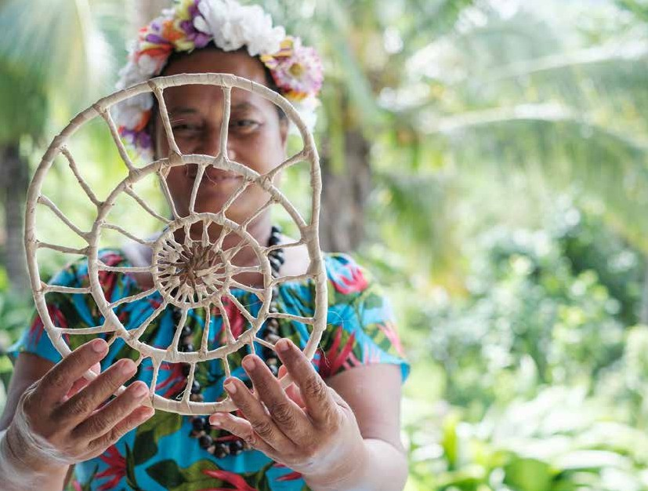
Progress Report (July 2021- June 2023) | Pacific Women Lead 5

1

PC: Rise Beyond the Reef

Executive

Summary

This is the first Progress Report for Pacific Women Lead (PWL), covering the first 2 years of implementation from July 2021 to June 2023. The report answers 5 evaluation questions (refer to Annex 1) outlined in the PWL Monitoring, Evaluation, and Learning Framework (MELF).
To answer the evaluation questions, the Pacific Community (SPC) and Pacific Women Lead Enabling Services (PWLES) jointly organised an inaugural PWL annual reflection and analysis workshop titled “Analysing Progress, Building Relationships, and Fostering Learning.” The workshop took place at the Pearl Resort in Fiji from September 5th to 8th, 2023, attended by 77 key PWL stakeholders. The objective of the workshop was to review data, establish a common understanding of progress, and formulate recommendations for program improvement in the future.
The predominate focus of the annual reflection and analysis workshop is on learning and program improvement. Accountability is also important, although it is acknowledged that self-assessment from program stakeholders may impact the independence of progress ratings agreed at the workshop. As this was the first reflection and analysis workshop held with stakeholders, the aim was to build trust and strong relationships. The methodology will continue to evolve to improve accountability in future workshops, while acknowledging that learning and program improvement will remain a predominate focus of these workshops. The program will use the mid-term and end-of-program evaluations to ensure an independent assessment of progress and impact is carried out.
Approach to data analysis and synthesis
Working in groups, stakeholders focused on PWL’s intermediate sub-outcomes (refer to Table 1). To facilitate the analysis process, groups were given data derived from PWL’s Monitoring, Evaluation and Learning (MEL) System. This data included:
- Quantitative data from PWL’s dashboard, such as data about the number of projects funded, value of funding commitment, type of implementing partner delivering the project and country of implementation.
- Quantitative data that reflects progress against the PWL quantitative indictors, where provided by partners, disaggregated by sex, gender and disability.
- Qualitative data in the form of a Results Chart and impact stories for each of the sub-outcome areas. The Results Charts pulled together the strongest evidence from partner reports that suggest progress to outcomes.
Using the above data, stakeholders discussed and responded to the following questions:
- What is the data telling you about PWL progress?
- What stands out as the best achievement for this sub-outcome area?
- Who is missing from the data? How might we address this?
- Are you satisfied with the level of evidence available?
- What are some gaps in implementation or areas where you think the program should focus on next year?
Throughout the workshop, stakeholders engaged in robust discussions and used the PWL Performance Rubric to collectively determine progress ratings for each PWL sub-outcome area. This process aims to guide future program direction, informed by the input and perspectives of PWL stakeholders. The table on page 7 outlines the final stakeholder progress ratings, along with the key recommendations for program improvement.
PC: Tautua
Partnership

PWL outcome | PWL  sub outcome |  | Progress rating | Recommendations | Who takes the forward recommendation
Outcome 1: Women’s leadership promoted | Women’s leadership promoted and disability inclusion |  | Less than expected | 1. Consider mandating each project allocate a percentage of funds to support disability inclusion (that is, preconditions for inclusion) and  consider setting a resource allocation for Organisations of Persons with a Disability (OPD) at the regional and national levels | SPC, DFAT
 |  |  |  | 2. Provide guidance and advice to PWL partners to support planning and implementation in a disability-inclusive way. This could extend to the draft PWL Disability Guidance Note, with a recommendation to produce a series of Guidance Notes that support partners in areas such as collecting disability-  inclusive data and other how-to-guides. | PWLES
 |  |  |  | 3. Ensure partners are supported to produce disaggregated project data using the Washington Group 6 short set of questions. | PWLES
 | Women and girls’ voice |  | As expected | 4. Improve how impact stories are collected, focusing on richer context information and the strategies that support or hinder women and girls’ leadership. Stakeholders also want to see more participatory story collection techniques, such as video and wider use of apps supported by smartphones. | PWLES
 |  |  |  | 5. Each component of the PWL program should consider how they can support emerging women’s CSOs to participate in national, regional, and international dialogues to support next generation leaders. | SPC, Women’s Funds and PWL Governance Board
 |  |  |  | 6. Recognise and fund women’s leadership, with a focus on women in sports, religious and/or church-based institutions. | SPC, Women’s Funds and PWL Governance Board
 | Pacific feminist movement |  | As expected | 1. Increase funding to support women’s rights activists and movements in the North Pacific, including funding their participation at regional and global convenings. | Women’s Funds
 |  |  |  | 2. Intentionally connect PNG PWL with the broader regional program. This could include inviting representatives from other regional components (Women’s Funds, SPC and PWLES) to PNG PWL events and ensuring strong PNG representation at regional PWL events. | DFAT (PNG) and PWLES
 |  |  |  | 3. Provide funding that strengthens governance and organisational development of Pacific women’s organisations. | Women’s Funds
Outcome 2: Women’s rights realised | Women’s rights realised and disability inclusion |  | Less than expected | - Collaborate with development partners to support national disability policy implementation, including under- served countries in the North Pacific. | SPC and DFAT
 |  |  |  | - Plan and report on inclusion and participation beyond preconditions. The PWLES could provide this support to partners through guidance notes and training. | PWLES
 |  |  |  | - Strengthened funded partnership with OPDs, with a focus on national OPDs and investigate new partnerships with OPDs in the North Pacific. | SPC and DFAT
 | Women’s health (sexual,  reproductive health and rights) |  | As expected to slightly less than expected | - Strengthen program integration for adolescent sexual reproductive health and rights (SRHR). As a first step, increase collaboration between UNFPA’s Transformative Agenda program and the Pacific Girl program, with a focus on increasing understanding of qualitative data and analysis of adolescent SRHR and teenage pregnancy. | SPC
 |  |  |  | - Coordinate and strengthen work with religious and cultural leaders across SRHR and look to broaden PWL strategies to reach more women and girls with a disability and people of diverse gender and sexual identities. | SPC and PWL Governance Board
 |  |  |  | - Define and measure what specific SRHR social norms the program aims to change. PWL could build consensus among partners to focus on 3 of the most dangerous or limiting social norms, such as religious beliefs that limit women and girls’ access to contraception or reproductive health services, or beliefs around menstruation as dirty, which leads to poor hygiene among women and girls. | PWLES
 | Women’s economic empowerment (WEE) |  | As expected to slightly more than expected | - Define and measure what specific WEE social norms the program aims to change. PWL could build consensus among partners to focus on 3 of the most dangerous or limiting social norms related to women’s economic empowerment and use story collection across the portfolio to investigate these social norms in greater detail. | PWLES
 |  |  |  | - Create more learning spaces for stakeholders to share innovation related to WEE. | SPC
 |  |  |  | - Build stronger links with government to support laws and policies that protect and advance WEE. | SPC
 | Women’s safety |  | As expected | - Define and measure what specific safety social norms the program aims to change. PWL could build consensus among partners to focus on 3 of the most dangerous or limiting social norms related to safety and use story collection across the portfolio to investigate these social norms in greater detail. | PWLES
 |  |  |  | - Increase and secure multiyear funding for crisis support services to facilitate the continued expansion and strengthening of services to remote islands. | DFAT
 |  |  |  | 3. Increase funding for projects that target men and boys as allies. An important note at the PWL reflection and analysis workshop from organisations working in women’s safety was for any work with men and boys as allies to run side by side with women’s advocacy to ensure best practice and accountability to the Pacific feminist movement. | SPC, Women’s Funds and PWL Governance Board
Outcome 3: Pacific ownership. regional effectiveness and gender mainstreaming |  | Less than expected |  | 1. Strengthen the PWL program logic for Outcome 3. This should include definitions for Pacific ownership and clarity on which organisations are driving the Pacific ownership agenda for the program. | SPC
 |  |  |  | 2. Bring greater visibility to the regional architecture for gender equality and strengthen stakeholder understanding of key regional policy commitments. | SPC and PIFS
 |  |  |  | 3. Bring greater visibility to the PWL Governance Board, including embedding their role in delivery of gender equality efforts under PWL. Disbursement of the Board’s grant allocation is a priority for the next 3-6 months (SPC). | SPC

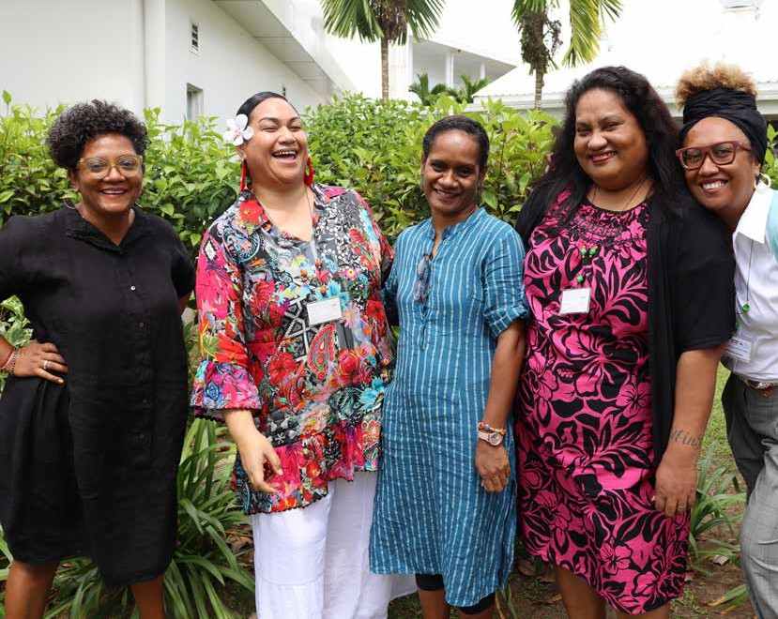
PC: PWLES

2

Pacific Women
Lead Background

PWL is a portfolio of regional investments to advance gender equality (AUD170 million over 5 years 2021- 2026). PWL is ambitious in its intent to take a Pacific- led, intersectional and transformative approach to promoting gender equality in the region. It is focused on delivering development outcomes for women and girls in all their diversity, bringing new emphasis to strengthening regional action and architecture in support of gender equality.
PWL builds on the strengths and lessons learned through Australia’s 10-year gender equality investment, Pacific Women Shaping Pacific Development. PWL is implemented through partnerships with SPC as a
regional intergovernmental technical agency, Pacific Islands Forum Secretariat (PIFS) through the Pacific Islands Forum Women’s Leaders Meeting, Pacific women-led civil society organisations including Pacific Women’s Funds, United Nations (UN Women, UNFPA and UNICEF), non-government organisations and the PWL Governance Board. PWL also includes the Pacific Women Lead Enabling Services (PWLES), bilateral gender equality investments and work to ensure regional approaches contribute to progress at the national level. In taking this approach, PWL has been designed to address and deliver Pacific and Australian Government commitments to gender equality in the region.

Figure 1: Pacific Women Lead Portfolio Components
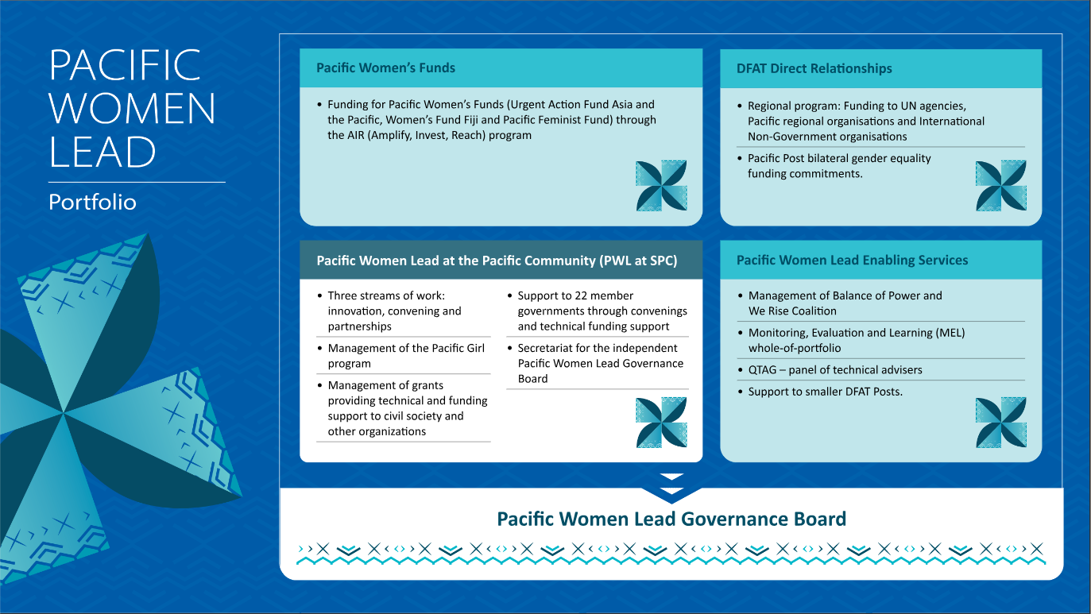

The goal of PWL is for: Pacific women and girls, in all their diversity, to be safe and equitably share in resources, opportunities and decision-making with men and boys.
PWL outcomes are focused on the promotion of women’s leadership, women’s rights and support to
Pacific regional partners, SPC and PIFS, to increase the effectiveness of regional gender equality efforts. This report provides a status update on progress for each outcome and their corresponding intermediate sub- outcomes (refer to Table 1 on page 13 for further details).

Table 1: PWL outcomes and sub-outcome areas

PWL outcome | PWL sub-outcome (intermediate: years 2-4)
Women’s leadership promoted | Women and girls’ voice: Women and girls, in all their diversity, take on and practice their leadership skills in decision-making spaces (household,  communities, business, sporting, local, national, regional and global spheres)  Women and girls’ voice: Pacific governments, civil society, private sector, and communities work to tackle social norms that limit diverse women and girls’ leadership opportunities at all levels
 | Pacific feminist civil society: There is recognition and amplification of the leadership of Pacific feminist civil society
Women’s rights realised | Women’s health: Health sectors across the Pacific provide quality and inclusive SRHR services  Women’s health: Pacific governments, civil society, private sector, and communities work to address social norms that limit diverse women and adolescent girls› access to SRHR services
Women’s safety: Pacific governments, civil society and private sector provide access to quality support services for diverse women and girls
Women’s safety: Pacific governments, civil society, private sector, and communities work to address social norms that contribute to diverse women and girls’ experience of violence
WEE: Pacific governments, civil society and private sector provide quality equitable and inclusive economic opportunities for diverse women
WEE: Pacific governments, civil society, private sector, and communities work to address social norms that limit diverse women’s economic empowerment
Partners are supported to increase Pacific ownership and effectiveness of regional gender equality efforts | Pacific ownership and regional effectiveness: The PWL Governance Board and regional partners are collaborating and contributing to the Pacific region’s gender equality commitments
 | Gender mainstreaming: Pacific governments and development partners are mainstreaming gender through sector programs

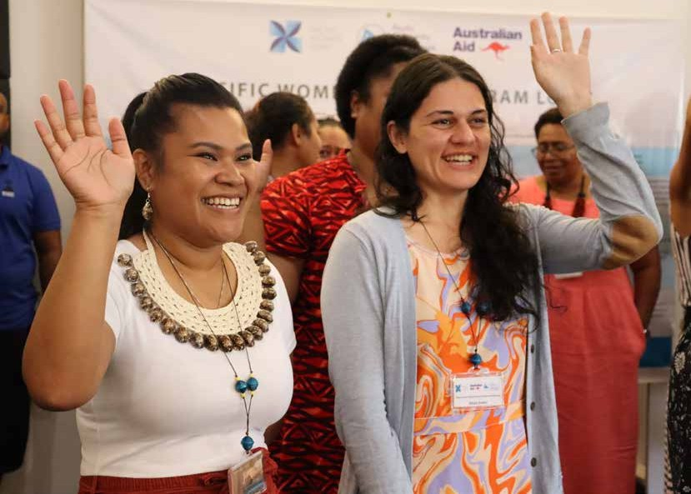
PC: PWLES

3

Report Overview

This first Progress Report for PWL covers the first two years of implementation (July 2021 – June 2023). PWLES compiled the progress reporting for the whole PWL portfolio. As the PWLES was mobilising and establishing the MEL system in 2022, it did not compile a year one report, hence this report covers the first 2 years of implementation. Going forward, the PWLES will compile an Annual Progress Report for the program.
This report presents quantitative and qualitative data against the PWL indicators to provide information on the scope and reach of the program, answers the 5 yearly evaluation questions outlined in the whole- of-portfolio MELF and provides recommendations for program improvement. The data used to draw conclusions about progress come from 2 data sources:
- partner reporting, which includes quantitative data on the number of women and girls reached by project activities, and narrative reporting, which speaks to partner progress against their project level outcomes.
- impact stories collected from a sample of projects across the PWL portfolio.
Where possible, this report also draws on the initial findings from the PWL qualitative baseline. The baseline will be finalised in November 2023 and will inform future PWL evaluations and annual progress reporting.
The findings against the evaluation questions and recommendations included in this report come directly from PWL stakeholders. SPC and the PWLES co-convened the first annual reflection and analysis workshop titled: Analysing Progress, Building Relationships and Fostering Learning at the Pearl Resort, Fiji from 5 to 8 September 2023. The workshop brought together 77 PWL stakeholders from across all program components to analyse data, build consensus of progress and identify recommendations for program improvement in the coming years (refer to Annex 2 for the list of workshop participants).
The reflection and analysis workshop was a pivotal moment in PWL’s continuous improvement journey. It provided a space for collaborative analysis and collective decision-making and contributed to increased awareness of the PWL portfolio, a growing sense of unity and shared purpose among the diverse stakeholders of PWL.

3.1 Methodology used for reflection and analysis
Each year, PWL will convene an annual reflection and analysis workshop, the first one being implemented in September 2023. These workshops serve multiple purposes:
- They help PWL stakeholders to understand PWL progress;
- They ensure PWL puts into practice principles of strengths-based and participatory sense-making;
- They support cohesion and contribute to coordination between partners;
- They provide a forum to carry out ‘deep dive’ analysis into important topics or strategies such as how PWL is addressing disability and social inclusion as outlined in its Gender Disability and Social Inclusion Strategy.

3.1.1 Analysis process from September 2023 workshop
Working in groups, stakeholders focused on PWL’s intermediate sub-outcome areas (refer to Table 1). To facilitate the analysis process, groups were given data derived from PWL’s MEL System. This data included:

      - Quantitative data from PWL’s dashboard, such as data about the number of projects funded, value of funding commitment, type of implementing partner delivering the project and country of implementation.
      - Quantitative data that reflects progress against the PWL quantitative indictors, where provided by partners, disaggregated by sex, gender and disability.
      - Qualitative data in the form of a Results Chart and impact stories for each of the sub-outcome areas. The Results Charts pull together the strongest evidence from partner reports that suggest progress to outcomes. The impact stories aim to provide further context to understand how and why change did (or did not) occur.

Using the above data, stakeholders discussed and responded to the following questions:
        - What is the data telling you about PWL progress?
        - What stands out as the best achievement for this sub-outcome area?
        - Who is missing from the data? How might we address this?
        - Are you satisfied with the level of evidence available?
        - What are some gaps in implementation or areas where you think the program should focus next year?
Over the course of the workshop, stakeholders engaged in robust discussions and used the PWL Performance Rubric (Figure 4) to agree on a progress rating for each sub-outcome area. While it is important for a rubric to be accurate and reliable, it is necessary to remember that it cannot be considered ‘exactly correct’ in the

Figure 2: PWL performance rubric
absolute sense. Rubrics are designed to provide a standardised framework and to support transparency in the decision-making process, but they are not infallible or absolute measures of performance. The PWL Performance Rubric was adapted from another PWL program, Balance of Power, and reviewed by the PWL MEL Reference Group to reflect the program’s needs. The rubric is meant to support stakeholders, who are experts in the Pacific gender equality space, to be involved in the synthesising and agreement of PWL’s progress. In this context, the rubric was used as a tool to gain consensus from program stakeholders on the overall progress of the program. In doing so, PWL seeks to gain buy-in on the program and reach a consensus on what the program needs to do to respond or adapt.
This collaborative analysis allows for a more nuanced exploration of achievements, gaps and opportunities, laying the foundation for informed recommendations to support program improvement. Through this process, the reflection and analysis workshops aim to foster a culture of learning, ensuring that PWL remains responsive to the evolving needs of our stakeholders and aligned with our overarching ambition of Pacific- led development.

Progress rating | Performance descriptors for answering key evaluation questions for Pacific Women Lead sub-outcome areas
More than expected | » Good things are happening more quickly, and/or at greater scale, than we projected  » PWL activities are getting more positive feedback and engagement than we expected  » Considering the context, progress is better than we would anticipate  » Is there a balance of quantitative and qualitative data (if appropriate) available to inform a perception of progress
As expected | » Good things are happening pretty much as we projected  » We are seeing the expected levels of engagement with Pacific gender stakeholders  » Our progress is what we would anticipate, given the context  » There are multiple forms of evidence available that point to positive progress
Less than expected | » It is taking longer to see good things happening, or they are happening on a smaller scale than we had projected  » Activities are not getting the level of engagement or feedback we expected from Pacific gender stakeholders  » Progress is not what we would anticipate, given the context
Stalled | » There are few/no sign of progress  » Engagement and feedback with Pacific gender stakeholders is little or absent  » The context means we can›t progress as we planned
Harm caused | » There are signs that activities may have caused harm to project stakeholders.  » There are signs that activities may have reinforced social norms that are harmful to diverse women and girls

3.1.2 Deep dive into disability practice
The final evaluation of Pacific Women Shaping Pacific Development found that while there were examples of good practice in disability inclusion, PWL needs to do more and expand disability inclusion throughout its projects and countries of implementation. Given this recommendation, PWL has committed to carrying out a deep dive analysis into disability inclusion at all reflection and analysis workshops. The deep dive involves separate groups analysing disability specific results charts for Outcomes 1 and 2. These results charts bring together all the quantitative and qualitative data related to disability against the draft PWL ‘From Exclusion to Realisation of Rights Framework’. Using this data, groups used the PWL Performance Rubric to agree on a progress rating for disability and provide recommendations for how the program could strengthen disability inclusion in the coming year.
“The workshop was a real aha moment and helped us to see and understand the type of reporting and data that the program needs for meaningful reporting and learning.”
Participant from PWL reflection

3.1.3 Limitations to the analysis process
In PWL’s first year (2021-2022), the MEL system relied heavily on partner reporting to build an understanding of progress. In year 2 (2022-2023), PWLES collected impact stories to strengthen and deepen the qualitative data across the program.
While reporting will remain an important accountability mechanism, we know that many partners struggle to present their program’s performance through formulaic written reports. Often, a significant challenge arises from the fact that many donors impose reporting requirements that may not necessarily align with the partners’ ability to authentically convey the story of their progress. PWL is not alone in this challenge
and continues to explore ways to strengthen the MEL system to bring in additional data sources and support partners to report in a meaningful way. In 2023, PWLES began collecting impact stories to expand understanding of progress, and in 2024 will extend this to include impact stories through new media forms. As projects undergo independent evaluations, these documents will be added into the MEL system to provide an externally validated assessment of project progress. Evaluations have already been undertaken for 2 large regional PWL programs (Balance of Power and Pacific Girl) and once the reports are finalised, these will also be entered into the MEL system.
Partner reporting challenges also underscore the importance of the annual reflection and analysis workshop. This space can also be used to identify examples of strong evidence of progress that may not have come through partner reporting, but that offer important learning opportunities.
Some stakeholders raised they felt uncomfortable making a judgement on the program’s progress. This wasn’t surprising, given it was the first reflection and analysis workshop, and the methodology of bringing such a diverse range of actors together to be involved in the analysis and judgement making process was new for many stakeholders. Ultimately, the evolution of MEL processes within PWL (MEL databases, reflection and analysis workshops, Annual Progress Reporting) should be seen as akin to a journey of growth and maturity. As the program unfolds and partners increasingly invest themselves in PWL outcomes, these processes and our understanding of what works should naturally deepen in significance. All PWL MEL processes should be seen as a reflection of a mutual commitment to better understand and enhance PWL’s impact.

3.1.4 Report recommendations
This report provides recommendations for each of the sub-outcome areas of the program logic, and for disability inclusion for Outcome 1 and 2. The recommendations were finalised with PWL stakeholders at the annual reflection and analysis workshop. For the purposes of transparency and accountability, the most appropriate program partner to take forward the recommendation in the coming year is noted in brackets after each recommendation. Recommendations have been allocated to the following program partners: SPC, DFAT, Women’s Funds, PWLES or the PWL Governance Board. In some instances, multiple program partners have a role in taking forward the recommendations.

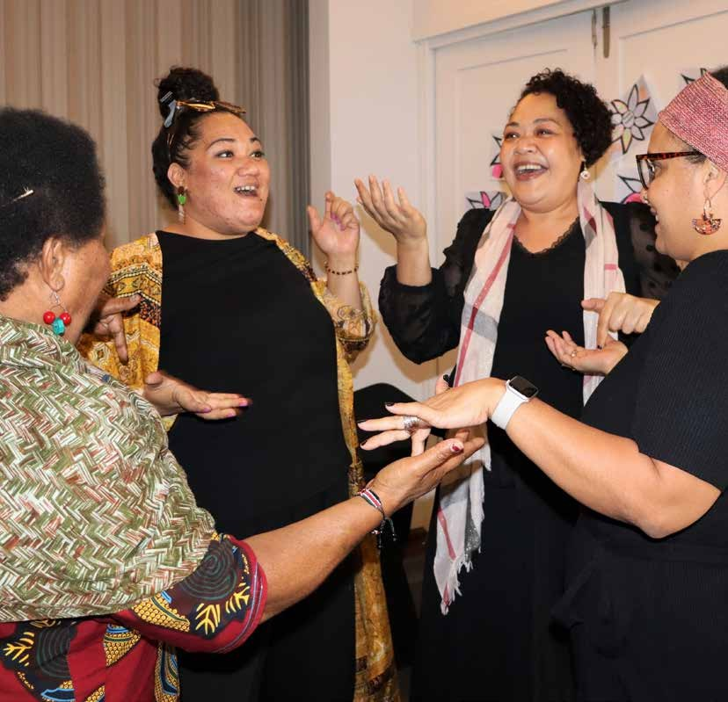
PC: PWLES

4

Pacific Women Lead Facts and Figures

Figure 3: Program Overview
-+
Partners
Underway
Completed
Bilateral Funding Regional Funding

Partners
Total Projects
Regional Projects
Bilateral Projects
Funding
Projects

PWL funds 58 projects (10 completed and 48 that are under way), delivered in collaboration with 43 distinct implementing partners1. These partners encompass a range of organisations, including Pacific non- governmental organisations (13), international non- governmental organisations (13), Pacific government partners (6), regional and multilateral partners (4), research and university partners (2), intergovernmental organisations (2), managing contractors (1), and private
sector organisations (1). This collaborative network of partners reflects PWL’s approach and underscores its commitment to engaging a wide array of stakeholders to effectively achieve its outcomes. Of the 58 projects funded, 35 are funded at the country level, through DFAT’s bilateral gender equality commitments and 23 projects are regional in nature (that is, work in more than one country) and are funded through DFAT’s Pacific regional gender program.

Implementing Partner Categories
13
12
11
10
09
08
07
06
05
04
03
02
01
0
13
13
International NGO
Pacific NGOs
6 Government partners
4 Regional and multilateral partners
2
2
Research and University partners
Inter-Governmental Organisations
1
1
1
1
Managing Contractors
Private Sector Organisation
Other OPDs

Many of the 58 projects work across multiple outcome areas (that is, leadership and safety, or women’s safety and economic empowerment), however, the PWL database tracks projects based on their primary area of focus. Based on this, most projects address the sub- outcome of women’s safety (22), followed by women
and girls’ voice (14), WEE (7), gender mainstreaming (5), the Pacific feminist movement (4), Pacific ownership (4) and women’s sexual and reproductive health and rights (2). In the coming year, PWLES will adapt the database to include a secondary outcome area of focus for each project.

Diagram 1: Funding and project count by sub-outcome
61m

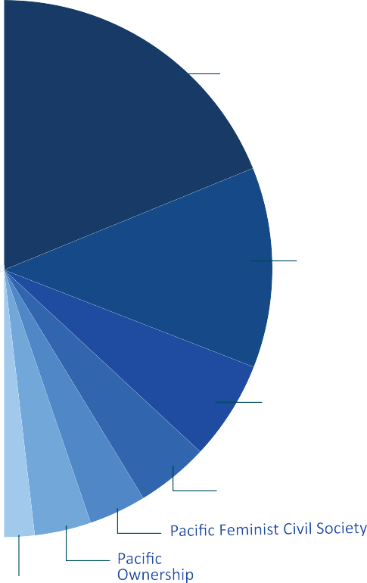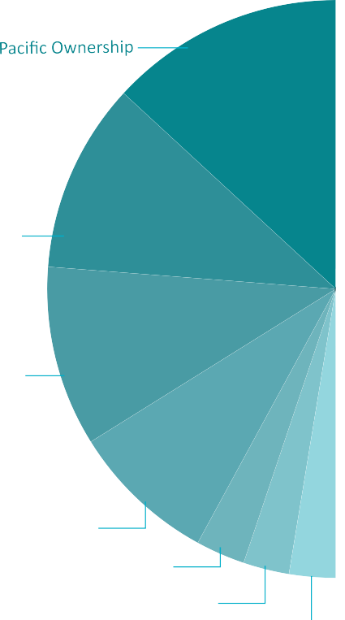
47m
Funding by sub-outcome
Projects by sub-outcome
Women's Health
Women's Economic Empowerment
Women's Economic Empowerment
13m
12m 12m
22
Women's Safety
Women's Safety
14
Women's/ Girl's Voice
7
5
Gender Mainstreaming
Women's/Girl's Voice
4
4
2
Gender Mainstreaming
Women's Health
49m
38m

4.1 Where we work
Projects funded by PWL are implemented in 14 Pacific Island countries (refer to map below). This includes both bilaterally funded and regionally funded projects. Papua New Guinea (PNG) has the highest number of bilateral projects (11), followed by Solomon Islands (7).
Regional projects are implemented in all 14 countries, and in some cases, these are the only gender-specific initiatives implemented in country, making them an important mechanism for smaller island countries. These countries include Cook Islands, Nauru, Niue, Palau and Tuvalu. For a full list of projects and countries of implementation, refer to Annex 3.

¹ Distinct implementing partner is the organisation that holds the primary grant agreement with PWL.

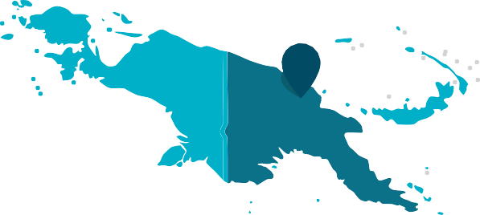

Diagram 2: Funding and project count by location

13 11
14

12

1
2
Regional Pacific 23
Papua New Guinea
11
7
Solomon Islands
Tonga Fiji Vanuatu Samoa
1
2
2
5
7

9

10

- Papua New Guinea
- Solomon Islands
- Vanuatu
- Fiji
- Tonga
- Samoa
- Niue
6
3
- Cook Islands 4 8
7
5
- Tuvalu
- Republic of Marshall Islands
- Nauru
- Federated States of Micronesia
- Palau

4.2 Who we have reached

5,208 of women and girls supported to assume a leadership role at community, provincial and national level²

4,891 70 46 185 16
Women Girls LGBTQI

Outcome 1 - Women’s leadership promoted

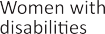

1,257 women and girls participating in civil society and intergovernmental forums
(for example, Pacific Feminist Forum and Triennial)

1,187 3 62 5
Women Girls

Outcome 2: Women's rights realised, safety
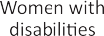
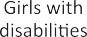
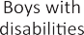

53,398 crisis services provided to women and children

41,092 1,906 734 14
Women Girls Boys LGBTQI

913 49 13 8,668
Data not
disaggregated

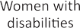
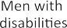
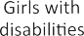
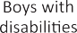

64,234 people who participated in sessions on gender issues and women’s equal rights
24,737 11, 226 14,227 7,192
Women Girls Men Boys

167 52 118 2

56 6,457
LGBTQI Data not
disaggregated

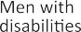

312 of men and boys who have undertaken male advocacy training and are actively participating to promote gender equality

302 3 6 1
Men Boys Boy with
a disability

333 police, law and justice officials trained to respond to incidents of violence against women
32 45 256
Women Men Data not
disaggregated

Outcome 2: Women's rights realised, economic empowerment
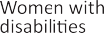

9,381 women entrepreneurs provided with financial and/or business development services.

7,659 47 7 1,668
Women LGBTQI Data not
disaggregated

Outcome 2: Women's rights realised health
Total unintended pregnancies averted

47,832
Women
Number of couples provided with 12 months of contraceptive protection³

229,436
Women

² In addition to the 5,208 women and girls, the program also supported the following people to assume a leadership role: 226 people with a disability (no sex disaggregated data was provided by implementing partners) and 999 people where implementing partners provided no sex, age, or disability disaggregation.
³ Estimates the amount of contraceptive protection distributed over 12 months based on the total number of contraceptives distributed. It uses a formula based on an assumed number of each kind of contraceptive method that would protect one couple for one year.

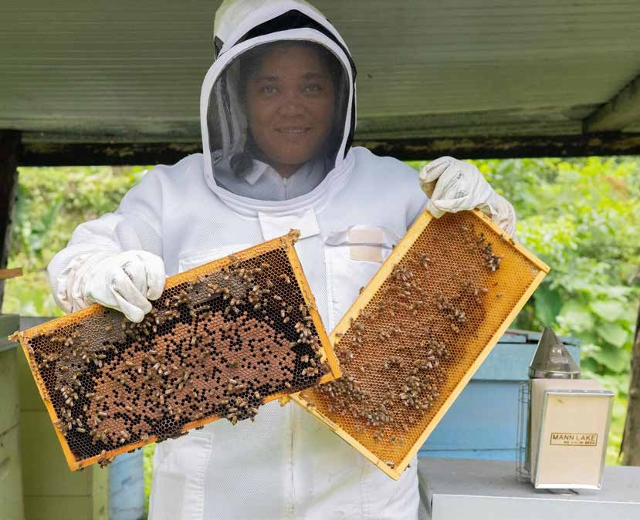
PC: Tautua Partnership

5

What Has Changed in the Operating Context?

How Should the Program Respond?

The operating context for PWL and the Pacific region more broadly has undergone significant changes between July 2021-June 2023. These changes encompass political developments, natural disasters and increased labour mobility to name just a few. Understanding and responding to these shifts is crucial for the program’s continued effectiveness and relevance. Here, we highlight the key changes and provide recommendations for how the program could respond.

5.1 National elections
National elections in Fiji, PNG, Samoa and Tonga offered opportunities for advancement in gender equality within each of these countries. In Fiji, while elections led to a more inclusive political landscape, this did not translate to more women in parliament. The number of women parliamentarians declined from 10 out of 51 Members of Parliament, to 6 out of
55. In PNG, 2 women (both supported through a PWL project) won seats in the 118-seat Parliament. While considered a great success, the low proportion of female representation remains a significant challenge for gender equality efforts in PNG. In Tonga, no women were successful in the 2021 general election. In August 2022, 3 Cabinet Ministers were unseated, triggering a by-election and through this process, one woman was successful in these elections.
Program response: Stakeholders at the PWL reflection and analysis workshop commented that strategies across Pacific countries to support women’s political leadership had not changed or evolved over the last 10 years. There was a sense of the ‘same old, same old’, which included ad hoc or one-off leadership trainings and activities. One workshop participant had just returned from the Women Deliver (WD) Conference, held in Rwanda, and commented on the incredible rise in women’s political participation in that country, currently sitting at 61%. While it was acknowledged as a significant example of women’s advancement in politics globally, stakeholders also noted it is advisable not to pick up projects or strategies delivered in one region and roll them out in a completely different region. There was, however, a definite sense of the need to rethink strategies to support women’s political leadership in the Pacific. The PWL program, through the Women’s Fund component, offers an opportunity for this re-strategising.
In the meantime, many workshop participants noted the importance of supporting women formal settings outside of national politics (such as sub-national or provincial) and in informal spaces (such as sport and community leadership). Sports and religious institutions were sighted as spaces where they wanted to see more projects being supported that target women’s leadership.

5.2 Pacific labour mobility schemes
The context of labour mobility in the Pacific has undergone notable changes in recent years, with significant implications for gender equality. Traditionally, labour mobility programs in the region, such as the Seasonal Worker Programme (SWP) and the Pacific Labour Scheme (PLS), primarily operated in male dominated industries like agriculture and meat processing in countries like Australia and New Zealand. However, there has been a growing recognition of the need to enhance the inclusivity of these programs and address gender disparities, with greater opportunities arising following the introduction of additional sectors, and concerted efforts to promote women’s participation in the scheme.
One of the key impacts of this shift in labour mobility is the increasing participation of Pacific women in such programs. Women are now being recruited for various roles, including in horticulture, aged care and hospitality sectors, allowing them to earn income and contribute to their families and communities. This empowers women economically and challenges traditional gender roles and norms within Pacific societies.
Program response: Pacific labour mobility was noted several times throughout the Pacific Women Lead (PWL) reflection and analysis workshop. It was acknowledged that labour mobility programs offered great potential to support Women’s Economic Empowerment and movement into non-traditional roles, but there are also known unintended consequences such as communication breakdowns in families, mistrust and conflict relating to spending and remittances. In response, PWL partners could explore ways to build coordination with the Pacific Australia Labour Mobility (PALM) scheme to strengthen understanding of gendered issues to inform responses.

5.3 Natural Disasters
The Pacific region continues to experience extreme weather events, climate change and disasters. Tonga and Vanuatu experienced significant natural disasters during this period, leading to disruptions in livelihoods and gender-specific vulnerabilities. It is widely acknowledged that the Pacific region will continue to experience climate related events across the life of the program, therefore all projects must consider how to respond. At the PWL reflection and analysis workshop, Pacific NGO DIVA for Equality (DIVA) delivered a session on the feminist climate nexus approach in the Pacific. This session sought to build awareness of the importance of feminist approaches to climate justice and support projects to integrate climate change approaches and principles into their activities and strategies.
Program response: Working with Pacific NGOs such as DIVA, the program should continue to support partners to integrate climate change approaches into project delivery. At the same time, PWL, perhaps through the Women’s Fund component or PWL Governance Board could explore supporting projects that specifically work to ensure women’s voices and needs are integrated into disaster risk reduction and recovery efforts.

5.4 Global gender and anti-rights backlash
In recent years, we have seen increasing global backlash against gender equality and human rights. The draft findings from the PWL situational analysis on the Pacific women’s movements found that traditional gender norms and values can perpetuate existing
PC: FWRM
gender disparities in the Pacific where many societies have deeply rooted cultural norms that favour men. The situation analysis found that the reinforcement of traditional gender roles hinders efforts to challenge and change these norms and also leads to burn-out of key leaders and activists in the movement.
Program response: PWL, through the Women’s Fund component, can continue to fund and support Pacific feminist leaders as the backbone of Pacific- led development. In the coming year, the program could focus on refreshed leadership or greater young women’s representation and organising at different levels to strengthen collaboration and connectivity of the Pacific feminist movement. The PWL situational analysis also identified the isolation of the PNG women’s movement and workshop participants identified the north Pacific’s women’s movement as areas where the program could focus in the coming year.

5.5 COVID-19
While COVID-19 lockdowns may be a thing of the past, many Pacific Island Countries are still recovering from the economic impact of the pandemic. The program witnessed examples of innovation during the pandemic, such as women entrepreneurs forming new partnerships or embracing technology to sustain their business and income, and the swift and urgent rollout of telephone counselling in response to the increase in violence against women. But overwhelmingly, COVID-19 brought about profound changes and setbacks in the context of gender equality in the Pacific. Rates of violence against women increased, disruption to healthcare systems affected women’s access to essential services such as sexual and reproductive health and many women and families’ financial situations were radically and adversely affected.
Program response: PWL, through PWLES or SPC, should ensure lessons and innovative practice brought about because of COVID-19 are promoted and shared across the portfolio. There are some great examples of how innovation was supported (that is, UN Women’s Market for Change Program, PNG’s Business Coalition for Women’s Pay It Forward Loan Scheme, and Rise Beyond the Reef, funded through the Women’s Fund Fiji), and this can continue in the post-COVID-19 world. PWL, through SPC or the DFAT component, could also investigate a partnership with DFAT’s Pacific Partnership for Social Protection program (P4SP) to address some of the adverse financial impacts of COVID-19 on women.

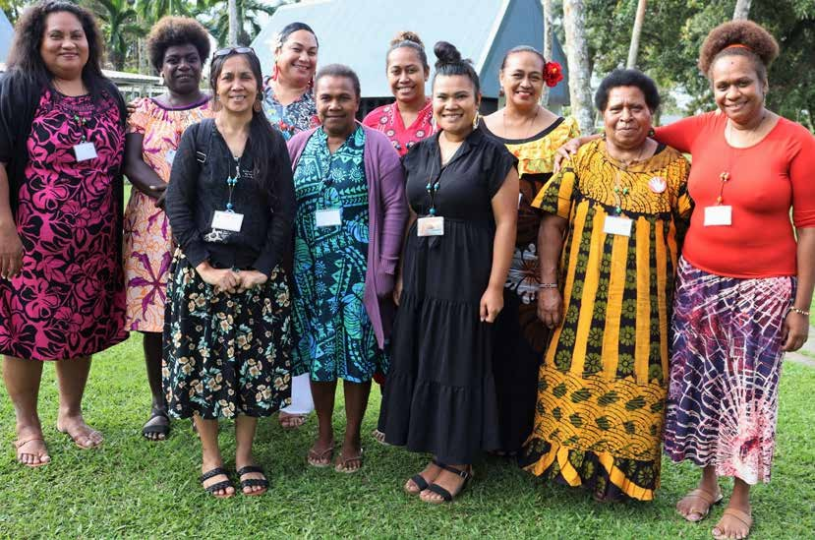
PC: PWLES

6

Program Effectiveness and Recommendations for the Coming Year

This section of the report answers 2 of the 5 yearly evaluation questions:
    - What progress towards outcomes (expected and unexpected) has been achieved for each of the PWL outcome areas?
    - What have been the key successes, opportunities, obstacles and challenges this year? Considering these, how should the program respond?
Findings from the first reflection and analysis workshop held in Fiji provided valuable insights into stakeholder perceptions of program effectiveness. At the reflection and analysis workshop stakeholders were given whole- of-portfolio quantitative and qualitative data for PWL sub-outcome areas. They used this data to agree on a progress rating for each sub-outcome and identify recommendations for how PWL should respond.

Outcome 1: Women’s Leadership Promoted
PWL funds 23 projects (19 under way and 4 completed) valued at AUD52 million (AUD43 million regional and AUD9 million bilateral) with a primary focus on the promotion of women’s leadership. These projects are implemented by 21 organisations: INGOs (8), Pacific NGOs (7), research and university partners (2), managing contractor (1) and Pacific organisation for peoples with disability (1).

    - Women’s leadership and disability inclusion
Overall stakeholder progress rating: Less than expected
There were 4 working groups that interrogated PWL data for Outcome 1 and progress towards meaningful disability inclusion. Three groups concluded that progress in leadership and disability inclusion was tracking ‘less than expected’ with one group concluding progress was ‘as expected’.
Table 2: Progress rating by group

Group number | Progress rating
Group 1 | Promising signs, but less than expected
Group 2 | As expected
Group 3 | Less than expected
Group 4 | Less than expected

Rating justification
Two groups acknowledged there was some good progress and that more projects were demonstrating disability inclusive project implementation when compared with the previous phase. Five projects supported preconditions to disability inclusion in women’s leadership activities (that is, projects partnered with Organisations of People with Disabilities (OPDs), trained staff on how to work with people with a disability, ensured accessible materials for visual impairments, ensured accessible venues and used sign language interpreters). Seven projects supported the inclusion of people with disabilities, which included representation in national and international forums, drafting of the Convention on the Rights of Persons with Disabilities reports and working with OPD’s and people with a disability in disaster response. Four projects showed evidence of meaningful engagement and equal outcomes for people with disabilities. One project supported a delegation of women with disabilities to the Asia Pacific Ministerial Conference on Disaster Risk Reduction and amplified recommendations to the conference on the critical importance of engagement with OPDs. Another provided cash vouchers to deaf girls that resulted in them purchasing things they needed, which was an enabler for them returning to boarding school. One project in Fiji led to more women with disabilities moving into leadership and there was collaboration with an OPD in PNG and Solomon Islands that led to government endorsement of a national disability policy.

Recommendations to improve disability inclusion in future programming
Overall, the vast majority of workshop participants wanted to see the program reach greater numbers of women and girls with a disability. The top 3 recommendations identified by stakeholders included:
- Consider mandating each project allocate a percentage of funds to support disability inclusion (that is, preconditions for inclusion) and consider setting a resource allocation for OPDs at the regional and national levels (SPC, DFAT).
- Provide guidance and advice to PWL partners to support planning and implementation in a disability- inclusive way. This could extend to the draft PWL Disability Guidance Note, with a recommendation to produce a series of Guidance Notes that support partners in areas such as collecting disability- inclusive data and other how-to-guides (PWLES).
- Ensure partners are supported to produce disaggregated project data using the Washington Group 6 short set of questions (PWLES).

Case study
Deaf girls can do anything
Project: Pacific Girls: Girls Arise program
Country: Fiji
Outcome: Women’s leadership promoted and disability inclusion – women and girls’ voice

Deaf girls can do anything,” signs Vasiti of the Fiji Women’s Rights Movement (FWRM)
Grow. Inspire. Relate. Lead. Succeed (GIRLS) Programme.

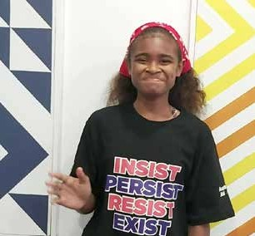
She is one of the many girls in 6 Pacific Island countries who have been reached by projects supported by Pacific Girl since it began in 2019. Through partner-led activities, girls – including girls with disabilities – are being supported to advance their rights and opportunities. The FWRM implements GIRLS ARISE, a program working with girls aged 10–12 years to build their life skills and confidence.
PC: FWRM
FWRM has since extended its GIRLS ARISE program to reach deaf girls through a partnership with the Fiji Association of the Deaf (FAD), over time extending their collaboration to other institutions, the Gospel School of the Deaf. FWRM’s approach aligns to broad principles of engagement with
Deaf girls as part of the Deaf community – a culturally distinct group that specifically identifies as ‘Deaf’ (with a capital D, i.e., “Deaf girls”) rather than the broader definition of people with hearing impairment.
Sign language is a core element of Deaf culture, with variations across the Pacific and, more broadly, the world. Therefore, connecting with the appropriate stakeholders, such as the Deaf community and its representative bodies, is vital to tailoring development initiatives that respond to their different needs, identities and language.
“We partnered with FAD to sensitise our work, particularly the toolkit,” explained Emeli Anise, FWRM’s Team Leader for the Intergenerational Women in Leadership Program (IWLP). “FAD helped us design the FWRM GIRLS Program Deaf Girls Engagement Strategy and through them, we identified a Deaf consultant to help us sensitise our work, specifically the toolkit.”

This collaboration is also reflected in a cross-sensitisation Memorandum of Understanding (MoU) with FAD. The 2 organisations have been sharing their respective expertise in gender equality and deaf inclusion since 2019, including FWRM staff learning Fiji Sign Language (FJSL).
“The toolkit consultant also developed a glossary for jargon we often use – like feminism and intersectionality – because there was no [FJSL] sign for it,” added Ms. Anise. “Right now, the glossary is being reviewed by FAD” and “the consultant has also helped our program content to be deaf girl friendly and linked us up with organisations that specifically work with Deaf children like Gospel School for the Deaf and Hilton Special School.”
Some of this work has been implemented by focusing on a core cohort of 10 Deaf girls, but engagement has also extended to a greater number of Deaf girls through platforms and events like the Girls Forum. This year, Deaf girls from both the core cohort as well as additional girls attending Gospel School of the Deaf attended the second Girls Forum – making the safe space for girls to amplify their voice and guide the advocacy priorities of the GIRLS program to be more inclusive.
This year, FWRM is sharing a series of messages from their core cohort of Deaf girls in a video on social media in commemoration of the International Day of Sign Languages. In the video girls highlight their rights, needs and priorities as well as encourage others to learn. “I need to have sign language in school,” highlighted Silina. “Sign language is fun,” added Shakshi. “Learn sign language. Respect my sign language.” According to Ms. Anise, finalising the toolkit and the partnerships with FAD and Gospel School of the Deaf are just the first steps to embed an inclusive approach to FWRM’s adolescent girl programming.
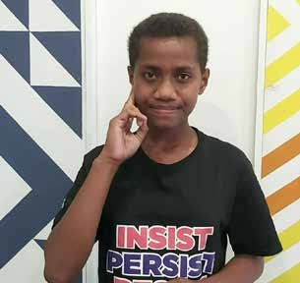
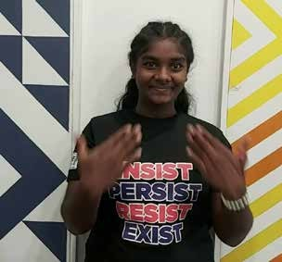
PC: FWRM
PC: FWRM

6.1.2 Women and girls’ voice
PWL funds 18 projects (14 under way and 4 completed) to the value of AUD39 million (AUD35 million regional and AUD4 million bilateral) with a primary focus on women and girls’ voice. These projects are implemented by 17 organisations: INGOs (7), Pacific NGOs (4), regional and multilateral partners (2), research and university partners (2), managing contractor (1) and Pacific OPD (1).
Overall stakeholder progress rating: As expected
Four working groups interrogated data on women and girls’ voice. Three of the groups concluded that progress was tracking ‘as expected’ with one group concluding progress was ‘as expected’ to ‘less than expected’.
Table 3: Progress rating by group
Group number | Progress rating
Group 1 | As expected
Group 2 | As expected
Group 3 | As expected to less than expected
Group 4 | As expected

Intermediate outcomes:

Women and girls’ voice: Women and girls, in all their diversity, take on and practice their leadership skills in decision making spaces (household, communities, business, sporting, local, national, regional and global spheres)

Women and girls’ voice: Pacific Governments, civil society, private sector, and communities work to tackle social norms that limit diverse women and girls’ leadership opportunities at all levels

Rating justification
From reports received after Year 2, PWL had supported a total of 5,208 women (made up of 4891 women, 185 women with a disability, 70 girls and 16 girls with a disability) to assume a leadership role at either community, provincial or national level. The greatest

challenge with this data is the inability to disaggregate the level and sectors at which the leadership position was assumed.
While there is good work under way and commencing, some workshop participants felt many projects were still emergent, and there was uneven progress across the region. Most progress (from reports received) took place in Fiji, Samoa, Solomon Islands, Tonga and Vanuatu, which resulted in all workshop participants noting the lack of leadership projects reaching the North Pacific.
Women’s formal leadership in almost all spheres where decisions are being made in the Pacific is very low. However, workshop participants noted women’s leadership is evidently clear in many spheres such as at community and provincial levels. This is not well captured by PWL, either quantitatively and/ or qualitatively. There are several reasons for this, including no standardised reporting templates across PWL components, partner reporting not necessarily reflecting the true depth of progress or lessons, attribution challenges and PWL qualitative indicators that are too broad and do not support a targeted understanding of shifting social norms or lessons.
There was good evidence of women taking on leadership in the private sector and on Boards (Tonga and Samoa). In 2021, the Women and Children’s Crisis Centre (WCCC) Tonga embarked on a new activity called the Fefine To’a Leaders (FFT) Experts List in response to the government’s appointment of Directors to its 12 Public Enterprises Boards where only one woman was appointed out of 31 appointments. WCCC created awareness using social media (namely Facebook) and was successful in obtaining registrations from 50 women for the Experts List. This list is open for ongoing registrations and is available to the private sector when they are recruiting new Board members. When BSB Bank advertised for new board members, WCCC reached out to women on the Experts List and encouraged them to apply. A BSB representative communicated to WCCC that because of their lobbying and advocacy around increasing representation of women in decision making spaces, BSB received 8 applications from women. BSB had not previously received any applications from women prior to WCCC’s intervention.
In Samoa, the Women in Leadership (WiL) Samoa project worked with the Samoa Institute of Directors to implement a professional development training program. The WiL investment expanded the reach for women to be trained in directorship, which resulted in an increase of women directors in public institution boards in 2021 to 33% from 29% in 2020. Forty-six out

of 76 (60%) women who applied were successful in becoming a board member. This is an increase of 10% from 42 in 2020.
Adolescent girls across the Pacific Girl projects (CARE: Vois Blong Mi; FWRM Girls Rise; Chuuk Women’s Council (CWC) Young Women’s Empowerment Program) reported that they are speaking up in their homes and schools about issues that are important to them, including issues such as menstruation that are socially sensitive topics, and are also managing to negotiate improved relationships with their families and peers. The more equal sharing of household chores between girls and boys was highlighted by several of the adolescent girls, while others also talked about sharing their new-found knowledge and supporting their female peers. At the same time however, adolescent girls also consistently reported challenges associated with raising the needs and priorities of girls and women, due to the prevalence at the community level of gendered social norms. The need for strengthening community outreach activities with parents, community leaders and other adolescents was emphasised by all girls.
“I have changed how I communicate with my parents and brothers and sisters especially when talking about household chores that society assigns to girls. By being assertive, I am making sure as an older daughter that both boys and girls have responsibilities to wash plates and dishes and cook, as far as taking care of our baby sister. The change in my behaviour and communication is also impacting my parents as they support us (in sharing chores) so that we have free time to do our schoolwork and play outdoor games.” Adolescent girl”.
Outer Islands CARE Vanuatu – Anietyum.
Groups also identified limitations and/or challenges, including lack of evidence of social transformation, with all groups wanting to see more evidence of how power relations and social norms that support women and girls’ leadership have been addressed. All groups wanted to see more evidence of context and broader reporting from partners that reflected on which
strategies were most effective at supporting women and girls’ leadership. When feeding back on progress, there was also a valuable discussion on the types of strategies that have been supported across the Pacific for many years. Workshop participants noted many ad hoc and one-off activities or trainings continue to be supported, or strategies such as Temporary Special Measures, do not always bear fruit at the national level but can be used at the provincial level. The Women’s Rights Action Movement (WRAM) project in Solomon Islands is one such example where TSMs were not successful at the national level but WRAM continued its collaboration with the Ministry of Women, Youth, Children and Family Affairs to progress women’s leadership through TSMs at the provincial level.
At the reflection and analysis workshop, participants challenged the program to think more innovatively about how it supports women and girls’ leadership. There was consensus as to the importance of supporting women and girls’ leadership outside of the formal leadership sphere, with multiple workshop participants wanting to see the program supporting the leadership of women and girls through sport, cultural and/or religious institutions.

Recommendations to strengthen women and girls’ voice in future programming
- Improve how impact stories are collected, focusing on richer context information and the strategies that support or hinder women and girls’ leadership. Stakeholders also want to see more participatory story collection techniques, such as video and wider use of apps supported by smartphones (PWLES to provide support to PWL partners to facilitate this improvement).
- Each component of the PWL program should consider how they can support emerging women’s CSOs to participate in national, regional, and international dialogues to support the next generation of leaders (SPC, Women’s Funds, Governance Board and DFAT).
- Recognise and fund diverse women’s leadership, with a focus on women in sports and religious and/ or church-based institutions. In the coming year, new grants disbursed by SPC, the Women’s Funds and the PWL Governance Board could specifically seek out opportunities in this space (SPC, Women’s Funds and PWL Governance Board).

Case study
Increasing the number of women
candidates in local elections in Tonga
Project: Balance of Power
Country: Tonga

Outcome: Women’s leadership promoted – women and girls’

voice
Tonga held elections for key local government positions in May 2023: town officers and district officers. In the lead up to the elections, FI-E-FI-A’a Fafine Tonga (FFFT), with Balance of Power (BOP) support, ran several public media activities to encourage women to nominate and advocate for voters to support women candidates. These activities included a television panel discussion and a radio ‘jingle’ which was aired repeatedly.
Ultimately, 25 women were nominated in these elections – more than ever before – and the FFFT developed and ran a short series of candidates’ workshops to provide targeted support to them. The workshops mainly reached the candidates based on Tongatapu, the main island, with 15 attending the first workshop and 9 candidates attended the second. One of these candidates running for town officer elections for Nukunuku Village, was Milise Vaiangina.
“I heard a promotional message on the radio by BOP and FFFT. Listening to the perspectives of women who were exercising leadership and making significant impacts in their communities truly sparked something within me. At that moment, I realised that I, too, could make a difference by seeking out opportunities to lead and serve. Inspired by the words of those women I heard on the radio, I decided to stand in the town officer elections in my community,” she said.
Once she had decided to stand in the election, the FFFT candidate workshops proved to be a valuable support for Milise in her candidacy, giving her peer support as well as practical tips. They showed her what she described as “the power of women supporting other women”. While Milise was not elected, she gained invaluable experience which she says was worthwhile. Not only has it changed the way she perceives herself as a leader, Milise has also decided to become active in the cause of women’s leadership more broadly and is now a new member of FFFT.
Milise was not the only woman influenced by the BOP-supported FFFT campaign. Data collected from the women who attended the second workshop, who represented more than a third of women candidates nation-wide, all reported that the FFFT advocacy had contributed to their decision to run in the elections. By elections day, 9 women were elected including several into positions which have never been held by women before. This shows that BOP’s support for FFFT’s public communications has contributed to women’s political participation in Tonga.

Pacific feminist movement
PWL funded 5 projects (all under way) to a value of AUD13 million (AUD8 million regional and AUD5 million bilateral) with a primary focus on Pacific feminist movements. These projects are implemented by 5 organisations: Pacific NGOs (3) and INGOs (3). Pacific feminist movement projects are implementing in Fiji, PNG, Samoa, Solomon Islands, Tonga and Vanuatu.
Overall stakeholder progress rating: As expected

All four working groups unanimously agreed that progress towards the intermediate outcome for Pacific feminist movements is ‘as expected’.

Table 4: Progress rating by group

Group number | Progress rating
Group 1 | As expected
Group 2 | As expected
Group 3 | As expected
Group 4 | As expected

Intermediate outcomes:
Pacific feminist civil society: There is recognition and amplification of the leadership of Pacific feminist civil society.

Rating justification
PWL has supported 1187 women, 62 women with a disability, 3 girls and 5 girls with a disability to engage in civil society and intergovernmental forums. More importantly, there was strong evidence of feminist movements growing in depth and being better connected through the convening of 11 National Women’s Forums (NWFs). In several countries, this was the first time a women’s forum had been convened. Across the region, NFFs have created new collective spaces, filled a vacuum of feminist action at the national level and built momentum for further collaboration among stakeholders to accelerate gender equality, at both national and regional levels. In May 2023, the We
Rise Coalition took the outcomes from the 11 NFF’s to the 3rd Pacific Feminist Forum, a space for Pacific feminists to come together, to share their experiences and strategies to address gender inequality. The outcomes from the Pacific Feminist Forum, in turn, informed the Pacific recommendations taken to the Women Deliver (WD) Conference. The WD Conference, held every 3 years, convenes thousands of decision makers from diverse fields, including civil society, government, the private sector and international agencies to identify solutions, bolster accountability and drive change in gender equality.
We Rise partners participated in the strategic planning of, and in the implementation of the WD convenings. The Executive Directors from Brown Girl Woke (Samoa), FWRM (Fiji) and Sista (Vanuatu) were members of the WD Pacific Oceanic Regional Convening Committee. We Rise Coalition partner, the International Women’s Development Agency (IWDA), took a leading role in the strategic planning and implementation of WD as a member of the Global Advisory Committee of Women Deliver 2023. DIVA, SPC, IWDA, and the Victorian Government established a Regional WD Steering Committee. Through this mechanism, the Regional WD Steering Committee created the space for a Pacific-led agenda to be forged and refined to bring to the global stage. Having created the space, We Rise partners were central to the Steering Committee and organising the regional activities that led to outcome statements, including for the first time, a Pacific outcomes document created by women with a disability.
In May 2023, the Pacific Feminist Fund (PFF) (supported by PWL) was launched. This was a milestone event as the Pacific region remains one of the most under- resourced regions for women’s rights organisations. The PFF is the first regional women’s fund in the Pacific and in 2024 will commence funding to women’s rights organisations across the region and support amplification of Pacific priorities across the globe.
Groups also identified limitations and/or challenges, including the lack of representation from the North Pacific, isolation of PNG from Pacific regional movement building activities, the increase in anti- rights and anti-gender movements, key leaders and activists in the movement feeling tired and burnt-out, and a perceived disconnect between regional and grassroot feminists.

Recommendations to strengthen Pacific feminist movements
- Increase funding to support women’s rights activists and movements in the North Pacific, including funding their participation at regional and global convenings. In the coming year, SPC and the Women’s Funds could take special note of funding and supporting movement building and women’s rights organisations in the North Pacific, especially as it relates to convening around Pacific and international obligations (SPC and Women’s Funds).
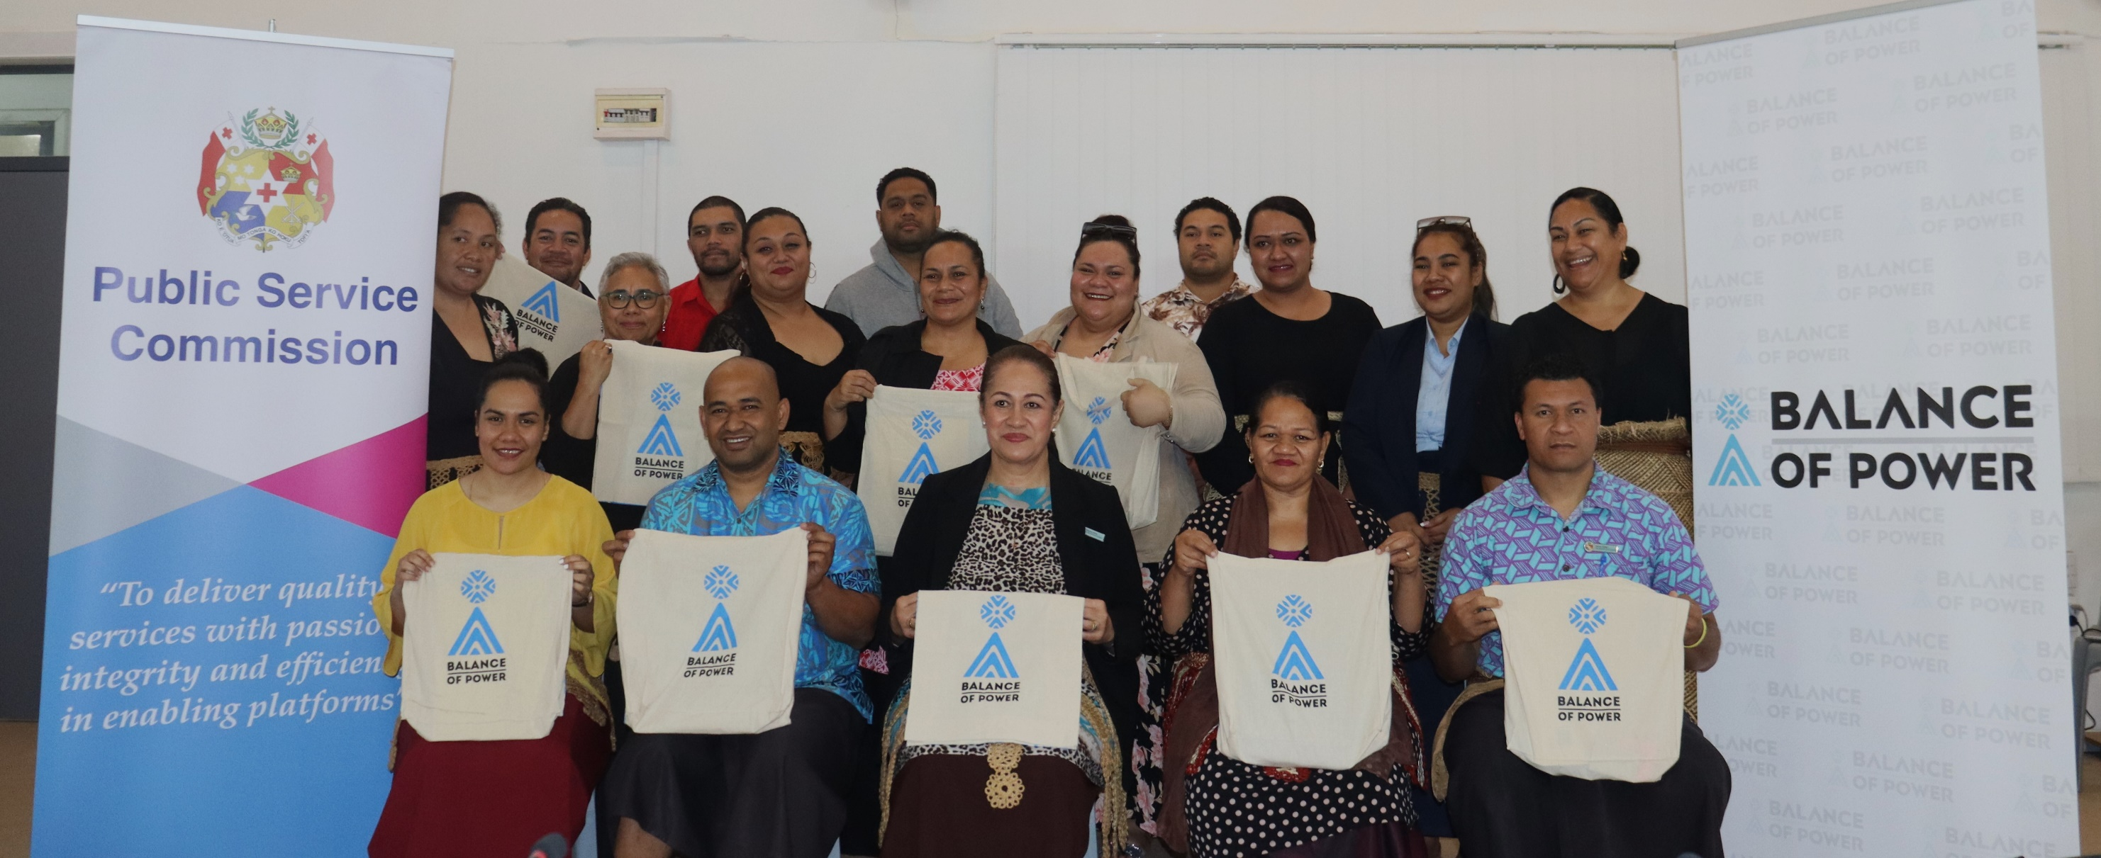
Intentionally connect PNG PWL with the broader regional program. This could include inviting representatives from the other regional components (Women’s Funds, SPC and PWLES) to PNG PWL events and ensuring strong PNG representation at regional PWL events (DFAT PNG and PWLES).
PC: Balance of Power
- Provide funding for institutional strengthening that supports good governance and organisational development of Pacific women’s organisations so they become competitive and can manage greater donor funding (Women’s Funds).

Case study
Establishment of the Pacific Feminist
Fund
Project: Amplify-Invest-Reach (AIR)
Country: Regional
Sub-outcome: Pacific feminist movement

The Pacific region remains one of the most under-resourced and underfunded regions in the world. In 2019, a scoping study commissioned by the Urgent Action Fund Asia and Pacific (UAF A&P) and the Women’s Fund Fiji (WFF) found that less than 1% of funding reaches women’s organisations in the Pacific and recommended setting up an independent Pacific Feminist Fund (PFF). With funding support from Foundation for a Just Society, UAF A&P and Women’s Fund Asia (WFA), the PFF set up its Steering Committee and Advisory Group. The PFF is now officially registered as a charitable organisation and incorporated in New Zealand and will be working towards registration in Samoa. As a registered entity, it has a 4-member Board of Trustees, Pacific feminists who have a breadth of experience, knowledge and skills that will continue to guide PFF’s strategic direction, institutional processes, and structure.
At present, the PFF is part of a consortium of women’s funds under the Amplify-Invest-Reach (AIR) Partnership with DFAT. The AIR partnership, which commenced in 2019, is a component under PWL. As the Pacific is the only region in the world not served by at least one regional Women’s Fund, the ‘invest’ component of the AIR partnership aimed to support the establishment of the PFF. The PFF would also focus on drawing international and regional attention to the needs and priorities of women, girls, transgender and non-binary persons in the Pacific, and would be modelled on the values and lessons learnt from established global women’s and feminist funds.
Michelle Reddy, the PFF Co-Lead said, “The origins and beginnings of an independent fund that is mandated by the Pacific women’s and feminist movement is political. It means that we are first and foremost accountable to the movement. The presence of home-grown women’s funds in the Pacific, that are situated and led within the Pacific movement is important. In 2017, the establishment of the WFF and UAF A&P was hugely celebrated. Now with the launch of the PFF in 2023, a new fierce and bold feminist fund. It’s groundbreaking!”
The PFF was launched in 2023 at the 3rd Pacific Feminist Forum, held at Pearl Harbour in Fiji. Professor Underhill-Sem, Board Trustee said “There has also been a lot of learnings, the most important being the need to create an independent Pacific Feminist Fund, to facilitate engagement with new financing modalities and to improve the transparency of funding data so that dialogues with Pacific women’s organisations are more informed and inclusive,” and “Amid the diversity of peoples that constitute the Pacific, the politics of indigeneity, race and climate change will continue to add further complexities. However, our understanding of gendered power relations in the Pacific shows that patriarchal privilege

prevails to the detriment of women regardless of the hue of their skin, the superiority of their skill or knowledge, the quality of their education or their leadership potential. While it may take generations to transform this – the PFF will ensure the pulse of feminist hearts remain strong, and fuelled by resources that will make a difference.”
AIR partners have acted as incubators for the PFF. UAF A&P is the PFF’s fiscal sponsor while PFF establishes its institutional processes. AIR partners have successfully connected PFF to new donors in the region. For instance, WFA have connected PFF to the Foundation Chanel, who are in the process of finalising grant agreement with PFF for a period of 3 years.
All partners are collectively working together to ensure that PFF is a part of key spaces, meetings and events around resource mobilisation and advocacy and can directly access donors and secure funding. In December 2022, WFF and UAF A&P nominated PFF to be a keynote speaker for Global Philanthropy Project’s 2023 Asia Pacific Donor Conference, and Sydney World Pride. Because of the PFF status as a new actor in the region, the speaking opportunity was only made possible through these recommendations. The panel titled “Resourcing LGBTIQ Movements for Change in Asia and the Pacific’’ and “Resourcing LGBTQIA+ Movements for Success’’ provided a public platform for advocacy by the PFF. The Australian Government’s Department of Foreign Affairs and Trade (DFAT) Ambassador for Gender Equality facilitated this panel, demonstrating the strength of the AIR Partnership to address issues of marginalisation and exclusion.
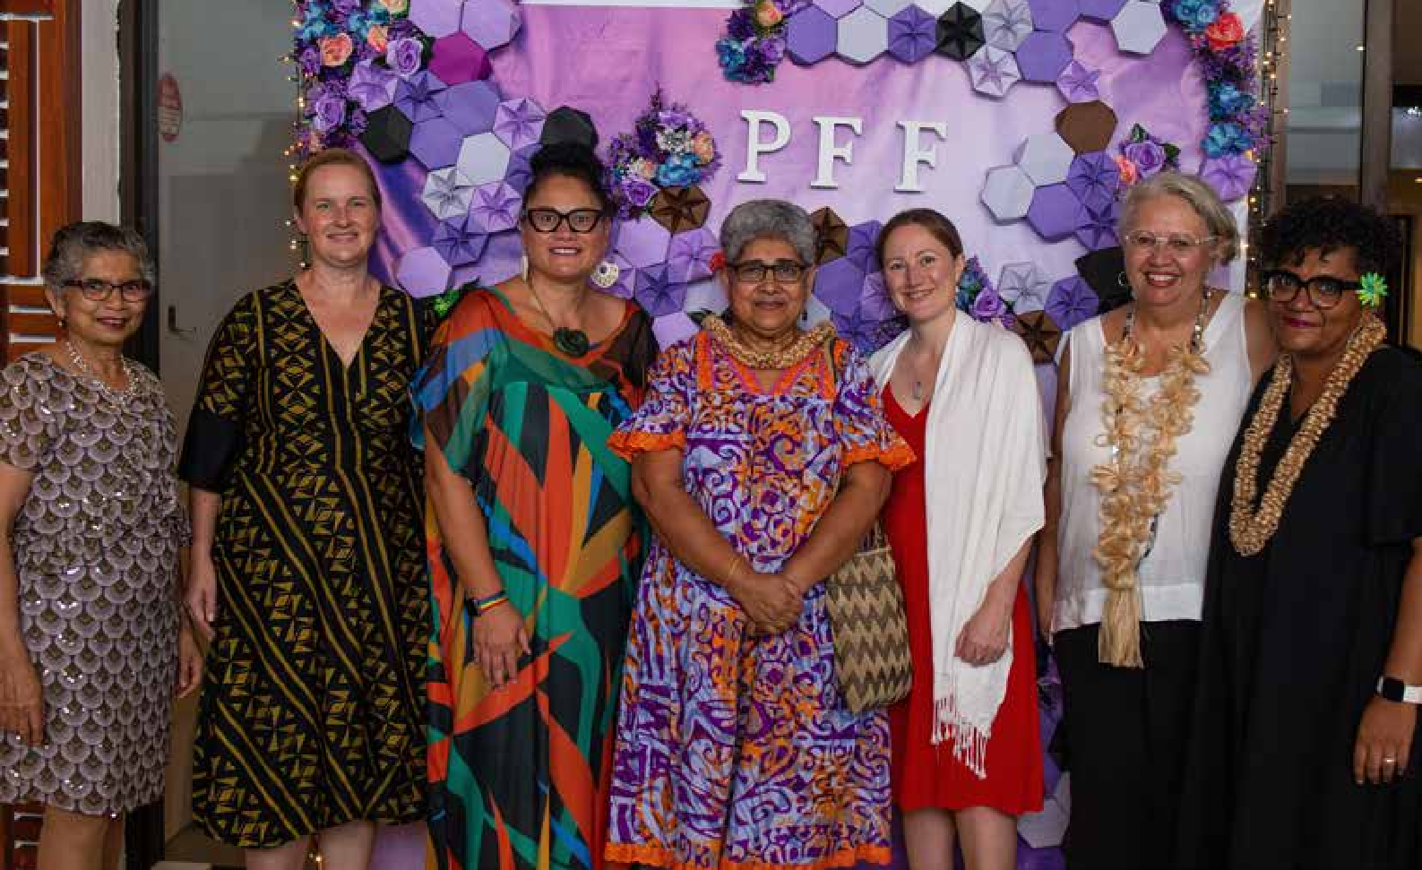
By working together and identifying collective solutions to identified needs, AIR partners have grown and increased the sustainability of the feminist aid architecture in a strategic and meaningful way. By delineating responsibilities, facilitating the exchange of knowledge and practices, consolidating the strength of new actors, and directing donors to the appropriate actor, the AIR partners have also increased support and resources to women, girls, trans and non-conforming defenders, organisations and networks in the Pacific.
Launch of the Pacific Feminist Fund in Fiji. PC: PFF

6.2 Outcome 2: Women’s Rights Realised
Women’s rights realised is made up of 3 sub-outcome areas: women and girls’ sexual and reproductive health and rights, WEE and women’s safety.
PWL funds 33 projects (28 under way and 5 completed) valued at AUD110 million (AUD79 million regional and AUD31 million bilateral) with a primary focus on women’s rights realised. These projects are implemented by 28 organisations: 10 Pacific NGOs, 8 INGOs, 4 Pacific government partners, 3 regional and multilateral partners, one private sector organisation, one intergovernmental organisation and one ‘other’.

6.2.1 Women’s rights realised and disability inclusion

Overall progress rating: Less than expected

Similar to the process of analysis for Outcome 1 (women’s leadership promoted), 3 separate groups analysed data for Outcome 2 (women’s rights realised) and disability inclusion. Two groups concluded that progress for women’s rights realised and disability inclusion was tracking ‘less than expected’ with one group concluding progress was ‘as expected’.

Table 5: Progress rating by group

Group number | Progress rating
Group 2 | Less than expected
Group 3 | Less than expected
Group 4 | As expected

6.2.2 Rating justification
Quantitative data illustrates that more people with disabilities received safety services compared to any other sub-outcome. This aligns with qualitative data provided in the narrative reports. No narrative reports provided information about the engagement of people with disabilities in economic empowerment activities. Overall reach and coverage for women and girls with a disability is less than 2% of the total numbers reported for Outcome 2.
There were some good signs of progress related to preconditions, with activities implemented in Solomon Islands (4), Vanuatu (2), Fiji (1), Tonga (1), PNG (1), Kiribati (1) and at the regional level (2).
The Responding to Violence Against Women project in Solomon Islands, a partnership between the Family
Support Centre (FSC), Christian Care Centre (CCC) and IWDA demonstrated good evidence of considering disability preconditions. Working in partnership with the People with Disabilities Solomon Islands (PWDSI) the project undertook access audits at the FSC and CCC in 2021. FSC and the CCC formed a partnership with PWDSI to improve service provision to survivors with disabilities. FSC has modified their office space and car park so that it is accessible, led regular awareness of disability inclusion, translated GBV awareness materials into braille, and made pidgin awareness materials accessible for deaf clients. CCC, with PWDSI support, has installed ramps, refurbished the bathroom, painted walls and walkways in high contrast colours to assist people with low vision, and improved lighting. PWDSI has reviewed FSC’s policies and procedures and delivered introductory sign language classes to 13 CCC sisters and staff. PWDSI and FSC have developed a Disability Inclusion Policy and delivered disability inclusion training for all staff and provincial committee members.
PWL funded 6 projects that supported the inclusion of women with disability. Five projects focussed on women’s safety, and one on women’s health. An example of inclusion was UNFPA’s Transformative Agenda program, which sought to involve people with disabilities and OPDs in the delivery of activities. In Fiji, SRHR outreach was co-facilitated by people with disabilities with the aim of empowering people with disabilities to engage their communities. In Samoa, the OPD Nuanua ole Alofa is a member of the Core Review Committee of the Adolescent and Youth Friendly Health Services National Operational Guidelines.
PWL funded 4 projects that resulted in meaningful engagement and equal outcomes for people with disabilities, focused on women’s safety and one on health. SPC’s Human Rights and Social Development (HRSD) Division supported 3 needs assessments studies on women and young people with disabilities and issues related to SRHR, gender-based violence and access to essential services, in collaboration with international and national OPDs, in Samoa (2021), Fiji and Vanuatu (both 2022). In Fiji, the report prompted the formation of a government-civil society partnership that has trained persons with disabilities as community-based SRHR officers. With health officials, they co-lead community outreach on disability rights and inclusion.
Workshop participants noted the gaps in the North Pacific, with no engagement with disability rights organisations in this region, while conversely, project engagement in Samoa was viewed as intentional and implemented with care and safety.

6.2.3 Recommendations to improve disability inclusion in future programming
While there was evidence of good progress for disability inclusion, workshop participants wanted to see more evidence of participation and meaningful engagement with women and girls with disabilities.
The top 3 recommendations identified by stakeholders included:
- Collaboration with other development partners to support national disability policy implementation, including under-served countries in the North Pacific (SPC and DFAT).
- Plan and report on inclusion and participation beyond preconditions. The PWLES could provide this support to partners through guidance notes and training (PWLES).
- Strengthened funded partnership with OPDs, with a focus on national OPDs and investigate new partnerships with OPDs in the North Pacific (DFAT and SPC).

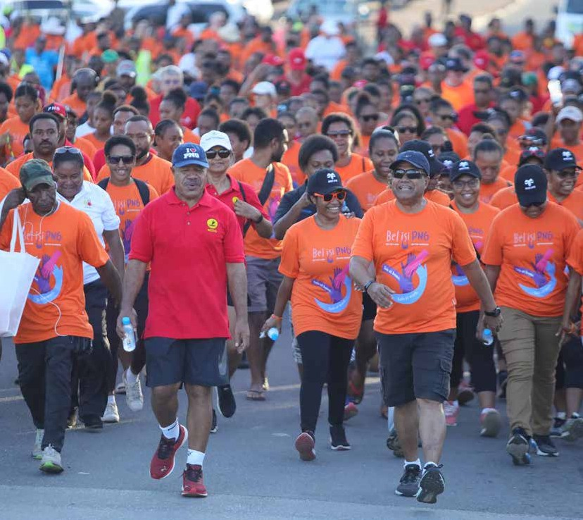

NCD Governor Powes Parkop and Santos PNG Country Chair Leon Buskens leading the participants of the Bel isi PNG organised Elimination of Violence Against Women walk on 25th November 2022.
Progress Report (July 2021- June 2023) | Pacific Women Lead 39
PC: Next of Kin.

Case study
Adapting to be more inclusive

Project: Samoa Gender Partnership Program

(Tautua and Samoa Women in Business)

Country: Samoa

Sub-outcome: Women’s Rights Realised – women’s economic empowerment and disability inclusion

This year, we’re probably about 32 years old. As part of the organisation’s staff, it is difficult for us to identify which changes Tautua has contributed to as we have a few funding sources. We can’t say we have projects funded by specific donors, but we do have a program supported by various funders.
One thing that has grown during the last year is our inclusion program. The program started with a young girl with Down Syndrome, and she’s been our receptionist for the longest time. During COVID-19 we started working with 3 people with disabilities as interns to help us make the soaps. But thanks to funding, we were able to hire people with disabilities as staff. While we had always wanted to work with people with disabilities, we just did not really know how to. Now, we have between 2-8 people with disabilities helping us with different tasks like taking care of the database.
To work with our deaf staff, we’ve managed to hire 2 sign language interpreters to teach our staff. None of us knew sign language and now 2 of our young girls in the field have become really good at it. For example, one of our girls went up the hill to a coconut oil production site and they had a young deaf man working there. She was able to translate for him and to the landlord. During another visit, she learned that there was another deaf person in the same village, so she asked his family if the coconut production site could hire him. There are now 2 deaf people working for the same site.
The Deaf Association says they have seen improvements in their deaf staff in the way they communicate and interact. They have become more independent. It is lovely to look outside at lunchtime and see us all laughing together.
We have also hired a young man with a physical disability who people perceived as unable to work due to a hand deformity. There was nothing wrong with his hand and he was able and comfortable to use it while working with us. We now get applications from people with disabilities all the time and I feel so bad that we cannot hire more. There’s been a lot of learning for everyone here, and staff using sign language seems like a huge change for us in the last year, but we did not realise it at the time.

6.2.4 Women and girls sexual and reproductive health and rights
PWL funds 2 projects (both under way) to a value of AUD47 million (both regionally funded) with a primary focus on women and girls’ sexual and reproductive health and rights. These projects are implemented by 2 organisations: one INGO (International Planned Parenthood) and one multilateral organisation (UNFPA).
Overall stakeholder progress rating: As expected

There were 3 working groups analysing the women’s health data at the PWL reflection and analysis workshop. Two groups ranked progress ‘as expected’ to ‘slightly less than expected’, and one group ranked progress ‘as expected’.

Table 6: Progress rating by group
Group number | Progress rating
Group 1 | As expected to less than expected
Group 2 | As expected
Group 3 | As expected to less than expected

Intermediate outcomes:
Women’s health: Health sectors across the Pacific provide quality and inclusive SRHR services

6.2.5 Rating justification
In its first 2 years, through distribution of modern- day contraceptives, PWL has funded women’s health projects to empower women to prevent an estimated 47,832 unplanned pregnancies from occurring and delivered 12-months of contraceptive protection to 229,436 couples.
Health sectors have been supported to provide quality and inclusive SRHR services through training of health care staff, provision of modern-day contraceptives and implementation of comprehensive sexuality education. In collaboration with Ministries of Health and Family Planning New South Wales, UNFPA continued to provide training to strengthen the capacities of in-service health workers to offer youth- friendly and disability-inclusive family planning. Five countries trained 219 health workers in 2022, with all training taking a human rights and client-centred approach to counselling and the provision of modern contraceptives. Samoa and Tonga achieved 100% health facility coverage with at least one trained health worker. The Tonga Family Planning training involved a Fijian master trainer and served as an inspiring example of South-South cooperation.
The UNFPA Midwifery Faculty Development Programme continued to strengthen capacities across the Pacific. In 2022, Kiribati, Samoa, Solomon Islands and Tonga revised their pre-service midwifery curriculums to align to international standards. Fiji conducted a curriculum gap analysis and expects to start curriculum renewal in 2023. In Vanuatu, the Ministry of Health endorsed the need for a midwifery curriculum review.
With UNFPA technical support, 4 countries, Fiji, Samoa, Solomon Islands and Vanuatu finalised out-of-school family life education and comprehensive sexuality education (CSE) with context-specific, culturally relevant approaches. Kiribati and Tonga have drafts to be finalised in 2023. The curriculum aligns with international standards and includes supplementary activities for select youth groups, such as youth with disabilities, youth with diverse sexual orientations and gender identities and expressions, and youth in emergencies. Fiji requested an additional module on mental health, nutrition and non-communicable diseases. With support from International Planned

³ Estimates the amount of protection distributed over 12 months based on the total number of contraceptives distributed. It uses a formula based on an assumed number of each kind of contraceptive method that would protect one couple for one year.

Parenthood Federation member associations, Fiji, Kiribati, Samoa, Solomon Islands and Vanuatu trained
256 out-of-school CSE facilitators. This initiative resulted in reaching 256 people out of the regional target of 800, accounting for 32% achievement. Facilitators educated 400 in Samoa, 1,015 in Solomon Islands and 72 out-of-school young people in Vanuatu. Due to the slow start of this intervention, progress has led to achieving 11% of the regional target of 13,500 out-of-school young people. There was also progress (although to a lesser extent) of organisations and communities working to address social norms that limit diverse women and adolescent girls’ access to SRHR services and workshop participants identified the opportunities to build stronger collaboration between the UNFPA and Pacific Girl program.
Behaviour change communication (BCC) interventions took place in all countries, reaching approximately 157,660 women and young people, including people with disabilities. The achievement surpassed its regional target 45,200 by three-fold. Various platforms – including community outreach, audio, and printed materials – were used to disseminate messages, increase awareness and demystify different sexual and reproductive health and family planning topics to generate demand for services, predominantly among women and young people, including people with disabilities.
Kiribati, Tonga and Vanuatu established BCC task groups or Reproductive, Maternal, Neonatal, Child and Adolescent Health Subcommittees to build capacities to design and implement BCC. Implementation of a BCC monitoring and evaluation framework began late in 2022 with 3 audience research studies in Kiribati, Samoa and Solomon Islands. The study in Solomon Islands found that targeted radio spots prompted 94%of listeners with no prior awareness of SRHR services to say they were more likely to use them. An analysis of all 3 studies concluded that the UNFPA program has largely invested in the most appropriate and effective BCC interventions.
Brown Girl Woke (BGW) in Samoa showed progress in addressing issues such as mental health, suicide prevention and SRHR with a particular focus on menstrual health. BGW has challenged taboos around menstruation and period poverty affecting girls in Samoa through releasing a video within their 6
participating schools on menstrual hygiene and distributing reusable period pads to schoolgirls. The educational video has caught the attention of the Ministry of Education and is being rolled out across additional schools outside of BGW target areas by the ministry. Addressing menstruation has enabled BGW to start discussions about sexual and reproductive health and rights within schools in Samoa.
Kiribati Family Health Associations (KFHA) was granted approval to facilitate a 2-day SRHR workshop with a large group of Catholic community leaders. The Catholic population constitute roughly 60% of Kiribati’s population and KFHA’s programs and services had been banned by the Catholic leaders for over 2 years. This significant achievement demonstrates a revitalisation of partnership between KFHA and the Catholic church and sees KFHA ensuring SRHR services are accessible to all.

6.2.6 Recommendations to strengthen women and girls’ sexual and reproductive health and rights
      - Strengthen program integration for adolescent sexual and reproductive health. As a first step, increase collaboration between UNFPA’s Transformative Agenda program and the Pacific Girl program, with a focus on increasing understanding of qualitative data and analysis of adolescent SRHR and teenage pregnancy (SPC).
      - Coordinate and strengthen work with religious and cultural leaders across SRHR and look to broaden PWL strategies to reach greater numbers of women and girls with a disability and people of diverse gender and sexual identities (SPC and PWL Governance Board).
      - Define and measure what specific SRH social norms the program aims to change. PWL could build consensus among partners to focus on 3 of the most dangerous or limiting social norms, such as religious beliefs that limit women and girls’ access to contraception or reproductive health services, or beliefs around menstruation as dirty, which leads to poor hygiene among women and girls (PWLES).

Case study
Taking health services to
remote locations
Project: Samoa Gender Partnership Program (Tautua) and Samoa Family Health Association
Country: Samoa
Outcome: Women’s Rights Realised – women and girls’ sexual reproductive health and rights

I have been working as a clinician at the Samoa Family Health Association (SFHA) for 3 years. As a registered nurse and mid-wife, I wanted to work with SFHA because they are an outreach focused organisation, which I believe creates a healthy welcoming environment. Due to a shortage of staff, I am now working with the mobile clinics, and I look after antenatal care, sexually transmitted disease (STI) testing, family planning, and outreach programs taken out to the community.
The most significant change has been the ability to go out to deliver a service to women and the elderly in remote areas leading to an increase of clients reached. I have always had a fear of travelling outside of Apia to remote areas due to the steep terrain. But since I started working with the mobile clinic, I have overcome this fear and have started to find it fun and a worthwhile adventure.
I was also able to witness the need for our services and I am so pleased that we are able to help so many women and the elderly who look forward to our visits. We check their blood pressure and sugar levels, and I often get phone calls from the women to confirm the dates of our visit because they are eager to access our free services. Most women raised that the services help them save money because of increased transportation costs to travel to the hospital.
Although women often migrate from village to village, I have their contact details to ensure that I include their new villages in my logistics plan to ensure that I take the service to their village or nearby villages for ease of access. In terms of numbers, I would say even remote areas such as Uafato now have about 15 women who can access sexual reproductive health services. This is a huge number given the remoteness of the area. For villages like Siumu and Laulii, I am no longer afraid of crossing strong flowing rivers and would cross any river to reach that one woman who needs the service.
Bigger changes have occurred since we took the service off the mainland to Savaii and outer islands like Manono tai. The program costs cover the boat fares to take the service to many clients in Savaii and about 20 women who eagerly wait for me at Manono tai island. I know they are appreciative of the service due to the food and hospitality provided whenever I visit. The women there know very well that the fare to travel to the mainland of Upolu is expensive in addition to the fare from the harbour to the nearest hospital or clinic. Most clients are excited to have the service readily available every 3 months reaching about 500-600 clients in total per month. With the service provided most elderly and women continue using the service while other women get pregnant. This change is important because we are the only organisation helping the Ministry of Health to raise awareness and provide services to rural communities.

6.2.7 Women’s economic empowerment
PWL has funded 7 projects with a primary focus on WEE (6 underway and 1 completed) to the value of AUD13 million (AUD11 million regionally and AUD2 million bilaterally). It is acknowledged that projects primarily targeting other sub-outcome areas sometimes also address WEE, the most common example being projects that focus on women’s safety. Primary WEE projects are implemented in Fiji, Federated States of Micronesia, Palau, Republic of the Marshall Islands, Samoa, Solomon Islands and Vanuatu. WEE projects are implemented by 7 organisations: 2 government partners, 2 Pacific NGOs, 1 inter-governmental organisation, 1 INGO and 1 regional and/or multinational partner.
Overall progress rating: As expected to slightly more than expected

There were 2 working groups analysing the women’s WEE data at the PWL reflection and analysis workshop. Both groups ranked progress ‘as expected’ to ‘more than expected’.

Table 7: Progress rating by group
Group number | Progress rating
Group 1 | As expected to more than expected
Group 2 | As expected to more than expected

Intermediate outcomes:
Women’s economic empowerment:
Pacific Government, civil society and private sector provide quality equitable and inclusive economic opportunities for diverse women

Women’s economic empowerment: Pacific Governments, civil society, private sector, and communities work to address social norms that limit diverse women’s economic empowerment

6.2.8 Rating justification
In its first two years, PWL has provided 7,659 women and 47 women with a disability with financial and/or business development services.
There were several examples of how COVID-19 supported innovative solutions for women to continue to earn an income. An excellent example was a project supported through the UAF A&P and WFF to Fiji Social Enterprise Rise Beyond the Reef (RBTR). RBTR aims to improve women’s lives through ecologically sustainable income-generating projects that use traditional skills and materials to produce handicrafts that are sold domestically, regionally and most recently, globally. RBTR received a grant from UAF A&P and WFF during the peak of COVID-19 when retailing in local marketplaces was disrupted. RBTR had requested support to build a website to market their handicrafts and goods globally. Being able to move their business online helped the women’s collective to continue to earn an income when their traditional ways of selling were disrupted. RBTR reports that from January 2023 to date, women and small to medium enterprises have earned more than FJD94,000 through arts and crafts income, and this year RBTR aims to exceed women earning more than FJD1,000,000 In Tukuraki Village, earnings have grown more than 300% during this timeframe. Several women have primary aged school children who struggled to access schoolwork online due to connectivity issues since they live in the mountains. With the income they earned, they purchased a router and put aside funds for data to help provide steady online access for students.
The Centre for International Private Enterprise (CIPE) in PNG piloted a new capital initiative, the Pay It Forward (PIF) Loan program. PIF provided monetary support to PNG women entrepreneurs who have been adversely affected by the impacts of COVID-19. Though technically a grant, the PIF Loan is called a loan for recipients to retain a sense of responsibility regarding repayment of the principal amount, through the idea of “paying it forward” by contributing to the growth of other businesses, their communities, and ultimately the PNG economy. On August 1, 2022, CIPE officially launched the PIF Loan Initiative and 24 women in 4 industries, including 4 women with disabilities, across 8 provinces and the National Capital District were granted loans of up to PGK7,000 (or AUD2,800). Women have begun using the financial assistance to strengthen their businesses and started making “repayments” forward to others. Loan recipients have offered skills trainings and donations of supplies, among other “repayments”

The Markets for Change (M4C) program works to ensure marketplaces in rural and urban areas in Fiji, Samoa, Solomon Islands and Vanuatu are safe, inclusive and non-discriminatory. Through partnerships, M4C aims to improve socioeconomic security of women market vendors (WMVs) and provide financial and business development opportunities. M4C coordinates with 21 Market Vendor Associations across the 4 countries. Through them, rural women farmers and market vendors are identified to participate in project trainings (that is, leadership development, financial literacy, business management, agriculture value addition and protective cropping). M4C partners with ANZ Pacific, Vodafone Fiji and Digicel Pacific to support WMVs to access digital and banking services.
Over 700 rural WMVs reported improved socioeconomic security in Fiji and Vanuatu, based on increased income, savings or financial capital. Following training in Fiji, about 40% of trainees interviewed reported improved socioeconomic security and agency in financial decision-making in their business and households. They said they are now accessing gender-inclusive financial and social services and have increased business and financial skills, such as to start and maintain savings and record-keeping.
There were fewer examples across reporting of how WEE projects were helping to shift social norms to be more supportive of women and gender equality more broadly. Workshop participants noted the
lessons learned under Pacific Women Shaping Pacific Development that identified the importance of supporting women’s coalitions, not just individual women, when it came to economic empowerment programming. Supporting economic empowerment through women’s coalitions provides individual women with greater access to resources, training and support, which may also increase their access to basic services such as health and safety services. Coalitions also provide individual women with a safe space to practice leadership and decision-making, which over time increases the confidence of individual women to potentially venture into women-led enterprises.

6.2.9 Recommendations to

strengthen women’s economic

empowerment
      - Define and measure what specific WEE social norms the program aims to change. PWL could build consensus among partners to focus on 3 of the most dangerous or limiting social norms related to women’s economic empowerment and use story collection across the portfolio to investigate these social norms in greater detail (PWLES).
      - Create more learning spaces for stakeholders to share innovation related to WEE (SPC).
      - Build stronger links with government to support laws and policy that protect and advance WEE (SPC).

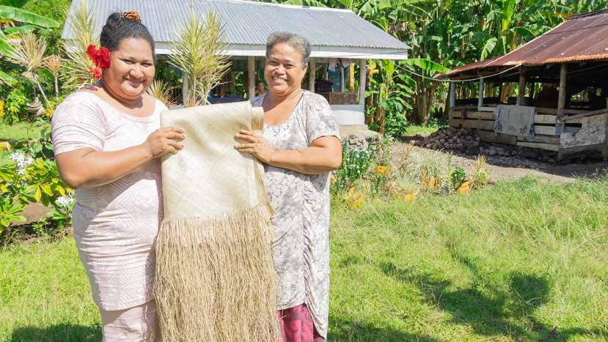
PC: Tautua Partnership

Case study
Re-defining Market Opportunities
for Women in Kioa
Project: Women’s Fund Fiji
Country: Fiji

Sub-outcome: Women’s Rights Realised – women’s economic empowerment
The Women’s Fund Fiji (the Fund), funded under PWL, supported Kioa Women’s Organisation (KWO) members to become more economically empowered. A key achievement has been the project’s ability to connect to a reliable and convenient market for the KWO’s handicraft and kamaimai (coconut nectar). These markets came about through KWO’s partnership with the Fund’s grantee partner Rise Beyond the Reef (RBTR).
Previously, the women incurred high transportation costs to take their handicrafts to sell in Taveuni and Savusavu towns. This would cost FJD100 and FJD40 respectively to hire a boat for one-way travel. If the charge is per passenger, each passenger would pay FJD5 to reach the main jetty and an additional FJD10.95 for a 2-hour bus ride to the towns. On average, a member would have to spend at least FJD31.90 for transportation, 4 hours in travel time and 5 hours at the market to sell their crafts. If sales were poor, the women would walk from door to door around Savusavu Town to see if anyone was interested in making a purchase. Often, if there were not many sales, the women would try to secure a sale by reducing the price which often meant they were sold below their actual value. Sometimes a tourist boat may come around, but that would be only twice a year.
Today, RBTR brings the market to their doorstep. On its first purchasing trip to Kioa, RBTR bought baskets, bowls, trays and mats from 29 women who received a total amount of FJD6,263. For all new purchases from KWO, RBTR also covers the cost of transportation and freight. Similarly, Marama Niu (supported by the Australian Government’s PHAMA Plus program) provides a market for the women’s kamaimai. Marama Niu pays FJD20 per litre, as well as the cost of transportation and freight fees to Suva.
The Fund has supported social enterprise RBTR since 2018. RBTR addresses the unique development needs of rural and remote communities through ecologically sustainable income-generating projects using traditional skills and materials, addressing gender inequalities, building women leaders, and empowering women and girl survivors of domestic violence. Grant funding supported RBTR to pivot to e-commerce during COVID-19. Over this reporting period, the online store allowed RBTR to offer new markets to remote and rural women such as Lauan masi makers, mat weavers from Nairai, and handicrafts from Kioa. Online sales also allowed RBTR to scale markets for lower skilled artisans from Ba and Ra. RBTR continues to develop markets outside of Fiji for their products via e-commerce and new US, Australia and New Zealand retail partnerships.
However, RBTR has realised that they must raise more operating funds to sustain this level of programming. In the long-term, they aim to achieve a 40/60 balance with 40% grant-funded and 60% funded through sales income. Through this ratio, they will be in a better position to absorb the necessary costs to reach truly marginalised rural remote women and their communities. Currently, they are working with almost 3 times the number of women compared to 3-4 years ago but with the same overall resources. RBTR is now focused on raising an additional FJD200,000 per year to help make their program more sustainable to run.

6.2.10 Women’s safety
PWL has funded 24 projects with a primary focus on safety (20 underway and 4 completed) to the value of AUD 49 million (AUD21 million regionally and AUD29 million bilaterally). Safety projects are implemented in Fiji, FSM, Kiribati, PNG, RMI, Samoa, Solomon Islands, Tonga and Tuvalu. Twenty implementing partners support this work, including 8 Pacific NGOs;
6 international NGOs; 2 regional and multilateral partners; 2 Pacific governments; one private sector and one ‘other’.
Overall progress rating: As expected
There were 3 working groups analysing the women’s safety data, with all groups ranking progress ‘as expected’.

Table 8: Progress rating by group
Group number | Progress rating
Group 1 | As expected
Group 2 | As expected
Group 3 | As expected

Intermediate outcomes:
Women’s safety: Pacific Government, civil society and private sector provide access to quality support services for diverse women and girls.

Women’s safety: Pacific Governments, civil society, private sector, and communities work to address social norms that contribute to diverse women and girls’ experience of violence.

6.2.11 Rating justification
In its first 2 years, PWL has provided 41,092 crisis services (health, counselling, access to justice) to women, 913 crisis services to women with a disability and 2,701 crisis services to children (1,906 to girls, 49 to girls with a disability, 734 to boys and 12 to boys with a disability).

“I have used the helpline to call and ask for help because I didn’t trust talking to anyone about it here on the island and I was able to ask questions and then I was given the right guidance to access the help that I needed. Although it was hard returning back to the island, I am glad that I know there are people who are ready to help me if I experience it again and next time, I know to ask for help to leave the island and to also take my children with me because the first time I just left, and I didn’t know that my children could come with me…”
Excerpt from WCCC project
PWL at SPC increased support for survivors of GBV through 3 training programs: ‘Domestic Violence Counsellor Skills Training’ for the Tongen Inepwineu Counselling Centre in FSM, and Weto in Mour crisis centre in Marshall Islands, ‘Regional GBV Telephone Counsellor Skills Training’ for counsellors and caseworkers from RMI, Chuuk in the FSM, Solomon Islands, PNG and Tonga, and the first in-person PNG Skills Training on GBV telephone counselling to counsellors and safe house service providers. Telephone counselling is one way the program supported women and children through COVID-19 lockdown and is also a way services are reaching women and children in rural and remote areas. The Women and Children’s Crisis Centre (WCCC) in Tonga continues to rollout out its helpline. This is a new concept in Tonga; however, more people are starting to use the service, especially rural women as 51% of calls are from rural, remote and outer island areas.
The program has made solid progress and is reaching more rural and remote women and children. The Kiribati Women and Children Support Centre established a branch on Kiritimati Island, a huge achievement given the remoteness of this island. The WCCC has expanded services to reach women and children living in Vava’u, Ha’apai and ‘Eua. All 3 branches reported that the awareness about their services and location is increasing. The extension of services also expands the reach of WCCC’s awareness programs and trainings and gave women and young girls the confidence to seek help if they experience violence.
Nazareth Centre for Rehabilitation (NCfR) operates 4 safe houses in Arawa, Buin, Buka and Chabai, working across all regions of Bougainville (North, Central and South). As a result of NCfR trainings, women human rights defenders in Bana and Upper Lato have set up safe houses to support community members. High risk cases are referred to Arawa and Chabai safe houses. Most clients were from Bougainville, but some were from other regions of PNG, demonstrating that NCfR’s services are known across various regions, and networking partners are working together to relocate clients. In May 2022, there was an official opening for FSC first branch in Gizo (Solomon Islands). The branch opening has strengthened ties between FSC and provincial SAFENET members. The Gizo Police Station was quoted saying “the new office will help us a lot. Over the years, we find it hard to counsel the victims of domestic violence, for now, it will be easy for those trained to do counselling rather than victims going through the police for counselling”. On 29th Sept 2022, FSC also established a Provincial Committee in Choiseul and FSC is now present in 7 of the 9 Solomon Islands provinces.
While there was a lot of good work noted around extending crisis services to remote and rural areas, workshop participants noted there was an assumption that any counselling service could provide safe and responses services to women and children. This raised questions about standards and common understanding related to the notion of ‘quality’ support services.
Many participants also noted the funding required to reach women and children across remote and rural areas. In particular, the need for secure, long- term funding that allowed crisis services to plan and resource this expansion was stressed several times at the workshop.
The impact of prevention work was noted as difficult to measure. All crisis centres and UN Women’s Pacific Partnership to End Violence Against Women and Girls (PPEVAWG) are working in this area and while there is some evidence of prevention activities supporting change through sports and religious leaders, the evidence through reporting is limited. The strongest evidence of prevention work came from PWL partner the Vanuatu Women’s Centre (VWC). As a result of their community awareness, and in particular the male advocacy training with chiefs and male leaders in Vanuatu, VWC and the Malampa Counselling Centre (MCC) is seeing more girls aged between 3 and 17 years who have been sexually abused by family members. This provides some evidence that the population around Malampa are becoming more aware that these abuses are criminal offences, and that abuses kept hidden before are now talked about and reported. MCC has noticed that more leaders are now assisting victims to come to the centre and referring clients, even when they live very far from the office. When chiefs are dealing with cases of domestic violence, many who have been trained by MCC and VWC now call up for advice and information on how to deal with these cases in the communities. For example, South- East Ambrym was known as an area where women will never come forward for help. Since VWC conducted a male leaders’ workshop in 2021, chiefs have begun to refer cases to MCC, and assist clients to come to MCC.

6.2.12 Recommendations to strengthen women’s safety
      - Define and measure what specific safety social norms the program aims to change. PWL could build consensus among partners to focus on 3 of the most dangerous or limiting social norms related to safety and use story collection across the portfolio to investigate these social norms in greater detail (PWLES).
      - Increase secure multiyear funding for crisis support services to facilitate the continued expansion and strengthening of services to remote islands (DFAT).
      - Increase funding for projects that target men and boys as allies. An important note at the PWL reflection and analysis workshop from organisations working in women’s safety was for any work with men and boys as allies to run side by side with women’s advocacy to ensure best practice and accountability to the Pacific feminist movement (SPC, Women’s Funds, PWL Governance Board).

Case study
Taking crisis services to Kiritimati Island

Project: Kiribati Women and Children Support Centre
Country: Kiribati

Outcome: Women’s Rights Realised – Women’s safety
In January 2018, under the previous phase of the program (Pacific Women Shaping Pacific Development), the Kiribati Women and Children Support Centre (KWCSC) opened in the capital, South Tarawa. Prior to the establishment of KWCSC, there were known gender-based violence (GBV) cases on Kiritimati Island. There were about 10 cases reported each year, while this may not be regarded as very high, it was more than reported from outer islands. The severity of the Kiritimati cases was also a concern – where victims suffered brutal injuries or died at the hands of their perpetrator.
Kiritimati Island is not easily accessible from Tarawa, there is one weekly flight to the island, via Fiji which continues to Honolulu. The option of travelling direct from Tarawa to Kiritimati by sea involves a 7-day journey. Communication services are lacking, internet connectivity is intermittent, and phone services are unreliable. Kiritimati Island is, however, the third most populated island after the main urban centers of Betio and South Tarawa. The island attracts game fishermen, mainly from the United States, coming through Hawaii and the Kiribati Government has designated the island as a developing urban center.
In 2020, KWCSC received funding to expand crisis services to the Line & Phoenix Islands, by setting up the Kiritimati branch. These plans were disrupted with the onset of COVID-19, but discussions continued, and in 2021, I (Teretia Tokam, Executive Director of KWCSC) was able to travel to Kiritimati on a government-chartered flight with restricted passenger numbers. The Kiritimati KWCSC office opened on 30 July 2021.
On this trip, we convened important consultations and trainings with the police, health workers, government staff, the Kiritimati Council, communities, and youth and women groups. The revival of SafeNet on Kiritimati Island was our priority and as part of reviving SafeNet we provided important training to SafeNet members. I participated in meetings with the police early to establish good relations and determine existing protocols for dealing with GBV cases. It was discovered that there were no existing procedures in place, therefore response to complaints was slow and victims did not report complaints to the police and social welfare officers because they didn’t feel secure reporting to the authorities. The Centre and relevant bodies on the island agreed and created temporary Standard Operation Protocols (SOPs) to enable efficient and effective referrals.
We established the Orange Door Initiative and the office’s telephone number was set up and shared with police. Almost immediately after the creation of the Orange Door, in August and early September 2021, there were 3 women seeking refuge at the crisis centre. The first women to receive protection at the Orange Door facility shared, “We really appreciate this support - we would have not been able to find a secure and safe place if there was no Orange Door space, we know we would have faced more serious consequences”.

In total there were 5 cases reported to the office and 3 of these were sent to the Orange Door due to the seriousness of their cases in the first quarter of 2022. Together with the newly appointed staff of the Kiritimati KWCSC, we initiated consultations with community groups. Most of these meetings were dominated by men who were not receptive to discussions around gender equality and expressed views that normalised domestic violence. There was fear from male participants that the advocacy activities by KWCSC would change attitudes and thinking of women and lead them to question cultural norms.
A lot has happened since the implementation of the project. There is now a Centre that can respond to needs of women and children, there are SOPs in place, with service providers aware of what they need to do when a case is reported. The Centre staff can offer counseling services either face to face or on the phone, and of special significance, there is now a place to house victims who are in danger (Orange Door safe house). The needs for food and clothing are provided through the Survivor Support Fund (SSF), which is seen as very useful – because it can provide immediate support in times of emergencies.
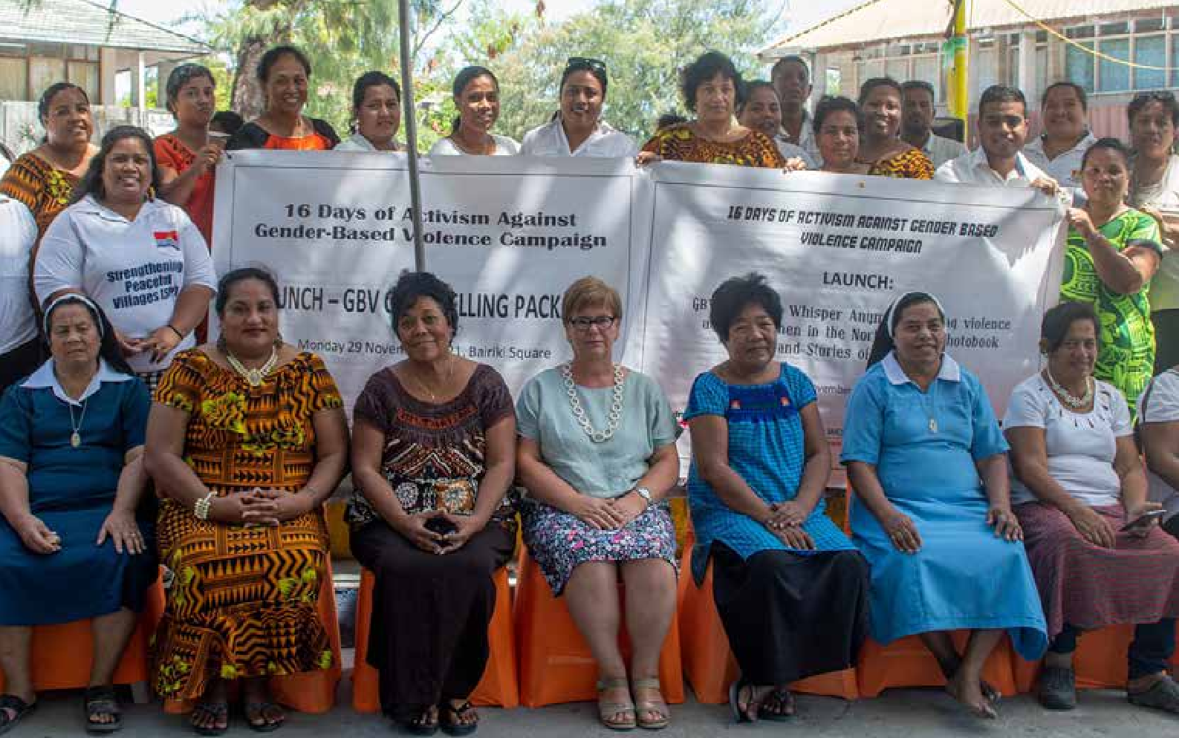
Currently, the office is open with 2 full-time staff, however this is not sufficient. One of the staff is the designated counselor but has not received formal training and qualifications and thus cannot be a registered counselor in compliance with Kiribati laws. The Centre would like to expand its services to more remote settlements on Kiritimati and other nearby islands, however it faces funding constraints. Hopefully, over time we can empower more women and get men on board to engage more in our work to reduce domestic violence on Kiritimati.

16 Days of Activism campaign in Kiribati in 2022. PC: KWCSC

6.3 Outcome 3: Pacific Ownership And Regional Effectiveness
The program logic for Outcome 3 acknowledges that collaboration and Pacific ownership is paramount to meeting regional gender equality commitments. Ultimately, achieving gender equality is not a task that any one organisation or entity can accomplish in isolation. It requires a concerted effort from multiple stakeholders including regional organisations, governments, and Pacific civil society.
Assessing progress to Outcome 3 took a different approach at the reflection and analysis workshop to Outcome 1 and 2. SPC is the lead partner for Outcome 3, and the work under this pillar predominately consists of resourcing collaboration between SPC and PIFS for technical assistance, either through SPC or Gender Advisers, to support Pacific governments to meet their gender equality commitments. As one participant at the workshop noted, Outcome 3 is about ‘connecting the dots to increase effectiveness and impact’.

Intermediate outcomes:
Pacific ownership and regional effectiveness: the PWL Governance Board and regional partners are collaborating and contributing to the Pacific region’s gender equality commitments.
Gender mainstreaming: Pacific Governments and development partners are mainstreaming gender through sector programs

The assessment process for Outcome 3 saw SPC hold an internal meeting with their HRSD Division to surface their contribution to progress. This information was then presented and further discussed at a smaller stakeholder meeting held on Monday 4 September 2023. Participants at this meeting included SPC, PIFS, DFAT, PWL Governance Board and PWLES representatives.
At the PWL reflection and analysis workshop, SPC PWL Manager Programmes (Tara Chetty) facilitated a session with Ofa Guttenbeil Likiliki, a consultant working with PWL to finalise a qualitative context analysis that will be used as a baseline for Outcome
- At this session, Tara and Ofa fed back progress ratings from the pre-workshop meetings and engaged workshop participants in an exercise to identify recommendations to strengthen Outcome 3.
Overall progress rating: less than expected

Rating justification
There has been some evidence of progress towards end-of-program outcomes under this area of work however, on balance, participants assessed that there was less than expected progress towards the intermediate outcome.
Most notably, what was uncovered at the reflection and analysis workshop was the misunderstanding among stakeholders on what Outcome 3 means, including definition of Pacific ownership and who, in the context of PWL, constitutes a regional partner. While there are many regional partners supporting gender quality efforts in the Pacific (UN Women, INGOs, donors), at the heart of Pacific ownership for PWL are SPC and PIFS. When PWL uses the language of ‘regional partners’ in the PWL program logic, it is specially talking about SPC and PIFS as the Pacific intergovernmental organisations with the mandate to progress gender equality in the region.
It was also evident from the reflection and analysis workshop that many partners are not clear on key regional policy commitments such as the 2050 Strategy for the Blue Pacific Continent. It was noted that Pacific CSOs are doing great work, but there is a disconnect between what they are doing and the broader regional architecture for gender equality. Understanding key regional policies is a critical part of holding governments accountable to their commitments, and something that needs to be improved in the coming year.
There were strong examples of collaboration between SPC, PIFS, Pacific governments and Pacific CSOs during the 67th Commission on the Status of Women (CSW67) in New York. This collaboration resulted in stronger language in the final outcomes document, with

Pacific organisations standing firm on gender equality language. Key wins for the region included an explicit reference to “maritime areas” and the inclusion of “islands” in the context of specific vulnerabilities. The Pacific Island countries were also united in their support for “gender-responsive” language and the need to explicitly address technology-facilitated gender-based violence. It was acknowledged that this work at CSW is ongoing and pre-dates PWL. However, the extra resources allowed SPC and PIFS to provide a package of technical and funding support to Pacific government delegations, which also included some CSO and youth representatives that contributed to the strong Pacific outcomes at this event. Apart from CSW67, there were numerous other collaboration activities that were identified including support to the Pacific Disability Regional Conference; preparation and participation at the Conference of the Parties to UNFCCC (COP27), support and collaboration in the lead up to Pacific Islands Forum Women Leaders Meeting (PIFWLM) and the PPEVAWG prevention summit and symposium.
Also noted by PWL stakeholders was the strong leadership on the PWL Governance Board, which everyone felt increased the credibility of the program, along with the funds (AUD5 million) that the PWL Governance Board members have decision-making powers over. Stakeholders at the workshop felt the Board needed to be more visible and greater resources should be provided to help implement the Board’s strategic direction, especially as it relates to the identification and disbursement of their grant funds.
PWL supports Gender Advisers in FSM, Nauru and Tuvalu who work with government (often Ministries of Women) to support greater gender mainstreaming. SPC also provides technical assistance to Pacific
governments to support implementation of regional and national gender equality commitments. There are indications of progress against the intermediate outcome area of Pacific Governments and development partners mainstreaming gender through sector programs, including through SPC’s gender flagship program. In particular, participants cited signs of progress with initiatives within SPC to advance gender strategies and frameworks in different sectors, such as support by energy sector stakeholders for the Pacific Energy and Gender Strategic Action Plan (PEGSAP) at the 2022 Pacific Women in Energy Conference. Bolstering gender mainstreaming opportunities and understanding the most effective strategies to support Pacific governments and intergovernmental organisations is an area for the program to focus on in the coming year.

Recommendations to strengthen Pacific ownership and regional effectiveness
      - Strengthen the PWL program logic for Outcome
3. This should include definitions for Pacific ownership and clarity on which organisations are driving the Pacific ownership agenda for the program (SPC).
      - Bring greater visibility to the regional architecture for gender equality and strengthen stakeholder understanding of key regional policy commitments. (SPC and PIFS).
      - Bring greater visibility to the PWL Governance Board, including embedding their role in delivery of gender equality efforts under PWL. Disbursement of the Board’s grant allocation is a priority for the next 3-6 months (SPC).

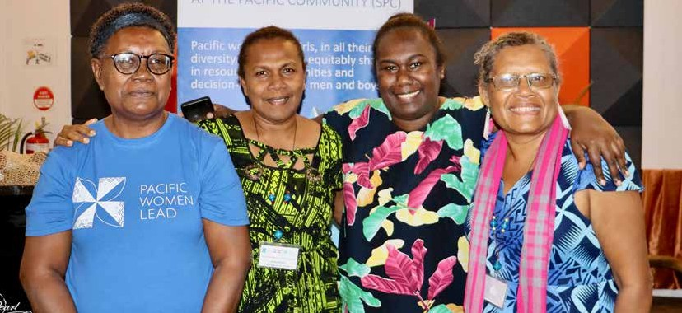
PC: PWLES

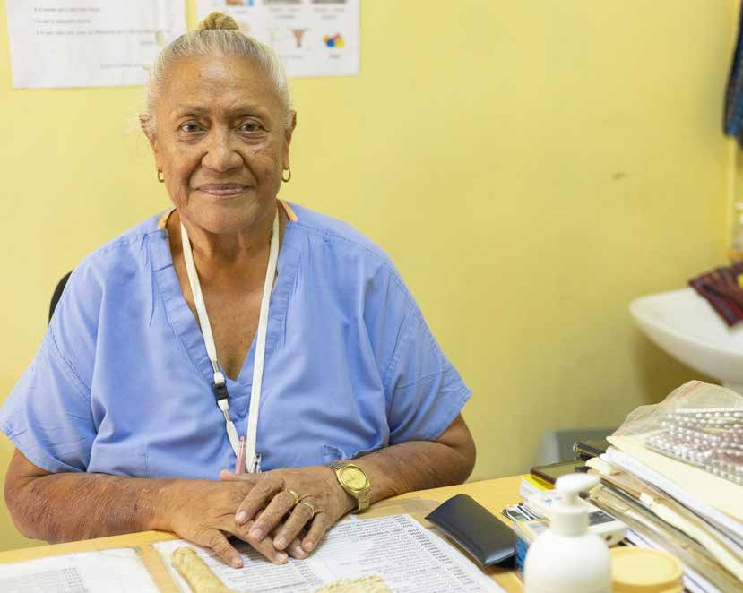
PC: Tautua Partnership

7
How Well are PWL Strategies Working? What are We Learning About How Transformational Change happens?

The PWL program logic identifies 4 strategies that underpin how the program will support change and achieve the end-of-program outcomes. The following section reflects on how well these strategies are working. Where it is identified that the program may need to adapt, these changes will be included in the 2024 update of the PWL MELF.

7.1 Grant making in thematic areas of leadership, SRHR, WEE and safety
PWL is funding a large portfolio of work (58 projects), but there is a need to expand funding. Through SPC’s first call for open grants, PWL will soon be funding a greater number of projects and organisations, and once the Pacific Feminist Fund and PWL Governance Board commence funding, the number will increase further. It will be important to track the sub-outcome areas and countries that receive this funding. Right now, the North Pacific is receiving substantially lower amounts of funding, and this should be taken into consideration when grant-making into the future.
The PWL MEL database also needs to expand its capabilities to capture and track grants to ‘downstream’ partners. Right now, the database does include and track SPC grantees, but it does not include grantees from the WFF, the Tautua program in Samoa or the Pacific Feminist Fund (once it starts to grant). Being able to track all the grants funded by the program will be critical to understanding the scope of projects being funded. The PWLES will ensure this capability is built in the coming months.

7.1.1 Grant making in leadership
There was broad consensus at the PWL reflection and analysis workshop that strategies to support women in national leadership positions were not bearing fruit, and many felt it was important to restrategise in this area. The Women’s Funds component could be a part of the program well placed to take on this restrategising, and several workshop participants want to see PWL supporting women in less formal leadership spheres, such as sport and religious institutions. Workshop participants noted that by
challenging gender stereotypes through sports, we challenge broader societal norms that limit women’s opportunities. Religious institutions also hold significant influence in the Pacific, and supporting women within these contexts can drive cultural shifts towards broader gender equality outcomes. Women’s active involvement in religious leadership roles can challenge traditional gender norms and promote a more inclusive interpretation of faith that supports women’s rights.

7.2 Linking, learning and collective action that supports genuine partnerships and strategies for change in social norms and shifts in social norms across all cultural contexts, including in the Pacific
While traditional gender roles have been deeply ingrained in many Pacific societies, there is growing recognition of the need to challenge these norms to achieve greater gender equality. It is crucial to recognise that these shifts in social norms present a spectrum of opportunities and challenges, often encountering resistance from conservative elements. This factor was recently identified during the PWL baseline and context analysis conducted for feminist movements.
The PWL MELF will be reviewed in late 2023-early 2024. Many participants at the PWL reflection and analysis workshop identified that the qualitative indicators to address social norms are too broad. Participants suggested identifying the top 3 social norms across outcomes in leadership, economic empowerment, safety and sexual and reproductive health that prevent progress to gender equality. By establishing consensus and agreement on these top 3 social norms, stakeholders can embark on a more nuanced exploration of these factors, thereby enabling more targeted and effective interventions.

7.3 Technical support, coaching and mentoring to support greater gender mainstreaming and gender equality outcomes for Pacific government and development partner sector programs
PWL supports Gender Advisers in FSM, Nauru and Tuvalu who work with government (often Ministries of Women) to support greater gender mainstreaming. At present, this reporting isn’t captured well within the PWL MEL system and this needs to be strengthened next year. SPC also provides technical assistance to Pacific governments to support implementation of regional and national gender equality commitments. While this work has been under way for several years, less is known about how the strategies of technical support, coaching and mentoring are (or are not) working. In the coming year, SPC and PWLES could investigate opportunities to bring PWL Gender Advisers and key government counterparts together to synthesise learning and shed light on successful strategies.

7.4 Collaborative portfolio-level monitoring, evaluation and learning, which includes sense-making to inform PWL decision-making
PWL is a complex program design made up of diverse projects implemented by a variety of implementing partners. Portfolio-level MEL provides a structured framework for collecting, analysing, and interpreting data throughout the program’s lifecycle.
The PWLES has used whole-of-portfolio MEL as a mechanism to build stakeholder understanding of the program, including the complex design. MEL activities that have contributed to this include the 2022 MELF design workshop, the March 2023 pilot annual reflection and analysis workshop and most recently, in September 2023, the inaugural PWL reflection and analysis workshop. The September workshop demonstrated how whole-of-portfolio MEL can be an effective mechanism for fostering a shared sense of purpose among stakeholders and facilitating real- time, data-driven decision-making. This strategy of leveraging the power of portfolio-level MEL to foster consensus on successful strategies and pinpoint areas for improvement should be actively endorsed and sustained throughout the program’s life.

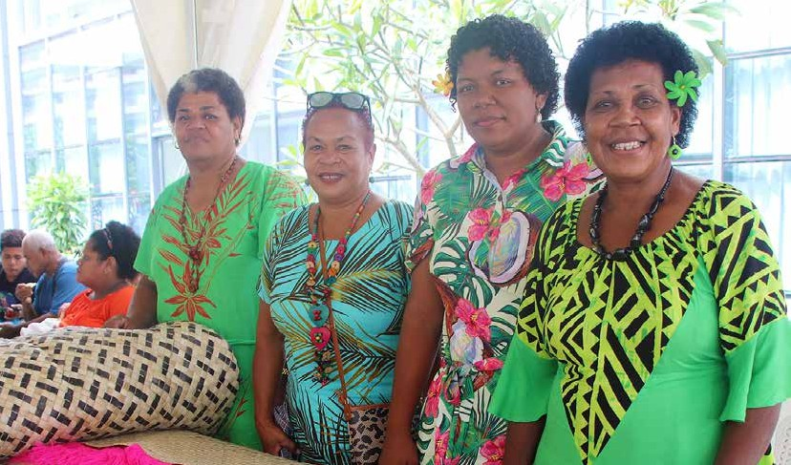
PC: Women’s Fund Fiji

Annex 1

PWL Key Evaluation Questions

When will these evaluation questions be answered? | Key evaluation questions
Yearly, through whole-of-portfolio annual reflection and analysis workshops (small-e) | - What did we do and who is benefitting from PWL?  - Types of activities/services delivered/partnerships formed  - PWL reach (age, sex, location, disability, SOGIESC)  - Financial disbursement of funds  - Evidence of outcomes and results across thematic areas and from diverse stakeholders  - What progress towards outcomes (expected and unexpected) has been achieved each year in the areas of:  - Women and girls’ leadership  - Women’s rights realised  - Partners’ effectiveness of gender equality efforts and ownership  - What have been the key successes, opportunities, obstacles and challenges each year? Considering these, how should PWL respond?  - What has changed in the operating context? How should PWL respond?  - How well are PWL strategies working? What are we learning about how transformational change happens?

Annex 2

PWL Annual Reflection and Analysis Workshop Participant List

 | Name | Position | Organisation
1. | Ethel Sigimanu | Board member | PWL Governance Board
2. | Rhema Misa | Board member, Disability Rep | PWL Governance Board
3. | Miles Young | Director | Human Resources and Social Division, SPC
4. | Tara Chetty | PWL Manager Programs | PWL at SPC
5. | Sala Tupou | PWL Program Coordinator | PWL at SPC
6. | Julie Bukikun | Coordinator - Women in Leadership Program | PWL at SPC
7. | Kaisha Crupi | MEL Manager | PWL at SPC
8. | Sian Rolls | Communications Officer | PWL at SPC
9. | Arti Devi | Database Officer | PWL at SPC
10. | Jennifer Danford | Research Officer | PWL at SPC
11. | Vilimaina Naqelevuki | Communications Assistant | PWL at SPC
12. | Lestina Berdo | GBV Counsellor, Tongen Inepwineu Counselling Center | Chuuk Women Council
13. | Saramita Salle | Program Coordinator Young Women’s Empowerment Program | Chuuk Women Council
14. | Isabelle Charlie | Program Manager | CARE Vanuatu
15. | Ana Malia Falemaka | Board Member, Youth Rep | Talitha Project  PWL Governance Board
16. | Carolyn Kitione | Regional Young Women Focal Point | Shifting the Power Coalition, ActionAid Australia
17. | Alisia Evans | Programme Director, Monitoring, Evaluation and Research | Shifting the Power Coalition, femLINKPACIFIC: Media Initiatives for Women
18. | Danyia Donna Note | Case Worker | Women's United Together Marshall Islands
19. | Taitusi Arhelger | Program Officer | Pacific Girl, PWL at SPC
20. | Michelle Reddy | Co-Lead | Pacific Feminist Fund
21. | Sereima Kalouniviti | Grants Enabler | Pacific Feminist Fund
22. | Virisila Buadromo | Co-Lead | Urgent Action Fund Asia & Pacific
23. | Noelene Powell | Resource Mobilisation Facilitator | Urgent Action Fund Asia & Pacific
24. | Niumai Kavoa | Program Officer | Women's Fund Fiji
25. | Makereta Tawake | MEAL Officer | Women's Fund Fiji
26. | Sua Mandria | Program Activity Coordinator | Tautua Partnerships
27. | Eva Inamuka | MEL Manager | PNG Women Lead
28. | Eli Webb | Country Director | Centre for International Enterprise
29. | Rebecca Kossin | Project Officer | Nazareth Centre for Rehabilitation
30. | Lily BeSoer | Executive Director | Voice for Change
31. | Ofa Guttenbeil Likiliki | Director | Women and Children’s Crisis Centre
32. | Kelianita Soana Pongi | MEL Officer | Women and Children’s Crisis Centre
33. | Tracey Tupou | GEDSI Adviser | Tonga Australia Support Platform
34. | Miliana T. Tarai | Legal Services Manager | Fiji Women's Crisis Centre
35. | Muliagatele Pepe Tevaga | Communications Manager | Samoa Victim Support Unit
36. | Teretia Tokam | Coordinator and PWL Governance Board | Kiribati Women and Children Support Center
37. | Preeya Ieli | Regional Program Manager | Markets for Change (UN Women)
38. | Kathleen Taylor | International Programme Coordinator | Transformative Agenda (UNFPA)
39. | Seraseini Vulavou | M&E Officer | IPPF
40. | Tatavola L Matas | Coordinator | Vanuatu Crisis Service
41. | Lorio Sisiolo | Center Manager | Family Support Centre
42. | Michael Copland | Chief Child Protection | Child Protection Program (UNICEF)
43. | Emeli Anise | Team Leader, Intergenerational Women’s Leadership Programme | Fiji Women's Rights Movement
44. | Doris Tulifau | Executive Director | Brown Girl Woke
45. | Mereani Rokotuibau | Executive Director | Balance of Power
46. | Epeli Tinivata | MEL Officer | Balance of Power
47. | Noelene Nabulivou | Executive Director | DIVA
48. | Viva Tatawaqa | Management Collect/Political Coordinator | DIVA
49. | Sainimili Tawake | Manager Inclusive Development | Pacific Disability Forum
50. | Laisa Vereti | Director Operations | Pacific Disability Forum
51. | Iris Low | Co-Director | PWL Enabling Services – Technical Partner, Collaborate Consulting Pte Ltd (CoLAB)
52. | Geraldine Tyson | Assistant Director, Pacific Gender and Disability Section | DFAT Canberra
53. | Jane Baskin-Sikimeti | Director, Pacific Gender Section | DFAT Canberra
54. | Pam Rugkhla | Assistant Director, Gender Performance and Effectiveness Unit | DFAT Canberra
55. | Julianne Cowley | A/g Assistant Secretary, Pacific Development Branch | DFAT Canberra
56. | Iliesa Lutu | Senior Program Manager, Human Rights, UN Partnerships and Disability | DFAT Suva
57. | Olita Nagera | Program Manager, Regional Gender | DFAT Suva
58. | Emily Elliot | Gender Focal Point Suva Post | DFAT Suva
59. | Sheron Narayan | Senior Program Manager, Gender/Gender Focal Point | DFAT Suva
60. | Rusila Tekamotiata | Assistant Program Manager, Health, Gender, Disability/Gender Focal Point | DFAT Kiribati
61. | Angelyn Amos | Senior Program Manager, Program Strategy and Gender/Gender Focal Point | DFAT PNG
62. | Joanne Zoleveke | Senior Gender Adviser/Gender Focal Point | DFAT Solomon Islands
63. | Zabeta Moutafis | First Secretary | DFAT Solomon Islands
64. | Edwina Tangitau | Program Manager, Economic Governance and Gender/Gender Focal Point | DFAT Tonga
65. | Kenye Rikin | Senior Program Manager/Gender Focal Point | DFAT FSM
66. | Samelda Leon | Policy and Program Manager/Gender Focal Point | DFAT RMI
67. | Alexandra Iakopo | Program Manager, Gender and Disability/ Gender Focal Point | DFAT Samoa
68. | Jodie Kapalu | Program Manager/Gender Focal Point | DFAT Vanuatu
69. | Sally Baker | Disability Specialist | PWL Enabling Services - QTAG Consultant
70. | Joanne Lee Kunatuba | Team Leader | PWL Enabling Services
71. | Mai Nguyen | QTAG Coordinator | PWL Enabling Services
72. | Junita Ngai | MEL Manager | PWL Enabling Services
73. | Emily Miller | MEL Specialist | PWL Enabling Services
74. | Shaazreen Saista Bi | Information Management Officer | PWL Enabling Services
75. | Anna Cowley | GEDSI Adviser | PWL Enabling Services
76. | Erica Lee | Communications Specialist | PWL Enabling Services
77. | Dareen Khatib | Child Protection Specialist | Child Protection Program (UNICEF)

Annex 3

List of PWL Projects

 | PROJECT NAME AND PARTNER | PROJECT DESCRIPTION | END OF PROJECT OUTCOMES | COUNTRIES | TIMEFRAME
1. | Amplify -  Invest - Reach:  Partnership with  Women’s Funds,  Pacific Feminist  Fund Inception  Phase Project (Pacific Feminist  Fund) | A grant to Pacific Feminist  Fund Charitable Trust  Board for the inception  phase of the Pacific  Feminist Fund. | » Increase grants and accompaniment support to women’s organisations and networks in the region,  » Document participatory grant making and accompaniment approach,  » Build strategic alliances and partnerships that shift the culture of giving and expand resourcing for women’s human rights in the Pacific,  » More and increasingly diverse funding resources for the sustainability of the activism for women’s human rights,  » Virtual working environment with secure ICT tools and staffed by a skilled team; an accountable, transparent and resilient feminist fund. | All Pacific  countries | 2023 – 2026
2. | Amplify - Invest - Reach:  Partnership with Women’s Funds, Urgent Action Fund Asia & Pacific  (Urgent Action Fund Asia & Pacific) | Provides one-off rapid response grants solely to women and non- binary human rights defenders facing security and safety issues and to assist them to maintain their well-being. Rapid response grants are for security support and for well-being support. A second type of grant, resourcing resilience, is by invitation only. These grants are intended to provide support to organisations and women and non-binary HRD who are facing or have faced a crisis to help build their resilience into the future. UAF A&P is an important bridge between emergency assistance to and protection of those at the front line, and the broader women’s movement that can sustain and inform them and their work. |  | All Pacific countries | 2022 – 2025
3. | Balance of Power  (DT Global) | The Balance of Power program aims to initiate dialogue and action around social norms and women’s roles in decision making and leadership in the Pacific region. | » There is a shifting balance of power towards women and men sharing decision-making at all levels,  » Women’s right to participate in the public sphere, including their right to vote independently, is increasingly understood and accepted by women and men,  » Traditional, church, and democratic governance institutions demonstrate action consistent with their commitments on women in leadership and role model gender sensitive practices. | Fiji Tonga Vanuatu | 2021 - 2024
4. | Building Prosperity for Women Producers,  Processors and Women-owned Businesses through Organic Value Chains  (Land Resource Division (LRD), SPC) | The BPWP project aims to strengthen the recognition of women’s role in organic agriculture. The project uses a combination of inter-linked activities such as trainings to project partners, capacity development of national organic farmer groups, technical assistance to primary actors, and advocating for policy and regulatory standards in countries, to promote organic agriculture and gender equality and social inclusion (GESI). | » The Pacific organic sector has more gender equitable policies and practices,  » Women and men benefit from viable organic value chains that meet market needs and increase food security,  » Women are increasingly participating in organic value chains including decision-making processes,  » Women have increased financial independence and influence in decision-making within the household. | Federated States of Micronesia Kiribati Palau Republic of Marshall Islands | 2021 – 2023
5. | Child Protection in Kiribati, Solomon Islands and Vanuatu  (UNICEF) | The programme aims to protect children in Kiribati, Solomon Islands, Vanuatu and Samoa from neglect, abuse,  and exploitation by strengthening multi- sector multi-stakeholder child protection (CP) systems. It includes three components: establishing a normative framework; strengthening services; and promoting social and behaviour change. | » Governments have strengthened child protection institutional frameworks,  » Government and other service providers (non-governmental agencies)  have enhanced capacities to provide child protection services which prevent and respond to violence and abuse,  » Caregivers, families and communities have increased knowledge and skills to eliminate harmful practices and better protect children from violence and abuse. | Kiribati Solomon Islands Vanuatu | 2021 – 2024
6. | Core Funding for IPPF Global Strategic Framework Funding 2018 –  2022 (Niu Vaka Strategy)  (IPPF) | The Strategy provides a framework and guidance on a life course approach to SRHR in the Pacific.  This entails broadening the focus from family planning to services across the life span from pregnancy and prenatal care and pre- menstruation through  menopause. It also looks at critical factors for the Pacific including climate change, gender, disability, non-communicable diseases and sexual and gender-based violence. | » Pacific Island governments increasingly promote, respect, protect and fulfil commitments to SRHR and gender  equality,  » People in Pacific countries can act freely on their SRHR,  » Expanded quality, integrated, gender and rights-based,  » Sexual and reproductive health (SRH) services are delivered with a focus on reaching the underserved,  » A high performing, accountable and united federation drives sustainable positive change in SRHR in the Pacific. | Cook Islands Fiji  Kiribati Papua New Guinea Samoa Solomon Islands Tonga Tuvalu Vanuatu | 2021 – 2026
7. | Feminist movements for transformative change: We Rise Coalition Phase 3  (IWDA) | The goal of the We Rise Coalition is to develop, demonstrate and strengthen feminist coalitions and partnerships in order to grow and uphold inclusive governance, equality, diversity, justice and women’s human rights. | » Coalition and organisational strengthening: Diverse Fiji and Pacific Women are contributing to a coordinated, feminist social movement,  » Movement Building: We Rise partners and the Coalition demonstrate feminist praxis and solidarity.  » Policy, structural and institutional reform: Pacific women influence local, national and regional decision-making to reflect Pacific women’s human rights concerns. | Fiji  Papua New Guinea Samoa Vanuatu | 2021 - 2024
8. | Gender responsive Climate Policy and Women’s Climate Leadership in the Pacific  (WEDO) | Advance Pacific women’s leadership in climate change decision-  making via WEDO’s Women Delegates Fund (WDF) program, as well as enhance the implementation of gender-responsive climate policy via  capacity strengthening for National Gender and Climate Change Focal Points in the Pacific. | » Strengthen Pacific women’s leadership in climate change diplomacy and policymaking via travel support, training and networking,  » Support effective operationalisation of the role of National Gender and Climate Change Focal Points across Pacific Island countries. | All Pacific countries | 2022 – 2024
9. | Markets for Change (M4C)  Phase 2  (UN Women) | Markets for Change Phase II aims to promote gender equality and the economic empowerment of market vendors, with specific attention to the needs and aspirations of women market vendors. | » Inclusive, effective and representative marketplace groups are created and grow, further enabled and recognised,  » Improved socio-economic security of women market vendors,  » Local governments, market management and other decision-makers are gender-responsive, effective and accountable to women market vendors,  » Physical market structures and operating systems are improved to make markets more gender- responsive, safer, more accessible, sustainable and resilient to disaster risks and climate change. | Fiji Samoa Solomon Islands Vanuatu | 2022 – 2026
10. | Netball Australia (Pilot Pacific Women’s Sports Administration Program)  (Netball Australia) | The program focuses on governance and administration support – recognizing that  this enables netball associations to advance women in decision-making and leadership roles (and their effectiveness in those roles), as well as  enhancing access to safe and inclusive competition for women and girls across the Pacific. | » Improved governance and administration,  » Increased women in leadership and decision-making roles,  » Increased grassroot participation rates of women and girls in safer and more accessible environments. | Fiji  Papua New Guinea Samoa Tonga | 2021 - 2023
11. | Oceania Rise Rugby Project  (Oceania Rugby) | Strengthen the participation, influence and visibility of women in all parts of the game, both on and off the field. | » 4 new high profile women’s domestic rugby competitions, completing several women’s rugby pathways,  » 11 Pacific women in new full-time Senior or Middle Management  positions,  » 45 emerging Pacific women leaders trained and mentored in governance, leading to more women appointed in  decision making roles and improved governance practice,  » Over 200 women completing Rugby Accreditations and in leadership roles within the new domestic competitions (as Coaches, Match Officials, Strength & Conditioning coaches, First Aid, Club Administrators),  » Oceania Women in Rugby Network established supporting individuals,  peer learning and collective advocacy,  » 4000< girls participating in high-quality rugby,  » Communities witnessing girls and women play, lead and be celebrated  in a formerly ‘men’s’ sport, helping to drive positive change in attitudes and norms gender equality,  » Australia and DFAT celebrated as the primary supporter of these successes,  opportunities and significant shifts,  » Australian dignitaries visible and engaged at high profile, newsworthy announcements, events and competitions,  » Direct engagement between Australian government representatives and both profiled and emerging Pacific Island leaders  » Alignment and mutual reinforcement of other significant Oceania Rugby activities driving the participation and empowerment women in Pacific Islands and Australian diplomacy. | Fiji Samoa Solomon Islands Tonga | 2022 – 2024
12. | Pacific Partnership to End Violence Against Women and Girls  (UN Women) | The Pacific Partnership seeks to promote Gender Equality, prevent VAWG, and increase access to quality VAWG response services for survivors. The programme engages with over 100 partners across the region, including national governments, CSOs, EVAWG networks, faith-based groups, and sports associations. | » To enhance Pacific youth’s formal in-school and informal education on gender equality and prevention of violence against women and girls,  » To promote gender equitable social norms at individual and community levels to prevent violence against women and girls, and to ensure survivors have access to quality response services,  » To empower national and regional civil society organisations (CSOs) to advocate, monitor and report on regional institutions and governments commitments to enhance gender equality and prevent violence against women and girls. | Fiji Kiribati  Papua New Guinea Republic of Marshall Islands Samoa Solomon Islands Tonga Tuvalu Vanuatu | 2021 – 2027
13. | Pacific Community’s Human Rights and Social Development (HRSD) Division Support  (HRSD, SPC) | HRSD leads SPC’s work in the areas of human rights, gender equality and social development. | » Strengthen inclusive, transparent, and responsive governance and institutions for human rights, gender equality and social development,  » Mobilise, empower, and build conditions for gender equality, equity and social inclusion in society and development,  » Promote, preserve, and protect positive expressions of culture,  » Accelerate impact on human rights, gender equality and social development through knowledge, learning and innovative solutions. | All Pacific countries | 2022 – 2026
14. | Pacific Island Forum Secretariat Gender Disability and Social Inclusion  (Pacific Islands Forum Secretariat) | Progressing Pacific Island Forum Secretariat  Gender Equality Disability and Social Inclusion priorities | » PIFS Social Policy team to implement priorities on gender equality, disability and social inclusion including in the  implementation and monitoring of the 2050 Strategy for the Blue Pacific Continent including gender policy capability and advice,  » Enhanced strategic engagement and communications,  » Support to members and actioning outcomes,  » Progressing disability inclusion,  » Progressing implementation of social policy program. | All Pacific countries | 2026 - 2023
15. | Pacific Women Lead  (SPC) | PWL at SPC sits within SPC’s Human Rights and Social Development (HRSD) division  and supports the implementation of key regional commitments outlined in the Pacific Leaders’ Gender Equality Declaration, the Pacific Platform for Action on Gender Equality and Women’s Human Rights, and the outcomes of the Triennial Conference of Pacific Women.  Through PWL, SPC provides technical, convening and funding support to government ministries, civil society, and other partners, while also acting as Secretariat for the PWL Governance Board. |  | All Pacific countries | 2021 - 2026
16. | Pacific Women Lead Enabling Services  (DT Global) | Provides support to SPC and DFAT to implement PWL. This includes whole-of-program monitoring, evaluation, and learning (MEL), partnership brokering, and the delivery of an independent Quality and Technical Assurance Group (QTAG).  Through the QTAG, PWLES supports seven bilateral posts in the Pacific – FSM, Kiribati, Nauru, Niue, Palau, RMI and Tuvalu.  The Enabling Services is responsible to compile a yearly whole-of-program report for the Pacific Women Lead program. |  | All Pacific countries | 2021 – 2026
17. | Progressing Gender Equality in the Pacific  (HRSD, SPC) | PGEP’s overall objective is to strengthen gender mainstreaming, policy design, and implementation, including strategic support to civil society organisations, while supporting country and regional gender data and statistical initiatives | » Gender Mainstreaming: Public Institutions are implementing policies, practices and programs that support  gender equality,  » Accountability Mechanisms: Government gender mainstreaming planning budgeting, accountability, monitoring, and reporting systems enhance progress towards achieving gender equality commitments | Fiji Tonga Samoa Kiribati  Cook Islands RMI  Tuvalu Vanuatu Palau FSM  Nauru Solomon Islands | 2021– 2023  Completed  Will come under PWL at SPC in 2024
18. | RiseUp! Mobilising Young Women’s Leadership and Advocacy Phase IV  (World YWCA) | Leadership program developed and led by young women for young women, taking into account local contexts and priorities. RiseUp! provides training, networking and peer support to young women between the ages of 18 and 30 years. It supports young women in contexts where their rights and voices are repressed to know and claim those rights within their peer, family and community networks, and to work collectively to mobilise for change. | » Young women take up informal and formal leadership roles in their peer and family networks, communities, countries, region or globally. | Papua New Guinea Samoa Solomon Islands | 2020 – 2025
19. | Tennis Australia Women and Girls Pacific Extension - Emerging onto the World Stage  (Tennis Australia) | Deliver programs and pathways to create sustainable benefits for women in the Pacific, either as a player, coach or paid administrator/ Development Officer.  Create economic efficiencies, seeing supporting partners (International Tennis Federation, Oceania National Olympic Committees, Tennis Australia) come together to maximise opportunities for program stakeholders. | Stream 1: Coaching  » Increase the number of women in decision-making and leadership roles,  » Strengthen career and volunteer pathways and opportunities on the  court,  » Create sustainable networks to influence and advance women,  » Inspire and develop women to be a public voice for tennis from grassroots  to the world stage.  Stream 2: Community Leadership  » Increase the number of women in decision-making and leadership roles in Tennis organisations,  » Develop the governance structures to create safe, welcoming and inclusive  environments for women and girls.  Stream 3: Talent  » Improve access to safe inclusive sporting competitions and facilities to encourage higher participation of girls  and young women,  » Provide pathways for elite players to transition from Juniors to the Professional Tour (ITF and WTA),  » Increase retention of women elite players able to transition to coaches and leaders in the sport. | Fiji  Papua New Guinea  Samoa Solomon Islands Vanuatu | 2022 – 2026
20. | Transformative Agenda for Women, Adolescents and Youth in the Pacific: Towards Zero Unmet Need for Planning 2018  – 2022 (Phase 1  and 2) (UNFPA) | The Transformative Agenda outlines action that will increase the demand for, and supply of, SRH services and information (particularly family planning) and create an enabling environment for their progress.  Goal - Transformative change in the lives of women, adolescents and youth across the Pacific by 2022. | » Increased and improved supply of integrated sexual and reproductive health (SRH) information and services,  particularly for family planning,  » Increased demand for integrated SRH information and services, particularly for family planning,  » More conducive and supportive environment for people to access and  benefit from quality SRH, especially contraceptive choice. | Fiji Kiribati Samoa Solomon Islands Tonga Vanuatu | 2021 – 2028
21. | UN Trust Fund to End Violence Against Women Strategic Plan 2021 – 2025  (UN Women) | Grant-giving for CSOs/ WROs focussed on improved access for women and girls to essential, specialist, safe and adequate multisectoral services, improved prevention of  VAW/G through changes in behaviours, practices and attitudes, and increased effectiveness of legislation, policies, national action plans and accountability systems. | » Enabling CSOs and WROs in their demand-driven efforts to end VAW/G,  » Ensuring UN, national and other partner EVAW/G programming is informed by practitioner-based knowledge,  » Mobilising financial and political support for the essential role of CSOs and WROs in ending VAW/G. |  | 2021 – 2025
22. | Women’s Resilience to Disasters (WRD)  Program  (UN Women) | Program Goal: the lives and livelihoods of women and girls are resilient to disasters and climate change; contributing to sustainable, secure and thriving communities.  Support women and girls to increase their adaptive capacity and build resilience in the face of myriad disasters and threats. | » Prevention, preparedness, and recovery Policy frameworks, systems, processes, and tools are gender-responsive and implemented as a result of local women’s and girls’ advocacy,  » Women and girls have voice and agency to withstand multiple hazards, recover from disasters, and increase their resilience to future disasters and threats. | Fiji Kiribati Vanuatu | 2021 - 2026
23. | Women in Leadership (SPC) | The WIL programme will enhance SPC’s corporate direction to embed substantive equality through a  change in organisational culture, strengthening of accountability  mechanisms, policies and procedures. | » Component 1:SPC and CROP Gender Equality and WIL Networks,  » Component 2:SPC Gender Equality in the workplace and women’s leadership  staff capabilities,  » Component 3:SPC safe and respectful workplace approach to prevent and respond to GBV and gender-based  discrimination,  » Component 4:SPC HR systems, policies and practices are strengthened,  » Component 5: Accountability, evidence, impact and learning. | Internal SPC | 2021 - 2026

Bilateral Projects
FIJI

No. | PROJECT NAME AND PARTNER | PROJECT DESCRIPTION | END OF PROJECT OUTCOMES | TIMEFRAME
1. | Programs to Eliminate | Continuing core funding to | » Women are asserting their rights and are empowered to make their own choices and decisions,  » Service providers, leaders and community members respond sensitively to women  survivors and promote equal rights, and duty bearers implement laws and policies,  » Women, community leaders and members, and service providers in  rural, remote, maritime areas of Fiji are accessing effective prevention and response services,  » Government, other policy makers and decision makers develop and review laws  and policies that promote women’s rights in Fiji and the Pacific region,  » Regional Network members and partners  use best practice in their prevention and  response to violence against women,  » Male advocates promote equal decision making and rights for women in family, community, workplace, organisations and  society. | 2021 – 2023
 | Violence Against Women in Fiji and the Pacific  (FWCC) | the Fiji Women’s Crisis Centre, the leading crisis and support service for women and girls in Fiji.  FWCC’s program goal is the  elimination of all forms of  violence against women and  girls in Fiji and the Pacific  region using a human rights  and development framework.
2. | Women’s Fund Fiji | Supporting local women’s groups, organisations and networks in Fiji to expand and enhance their work on women’s empowerment and gender equality. Reaching women living in rural and remote locations and those who are marginalised. | » Feminist and women’s rights organisations are empowered through enhanced capacity to contribute to gender justice,  » Feminist and women’s movements are diverse, vibrant and have critical spaces to enhance their spheres of influence,  » The Fund has secured long term and core support from donors, private sector, and  philanthropic organisations to advance women’s human rights,  » The Fund has contributed to influencing  support to the larger, global feminist  funding ecosystem,  » The Women’s Fund Fiji is established, empathetic and adaptive in its resources, operations, and programs. | 2022 – 2025

KIRIBATI
No. | PROJECT NAME AND PARTNER | PROJECT DESCRIPTION | END OF PROJECT OUTCOMES | TIMEFRAME
1. | Kiritimati Infrastructure  Development for  Social and EconomicInclusion  (Ministry of Line  and Phoenix Island  Development – MLPID) Inclusion | Support for infrastructure developments for women  umbrella organisation in  Kiritimati Island, Nei Baneawa Association (a member of AMAK) - office, sewing and  cooking rooms, and meeting  room | » Women economic empowerment is prioritised as a priority intervention to promote gender equality,  » Building women’s capacity contributes to improving their livelihoods and to achieving Government national goal on economic growth. | 2022 - 2024
2. | Support to KWCSC  (Kiribati Women and Children Support Centre - KWCSC) | Supporting the Kiribati Women and Children Support Centre to continue to the provision of psychosocial support and counselling services to survivors of domestic violence | » Quality victim/survivor services: Victim/ survivors have increased access to quality essential support and empowerment services (including women with disabilities and women in outer islands),  » Reduced tolerance of violence by men  and women: The community have  greater awareness of their right to live free from violence and reduced tolerance of violence against women and children,  » Increased collaboration to uphold women’s rights: The Centre  demonstrates sector leadership, strengthened multi-agency coordination and effective partnerships,  » Strengthened Governance, Management and Evidence: The staff and Council  members of the Centre effectively govern and manage the KWCSC response and prevention services using evidence. | 2021 - 2024
3. | Support to KWCSC Operations | Funding support to KWCSC operations |  | 2021
4. | Support to Women Development Activities  (Ministry of Women,  Youth, Sports and Social Affairs  -MWYSSA) | Support for MWYSSA WDD  zoom facility equipment,  media communication  equipment for gender mainstreaming advocacy and salary support for Aia  Maea Ainen Kiribati (AMAK)  Coordinator and Finance  Administrator. | » Improving services to end violence against women,  » Women economic empowerment,  » Enhancing women agencies.
5. | Support to Women Development Division Programs  (MWYSSA) | Support to Women Development Division (WDD) at MWYSSA for the development of an  Implementation Plan for the Gender Equality and Women Development Policy (GEWD), a Women Loan Scheme revolving funds including review and validation of the translated Family Peace Act | » Gender Mainstreaming - Gender is mainstreamed across all Key Ministry and stakeholders plans and policies and there  is an improved public understanding of gender,  » Women’s Economic Empowerment -The  livelihoods and standards of living of  women and their families are improved,  » Stronger Informed Families - National key social and economic challenges are addressed,  » Women’s leadership and political participation - Participation of Women is  increased in leadership and politics,  » Eliminating Sexual and Gender-Based Violence. | 2021 - 2023
6. | UNW EVAWG  Programme (UN Women) | Support to UN Women under the PPEVAWG program  to implement programs with MWYSSA Kiribati to ensure that women and girls (especially from minority groups) who experience violence have access to quality essential services  (health, social service, police and justice) to recover; that national actors (government and community service organisations) develop and adopt best practice standards and guidelines for multisector services; and to ensure that front line service providers have strengthened capacity to provide quality services to GBV survivors. | » Women and men in target communities demonstrate support to survivors of  violence and practice balanced power in their relationship,  » Women and girls who experience  violence have access to quality essential  services (health, social service, police, and justice) to recover from violence,  » Laws, policies, and strategies are  adopted and implemented in-line with international standards and informed by voices of women survivors in order to prevent and respond to all forms of VAWG. | 2021 – 2023
7. | Restoration of Kiribati Women’s Umbrella Organisation (AMAK Infrastructural Developments) | Support for infrastructure developments for AMAK - office, sewing and cooking centres, and maneaba | » Ensure opportunity and space for women to support economic empowerment activities,  » Ensure women networks and relationships are supported and strengthened. | 2021 – 2022

PAPUA NEW GUINEA

No | PROJECT NAME AND PARTNER | PROJECT DESCRIPTION | END OF PROJECT OUTCOMES | TIMEFRAME
1. | Bel Isi PNG  (Santos Foundation) | The project aims to galvanise the private sector in partnership with government and civil society to play a transformational leadership role in changing attitudes towards family and sexual violence and improving services for survivors. | » The private sector is actively supporting initiatives which address family and sexual violence and companies are  contributing resources to support survivors,  » Survivors of family and sexual  violence living and/or working in Port  Moresby have improved access to coordinated, safe and secure short-term accommodation and high-quality case management services supported by businesses and other stakeholders,  » An innovative service delivery model, addressing family and sexual violence  in Port Moresby through public-private and civil society partnerships, has been effectively governed and managed ensuring the safety and security of staff and clients. | 2021– 2023
2. | From Gender Based Violence to Gender Justice and Healing Phase 2  (IWDA) | The project aims to reduce family and sexual violence in Bougainville by addressing the root causes of gender  inequality. It does this through supporting Bougainville women’s human rights defenders to lead responses to, and prevention of,  family and sexual violence with government and communities; and by enabling men and women to prevent family and sexual violence at community level by promoting shared power and decision making between women and men. | » Crisis services are provided to survivors of family and sexual violence (counselling, accommodation, access to justice, repatriation, case management and referrals),  » Ongoing capacity building for trauma  counsellors,  » Strengthening the work of women’s human rights defenders and working with communities on preventing and addressing gender-based violence,  » Working with male advocates and men. | 2021 - 2023
3. | Funding to Femilli PNG to operate the Family and Sexual Violence Case Management Centre  (Femili PNG) | Femili PNG established the first case management center in Lae to support survivors  to access emergency medical care, access emergency shelter of an adequate duration and standard, provide counselling support and assistance to obtain police, legal and social services if requested. | Femili PNG Strategic Objectives:  » As a national centre of excellence, provide effective and coordinated case  management approaches for people experiencing family and sexual violence,  » Foster strong partnerships with other  Papua New Guinea government and civil  society agencies to promote effective responses to family and sexual violence, both in Lae and across Papua New Guinea,  » Undertake operations and research- based advocacy to improve the response  to family and sexual violence across Papua New Guinea,  » Be a well-run and sustainable Papua New Guinean non-governmental organisation. | 2021 – 2023
4. | Strengthening the Business Coalition for Women  (PNG Business Coalition for Women) | This project supports the Business Coalition for Women to improve the status and safety of women in workplaces. The project is working to empower women economically and improve businesses. | » Economic opportunities and participation for women,  » Women in leadership and decision making,  » Prevention of gender-based violence and workplace safety,  » Knowledge creation and system’s change. | 2021 - 2023
5. | Safe Schools Strong Communities (Equal Playing Field) | This project is preventing gender-based violence experienced in schools by building respectful ways of communicating between girls and boys in school, as well  as creating enabling school environment with support and upskilling to teachers. | » Age-appropriate facilitators are upskilled to deliver participatory gender transformative programming,  » Young people display more positive knowledge, attitudes and behaviours in  the space of gender and cultural norms,  » Teachers and institutions are resources and their capacity built to deliver child protection and respectful relationship  education,  » Partner schools are more able to appropriately address child protection and school-based gender-based violence. | 2021 - 2023
6. | Responding to Gender Based and Sorcery Related Violence in Highlands of PNG (Oxfam Australia) | This project is preventing violence against women by challenging traditional community attitudes to sorcery, implementing  behavioural change activities with communities and conducting research on the effectiveness of repatriation of survivors. | » Positive changes in attitudes, behaviours and norms related to violence against women and girls (VAWG) and sorcery  accusation related violence,  » A whole-of-system approach that coordinates quality crisis services that are adaptive to the needs of survivors,  » Partners are able to better access and mobilise government funds for their  programs and services,  » Duty bearers have better policy and practice to address and prevent gender- based and sorcery accusation related violence. | 2021 – 2022  Completed
7. | Strengthening the Entrepreneurial Ecosystem for Women in PNG Phase 3 (Center for International Private Enterprise) | This project involves separate but related grants to two partners. The project is  co-financed by the US Government. Collectively the two grants aim to establish an entrepreneurial  ecosystem for women in PNG to enable women’s economic empowerment. Grant 1: The Center for International Private Enterprise (CIPE) will establish a Women’s Business Centre in partnership with other development partners, to increase women’s profits. Grant 2: The StartUp Cup  Inc. grant supports women’s economic empowerment through the WECREATE Challenge to provide skills training and mentoring to female entrepreneurs through the Women’s Business Centre established by CIPE. | » Increase women’s access to resources for economic empowerment such as training, mentoring and rights awareness via a walk-in business centre,  » Set the Women’s Business Resource Centre on the path towards long-term self-sufficiency,  » Educate Papua New Guinean university students through formal  entrepreneurship instruction,  » Develop participatory formative and summative evaluations to capture lessons learned and improve service delivery. | 2021 – 2023
8. | Scaling up technical support to Family Support Centers (Family Health International) |  |  | 2021 - 2022
9. | Women’s Empowerment and Voice for Equal Rights in Papua New Guinea (IWDA) |  |  | 2021 - 2024
10. | Creative Approaches for Impact in International Development (Queensland University of Technology) |  |  | 2021 – 2022  Completed
11. | Supporting Participatory Democracy in PNG (Australia National University) |  |  | 2022 - 2023
SAMOA
 | PROJECT NAME AND PARTNER | PROJECT DESCRIPTION | END OF PROJECT OUTCOMES | TIMEFRAME
1. | Samoa Women in Leadership (UNDP and UN Women joint program) | Strengthened women’s leadership and gender equality in Samoa. | » Strengthened opportunities for women’s participation in leadership pathways,  » Promoting political inclusivity and supporting women’s political  participation through a focus on development,  » Increased public awareness of and  engagement in inclusive and effective  political participation,  » Sharing knowledge of Samoa’s experience in promoting women’s leadership. | Budget expended under Pacific Women Shaping Pacific Development.  2018 – 2022  Completed
SOLOMON ISLANDS

 | PROJECT NAME AND PARTNER | PROJECT DESCRIPTION | END OF PROJECT OUTCOMES | TIMEFRAME
1. | Channels of Hope Phase 3  (World Vision Solomon Islands) | Channels of Hope is a faith- based approach to dealing with gender-based violence. It focuses on Churches as catalysts of change through a re-exploration of Biblical messages. | » Target communities and churches demonstrate more respectful behaviors that value men, women, boys and girls,  » Survivors of GBV have improved community support and improved access  to support services,  » Target communities better address substance abuse or other triggers for GBV. | 2021 – 2023
2. | Let’s Make Our Families Safe Phase 2 (Safe Families) Project  (Oxfam) | Safe Families is a multi- layered approach to violence prevention that aims to influence the social and cultural norm, values, attitudes and beliefs that support family and sexual violence, as well as enabling and resourcing collective action. Oxfam works with the Solomon Islands National Provincial Council of Women to implement the Safe Families Project through Provincial Council of Women in Malaita, Western, Choiseul and Temotu Provinces. | » Women Stakeholders at Provincial and National level have increased institutional capacity to effectively play a key role in the implementation of the FPA and coordination of the EVAW policy to advance gender equality and prevent violence in Solomon Islands,  » Increased collaboration between PCW, PA and PG in the establishment of prevention and response support structures / mechanisms such as SAFENET and PTF EVAW Force and in the implementation of provincial EVAW policy to prevent and respond to gender-based violence,  » Increased number of PCW and WCW members are empowered to design and  implement violence prevention program to facilitate transformational change and lead advocacy and campaign initiatives to ensure women and girls have a life free from violence,  » Provincial Alliance become an effective platform for holding Provincial  Government and service providers accountable through active engagement between civil society and government institutions,  » Increased number of women and girl survivors have awareness of their right to referrals to support services,  » Increased capacity at community and service providing organisation to provide primary services and facilitate referral for survivors of violence,  » There are positive changes among men and women in beliefs, attitudes and social norms relating to family violence, and communities and provinces develop new norms that support gender equality, and,  » Men, women, girls and boys adopt non-  violent conflict resolution methods and respectful behaviour to address gender- based issues at household level. | 2021 – 2023
3. | People With Disability Solomon Islands  (PWDSI) | Funding support to People with Disabilities in Solomon Islands ensures Australia is supporting a suite of women’s group that enable and empower women’s voices in public discourses across the portfolio of activities. |  | 2021 – 2022  Completed
4. | Responding to Violence against Women Phase 2  (IWDA with the Family Support Centre and the Christian Care Centre) | Providing core funding, technical support and capacity building to the Christian Care Centre and Family Support Centre, two key organisations providing emergency shelter, first aid, counselling, and legal services to survivors of violence. This includes funding to explore options (including through property construction, purchase or  long-term rental) for ensuring that the Family Support Centre have permanent location in Honiara to provide services to survivors of violence. |  | 2021 – 2023
5. | Solomon Islands Women in Business Association  (SWIBA) | Funding support to change to Solomon Islands Women in Business Association ensures Australia is supporting a suite of women’s group that enable and empower women’s voices in public discourses across the portfolio of activities. |  | 2021 – 2022  Completed
6. | Supporting the Ministry of Women, Youth, Children and Family Affairs  (Managing Contractor DT Global, through Australia Solomon Islands Resource Facility and MWYCFA) | Supporting the MWYCFA with its role of working across the Solomon Islands Government on gender equality policy and implementation, including research, policy development and gendered impacts of COVID-19 and activities arising from the review of the Family Protection Act 2014. This includes through technical support and support for coordinator positions and flexibilities to fund activities identified throughout the year. |  | 2021 – 2023
7. | Women Ignite Stability and Economic Recovery in Solomon Islands (WISER)  (International Women’s Development Agency and Women’s Rights Action Movement) | Core support is provided to WRAM and support for  women’s leadership through TSM. |  | 2021 – 2023
TONGA
No | PROJECT NAME AND PARTNER | PROJECT DESCRIPTION | END OF PROJECT OUTCOMES | TIMEFRAME
1. | Eliminate Violence Against Women and Children in Tonga using a human rights framework  (Tonga Women and Children Crisis Centre) | Supported existing violence against women service providers to increase the quality, coverage and awareness of services. Funded additional support following Tropical Cyclone Gita. | » Improved access by vulnerable and rural women and children to appropriate and effective support services,  » Key institutions incorporate human rights and gender equality into their daily roles,  » Key decision makers and the wider community are informed about the  WCCC’s work and influenced to change policy, practices and the law,  » Effective management and coordination  of response programs. | 2021 - 2024
2. | Families Free of Violence  (Australia Federal Police program) | The Families Free of Violence (FFOV) Program is an Australian Government-  supported initiative to support the Government of Tonga  to achieve its objectives in strengthening its response to gender-based violence (GBV). FFOV will continue to work towards the overarching goal: “Survivors of family violence in Tonga access better  quality services and ongoing support.” | » Women’s Affairs and Gender Equality Division (WAGED) is effectively coordinating implementation of the FPA,  including the SDP, with diverse service providers,  » Tonga Police demonstrates improved  frontline response to survivors of family  violence, including on the outer islands,  » Civil Society Forum of Tonga (CSFT) supports increased awareness and engagement in implementation of the  FPA and SDP by diverse CSOs. | 2022 - 2026
3. | Provision of economic empowerment services for women survivors of violence alongside their counselling and support services (Tonga National Centre for Women and Children) | Supported women and girls, including survivors of violence against women and girls, to have access to and control over expanded economic opportunities and to be able to make strategic life choices. | » Women & girls, including survivors of VAWG, have access to and control over expanded economic opportunities, and  are able to use them to make strategic life choices. | 2021 – 2023  Completed
4. | Support to the Women’s Affairs Division, Ministry of Internal Affairs  (Ministry of Internal Affairs) | Providing institutional strengthening and gender mainstreaming and equality support to the Women’s Affairs Division.  Supporting consists of funding three positions at WAGED:  a Family Protection Act Co- ordinator, a Principal Policy Officer, and a Monitoring & Evaluation officer, including a Safety and Protection Cluster Coordinator in the CEO’s office to highlight the importance of effective safety and protection for vulnerable community members throughout the Disaster Risk Management Cycle: DRR, Emergency Response, and Recovery Stage. Additional funding  was also provided to cater for activities to strengthen policy and practice of WAGED. | » N/A | 2021 – 2023  Completed
5. | Support to the Ministry of Justice for Family Protection Legal Aid Centre | FPLAC provides free legal advice to clients in response to Family violence. |  | 2021 – 2022  Completed

VANUATU
 | PROJECT NAME AND PARTNER | PROJECT DESCRIPTION | END OF PROJECT OUTCOMES | TIMEFRAME
1. | Vanuatu Women’s Centre Program Against Violence Against Women - Vanuatu Gender Equality Program Phase 8  (Vanuatu Women’s Centre) | Program Goal: The elimination of violence against women and children throughout Vanuatu.  Overarching Program Outcome: Effective prevention and response to violence against women and children. | » Survivors are empowered to claim their rights and access justice,  » Women, children, and community members throughout Vanuatu are  accessing effective services for violence against women and children,  » Increased community acceptance that  violence against women and children is a  violation of human rights,  » Government policymakers, legislators and targeted organisations and male advocates reduce discrimination and  promote gender equality,  » VWC and branch staff are effectively managing and coordinating the VWC Network’s prevention and response  services. | 2021 – 2026
2. | Gender Equality Together! (Phase 2) Building a movement for gender equality and freedom from violence in Vanuatu (CARE Vanuatu) | Project Goal: To strengthen the collective leadership, capacity and coordination of civil society and government actors in Vanuatu to more effectively work towards  the promotion of gender equality and the elimination of violence against women and girls with and without disabilities in peacetime and disasters. | » Increased women’s leadership for gender equality and EVAWG,  » Increased civil society capacity for gender equality and EVAWG,  » Increased coordination for EVAWG in peacetime and disasters. | 2022 – 2025

FEDERATED STATES OF MICRONESIA
Technical Advisers

No | PROJECT NAME AND PARTNER | PROJECT DESCRIPTION | END OF PROJECT OUTCOMES | TIMEFRAME
1. | Family Protection Adviser | Provide remote technical support, training and capacity development to FSM Government family protection service providers to provide safe and quality essential services to survivors of sexual and family violence  in the COVID-19 response and recovery context. This includes working with key government and non-government stakeholders to strengthen services, collaboration and referrals between services providers. It involves supporting them to develop and implement minimum service standards, standard operating procedures, and referral pathways and work with and build the capacity of civil society organisations and community-based advocates to develop and implement community awareness and violence prevention activities. | » Strengthen technical, leadership and organisational capabilities in sexual and family violence essential services in the  COVID-19 response and recovery context,  » Strengthen the capacity of government and civil society to implement community education programs about COVID-19  and family violence and how to access available services. | 2022 - 2024

NAURU
 | PROJECT NAME AND PARTNER | PROJECT DESCRIPTION | END OF PROJECT OUTCOMES | TIMEFRAME
2. | Gender Equality and Social Inclusion Adviser | Provide technical support to AHC, the Government of Nauru and Pacific Women Lead partners in GEDSI,  including supporting capacity development for AHC staff to advance GEDSI mainstreaming across the Australian development cooperation program in Nauri in  alignment with the Australian Government Partnerships for Recovery policy. |  | 2022  (completed)

TUVALU
 | PROJECT NAME AND PARTNER | PROJECT DESCRIPTION | END OF PROJECT OUTCOMES | TIMEFRAME
3. | Gender Equality and Social Inclusion Adviser | Provide advice and technical assistance to Tuvalu  post to support capacity development of Tuvalu post to advance gender equality and social inclusion of the most vulnerable across  the Australian government engagement in Tuvalu;  to develop and progress outcomes of the Tuvalu Pacific Women Lead Country Plan; and to support Post and partners in implementing, monitoring, reporting and coordinating Pacific Women GESI program activities in Tuvalu. This will include support to Post for interim review of the country plan during the transition to  and consolidation of Pacific Women Lead. | » Strengthen leadership, technical, and organisational capabilities in gender transformative and social inclusion  strategies in the COVID-19 recovery environment to reduce long-term negative impacts on women’s safety, health, social and economic security,  » Provide technical assistance, institutional strengthening and capacity development  to strengthen government capabilities and PWL implementing partner capabilities, to progress national GESI commitments, policy, legislation, plans and programs,  » Strengthen government and civil society capacity to implement community  education and social norms change programs about COVID-19 and gender equality,  » Support the capacity of PWL partners to develop and implement gender  transformative and responsive policies, programs and projects across development sectors in the region. | 2022 - 2024
4. | Gender Equality and Social Inclusion Advocate | Provide technical, mentorship, coordination and logistical support to implement, and monitor the implementation of the Pacific Women Lead program in Tuvalu. Co-lead and support stakeholder  engagement; support analysis and facilitate dialogue. |  | 2022 – 2023  (completed)

Research Projects

 | PROJECT NAME AND PARTNER | PROJECT DESCRIPTION | END OF PROJECT OUTCOMES | TIMEFRAME
1. | Building Back Better: Promoting gender data-driven response to the COVID-19 pandemic in the Pacific and South-east Asia  (UN Women) | The Project seeks to increase the production and use of quality timely data to ensure COVID-19 response and recovery efforts are sensitive to gender inequality considerations, provide maximum production  from COVID-19 impacts, and enable women’s and girls’ fullest contributions to recovery. | » Timely gender-sensitive data on the impact and responses to crisis, most importantly COVID-19, are produced to  inform decision-making,  » Gender-responsive COVID-19 policies and recovery plans are in place,  » COVID-19 gender data are accessible and used to inform policies, programmes,  advocacy and research. | 2021 – 2023
2. | Equality Insights: Gender data supporting  COVID-19 response and recovery in the Pacific  (IWDA) | The program goal is to improve the gender equality outcomes of COVID-19 recovery through use of Equality Insights Rapid data | » Improved evidence base for implementing COVID-19 recovery that advances gender equality in select  Pacific countries,  » Bilateral and other decision-makers and change agents can access and are using Equality Insights Rapid data,  » Policy, programming, advocacy and/or resource allocation for COVID recovery is  informed by Equality Insights Rapid data in at least two countries,  » Regional actors recognise and use  Equality Insights data and/or tools. | 2020 – 2022
3. | kNOwVAWdata Phase 2  (UNFPA) | Works to sustainably strengthen regional and national capacities to measure the prevalence of violence against women in Asia and the Pacific. kNOwVAWdata improves the availability and quality of data to inform more effective policy and programme responses to prevent and end violence against women. | » Data-driven, context-specific decision- making in VAW policy and programme design,  » Quality data on what works and what does not work to address VAW effectively,  » Effective policies and programmes to address VAW are implemented,  monitored and evaluated. | 2021 – 2024
4. | Making Every Woman and Girl Count Phase 2 | Since 2016, UN Women has implemented Making Every Woman and Girl Count (hereafter referred to as Women Count), which is a multi-donor flagship program that aims to create a radical shift in how gender statistics are used, created and promoted to inform policy  and advocacy on gender equality and women’s rights. Working with partner governments, international agencies and other actors including civil society organisations and academia, UN Women’s program is focused on the following three areas of work:  » Creating an enabling environment: Promoting a  supportive policy environment to address institutional and financial constraints and to strengthen policies and practices governing the production and use of gender statistics.  » Increasing data production: Supporting efforts to improve  the regular production of gender statistics to monitor the SDGs and other national and international policy priorities.  » Improving data accessibility and use: improving access to data to inform policies and advocacy through solutions such as open access, dissemination tools and user-producer dialogues so that data users are better able to use gender statistics to inform policy, programs and advocacy. | » Creating an enabling environment: promoting a supportive policy environment to address institutional and  financial constraints and to strengthen policies and practices governing the production and use of gender statistics,  » Increasing data production: supporting efforts to improve the regular production  of gender statistics to monitor the SDGs and other national and international policy priorities,  » Improving data accessibility and use: improving access to data to inform policies and advocacy through solutions such as open access, dissemination tools and user-producer dialogues so that data users are better able to use gender statistics to inform policy, programs and advocacy. | 2022 - 2026
5. | National Gender- based Violence Prevalence Study | Vanuatu Women’s Centre will conduct a second national prevalence survey to present updated data on violence against women and children in Vanuatu. |  | 2021 - 2025

