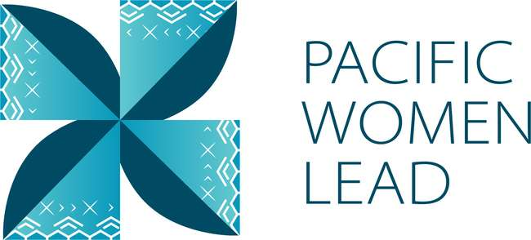

Pacific Women Lead

Papua New Guinea

Program Brief
August 2023

Contents
1 Pacific Women Lead overview 1
2 Program components 2
3 Pacific Women Lead Governance Board 2
4 Brief purpose 3
5 Bilateral activities 3
5.1 Project and implementing partner count by outcomes and sub-outcomes. 4
5.2 Type of implementing partner 5
5.3 Committed funding by outcomes and sub-outcomes 6
5.4 Reach data by projects and indicators 6
6 Regional activities 3
6.1 Project and implementing partner count by outcomes and sub-outcomes 3
6.2 Type of implementing partner 4
6.3 Committed funding by outcomes and sub-outcomes 5
7 Pacific Women Lead at SPC activities 5
7.1 Project and implementing partner count by outcomes and sub-outcome 5
7.2 Type of implementing partner 5
7.3 Committed funding by outcomes and sub-outcomes 6
8 Amplify-Invest-Reach (AIR) Program: Funding to Pacific Feminist Funds 6
9 Pacific Women Lead Enabling Services 6
9.1 Monitoring, Evaluation and Learning Support 6
9.2 Quality Technical Assurance Group (QTAG) 7
9.3 Grant Management 7
Annex 1: Pacific Women Lead Projects in PNG 9
Annex 2: Whole-of-Portfolio PWL Indicators 19

Pacific Women Lead overview
Pacific Women Lead (PWL) is a portfolio of regional investments to advance gender equality ($170AUD over five years 2021-2026). PWL is ambitious in its intent to take a Pacific-led, intersectional and transformative approach to promoting gender equality in the region. It is focused on delivering development outcomes for women and girls in all their diversity and bringing new emphasis to strengthening regional action and architecture in support of gender equality.
PWL builds on the strengths and lessons learned through Australia’s 10-year gender equality investment, Pacific Women Shaping Pacific Development. Implementation is through partnerships with the Pacific Community (SPC) as a regional intergovernmental technical agency, Pacific Islands Forum Secretariat (PIFS) through the Pacific Islands Forum Women’s Leaders Meeting, Pacific women-led civil society organisations including Pacific Women’s Funds, United Nations (UN Women, UNFPA and UNICEF) and other non-government organisations and Governance Board. PWL also includes bilateral investments and works to ensure that regional approaches contribute to progress at the national level. In taking this approach, PWL has been designed to address and deliver on both Pacific and Australian Government commitments to progress gender equality in the region.
The goal of PWL is for: Pacific women and girls, in all their diversity, to be safe and equitably share in resources, opportunities and decision-making with men and boys.
The program works across three outcome areas with the following end-of-PWL sub-outcomes:
Table 1 Pacific Women Lead outcomes and sub-outcomes
Outcomes | Sub-outcomes
Women’s Leadership Promoted (WLP) | More women and girls, in all their diversity, are respected, listened to and are influencing decision-making at all levels (Women and girls’ voice)
 | The Pacific feminist movement has grown in depth, is better connected and their expertise is drawn upon by Pacific partners (Pacific feminist civil-society)
Women’s Rights Realised (WRR) | Diverse women and adolescent girls have improved access to quality health services, especially sexual and reproductive health (Women’s health – SRHR)
 | Diverse women have more equitable access to resilient economic opportunities, including increased voice in economic decision-making (Women’s Economic Empowerment)
 | Violence against women and children is reduced and survivors have access to quality support services, including in times of disasters (Women’s safety)
Regional effectiveness and Pacific ownership | Pacific Governments and development partners are implementing programs and policies that support gender equality (Gender mainstreaming)
 | There is robust engagement, cooperation and mutual sharing between regional agencies and intergovernmental organisations to deliver on gender equality commitments (Pacific ownership)

Program components
Implementation of PWL is through complementary partnerships with SPC, targeted Pacific women-led civil society organisations, including Pacific Women’s Funds, Governance Board funds and DFAT bilateral and regional gender projects (including projects with Pacific civil-society, INGOs and UN agencies).
The components of the portfolio include:
The Pacific Community (SPC) as a key implementing partner of PWL. PWL at SPC sits within SPC’s Human Rights and Social Development (HRSD) division and supports the implementation of key regional commitments outlined in the Pacific Leaders’ Gender Equality Declaration, the Pacific Platform for Action on Gender Equality and Women’s Human Rights, and the outcomes of the Triennial Conference of Pacific Women.
Through PWL, SPC provides technical, convening and funding support to government ministries, civil society, and other partners, while also acting as Secretariat for the PWL Governance Board.
Pacific Women’s Funds are supported to expand their work with women’s rights organisations and human rights defenders in the Pacific. This includes funding their advocacy activities to draw more resources for work towards gender equality to the region and funds to support the establishment of the first Pacific Feminist Fund.
DFAT bilateral programs manage and fund country-level gender projects. Importantly, bilateral programs have autonomy in design, delivery and governance, but their gender programming aligns with the PWL goal and outcomes, and they will report results into the Pacific Women Lead Enabling Services (PWLES).
DFAT regional program manages direct funding arrangements for regional gender projects, including (but not limited to) UN Women’s Markets for Change and Pacific Partnership to End Violence Against Women and Girls, and UNFPAs Transformative Agenda program. These projects are also aligned with the PWL goal and outcomes, and report results into the PWLES.
Pacific Women Lead Enabling Services (PWLES) managed by DT Global, provides support to SPC and DFAT to implement PWL. This includes whole-of-portfolio monitoring, evaluation, and learning (MEL), partnership brokering and the delivery of an independent Quality and Technical Assurance Group (QTAG). It is the role of the MEL team within the PWLES to compile a yearly whole-of-portfolio progress report, which brings together all the above components of PWL.

Pacific Women Lead Governance Board
The PWL Governance Board is made up of 13 members, 12 of whom are from the Pacific region. DFAT’s Assist Secretary of the Pacific Development Branch is an ex-officio member of the Board.
The Governance Board has a direct strategy and decision-making role in relation to PWL activities managed by SPC. The Board will receive reporting on outcomes for all other portfolio components through the PWL Annual Progress Report, compiled by the PWLES MEL Team, but does not provide direct strategy advice or have a decision-making role over the DFAT bilateral components or Women’s Funds component of PWL.
Under the SPC-managed component, AUD 5 million has been set aside for activities funded at the discretion of the Governance Board. By making decisions on the allocation of these funds, the Board is more directly engaging in gender equality programming and decision making in the region. These activities may be regional or multi-country in scale including to add value to and build on national activities. As the Secretariate for the Governance Board, SPC has developed seven criteria to guide the use of the Board funds. The seven criteria include: 1) alignment with PWL outcomes; 2) Pacific-led approaches; 3) regional or multi-country in scale; 4) promoting transformational change; 5) development effectiveness; 6) diversity and inclusion; 7) informed by research, evidence and data.
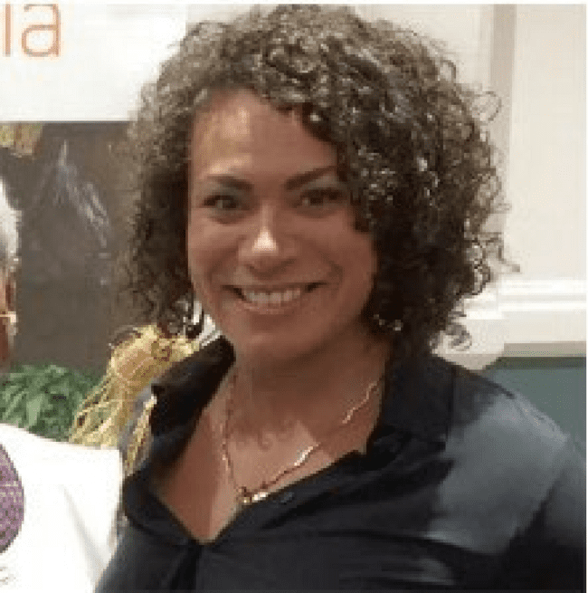
Tahina Booth is one of the Papua New Guinea representatives on the PWL Governance Board. Ms. Booth is an accomplished tri-international athlete representing Australia in Olympic weightlifting and powerlifting and in the Rugby League for the Papua New Guinea Orchids. Elite sport has instilled in Tahina discipline and leadership, and the many other skills learnt through sport have transferred into Tahina’s professional life. Tahina founded the Grass Skirt Project (GSP), a Papua New Guinea NGO and social enterprise using sport to prevent gender-based violence through collaborative partnerships and innovative health and wellness events for grassroots communities.
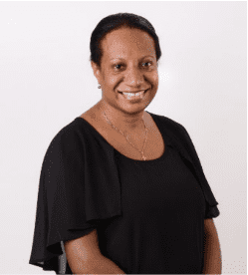
Susil Nelson-Kongoi is the second Papua New Guinea representative on the PWL Governance Board. Susil is a senior executive with ExxonMobil PNG with over 15 years’ experience in the development and professional services sector. In addition to her role as ExxonMobil PNG Media and Communications Manager, Ms Nelson-Kongoi is the Chair of Incentive Fund, Vice President (International) of the Business Council of PNG, Chair of the PNG Business Advocacy Network, and Honorary Treasurer on the Board of Coalition for Change. She is actively involved in other non-profit organisations, such as the Business and Professional Women's Association, advocating for the promotion of women’s participation in the economy, respecting women’s rights and ending violence against women and children. Susil has a Bachelor of Commerce from Canterbury University, New Zealand, and also holds a Master of Business Administration from Divine Word University, Papua New Guinea.

Brief purpose
This brief provides information on the Papua New Guinea (PNG) Women Lead and whole-of-portfolio Pacific Women Lead activities that are being implemented in PNG. It also serves as a mechanism for the PWLES MEL team, PNG DFAT Post and Abt Associates (PNG Women Lead managing contractor) to undertake a review of all project details (i.e., project timeframes and budgets) to ensure all information captured in the database is correct. This will be an ongoing collaborative activity. As such, these briefs will be updated and sent to Post and Abt Associates on a six-monthly basis.
The data is drawn from the PWL quantitative database as of 30 August 2023.
This brief provides information on:
- Number of bilateral activities
- Total activities and number and type of implementing partners
- Total number of activities per outcome and sub-outcome area
- Total funding per outcome and sub-outcome area
- Number of regional projects
- Total activities and number and type of implementing partners
- Reach data against PWL quantitative indicators. Reach data refers to the coverage of activities: how many diverse men, women, boys and girls have been reached by an activity or project.

Bilateral activities
The information presented in this section provides an overview of the PNG Women Lead activities that are funded by DFAT and managed by Abt Associates in PNG.

Project and implementing partner count by outcomes and sub-outcomes.
There are 11 projects and 10 distinct implementing partners in PNG (refer to Annex for detailed information). The managing contractor is setting up PNG Women Lead. Additional updates will be included in the next six-monthly program update, including information on downstream implementing will be included, if any.
Table 2 Bilateral implementing partners, and outcomes/sub-outcomes
Project | Distinct implementing partner | Downstream implementing partner | Outcomes and sub-outcomes
Bel Isi PNG | Santos Foundation (formerly Oil Foundation) | Femili PNG | Women’s rights realised – women’s safety
Creative Approaches for Impact in International Development | Queensland University of Technology |  | Women’s leadership promoted – women and girls’ voice
From Gender-based Violence to Gender Justice and Healing Phase 2 | International Women’s Development Agency | Nazareth Centre for Rehabilitation (NCFR) | Women’s rights realised – women’s safety
Funding to Femili PNG to operate the Family and Sexual Violence Case Management Centre | Femili PNG Inc | Nil | Women’s rights realised – women’s safety
Responding to Gender-based and Sorcery-related Violence in Highlands of Papua New Guinea | Oxfam Papua New Guinea |  | Women’s rights realised – women’s safety
Safe Schools Strong Communities | Equal Playing Field (EPF) | Nil | Women’s rights realised – women’s safety
Scaling up technical support to Family Support Centres | Family Health International 360 |  | Women’s rights realised – women’s safety
Strengthening the Business Coalition for Women | PNG Business Coalition for Women |  | Women’s rights realised – women’s economic empowerment
Strengthening the Entrepreneurial Ecosystem for Women in Papua New Guinea Phase 3 | Center for International Private Enterprise (CIPE) | Pacific Adventist University,  IBS University | Women’s rights realised – women’s economic empowerment
Supporting Participatory Democracy in PNG | Australia National University |  | Women’s leadership promoted – women and girls’ voice
Women's Empowerment and Voice for Equal Rights in Papua New Guinea (WEAVERs) | International Women’s Development Agency | Voice for Change (VfC)  Wide Bay Conservation Society. | Women’s leadership promoted – women and girls’ voice

Of the 11 projects, three work in Women’s leadership promoted: women and girls’ voice (3). Six projects work in Women’s rights realised in women’s safety (6), and two in women’s economic empowerment (2).
Figure 1 Projects by outcomes and sub-outcomes
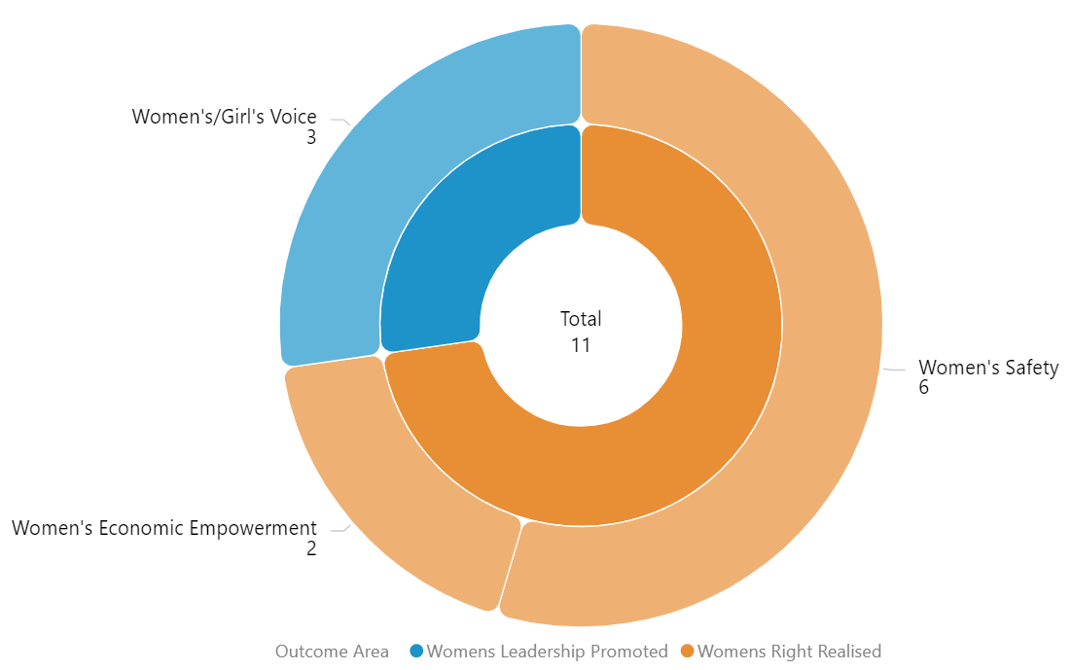

Type of implementing partner
Of the 10 distinct implementing partners, four are international NGOs, three Pacific NGOs, and two research/university partners and one private sector organisation.
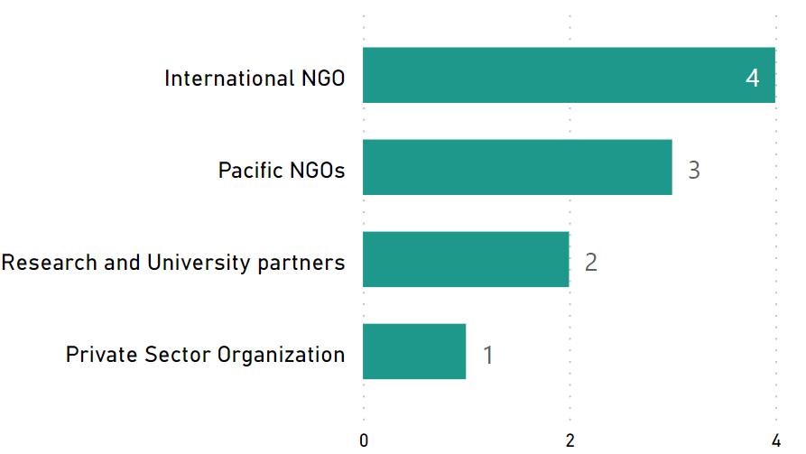
Figure 2 Type of implementing partner

Committed funding by outcomes and sub-outcomes
Table 3 Funding committed for PNG projects by outcomes and sub-outcomes
Outcomes | Sub-outcomes | Funding Committed (AUD)
Women’s rights realised | Women’s safety | 5,161,410
Women’s rights realised | Women’s economic empowerment | 1,675,686
Women’s leadership promoted | Women and girls’ voice | 3,382,798
Total |  | 10,219,894.12
Note: For funding committed for each bilateral activity in PNG, refer to Annex 1.

Reach data by projects and indicators
Of the 11 projects, seven projects provided quantitative data against Pacific Women Lead Indicators. Table 5 provides detailed data against each indicator.
Table 4 Projects providing quantitative data by outcomes and sub-outcomes
Outcomes | Sub-outcomes | Projects
Women’s rights realised | Women’s safety | - Bel Isi PNG  - From Gender-based Violence to Gender Justice and Healing Phase 2  - Funding to Femili PNG to operate the Family and Sexual Violence Case Management Centre  - Responding to Gender-based and Sorcery-related Violence in Highlands of PNG  - Safe Schools Strong Communities  - Scaling up technical support to Family Support Centers  - Strengthening the Business Coalition for Women
Women’s rights realised | Women’s economic empowerment | - Bel Isi PNG  - From Gender Based Violence to Gender Justice and Healing Phase 2
Women’s leadership promoted | Women and girls’ voice | - Strengthening the Business Coalition for Women  - Strengthening the Entreprenuerial Ecosystem for Women in PNG Phase 3

Table 5 Reach data for PNG bilateral projects
Outcome Indicators | Sub Outcome Indicators | Project Title | Indicators | Girl | Girls  Disabled | Women | Women  Disabled | Total  Women and Girls | Boys | Boys  Disabled | Men | Men  Disabled | Total  Men and Boys | LGBTQIA | Data not  disaggregated | Total  Part
Women's Rights Realised | Women's Economic Empowerment | Bel Isi PNG | Diverse women entrepreneurs provided with financial and/or business development services | 0 | 0 | 11 |  | 11 | 0 | 0 |  |  | 0 |  | 0 | 11
Women's Rights Realised | Women's Safety | Bel Isi PNG | Men who have undertaken male advocacy training and actively participating to promote gender equality | 0 | 0 | 192 |  | 192 | 0 | 0 | 56 | 2 | 58 |  | 0 | 250
Women's Rights Realised | Women's Safety | Bel Isi PNG | Number of services provided to diverse women and children and other survivors of violence | 126 | 25 | 937 | 83 | 1171 | 78 | 1 | 16 | 5 | 100 |  | 20 | 1291
Women's Rights Realised | Women's Economic Empowerment | From Gender Based Violence to Gender Justice and Healing Phase 2 | Diverse women entrepreneurs provided with financial and/or business development services | 0 | 0 | 182 | 3 | 185 | 0 | 0 | 84 | 1 | 85 |  | 0 | 270
Women's Rights Realised | Women's Safety | From Gender Based Violence to Gender Justice and Healing Phase 2 | Men who have undertaken male advocacy training and actively participating to promote gender equality | 1 | 0 | 123 | 0 | 124 | 6 | 1 | 157 | 1 | 165 |  | 679 | 968
Women's Rights Realised | Women's Safety | From Gender Based Violence to Gender Justice and Healing Phase 2 | Number of counsellors graduating from recognized counselling institutions | 0 | 0 | 44 |  | 44 | 0 | 0 | 44 |  | 44 |  | 0 | 88
Women's Rights Realised | Women's Safety | From Gender Based Violence to Gender Justice and Healing Phase 2 | Number of people who participated in sessions on gender issues and women’s equal rights | 566 | 3 | 2538 | 5 | 3112 | 560 | 2 | 637 | 4 | 1203 |  | 91 | 4406
Women's Rights Realised | Women's Safety | From Gender Based Violence to Gender Justice and Healing Phase 2 | Number of services provided to diverse women and children and other survivors of violence | 245 | 0 | 691 | 5 | 941 | 132 | 1 | 453 | 2 | 588 |  | 638 | 2167
Women's Rights Realised | Women's Safety | Funding to Femili PNG to operate the Family and Sexual Violence Case Management Centre | Number of people who participated in sessions on gender issues and women’s equal rights | 0 | 0 | 102 |  | 102 | 0 | 0 | 41 |  | 41 |  | 0 | 143
Women's Rights Realised | Women's Safety | Funding to Femili PNG to operate the Family and Sexual Violence Case Management Centre | Number of services provided to diverse women and children and other survivors of violence | 27 | 1 | 2421 | 0 | 2449 | 9 | 0 | 270 | 0 | 279 |  | 989 | 3717
Women's Rights Realised | Women's Safety | Responding to Gender Based and Sorcery Related Violence in Highlands of PNG | Number of people who participated in sessions on gender issues and women’s equal rights | 41 | 0 | 312 | 0 | 353 | 25 | 0 | 213 | 2 | 240 |  | 0 | 593
Women's Rights Realised | Women's Safety | Responding to Gender Based and Sorcery Related Violence in Highlands of PNG | Number of services provided to diverse women and children and other survivors of violence | 4 | 0 | 16 | 0 | 20 | 0 | 0 | 7 | 0 | 7 |  | 0 | 27
Women's Rights Realised | Women's Safety | Safe Schools Strong Communities | Number of people who participated in sessions on gender issues and women’s equal rights | 460 | 0 | 1015 | 0 | 1475 | 424 | 0 | 1043 | 0 | 1467 |  | 116 | 3058
Women's Rights Realised | Women's Safety | Scaling up technical support to Family Support Centers | Number of people who participated in sessions on gender issues and women’s equal rights | 0 | 0 | 118 | 2 | 120 | 0 | 0 | 39 |  | 39 |  | 20 | 179
Women's Rights Realised | Women's Safety | Scaling up technical support to Family Support Centers | Number of services provided to diverse women and children and other survivors of violence | 89 | 0 | 219 | 0 | 308 | 9 | 0 | 47 | 0 | 56 |  | 0 | 364
Women's Leadership Promoted | Women & Girls Voices | Strengthening the Business Coalition for Women | Diverse women & girls supported to assume a leadership role at community, provincial & national | 0 | 0 | 171 |  | 171 | 0 | 0 | 13 |  | 13 |  | 0 | 184
Women's Rights Realised | Women's Safety | Strengthening the Business Coalition for Women | Number of people who participated in sessions on gender issues and women’s equal rights | 0 | 0 | 798 |  | 798 | 0 | 0 | 445 | 1 | 446 |  | 70 | 1314
Women's Leadership Promoted | Women & Girls Voices | Strengthening the Entreprenuerial Ecosystem for Women in PNG Phase 3 | Diverse women & girls supported to assume a leadership role at community, provincial & national | 0 | 0 |  |  | 0 | 0 | 0 |  |  | 0 |  | 4 | 4
Women's Rights Realised | Women's Economic Empowerment | Strengthening the Entreprenuerial Ecosystem for Women in PNG Phase 3 | Diverse women entrepreneurs provided with financial and/or business development services | 0 | 0 | 848 |  | 848 | 0 | 0 | 17 |  | 17 |  | 1237 | 2102
Women's Rights Realised | Women's Safety | Strengthening the Entreprenuerial Ecosystem for Women in PNG Phase 3 | Number of people who participated in sessions on gender issues and women’s equal rights | 0 | 0 |  |  | 0 | 0 | 0 |  |  | 0 |  | 92 | 92
Women's Leadership Promoted | Pacific Feminist Civil Society | Women's Empowerment and Voice for Equal Rights in Papua New Guinea (WEAVERs) | Number of diverse women and girls participating in civil society and intergovernmental forums | 0 | 0 | 175 | 1 | 176 | 0 | 0 |  |  | 0 |  | 0 | 176
Women's Leadership Promoted | Women & Girls Voices | Women's Empowerment and Voice for Equal Rights in Papua New Guinea (WEAVERs) | Diverse women & girls supported to assume a leadership role at community, provincial & national | 0 | 0 | 164 | 4 | 168 | 0 | 0 | 55 |  | 55 |  | 16 | 239
Women's Rights Realised | Women's Economic Empowerment | Women's Empowerment and Voice for Equal Rights in Papua New Guinea (WEAVERs) | Diverse women entrepreneurs provided with financial and/or business development services | 0 | 0 | 48 | 1 | 49 | 0 | 0 | 16 |  | 16 |  | 0 | 65
Women's Rights Realised | Women's Safety | Women's Empowerment and Voice for Equal Rights in Papua New Guinea (WEAVERs) | Number of people who participated in sessions on gender issues and women’s equal rights | 0 | 0 | 246 | 1 | 247 | 0 | 0 | 254 | 1 | 255 |  | 0 | 502
Women's Rights Realised | Women's Safety | Women's Empowerment and Voice for Equal Rights in Papua New Guinea (WEAVERs) | Number of services provided to diverse women and children and other survivors of violence | 1 | 0 | 75 | 2 | 78 | 2 | 0 | 9 | 0 | 11 |  | 89 | 178
TOTAL |  |  |  | 1560 | 29 | 11446 | 107 | 13142 | 1245 | 5 | 3916 | 19 | 5185 | 0 | 4061 | 22388

Regional activities
The information presented in this section provides an overview of gender activities implemented in PNG that are managed and funded by DFATs regional program (either at Suva post or Canberra).

Project and implementing partner count by outcomes and sub-outcomes
There are 10 regional projects implemented in PNG and 8 distinct implementing partners.
Table 6 Regional implementing partners and outcomes/sub-outcomes
Project name | Distinct implementing partner | Outcomes and sub-outcomes
Core Funding for IPPF Global Strategic Framework Funding 2018 – 2022 | International Planned Parenthood Federation | Women’s rights realised – women’s health (SRHR)
Core funding for the IPPF global strategic framework (22-26) and Pacific Strategy (22-26) | International Planned Parenthood Federation | Women’s rights realised – women’s health (SRHR)
Gender responsive Climate Policy and Women’s Climate Leadership in the Pacific | Women Environment and Development Organisation | Women’s leadership promoted – women and girls’ voice
Netball Australia (Pilot Pacific Women’s Sports Administration Program) | Netball Australia | Women’s leadership promoted – women and girls’ voice
Pacific Community’s Human Rights and Social Development (HRSD) Division Support | Pacific Community’s Human Rights and Social Development (HRSD) Division Support | Pacific ownership and effectiveness – Pacific ownership
Pacific Islands Forum Secretariat Gender Disability and Social Inclusion | Pacific Islands Forum Secretariat (PIFS) | Pacific ownership and effectiveness – gender mainstreaming
Pacific Partnership to End Violence Against Women and Girls Phase 1 | UN Women | Women’s rights realised – women’s safety
Pacific Partnership to End Violence Against Women and Girls Phase 2 | UN Women | Women’s rights realised – women’s safety
RiseUp! Mobilising Young Women's Leadership and Advocacy Phase IV | World YWCA | Women’s leadership promoted – women and girls’ voice
Tennis Australia Women and Girls Pacific Extension – Emerging onto the World Stage | Tennis Australia | Women’s leadership promoted – women and girls’ voice

Of the 10 projects, four projects work in Women’s leadership promoted in women and girls’ voice (4). Four projects work in Women’s rights realised: two in women’s safety (2) and two in women’s health (SRHR) (2).
Two project works in Pacific ownership and effectiveness: Pacific ownership (1) and gender mainstreaming (1).
Figure 3 Projects by outcomes and sub-outcomes
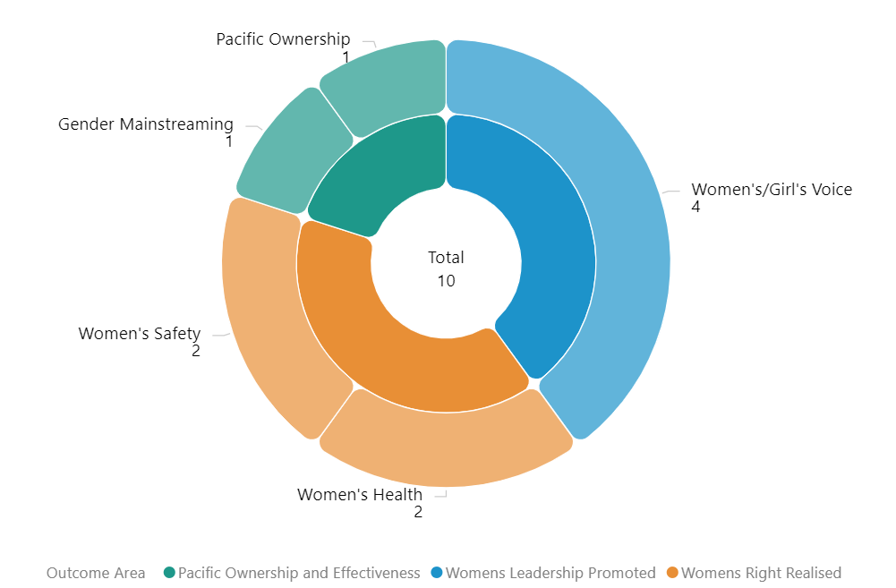

Type of implementing partner
Of the 8 distinct implementing partners, five are international NGOs, one is regional/multilateral partner and two is an inter-government organisation.
Figure 4 Type of implementing partner
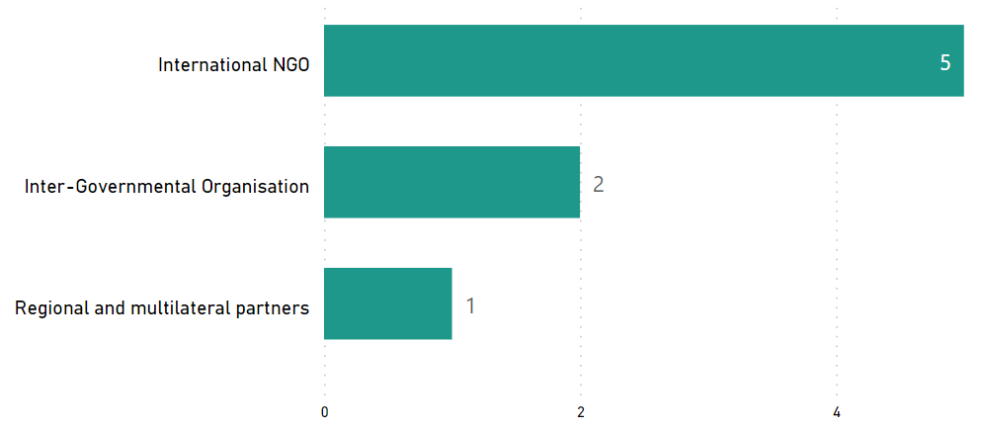

Committed funding by outcomes and sub-outcomes
Table 7 Funding committed for regional projects implemented in PNG
Outcomes | Sub-outcomes | Funding Committed (AUD)
Women’s rights realised | Women’s health | 2,500,000
Women’s rights realised | Women’s safety | 16,734,693.05
Women’s leadership promoted | Women and girls’ voice | 9,449,500
Pacific ownership and effectiveness | Pacific ownership | 2,700,000
Pacific ownership and effectiveness | Gender mainstreaming | 3,902,976
Total |  | 35,287,169.05
Note: the committed funding is total activity funding and is not broken down by funding allocation for PNG. It is not possible to provide funding amount or spend of regional projects for PNG. This information is not provided to the PWLES.

Pacific Women Lead at SPC activities
This section provides information on projects funded and managed by Pacific Women Lead at SPC (PWL at SPC). SPC has a direct grant agreement with DFAT to implement Pacific Women Lead, valued at AUD57,600,000. PWL at SPC’s grants program is funded out of the total value.
In addition to the 8 projects funded through PWL at SPC’s grants program, SPC has advertised a call for grant proposal. The SPC grants aim to support partners to implement Pacific regional gender equality commitments and contribute to Pacific Women Lead outcomes. The multi-stage grant application process is due for completion in the second half of 2023. This section will be updated when the grants process is completed to include successful grantees in PNG, if any.

Project and implementing partner count by outcomes and sub-outcome
There is one project funded under PWL at SPC that is being implemented in PNG by one distinct implementing partners, and two downstream implementing partners (refer to Annex for detailed information).
Table 8 PWL at SPC implementing partners, and outcomes/sub-outcomes
Project name | Distinct implementing partner | Downstream implementing partner | Outcomes and sub-outcomes
Shifting the Power Coalition: Strengthening Diverse Women's Leadership in Humanitarian Action | ActionAid Australia | - YWCA PNG  - Nazareth Centre for Rehabilitation | Women’s leadership promoted – feminist civil-society

Type of implementing partner
Shifting the Power Coalition is being implemented in PNG by ActionAid Australia, an international NGO.

Committed funding by outcomes and sub-outcomes
Outcomes | Sub-outcomes | Funding Committed (AUD)
Women’s leadership promoted | Pacific Feminist Civil Society | 532,233.07
Total |  | 532,233.07
Note: the committed funding is total activity funding and is not broken down by funding allocation for PNG. It is not possible to provide funding amount or spend of PWL at SPC for PNG. This information is not provided to the PWLES.

Amplify-Invest-Reach (AIR) Program: Funding to Pacific Feminist Funds
The Pacific Feminist Funds consists of funding to three funds, under the program name of the Amplify-Invest-Reach (AIR) program. The AIR contract is managed by the DFAT Gender Equality Branch in Canberra and supports three Pacific Feminist Funds:
Partner organisation | Funding Committed | Funding Source | Outcomes and sub-outcomes
Women’s Fund Fiji | 4,841,659.75 | Bilateral – Fiji | Women leadership promoted – Pacific feminist civil society
Urgent Action Fund Asia and the Pacific | 3,082,500 | Regional | Women leadership promoted – Pacific feminist civil society
Pacific Feminist Fund | 1,170,849 | Regional | Women leadership promoted – Pacific feminist civil society
Total | 9,095,008.75

This section will provide information on grants funded and managed by the two Pacific Feminist Funds (Urgent Action Fund and the Pacific Feminist Fund) once they start funding grantees. The Pacific Feminist Fund was recently launched in May 2023. To date there are no grants funded by the two regional Funds. Additional information will be provided in the next six-monthly update.

Pacific Women Lead Enabling Services
This section provides information on Pacific Women Lead Enabling Services (PWLES) activities and support to DFAT Posts and PWL at SPC and is valued at AUD20 million.

Monitoring, Evaluation and Learning Support
PWL MEL System: The PWLES MEL team holds responsibility for the design, implementation and review of PWL’s whole-of-portfolio MEL system. The MEL system is made up of the following components:
- Quantitative database that tracks progress against PWL indicators. Refer to Annex 2 for a full list of PWL quantitative indicators.
- Qualitative database that allows the PWLES MEL team to code partner narrative reports against qualitative change domains.
The PWL MEL system has the capability to provide Post with data for your DFAT reporting processes (IMR and Tier 2 reporting). The MEL system can also provide qualitative stories or quotes from regional projects that can be used for DFAT briefing documents or speeches.
Collection of qualitative impact stories: PWLES will collect impact stories from PWL projects twice per year (July and February). These stories will be used to inform the PWL MEL system but will also be provided to Post and can be used for your communication or public diplomacy needs.

Monthly Managing Contractor meetings: The PWLES MEL team has a standing monthly meeting with PNG Women Lead, Tautua Partnership Program (Samoa), Tonga Australia Support Platform Support (TASP). At these meetings, the PWLES MEL team confirms if any new gender activities have been funded, shares PWL updates and discusses reporting timelines so bilateral project-level data feeds into the PWL MEL system. There is also opportunity to share learnings across managing contractors.
Clear Horizon Academy PWL MEL Platform: The PWLES MEL team is developing training modules with Clear Horizon Academy to support PWL partners. Two modules: Using Data for Reporting and Learning and Collecting Impact Stories have been completed. The modules will be piloted with partners at the inaugural PWL Annual Reflection and Analysis workshop in September 2023.

Quality Technical Assurance Group (QTAG)
QTAG offers tailored GEDSI support through a panel of consultants.
Gender Focal Point (GFP) mentoring: QTAG provides regular mentoring to GFP in smaller DFAT Posts as a pilot approach to support GFPs to carry out their role with confidence. QTAG’s technical partner CoLAB has been engaged to provide mentoring support to GFPs. The mentoring will also provide a space to support GFPs broader professional development priorities including provide advice and feedback on communication, help with problem solving and to act as a sounding board to troubleshoot issues and ideas with the GFPs without conflicting with other management and supervision support provided by the GFP’s manager/supervisor, and the GFPs existing workload.
GEDSI Analysis and Country Plans/Design: Through its panel of consultants, QTAG provides support to smaller DFAT Posts to carry out GEDSI Analysis and develop their Gender Country Plan/Design. PWL support to the development of country briefs/designs includes PWL whole-of-portfolio MEL briefings to ensure there is alignment to the PWL whole-of-portfolio MEL Framework. Larger Posts can draw on this support to ensure alignment to PWL whole-of-portfolio MEL.

Grant Management
PWLES manages two regional grants, Balance of Power and We Rise Coalition. Funding committed to Balance of Power and We Rise Coalition comes out of the total PWLES AUD20 million.
Only We Rise Coalition is being implemented in PNG and PWLES can provide updates on this regional grant at quarterly DFAT or monthly Managing Contractor Meetings.
We Rise Coalition is being implemented by one distinct implementing partner in PNG and one downstream implementing partner (refer Annex for detailed information).
9.3.1. Project and implementing partner count by outcomes/sub-outcomes
Project name | Distinct implementing partner | Downstream implementing partner | Outcomes and sub-outcomes
Feminist movements for transformative change: We Rise Coalition Phase 3 | International Women’s Development Agency (IWDA) | Voice for Change (PNG) | Women’s leadership promoted – feminist civil society

9.3.2. Type of implementing partner
IWDA is an international NGO.
9.3.3. Committed funding by outcomes and sub-outcomes
Outcomes | Sub-outcomes | Funding Committed (AUD)
Women’s leadership promoted | Pacific feminist civil society | 3,193,822
Total |  | 3,193,822
Note: the committed funding is total activity funding and is not broken down by funding allocation for individual countries. The total committed fundings comes out of the PWLES total budget.

Annex 1: Pacific Women Lead Projects in PNG
The table provides a list of all bilateral, regional, PWL at SPC projects and PWLES-managed grants for PNG that have been entered into the Pacific Women Lead quantitative database. It provides detailed information on each project’s name, implementing partner, project description, end of project outcomes, total funding (AUD) and timeframe.
PWL Components | # Of Projects | Total Funding (AUD)
Bilateral | 11 | 10,219,894.12
Regional | 10 | 35,287,169.05
PWL at SPC | 1 | 532,233.07
A-I-R Program | N/A
PWLES-managed grants | 1 | 3,193,822
Total Combined Funding |  | 49,233,118.24
Total funding provided to grants that are managed under these components and does not reflect the total value of the components.

Note:
- The timeline and budget reflect the start date of Pacific Women Lead i.e. 1 July 2021.
- “Transformative Agenda for Women, Adolescents and Youth in the Pacific: Towards Zero Unmet Need for Planning 2018 – 2022’ Phase 2 is in development. The information presented is for Phase 1, which was completed in Year 1 of PWL.
- ‘Core Funding for IPPF Global Strategic Framework Funding 2018 – 2022’ was completed in Year 1 of PWL. The ‘Core Funding for IPPF Global Strategic Framework (22-26) and Pacific Strategic Strategy (22-26)’ is the active activity under PWL.

COUNTRY-LEVEL PROJECTS
NO. | AID-WORKS NUMBER PROJECT NAME AND PARTNER PROJECT DESCRIPTION END OF PROJECT OUTCOMES VALUE (AUD) AND TIMEFRAME
1 |  | Bel Isi PNG  (Santos Foundation) | The project aims to galvanise the private sector in partnership with government and civil society to play a transformational leadership role in changing attitudes towards family and sexual violence and improving services for survivors. | - The private sector is actively supporting initiatives which address family and sexual violence and companies are contributing resources to support survivors  - Survivors of family and sexual violence living and/or working in Port Moresby have improved access to coordinated, safe and secure short-term accommodation and high-quality case management services supported by businesses and other stakeholders.An innovative service delivery model, addressing family and sexual violence in Port Moresby through public-private and civil society partnerships, has been effectively governed and managed ensuring the safety and security of staff and clients. | $1,500,000  2021– 2023
2 | 77959 | From Gender Based Violence to Gender Justice and Healing Phase 2  (IWDA) | The project aims to reduce family and sexual violence in Bougainville by addressing the root causes of gender inequality. It does this through supporting Bougainville women’s human rights defenders to lead responses to, and prevention of, family and sexual violence with government and communities; and by enabling men and women to prevent family and sexual violence at community level by promoting shared power and decision making between women and men. | - Crisis services are provided to survivors of family and sexual violence (counselling, accommodation, access to justice, repatriation, case management and referrals)  - Ongoing capacity building for trauma counsellors  - Strengthening the work of women’s human rights defenders and working with communities on preventing and addressing gender-based violence  - Working with male advocates and men | $1,282,761.00  2021 - 2023
3 | 77962 | Funding to Femilli PNG to operate the Family and Sexual Violence Case Management Centre  (Femili PNG) | Femili PNG established the first case management center in Lae to support survivors to access emergency medical care, access emergency shelter of an adequate duration and standard, provide counselling support and assistance to obtain police, legal and social services if requested. | Femili PNG Strategic Objectives:  - As a national centre of excellence, provide effective and coordinated case management approaches for people experiencing family and sexual violence  - Foster strong partnerships with other Papua New Guinea government and civil society agencies to promote effective responses to family and sexual violence, both in Lae and across Papua New Guinea.  - Undertake operations and research-based advocacy to improve the response to family and sexual violence across Papua New Guinea  - Be a well-run and sustainable Papua New Guinean non-governmental organisation | $1,786,073.31  2021 - 2023
4 | 77951 | Strengthening the Business Coalition for Women  (PNG Business Coalition for Women) | This project supports the Business Coalition for Women to improve the status and safety of women in workplaces. The project is working to empower women economically and improve businesses. | - Economic opportunities and participation for women  - Women in leadership and decision making  - Prevention of gender-based violence and workplace safety  - Knowledge creation and system’s change | $260,340.73  2021 - 2023
5 | 77960 | Safe Schools Strong Communities  (Equal Playing Field) | This project is preventing gender based violence experienced in schools by building respectful ways of communicating between girls and boys in school, as well as creating en enabling school environment with support and upskilling to teachers. | - Age appropriate facilitators are upskilled to deliver participatory gender transformative programming  - Young people display more positive knowledge, attitudes and behaviours in the space of gender and cultural norms  - Teachers and institutions are resources and their capacity built to deliver child protection and respectful relationship education  - Partner schools are more able to appropriately address child protection and school-based gender based violence | $592,575.72  2021 - 2023
6 |  | Responding to Gender Based and Sorcery Related Violence in Highlands of PNG  (Oxfam Australia) | This project is preventing violence against women by challenging traditional community attitudes to sorcery, implementing behavioural change activities with communities and conducting research on the effectiveness of repatriation of survivors. | - Positive changes in attitudes, behaviours and norms related to violence against women and girls (VAWG) and sorcery accusation related violence  - A whole-of-system approach that coordinates quality crisis services that are adaptive to the needs of survivors  - Partners are able to better access and mobilise government funds for their programs and services  - Duty bearers have better policy and practice to address and prevent gender-based and sorcery accusation related violence. | Budget paid under previous phase.  2021 – 2022  Completed
7 | 77842 | Strengthening the Entrepreneurial Ecosystem for Women in PNG Phase 3 (Center for International Private Enterprise) | This project involves separate but related grants to two partners. The project is co-financed by the US Government. Collectively the two grants aim to establish an entrepreneurial ecosystem for women in PNG to enable women’s economic empowerment. Grant 1: The Center for International Private Enterprise (CIPE) will establish a Women’s Business Centre in partnership with other development partners, to increase women’s profits. Grant 2: The StartUp Cup Inc. grant supports women’s economic empowerment through the WECREATE Challenge to provide skills training and mentoring to female entrepreneurs through the Women’s Business Centre established by CIPE. | - Increase women’s access to resources for economic empowerment such as training, mentoring and rights awareness via a walk-in business centre.  - Set the Women’s Business Resource Centre on the path towards long-term self-sufficiency.  - Educate Papua New Guinean university students through formal entrepreneurship instruction.  - Develop participatory formative and summative evaluations to capture lessons learned and improve service delivery. | $1,415,345.48  2021 - 2023
8 |  | Scaling up technical support to Family Support Centers  (Family Health International) | PNGWL has no information on this. | PNGWL has no information on this | Budget paid under previous phase.  2021 - 2022
9 | 77830 | Women’s Empowerment and Voice for Equal Rights in Papua New Guinea  (IWDA) |  |  | $3,192,853.00  2021 - 2024
10 |  | Creative Approaches for Impact in International Development (Queensland University of Technology) | PNGWL has no information on this | PNGWL has no information on this. | Budget paid under previous phase.  2021 – 2022  Completed
11 | 77766 | Supporting Participatory Democracy in PNG (Australia National University) | PNGWL has no information on this | PNGWL has no information on this. | $189,944.88  2022 - 2023

REGIONAL-LEVEL ACTIVITIES
NO. |  | AID-WORKS NUMBER |  | PROJECT NAME AND PARTNER |  | PROJECT DESCRIPTION | END OF PROJECT OUTCOMES | VALUE (AUD) AND TIMEFRAME
1 |  | 74843 |  | Core Funding for IPPF Global Strategic Framework Funding 2018 – 2022 |  | The Strategy provides a framework and guidance on a life course approach to SRHR in the Pacific. This entails broadening the focus from family planning to services across the life span from pregnancy and prenatal care and pre-menstruation through menopause. It also looks at critical factors for the Pacific including climate change, gender, disability, non-communicable diseases and sexual and gender-based violence. | - Pacific Island governments increasingly promote, respect, protect and fulfil commitments to SRHR and gender equality.  - People in Pacific countries are able to act freely on their SRHR  - Expanded quality, integrated, gender and rights-based  - Sexual and reproductive health (SRH) services are delivered with a focus on reaching the underserved  - A high performing, accountable and united federation drives sustainable positive change in SRHR in the Pacific | $500,000.00  2021 – 2022  completed
2 |  | 77862 |  | Core Funding for IPPF Global Strategic Framework (22-26) and Pacific Strategic Strategy (22-26) |  | The strategy aims to come together and break through the barriers that limit sexual and reproductive health and rights (SRHR), thereby enabling quality SRHR to be realised for everyone in the Pacific. It is an ambitious agenda that is informed by the emerging challenges and opportunities in the region | - Centre Care on People: Expand choice and access in coordination with government partners and national civil society and explore digital options and self-care.  - Move the Sexuality Agenda: Shift attitudes and norms in the Pacific through grass roots advocacy to drive gains in SRHR, ensuring the voices of young people and marginalised or excluded groups are heard.  - Solidarity for Change: Create new strategic partnerships andcontribute to social movements on SRHR and intersectional areas, and harness opportunities for learning and sharing  - Nurture our Federation: Strengthen IPPF’s Secretariat and Member Associations through improvements in governance, financial and programmatic management, and draw on the Federation’s global expertise and knowledge base. | $2,000,000  2023 - 2026
3 |  | 77520 |  | Gender responsive Climate Policy and Women’s Climate Leadership in the Pacific  (WEDO) |  | Advance Pacific women's leadership in climate change decision-making via WEDO's Women Delegates Fund (WDF) program, as well as enhance the implementation of gender-responsive climate policy via capacity strengthening for National Gender and Climate Change Focal Points in the Pacific. | - Strengthen Pacific women’s leadership in climate change diplomacy and policymaking via travel support, training and networking  Support effective operationalization of the role of National Gender and Climate Change Focal Points across Pacific Island countries | $699,900  2022 – 2024
4 |  | 76569 |  | Netball Australia (Pilot Pacific Women’s Sport Administration Program) |  | The program focuses on governance and administration support – recognizing that this enables netball associations to advance women in decision-making and leadership roles (and their effectiveness in those roles), as well as enhancing access to safe and inclusive competition for women and girls across the Pacific. | - Improved governance and administration  - Increased women in leadership and decision-making roles  - Increased grassroot participation rates of women and girls in safer and more accessible environments | $1,638,600  2021 - 2023
5 |  | 69294/67 |  | Pacific Community’s Human Rights and Social Development Division (HRSD) support |  | HRSD leads SPC’s work in the areas of human rights, gender equality and social development. | HRSD Business Plan  - Objective 1 – Strengthen inclusive, transparent, and responsive governance and institutions for human rights, gender equality and social development.  - Objective 2 – Mobilise, empower, and build conditions for gender equality, equity and social inclusion in society and development  - Objective 3 – Promote, preserve, and protect positive expressions of culture  - Objective 4 – Accelerate impact on human rights, gender equality and social development through knowledge, learning and innovative solutions. | $2,700,000  2022 – 2026
6 |  | 74112 |  | Pacific Partnership to End Violence Against Women and Girls  (UN Women) |  | The Pacific Partnership seeks to promote Gender Equality, prevent VAWG, and increase access to quality VAWG response services for survivors. The programme engages with over 100 partners across the region, including national governments, CSOs, EVAWG networks, faith-based groups, and sports associations. | - To enhance Pacific youth’s formal in-school and informal education on gender equality and prevention of violence against women and girls.  - To promote gender equitable social norms at individual and community levels to prevent violence against women and girls, and to ensure survivors have access to quality response services.  - To empower national and regional civil society organisations (CSOs) to advocate, monitor and report on regional institutions and governments commitments to enhance gender equality and prevent violence against women and girls. | $800,000  2021 – 2023  Completed
 | 7 |  | 77334/8 |  | Pacific Partnership to End Violence Against Women and Girls Phase 2  (UN Women) | The Pacific Partnership seeks to promote Gender Equality, prevent VAWG, and increase access to quality VAWG response services for survivors. The programme engages with over 100 partners across the region, including national governments, CSOs, EVAWG networks, faith-based groups, and sports associations. | - To enhance Pacific youth’s formal in-school and informal education on gender equality and prevention of violence against women and girls.  - To promote gender equitable social norms at individual and community levels to prevent violence against women and girls, and to ensure survivors have access to quality response services.  - To empower national and regional civil society organisations (CSOs) to advocate, monitor and report on regional institutions and governments commitments to enhance gender equality and prevent violence against women and girls. | $15,934,693.05  2022 - 2027
8 |  | 78400 |  | Pacific Island Forum Secretariat Gender Disability and Social Inclusion  (Pacific Island Forum Secretariat) |  | Progressing Pacific Island Forum Secretariat Gender Equality Disability and Social Inclusion priorities | - PIFS Social Policy team to implement priorities on gender equality, disability and social inclusion including in the implementation and monitoring of the 2050 Strategy for the Blue Pacific Continent including gender policy capability and advice  - enhanced strategic engagement and communications  - support to members and actioning outcomes  - progressing disability inclusion  - progressing implementation of social policy program | $3,902,976  2023 - 2026
9 |  | 76453 |  | RiseUp! Mobilising Young Women's Leadership and Advocacy Phase IV  (World YWCA) |  | Leadership program developed and led by young women for young women, taking into account local contexts and priorities. RiseUp! provides training, networking and peer support to young women between the ages of 18 and 30 years. It supports young women in contexts where their rights and voices are repressed to know and claim those rights within their peer, family and community networks, and to work collectively to mobilise for change. | - Young women take up informal and formal leadership roles in their peer and family networks, communities, countries, region or globally. | $6,000,000  2020 – 2025
10 |  | 77821 |  | Tennis Australia Women and Girls Pacific Extension - Emerging onto the World Stage  (Tennis Australia) |  | Deliver programs and pathways to create sustainable benefits for women in the Pacific, either as a player, coach or paid administrator/Development Officer. Create economic efficiencies, seeing supporting partners (ITF, ONOC and TA) come together to maximise opportunities for program stakeholders. | Stream 1 – Coaching  - Increase the number of women in decision-making and leadership roles  - Strengthen career and volunteer pathways and opportunities on the court  - Create sustainable networks to influence and advance women  - Inspire and develop women to be a public voice for tennis from grassroots to the world stage  Stream 2 – Community Leadership  - Increase the number of women in decision-making and leadership roles in Tennis organisations  - Develop the governance structures to create safe, welcoming and inclusive environments for women and girls  Stream 3 - Talent  - Improve access to safe inclusive sporting competitions and facilities to encourage higher participation of girls and young women  - Provide pathways for elite players to transition from Juniors to the Professional Tour (ITF and WTA)  - Increase retention of women elite players able to transition to coaches and leaders in the sport | $1,111,000  2022 – 2026

PWL AT SPC ACTIVITIES
NO. | Grants Agreement No. | PROJECT NAME AND PARTNER | PROJECT DESCRIPTION | END OF PROJECT OUTCOMES | VALUE (AUD) AND TIMEFRAME
PWL at SPC Grantee
1 |  | Shifting the Power Coalition: Strengthening Diverse Women's Leadership in Humanitarian Action (ActionAid Australia) | Works to ensure diverse Pacific women’s voices are included in disaster planning and response at all levels with tangible outcomes around diverse women leaders in six countries.  The Coalition includes ActionAid Vanuatu, FemLink Pacific, Nazareth Centre for Rehabilitation, Pacific Disability Forum, Talitha Project Incorporated, Transcend Oceania, Vanuatu Young Women for Change, Vois Blong Mere, YWCA PNG and YWCA Samoa.  Shifting the Power Coalition partner in PNG is YWCA PNG and Nazareth Centre for Rehabilitation. | - 200 diverse women leaders in six countries will have increased capacity to engage in local and national disaster coordination mechanisms and to organise and influence decision making  - Diverse women’s needs and capacities in times of crises will be documented and contribute to evidence-based disaster planning and response at national and regional level  - Platforms will be established to strengthen diverse Pacific women’s voices in regional humanitarian and disaster resilience forums and their influence on policy and decision making | $532,233.07  2022 – 2024

AIR PROGRAM – PACIFIC FEMINIST FUNDS
PLWES is finalising a list of grantees funded under Urgent Action Fund Asia & Pacific and a table will be inserted here for activities implemented in PNG. Pacific Feminist Funds is in it’s inception stage and does not provide grants yet.

PWLES-MANAGED GRANTS
NO. | AID-WORKS NUMBER | PROJECT NAME AND PARTNER | PROJECT DESCRIPTION | END OF PROJECT OUTCOMES | VALUE (AUD) AND TIMEFRAME
1 |  | Feminist movements for transformative change: We Rise Coalition Phase 3 | The goal of the We Rise Coalition is to develop, demonstrate and strengthen feminist coalitions and partnerships in order to grow and uphold inclusive governance, equality, diversity, justice and women’s human rights.  We Rise Coalition partner in PNG is Voice for Change PNG. | - Coalition and organisational strengthening: Diverse Fiji and Pacific Women are contributing to a coordinated, feminist social movement.  - Movement Building: We Rise partners and the Coalition demonstrate feminist praxis and solidarity.  - Policy, structural and institutional reform: Pacific women influence local, national and regional decision-making to reflect Pacific women's human rights concerns. | $3,193,822  2021 - 2024

RESEARCH ACTIVITIES
There are currently no research activities implemented in PNG.

Annex 2: Whole-of-Portfolio PWL Indicators
Program Logic key outcome area | Quantitative indicators | Qualitative indicators
Women’s leadership promoted: women and girls’ voice | - # diverse women and girls supported to assume a leadership role  - # diverse women in non-traditional roles and fields of study and/or work  - # of sectoral policies or initiatives clearly addressing diverse women’s needs | - Change in social norms that support diverse women and girls’ leadership  - Successful strategies that have supported diverse women’s influence in decision-making  - Diverse women influencing/shaping national and regional development agenda
Women’s leadership promoted: Pacific feminist civil society | - # diverse women and girls participating in civil society and intergovernmental forums (e.g., Pacific Feminist Forum and Triennial)  - Number of women’s organisations, groups or coalitions actively engaged in the project  - Number of Pacific organisations of people with disability actively engaged in the project | - Evidence of how Pacific women’s organisations and the feminist movement have influenced the national and regional development agenda  - Evidence that the Pacific feminist movement has grown and is better connected  - Evidence that stakeholders have drawn on the Pacific feminist movements expertise and that this has led to outcomes that would otherwise not have happened.
Women’s Rights Realised – women’s health | - # diverse women and girls who received a modern method of contraception  - Number of unintended pregnancies averted  - Total couple-years protection for contraceptives distributed by countries to lower levels including service delivery points (SDPs) (disaggregated by method including emergency contraception and long-acting reversible contraception)  - Percentage of secondary and tertiary SDPs providing quality-assured, adolescents friendly, integrated SRH services | - Change in social norms that limit diverse women and girls’ access to SRHR services  - Improved collaboration within health ministries on SRHR initiatives, and what supported this collaboration  - Diverse women have improved access and use of SRHR services  - Evidence that men are supportive of women’s SRHR
Women’s Rights Realised – women’s economic empowerment | - # diverse women entrepreneurs provided with financial and/or business development services  - # diverse women who have attained formal qualifications | - Change in social norms that limit women’s economic empowerment  - Increased access to resilient economic opportunities for diverse women  - Pacific Governments, civil society, and private sector are implementing gender inclusive economic policies  - Recognition of women’s contribution to household livelihood (related to unpaid care work, financial contribution through food processing, handcraft production, food and water security, etc).
Women’s Rights Realised – women’s safety | - # of counsellors graduating from recognised counselling institutions  - # of services provided to diverse women and children (girls and boys) and other survivors of violence, such as counselling  - # people who participated in sessions on gender issues and women’s equal rights  - # men who have undertaken male advocacy training  - # police, law, and justice officials trained to respond to incidents of violence against women and girls according to an established protocol | - Change in social norms that contribute to women and girls experiencing reduced violence  - Increased capacity of Pacific police to respond to women experiencing violence  - Change in police responsiveness to violence against women and girls in all their diversity  - Evidence of successful strategies for increasing women’s safety  - Evidence of how men’s involvement and advocacy has supported gender equality
Partners supported to increase Pacific ownership and effectiveness of regional gender equality efforts – gender mainstreaming | - # of government staff and development practitioners applying gender mainstreaming tools  - # of mechanisms in place to support gender mainstreaming processes in the government | - Increased resources allocated to address gender issues  - Increased capacity of Pacific Governments and intergovernmental organisations in gender mainstreaming  - Evidence of how technical support mobilised through PWL has led to increased gender equality outcomes for Pacific Governments
Partners supported to increase Pacific ownership and effectiveness of gender and equality efforts – Pacific ownership and regional effectiveness |  | - Increased collaboration and political will between regional partners for stronger gender equality outcomes  - Evidence that the PWL Governance Board, SPC and Women’s Funds are influencing the regional gender equality agenda  - Evidence of increased accountability for gender equality and women’s human rights at regional and national levels
Program Logic strategies  - Grant making in the thematic areas of leadership, health (SRHR), women’s economic empowerment and safety  - Linking and learning and collective action that supports genuine partnerships and strategies for change in social norms and gender equally outcomes  - Technical support, training, coaching, and mentoring to support greater gender mainstreaming and gender equality outcomes for Pacific governments and development partner sector programs  - Collaborative portfolio level monitoring, evaluation and learning sense-making spaces to inform PWL decision-making | - Types of activities delivered (mentoring, training, coaching, campaigning, service delivery, convenings, learning events etc.)  - Number of diverse women and men reached through activities  - Dollar amount of funds released per Program Logic outcome area  - Number of grants supported  - Types of technical support requests from Pacific governments or through the QTAG  - Number of Tasking Notes completed through the QTAG (disaggregated by client)  - Rate of satisfaction with completed Tasking Notes through the QTAG

An ambition outlined in the PWL design was for SPC to progressively take over responsibility for the whole-or-program MEL. This process will need to be incremental and supported over an extended period. Further conversations will be had with SPC’s PWL MEL team and more details about how this could happen will be outlined in future PWL MELF updates.
Distinct implementing partner is the organisation that holds the contract with DFAT and has ultimate accountability for implementation of project activities.
Downstream implementing partners are organisations that receive funding for activity implementation from the distinct implementing partner. Downstream partners are always PNG organisations and often support from the distinct implementing partner includes organisational strengthening to ensure downstream partners can meet DFAT’s due diligence requirements.

