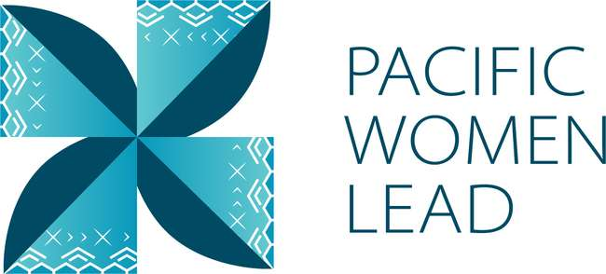

Pacific Women Lead

Solomon Islands

Program Brief
August 2023

Contents
1 Pacific Women Lead overview 1
2 Program components 2
3 Pacific Women Lead Governance Board 2
4 Brief purpose 3
5 Bilateral activities 3
5.1 Project and implementing partner count by outcome and sub-outcome areas. 3
5.2 Type of implementing partner 5
5.3 Committed funding by outcomes and sub-outcomes 6
5.4 Reach data by projects and indicators 6
6 Regional activities 3
6.1 Project and implementing partner count by outcome and sub-outcome areas 3
6.2 Type of implementing partner 5
6.3 Committed funding by outcomes and sub-outcomes 6
7 Pacific Women Lead at SPC activities 6
7.1 Project and implementing partner count by outcomes and sub-outcomes 6
7.2 Type of implementing partner 7
7.3 Committed funding by outcomes and sub-outcomes 7
9 Pacific Women Lead Enabling Services 7
9.1 Monitoring, Evaluation and Learning Support 8
9.2 Quality Technical Assurance Group (QTAG) 8
9.3 Grant Management 8
Annex 1: Pacific Women Lead Projects in Solomon Islands 9
Annex 2: Whole-of-portfolio PWL Indicators 23

Pacific Women Lead overview
Pacific Women Lead (PWL) is a portfolio of regional investments to advance gender equality ($170AUD over five years 2021-2026). PWL is ambitious in its intent to take a Pacific-led, intersectional and transformative approach to promoting gender equality in the region. It is focused on delivering development outcomes for women and girls in all their diversity and bringing new emphasis to strengthening regional action and architecture in support of gender equality.
PWL builds on the strengths and lessons learned through Australia’s 10-year gender equality investment, Pacific Women Shaping Pacific Development. Implementation is through partnerships with the Pacific Community (SPC) as a regional intergovernmental technical agency, Pacific Islands Forum Secretariat (PIFS) through the Pacific Islands Forum Women’s Leaders Meeting, Pacific women-led civil society organisations including Pacific Women’s Funds, United Nations (UN Women, UNFPA and UNICEF) and other non-government organisations and Governance Board. PWL also includes bilateral investments and works to ensure that regional approaches contribute to progress at the national level. In taking this approach, PWL has been designed to address and deliver on both Pacific and Australian Government commitments to progress gender equality in the region.
The goal of PWL is for: Pacific women and girls, in all their diversity, to be safe and equitably share in resources, opportunities and decision-making with men and boys.
The program works across three outcome areas with the following end-of-PWL sub-outcomes:
Table 1 Pacific Women Lead outcomes and sub-outcomes
Outcomes | Sub-outcomes
Women’s Leadership Promoted (WLP) | More women and girls, in all their diversity, are respected, listened to and are influencing decision-making at all levels (Women and girls’ voice)
 | The Pacific feminist movement has grown in depth, is better connected and their expertise is drawn upon by Pacific partners (Pacific feminist civil-society)
Women’s Rights Realised (WRR) | Diverse women and adolescent girls have improved access to quality health services, especially sexual and reproductive health (Women’s health – SRHR)
 | Diverse women have more equitable access to resilient economic opportunities, including increased voice in economic decision-making (Women’s Economic Empowerment)
 | Violence against women and children is reduced and survivors have access to quality support services, including in times of disasters (Women’s safety)
Regional effectiveness and Pacific ownership | Pacific Governments and development partners are implementing programs and policies that support gender equality (Gender mainstreaming)
 | There is robust engagement, cooperation and mutual sharing between regional agencies and intergovernmental organisations to deliver on gender equality commitments (Pacific ownership)

Program components
Implementation of PWL is through complementary partnerships with SPC, targeted Pacific women-led civil society organisations, including Pacific Women’s Funds, Governance Board funds and DFAT bilateral and regional gender projects (including projects with Pacific civil-society, INGOs and UN agencies).
The components of the portfolio include:
The Pacific Community (SPC) as a key implementing partner of PWL. PWL at SPC sits within SPC’s Human Rights and Social Development (HRSD) division and supports the implementation of key regional commitments outlined in the Pacific Leaders’ Gender Equality Declaration, the Pacific Platform for Action on Gender Equality and Women’s Human Rights, and the outcomes of the Triennial Conference of Pacific Women.
Through PWL, SPC provides technical, convening and funding support to government ministries, civil society, and other partners, while also acting as Secretariat for the PWL Governance Board.
Pacific Women’s Funds are supported to expand their work with women’s rights organisations and human rights defenders in the Pacific. This includes funding their advocacy activities to draw more resources for work towards gender equality to the region and funds to support the establishment of the first Pacific Feminist Fund.
DFAT bilateral programs manage and fund country-level gender projects. Importantly, bilateral programs have autonomy in design, delivery and governance, but their gender programming aligns with the PWL goal and outcomes, and they will report results into the Pacific Women Lead Enabling Services (PWLES).
DFAT regional program manages direct funding arrangements for regional gender projects, including (but not limited to) UN Women’s Markets for Change and Pacific Partnership to End Violence Against Women and Girls, and UNFPAs Transformative Agenda program. These projects are also aligned with the PWL goal and outcomes, and report results into the PWLES.
Pacific Women Lead Enabling Services (PWLES) managed by DT Global, provides support to SPC and DFAT to implement PWL. This includes whole-of-portfolio monitoring, evaluation, and learning (MEL), partnership brokering and the delivery of an independent Quality and Technical Assurance Group (QTAG). It is the role of the MEL team within the PWLES to compile a yearly whole-of-portfolio progress report, which brings together all the above components of PWL.

Pacific Women Lead Governance Board
The PWL Governance Board is made up of 13 members, 12 of whom are from the Pacific region. DFAT’s Assist Secretary of the Pacific Development Branch is an ex-officio member of the Board.
The Governance Board has a direct strategy and decision-making role in relation to PWL activities managed by SPC. The Board will receive reporting on outcomes for all other portfolio components through the PWL Annual Progress Report, compiled by the PWLES MEL Team, but does not provide direct strategy advice or have a decision-making role over the DFAT bilateral components or Women’s Funds component of PWL.
Under the SPC-managed component, AUD 5 million has been set aside for activities funded at the discretion of the Governance Board. By making decisions on the allocation of these funds, the Board is more directly engaging in gender equality programming and decision making in the region. These activities may be regional or multi-country in scale including to add value to and build on national activities. As the Secretariat for the Governance Board, SPC has developed seven criteria to guide the use of the Board funds. The seven criteria include: 1) alignment with PWL outcomes; 2) Pacific-led approaches; 3) regional or multi-country in scale; 4) promoting transformational change; 5) development effectiveness; 6) diversity and inclusion; 7) informed by research, evidence and data.
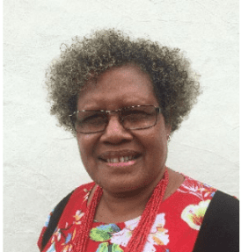
Ethel Sigimanu is the Solomon Islands representative on the PWL Governance Board. Ms Sigimanu has been instrumental in advancing gender equality and women’s human rights in the Solomon Islands. She is one of the longest-serving permanent secretaries in the Solomon Islands government, having spent 17 years as permanent secretary in various government ministries 10 of which were as Permanent Secretary for the Ministry of Women, Youth, Children and Family Affairs. During this time, she took leadership and was greatly influential in the work towards the passage of the Family Protection Act 2014, which is the first domestic violence legislation in Solomon Islands, as well as the Child and Family Welfare Act 2017. She also developed and reviewed National Gender Equality and Women’s Development policies and conducted a study on Family Health and Safety. In recognition of her courage, strength and leadership in the areas of human rights, social justice, women’s equality and advancement, Ms Sigimanu received the Women of Courage Award in 2019 by the US Secretary of State. Ms Sigimanu also serves on a number of national and regional boards, particularly in the areas of gender and human rights and other areas of the social services sector. Ms Sigimanu is now serving as a freelance consultant, focusing on areas that she is passionate about, particularly the advancement of gender equality and recognition of human rights.

Brief purpose
This brief provides information on the gender activities funded under PWL portfolio that are being implemented in Solomon Islands. It also serves as a mechanism for the PWLES MEL team and Solomon Islands DFAT Post to undertake a review of all project details (i.e., project timeframes and budgets) to ensure all information captured in the database is correct. This will be an ongoing collaborative activity. As such, these briefs will be updated and sent to Post on a six-monthly basis.
The data is drawn from the PWL quantitative database as of 30 August 2023.
This brief provides information on:
- Number of bilateral activities
- Total activities and number and type of implementing partners
- Total number of activities per outcome and sub-outcome area
- Total funding per outcome and sub-outcome area
- Number of regional projects
- Total activities and number and type of implementing partners
- Reach data against PWL quantitative indicators. Reach data refers to the coverage of activities: how many diverse men, women, boys and girls have been reached by an activity or project.

Bilateral activities
The information presented in this section provides an overview of the gender activities that are managed and funded by DFAT in Solomon Islands.

Project and implementing partner count by outcome and sub-outcome areas.
There are seven projects, six distinct implementing partners and six downstream implementing partners in Solomon Islands (refer to Annex for detailed information). The number of projects may increase when the new Solomon Islands Gender Design is completed in 2023.
Table 2 Bilateral implementing partners, and outcomes/sub-outcomes
Project | Distinct implementing partner | Downstream implementing partner | Outcomes and sub-outcomes
Channels of Hope Phase 3 | World Vision Solomon Islands |  | Women’s rights realised – women’s safety
Let’s Make Our Families Safe (Safe Families) Project Phase 2 | Oxfam Australia | Malaita Provincial Council of Women  Choiseul Provincial Council of Women  Western Provincial Council of Women | Women’s rights realised – women’s safety
People with Disability Solomon Islands | People with Disability Solomon Islands |  | Women’s leadership promoted – women and girls’ voice
Responding to Violence against Women (RVAW) Phase 2 | International Women’s Development Agency | Family Support Centre  Christian Care Centre | Women’s rights realised – women’s safety
Supporting the Ministry of Women, Youth, Children and Family Affairs | DT Global, through the Solomon Islands Australia Resource Facility |  | Pacific ownership and effectiveness - gender mainstreaming
Solomon Islands Women in Business | Solomon Islands Women in Business Association |  | Women’s leadership promoted – women and girls’ voice
Women Ignite Stability and Economic Recovery in Solomon Islands (WISER) | International Women’s Development Agency | Women’s Rights Action Movement (WRAM) | Women’s leadership promoted – feminist civil-society

Of the 7 projects, three work in Women’s leadership promoted: two projects in women’s and girls’ voice (2), and one project in Pacific feminist civil society (1).
Three projects work in Women’s rights realised in women’s safety (3), and one project work in Pacific Ownership and effectiveness in gender mainstreaming (1).
Figure 1 Projects by outcomes and sub-outcomes
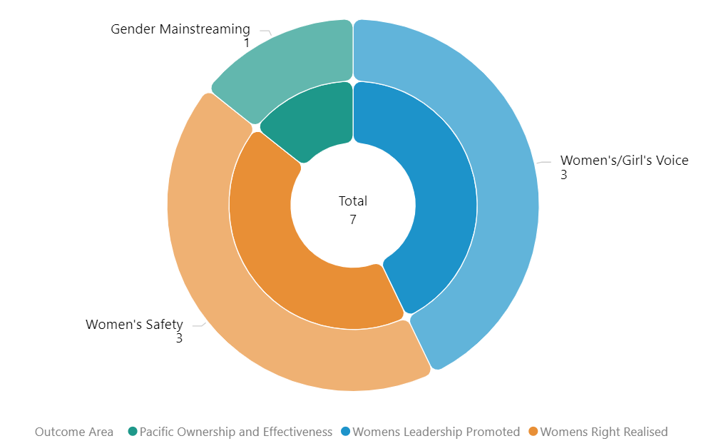

Type of implementing partner
Of the 6 distinct implementing partners, three are international NGOs, 1 is Pacific NGOs, 1 is Organisation for People with Disability and 1 is a government partner.
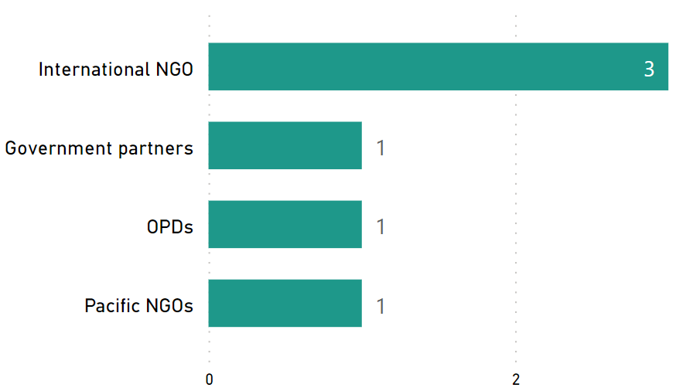
Figure 2 Type of implementing partner

Committed funding by outcomes and sub-outcomes
Table 3 Funding committed for Solomon Islands projects by outcomes and sub-outcomes
Outcome Areas | Sub-outcome Areas | Funding Committed (AUD)
Women’s rights realised | Women’s safety | 4,337,313
Pacific ownership and effectiveness | Gender mainstreaming | 3,070,645
Women’s leadership promoted | Women and girls Voice | 100,000
Women’s leadership promoted | Pacific feminist civil society | 942,207
Total |  | 8,450,165
Note: For funding committed for each bilateral activity in Solomon Islands, refer to Annex 1.

Reach data by projects and indicators
The 7 projects provided quantitative data against Pacific Women Lead Indicators. Table 5 provides detailed data against each indicator.
Table 4 Projects providing quantitative data by outcomes and sub-outcomes
Outcomes | Sub-outcomes | Projects
Women’s leadership promoted | Women and girls Voice | - Channels of Hope Phase 3  - People with Disability Solomon Islands  - Ministry of Women, Youth, Children and Family Affairs  - Women Ignite Stability and Economic Recovery in Solomon Islands (WISER)
Women’s leadership promoted | Pacific feminist civil society | - Women Ignite Stability and Economic Recovery in Solomon Islands (WISER)
Women’s rights realised | Women’s safety | - Channels of Hope Phase 3  - Let’s Make Our Families Safe (Safe Families) Phase 2  - People with Disability Solomon Islands  - Responding to Violence Against Women Phase 2  - Solomon Islands Women in Business  - Ministry of Women, Children, Youth and Family Affairs
Women’s rights realised | Women’s economic empowerment | - People with Disability Solomon Islands  - Responding to Violence against Women Phase 2  - Solomon Islands Women in Business
Pacific ownership and effectiveness | Gender mainstreaming | - Ministry of Women, Youth, Children and Family Affairs

Table 5 Reach data for Solomon Islands bilateral projects
Outcome Indicators | Sub Outcome Indicators | ProjectTitle | Indicators | Girl | Girls  Disabled | Women | Women  Disabled | Total  Women and Girls | Boys | Boys  Disabled | Men | Men  Disabled | Total  Men and Boys | LGBTQIA | Data not  disaggregated | Total
Women's Leadership Promoted | Women & Girls Voices | Channels of Hope Phase 3 | Diverse women & girls supported to assume a leadership role at community, provincial & national | 0 | 0 | 53 |  | 53 | 0 | 0 | 88 |  | 88 |  | 0 | 141
Women's Rights Realised | Women's Safety | Channels of Hope Phase 3 | Number of people who participated in sessions on gender issues and women’s equal rights | 0 | 0 | 852 | 28 | 880 | 0 | 0 | 841 | 29 | 870 |  | 0 | 1750
Women's Rights Realised | Women's Safety | Let’s Make Our Families Safe (Safe Families) Project Phase 2 | Men who have undertaken male advocacy training and actively participating to promote gender equality | 0 | 0 |  |  | 0 | 0 | 0 | 16 |  | 16 |  | 0 | 16
Women's Rights Realised | Women's Safety | Let’s Make Our Families Safe (Safe Families) Project Phase 2 | Number of people who participated in sessions on gender issues and women’s equal rights | 28 | 0 | 633 | 1 | 662 | 0 | 0 | 648 | 5 | 653 |  | 0 | 1315
Women's Rights Realised | Women's Safety | Let’s Make Our Families Safe (Safe Families) Project Phase 2 | Number of services provided to diverse women and children and other survivors of violence | 0 | 0 | 85 |  | 85 | 0 | 0 | 51 |  | 51 |  | 0 | 136
Women's Leadership Promoted | Women & Girls Voices | People with Disability Solomon Islands | Diverse women & girls supported to assume a leadership role at community, provincial & national | 0 | 0 |  | 9 | 9 | 0 | 0 |  | 7 | 7 |  | 0 | 16
Women's Rights Realised | Women's Economic Empowerment | People with Disability Solomon Islands | Diverse women entrepreneurs provided with financial and/or business development services | 0 | 0 | 30 |  | 30 | 0 | 0 |  |  | 0 |  | 0 | 30
Women's Rights Realised | Women's Safety | People with Disability Solomon Islands | Number of people who participated in sessions on gender issues and women’s equal rights | 0 | 0 |  | 40 | 40 | 0 | 0 |  | 30 | 30 |  | 16 | 86
Women's Rights Realised | Women's Economic Empowerment | Responding to Violence against Women Phase 2 | Diverse women entrepreneurs provided with financial and/or business development services | 0 | 0 | 69 |  | 69 | 0 | 0 |  |  | 0 |  | 0 | 69
Women's Rights Realised | Women's Safety | Responding to Violence against Women Phase 2 | Men who have undertaken male advocacy training and actively participating to promote gender equality | 0 | 0 |  |  | 0 | 0 | 0 | 58 |  | 58 |  | 15 | 73
Women's Rights Realised | Women's Safety | Responding to Violence against Women Phase 2 | Number of counsellors graduating from recognized counselling institutions | 0 | 0 | 8 |  | 8 | 0 | 0 |  |  | 0 |  | 0 | 8
Women's Rights Realised | Women's Safety | Responding to Violence against Women Phase 2 | Number of people who participated in sessions on gender issues and women’s equal rights | 0 | 0 | 677 | 14 | 691 | 0 | 0 | 729 | 2 | 731 |  | 0 | 1422
Women's Rights Realised | Women's Safety | Responding to Violence against Women Phase 2 | Number of services provided to diverse women and children and other survivors of violence | 60 | 0 | 855 | 18 | 933 | 13 | 0 | 130 | 3 | 146 |  | 968 | 2047
Women's Rights Realised | Women's Economic Empowerment | Solomon Islands Women in Business | Diverse women entrepreneurs provided with financial and/or business development services | 0 | 0 |  |  | 0 | 0 | 0 |  |  | 0 |  | 100 | 100
Women's Rights Realised | Women's Safety | Solomon Islands Women in Business | Number of people who participated in sessions on gender issues and women’s equal rights | 0 | 0 | 25 |  | 25 | 0 | 0 | 17 |  | 17 |  | 0 | 42
Pacific Ownership & Effectiveness | Gender Mainstreaming | Supporting the Ministry of Women, Youth, Children and Family Affairs | Number of mechanisms in place to support gender mainstreaming processes government | 0 | 0 | 252 |  | 252 | 0 | 0 | 33 |  | 33 |  | 0 | 285
Women's Leadership Promoted | Women & Girls Voices | Supporting the Ministry of Women, Youth, Children and Family Affairs | Diverse women & girls supported to assume a leadership role at community, provincial & national | 0 | 0 |  |  | 0 | 0 | 0 |  |  | 0 |  | 16 | 16
Women's Rights Realised | Women's Safety | Supporting the Ministry of Women, Youth, Children and Family Affairs | Number of Police, law and justice officials trained | 0 | 0 | 7 |  | 7 | 0 | 0 | 18 |  | 18 |  | 0 | 25
Women's Leadership Promoted | Pacific Feminist Civil Society | Women Ignite Stability and Economic Recovery in Solomon Islands (WISER) Women's Rights Action Movement | Number of diverse women and girls participating in civil society and intergovernmental forums | 0 | 0 | 110 |  | 110 | 0 | 0 |  |  | 0 |  | 35 | 145
Women's Leadership Promoted | Pacific Feminist Civil Society | Women Ignite Stability and Economic Recovery in Solomon Islands (WISER) Women's Rights Action Movement | Number of women’s organisations, groups or coalitions actively engaged in the project | 10 | 0 | 53 | 0 | 63 | 0 | 0 | 6 | 0 | 6 |  | 0 | 69
Women's Leadership Promoted | Women & Girls Voices | Women Ignite Stability and Economic Recovery in Solomon Islands (WISER) Women's Rights Action Movement | Diverse women & girls supported to assume a leadership role at community, provincial & national | 0 | 0 | 16 |  | 16 | 0 | 0 |  |  | 0 |  | 0 | 16
Total |  |  |  | 98 | 0 | 3725 | 110 | 3933 | 13 | 0 | 2635 | 76 | 2724 | 0 | 1150 | 7807

Regional activities
The information presented in this section provides an overview of gender activities implemented in Solomon Islands that are managed and funded by DFATs regional program (either at Suva post or Canberra).

Project and implementing partner count by outcome and sub-outcome areas
There are 15 regional projects implemented in Solomon Islands and 10 distinct implementing partners (refer to Annex for detailed information), plus an additional 3 research activities.
Table 6 Regional implementing partners and outcomes/sub-outcomes
Project name | Distinct implementing partner | Outcomes and sub-outcomes
Child Protection Program in Kiribati, Solomon Islands and Vanuatu | UNICEF | Women’s rights realised – women’s safety
Core Funding for IPPF Global Strategic Framework Funding 2018 – 2022 | International Planned Parenthood Federation | Women’s rights realised – women’s health (SRHR)
Core funding for the IPPF global strategic framework (22-26) and Pacific Strategy (22-26) | International Planned Parenthood Federation | Women’s rights realised – women’s health (SRHR)
Gender responsive Climate Policy and Women’s Climate Leadership in the Pacific | Women Environment and Development Organisation | Women’s leadership promoted – women and girls’ voice
Markets for Change Phase 2 | UN Women | Women’s rights realised – women’s economic empowerment
Oceania Rise Rugby Project | Oceania Rugby | Women’s leadership promoted – women and girls’ voice
Pacific Partnership to End Violence Against Women and Girls Phase 2 | UN Women | Women’s rights realised – women’s safety
Pacific Partnership to End Violence Against Women and Girls Phase 2 | UN Women | Women’s rights realised – women’s safety
Progressing Gender Equality in the Pacific | Pacific Community’s Human Rights and Social Development | Pacific ownership and effectiveness - gender mainstreaming
Pacific Community’s Human Rights and Social Development (HRSD) Division Support | Pacific Community’s Human Rights and Social Development (HRSD) Division Support | Pacific ownership and effectiveness – Pacific ownership
Pacific Islands Forum Secretariat Gender Disability and Social Inclusion | Pacific Islands Forum Secretariat | Pacific ownership and effectiveness – gender mainstreaming
RiseUp! Mobilising Young Women's Leadership and Advocacy Phase IV | World YWCA | Women’s leadership promoted – women and girls’ voice
Tennis Australia Women and Girls Pacific Extension – Emerging onto the World Stage | Tennis Australia | Women’s leadership promoted – women and girls’ voice
A Transformative Agenda for Women, Adolescents and Youth in the Pacific: Towards Zero Unmet Need for Planning 2018 – 2022 Phase 1 | UNFPA | Women’s rights realised – women’s health (SRHR)
A Transformative Agenda for Women, Adolescents and Youth in the Pacific: Towards Zero Unmet Need for Planning 2018 – 2022 Phase 2 | UNFPA | Women’s rights realised – women’s health (SRHR)
Research activities | Distinct implementing partner
Building Back Better: Promoting gender data-driven response to the COVID-19 pandemic in the Pacific and South-east Asia | UN Women | Research activity
Equality Insights | International Women’s Development Agency (IWDA) | Research activity
kNOwVAWdata Phase 2 | UNFPA | Research activity

Of the 15 projects, four projects work in Women’s leadership promoted in women and girl’s voice (4). Eight projects work in Women’s rights realised: three projects in women’s safety (3), four projects in women’s health (4) and one project in women’s economic empowerment (1).
Three projects work in Pacific ownership and effectiveness: two projects in gender mainstreaming (2) and one in Pacific ownership (1).
Figure 3 Projects by outcomes and sub-outcomes
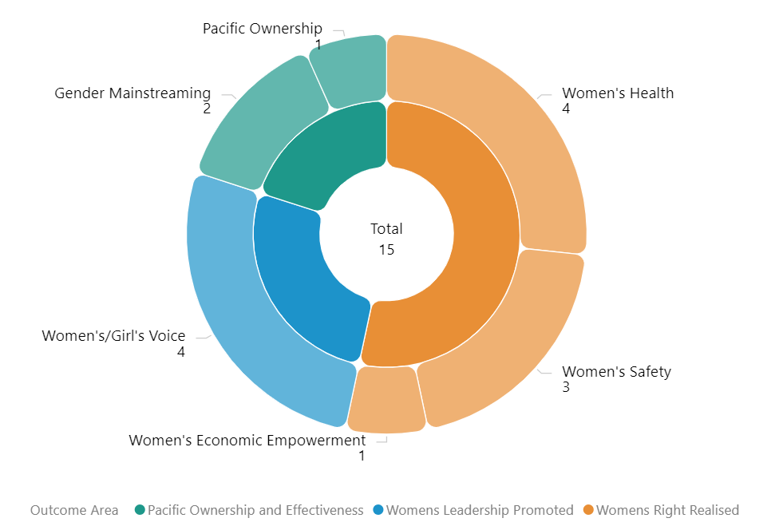

Type of implementing partner
Of the 10 distinct implementing partners, three are regional/multilateral organisations, five are international NGOs and two inter-governmental organisation.
Figure 4 Type of implementing partner
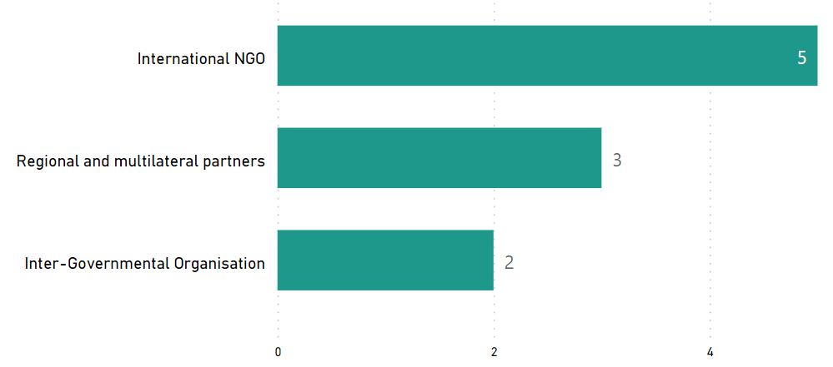

Committed funding by outcomes and sub-outcomes
Table 7 Funding committed for regional projects implemented in Solomon Islands
Outcomes | Sub-outcomes | Funding Committed (AUD)
Women’s rights realised | Women’s economic empowerment | 9,951,871
Women’s rights realised | Women’s health | 47,000,000
Women’s right realised | Women’s safety | 20,276,973.05
Women’s leadership promoted | Women and girls’ Voice | 10,743,900
Pacific ownership and effectiveness | Gender mainstreaming | 6,059,377
Pacific ownership and effectiveness | Pacific ownership | 2,700,000
Total |  | 96,732,121.05
Note: the committed funding is total activity funding and is not broken down by funding allocation for Solomon Islands. It is not possible to provide funding amount or spend of regional projects for Solomon Islands. This information is not provided to the PWLES.

Pacific Women Lead at SPC activities
This section provides information on projects funded and managed by Pacific Women Lead at SPC (PWL at SPC). SPC has a direct grant agreement with DFAT to implement Pacific Women Lead, valued at AUD57,600,000. PWL at SPC’s grants program is funded out of the total value.
In addition to the 8 projects funded through PWL at SPC’s grants program, SPC has advertised a call for grant proposal. The SPC grants aim to support partners to implement Pacific regional gender equality commitments and contribute to Pacific Women Lead outcomes. The multi-stage grant application process is due for completion in the second half of 2023. This section will be updated when the grants process is completed to include successful grantees in Solomon Islands, if any.

Project and implementing partner count by outcomes and sub-outcomes
There is one project funded under PWL at SPC that is being implemented in Solomon Islands by one distinct implementing partner and one downstream implementing partner (refer to Annex for detailed information).
Table 8 PWL at SPC implementing partners, and outcomes/sub-outcomes
Project name | Distinct implementing partner | Downstream implementing partner | Outcomes and sub-outcomes
Shifting the Power Coalition: Strengthening Diverse Women's Leadership in Humanitarian Action | ActionAid Australia | Vois Blong Mere | Women’s leadership promoted – feminist civil-society

Type of implementing partner
ActionAid Australia is an international NGO.

Committed funding by outcomes and sub-outcomes
Outcomes | Sub-outcomes | Funding Committed (AUD)
Women’s leadership promoted | Pacific feminist civil society | 532,233.07
Total |  | 532,233.07
Note: the committed funding is total activity funding and is not broken down by funding allocation for Solomon Islands. It is not possible to provide funding amount or spend of PWL at SPC for Solomon Islands. This information is not provided to the PWLES.

- Amplify-Invest-Reach (AIR) Program: Funding to Pacific Feminist Funds
The Pacific Feminist Funds consists of funding to three funds, under the program name of the Amplify-Invest-Reach (AIR) program. The A-I-R contract is managed by the DFAT Gender Equality Branch in Canberra and supports three Pacific Feminist Funds:
Partner organisation | Funding Committed | Funding Source | Outcomes and sub-outcomes
Women’s Fund Fiji | 4,841,659.75 | Bilateral – Fiji | Women leadership promoted – Pacific feminist civil society
Urgent Action Fund Asia and the Pacific | 3,082,500 | Regional | Women leadership promoted – Pacific feminist civil society
Pacific Feminist Fund | 1,170,849 | Regional | Women leadership promoted – Pacific feminist civil society
Total | 9,095,008.75

This section will provide information on grants funded and managed by the two Pacific Feminist Funds (Urgent Action Fund and the Pacific Feminist Fund) once they start funding grantees. The Pacific Feminist Fund was recently launched in May 2023. To date there are no grants funded by the two regional Funds. Additional information will be provided in the next six-monthly update.

Pacific Women Lead Enabling Services
This section provides information on Pacific Women Lead Enabling Services (PWLES) activities and support to DFAT Posts and PWL at SPC and is valued at AUD20 million.

Monitoring, Evaluation and Learning Support
PWL MEL System: The PWLES MEL team holds responsibility for the design, implementation and review of PWL’s whole-of-portfolio MEL system. The MEL system is made up of the following components:
- Quantitative database that tracks progress against PWL indicators. Refer to Annex 2 for a full list of PWL quantitative indicators.
- Qualitative database that allows the PWLES MEL team to code partner narrative reports against qualitative change domains.
The PWL MEL system has the capability to provide Post with data for your DFAT reporting processes (IMR and Tier 2 reporting). The MEL system can also provide qualitative stories or quotes from Solomon Island projects that can be used for DFAT briefing documents or speeches.
Collection of qualitative impact stories: PWLES has contracted a MEL Consultant from the Solomon Islands that will collect impact stories from PWL projects twice per year (July and February). These stories will be used to inform the PWL MEL system but will also be provided to Post and can be used for your communication or public diplomacy needs.
Quarterly DFAT Gender Focal Points (GFPs) meetings: The PWLES MEL team has a standing quarterly meeting with the DFAT Solomon Islands GFP. At these meetings, the PWLES MEL team confirms if any new gender activities have been funded, shares PWL updates and discusses reporting timelines so Solomon Islands project-level data feeds into the PWL MEL system.
Clear Horizon Academy PWL MEL Platform: The PWLES MEL team is developing training modules with Clear Horizon Academy to support PWL partners. Two modules: Using Data for Reporting and Learning and Collecting Impact Stories have been completed. The modules will be piloted with partners at the inaugural PWL Annual Reflection and Analysis workshop in September 2023.

Quality Technical Assurance Group (QTAG)
QTAG offers tailored GEDSI support through a panel of consultants.
Gender Focal Point (GFP) mentoring: QTAG provides regular mentoring to GFP in smaller DFAT Posts as a pilot approach to support GFPs to carry out their role with confidence. QTAG’s technical partner CoLAB has been engaged to provide mentoring support to GFPs. The mentoring will also provide a space to support GFPs broader professional development priorities including provide advice and feedback on communication, help with problem solving and to act as a sounding board to troubleshoot issues and ideas with the GFPs without conflicting with other management and supervision support provided by the GFP’s manager/supervisor, and the GFPs existing workload.
GEDSI Analysis and Country Plans/Design: Through its panel of consultants, QTAG provides support to smaller DFAT Posts to carry out GEDSI Analysis and develop their Gender Country Plan/Design. PWL support to the development of country briefs/designs includes PWL whole-of-portfolio MEL briefings to ensure there is alignment to the PWL whole-of-portfolio MEL Framework. Larger Posts can draw on this support to ensure alignment to PWL whole-of-portfolio MEL.

Grant Management
PWLES manages two regional grants, Balance of Power and We Rise Coalition. Funding committed to Balance of Power and We Rise Coalition comes out of the total PWLES AUD20 million.
These two projects are not being implemented in Solomon Islands. PWLES can provide updates on these regional grantees at quarterly Gender Focal Point meetings if there is interest.

Annex 1: Pacific Women Lead Projects in Solomon Islands
The table provides a list of all bilateral, regional, PWL at SPC projects for Solomon Islands that have been entered into the Pacific Women Lead quantitative database. It provides detailed information on each project’s name, implementing partner, project description, end of project outcomes, total funding (AUD) and timeframe.
PWL Components | # Of Projects | Total Funding (AUD)
Bilateral | 7 | 8,450,165
Regional | 15 | 96,732,121.05
PWL at SPC | 1 | 532,233.07
A-I-R Program | N/A
PWLES-managed grants | N/A
Total Combined Funding |  | 105,714,519
Total funding provided to grants that are managed under these components and does not reflect the total value of the components.

Note:
- The timeline and budget reflect the start date of Pacific Women Lead i.e. 1 July 2021.
- “Transformative Agenda for Women, Adolescents and Youth in the Pacific: Towards Zero Unmet Need for Planning 2018 – 2022’ Phase 2 is in development. The information presented is for Phase 1, which was completed in Year 1 of PWL.
- ‘Core Funding for IPPF Global Strategic Framework Funding 2018 – 2022’ was completed in Year 1 of PWL. The ‘Core Funding for IPPF Global Strategic Framework (22-26) and Pacific Strategic Strategy (22-26)’ is the active activity under PWL.

COUNTRY-LEVEL PROJECTS
NO. | AID-WORKS NUMBER PROJECT NAME AND PARTNER PROJECT DESCRIPTION END OF PROJECT OUTCOMES VALUE (AUD) AND TIMEFRAME
1 | 74682 | Channels of Hope Phase 3  (World Vision Solomon Islands) | Channels of Hope is a faith-based approach to dealing with gender-based violence. It focuses on Churches as catalysts of change through a re-exploration of Biblical messages. | - Target communities and churches demonstrate more respectful behaviors that value men, women, boys and girls.  - Survivors of GBV have improved community support and improved access to support services.  - Target communities better address substance abuse or other triggers for GBV. | $1,256,500  2021 – 2023
2 | 74888 | Let’s Make Our Families Safe Phase 2 (Safe Families) Project  (Oxfam) | Safe Families is a multi-layered approach to violence prevention that aims to influence the social and cultural norm, values, attitudes and beliefs that support family and sexual violence, as well as enabling and resourcing collective action. Oxfam works with the Solomon Islands National Provincial Council of Women to implement the Safe Families Project through Provincial Council of Women in Malaita, Western, Choiseul and Temotu Provinces. | - Women Stakeholders at Provincial and National level have increased institutional capacity to effectively play a key role in the implementation of the FPA and coordination of the EVAW policy to advance gender equality and prevent violence in Solomon Islands.  - Increased collaboration between PCW, PA and PG in the establishment of prevention and response support structures / mechanisms such as SAFENET and PTF EVAW Force and in the implementation of provincial EVAW policy to prevent and respond to gender-based violence.  - Increased number of PCW and WCW members are empowered to design and implement violence prevention program to facilitate transformational change and lead advocacy and campaign initiatives to ensure women and girls have a life free from violence,  - Provincial Alliance become an effective platform for holding Provincial Government and service providers accountable through active engagement between civil society and government institutions.  - Increased number of women and girl survivors have awareness of their right to referrals to support services,  - Increased capacity at community and service providing organisation to provide primary services and facilitate referral for survivors of violence.  - There are positive changes among men and women in beliefs, attitudes and social norms relating to family violence, and communities and provinces develop new norms that support gender equality, and  - Men, women, girls and boys adopt non-violent conflict resolution methods and respectful behaviour to address gender-based issues at household level. | $1,500,000  2021 – 2023
3 | 76862 | People With Disability Solomon Islands  (PWDSI) | Funding support to PWSI ensures Australia is supporting a suite of women’s group that enable and empower women’s voices in public discourses across the portfolio of activities. |  | $40,000  2021 – 2022  Completed
4 | 76873 | Responding to Violence against Women Phase 2 (IWDA with the Family Support Centre and the Christian Care Centre) | Providing core funding, technical support and capacity building to the Christian Care Centre and Family Support Centre, two key organisations providing emergency shelter, first aid, counselling, and legal services to survivors of violence. This includes funding to explore options (including through property construction, purchase or long-term rental) for ensuring that the Family Support Centre have permanent location in Honiara to p5rovide services to survivors of violence. |  | $1,580,813  2021 – 2023
5 | 76800 | Solomon Islands Women in Business Association (SWIBA) | Funding support to PWSI ensures Australia is supporting a suite of women’s group that enable and empower women’s voices in public discourses across the portfolio of activities. |  | $60,000  2021 – 2022  Completed
6 |  | Supporting the Ministry of Women, Youth, Children and Family Affairs  (Managing Contractor DT Global, through Australia Solomon Islands Resource Facility) | Supporting the MWYCFA with its role of working across the Solomon Islands Government on gender equality policy and implementation, including research, policy development and gendered impacts of COVID-19 and activities arising from the review of the Family Protection Act 2014. This includes through technical support and support for coordinator positions and flexibilities to fund activities identified throughout the year. |  | $3,070,645  2021 – 2023
7 | 76845 | Women Ignite Stability and Economic Recovery in Solomon Islands (WISER)  (International Women’s Development Agency and Women’s Rights Action Movement) | Core support is provided to WRAM and support for women’s leadership through TSM. |  | $942,207  2021 – 2023

REGIONAL-LEVEL ACTIVITIES
NO. |  | AID-WORKS NUMBER |  | PROJECT NAME AND PARTNER |  | PROJECT DESCRIPTION | END OF PROJECT OUTCOMES |  | VALUE (AUD) AND TIMEFRAME
1 |  | 72410/14 |  | Child Protection in Kiribati, Solomon Islands and Vanuatu  (UNICEF) |  | The programme aims to protect children in Kiribati, Solomon Islands, Vanuatu and Samoa from neglect, abuse, and exploitation by strengthening multi-sector multi-stakeholder child protection (CP) systems. It includes three components: establishing a normative framework; strengthening services; and promoting social and behaviour change. | - Governments have strengthened child protection institutional frameworks.  - Government and other service providers (non-governmental agencies) have enhanced capacities to provide child protection services which prevent and respond to violence and abuse  - Caregivers, families and communities have increased knowledge and skills to eliminate harmful practices and better protect children from violence and abuse |  | $ 3,542,280  2021 – 2024
2 |  | 74843 |  | Core Funding for IPPF Global Strategic Framework Funding 2018 – 2022 |  | The Strategy provides a framework and guidance on a life course approach to SRHR in the Pacific. This entails broadening the focus from family planning to services across the life span from pregnancy and prenatal care and pre-menstruation through menopause. It also looks at critical factors for the Pacific including climate change, gender, disability, non-communicable diseases and sexual and gender-based violence. | - Pacific Island governments increasingly promote, respect, protect and fulfil commitments to SRHR and gender equality.  - People in Pacific countries are able to act freely on their SRHR  - Expanded quality, integrated, gender and rights-based  - Sexual and reproductive health (SRH) services are delivered with a focus on reaching the underserved  - A high performing, accountable and united federation drives sustainable positive change in SRHR in the Pacific |  | $500,000.00  2021 – 2022
3 |  | 77862 |  | Core Funding for IPPF Global Strategic Framework (22-26) and Pacific Strategic Strategy (22-26) |  | The strategy aims to come together and break through the barriers that limit sexual and reproductive health and rights (SRHR), thereby enabling quality SRHR to be realised for everyone in the Pacific. It is an ambitious agenda that is informed by the emerging challenges and opportunities in the region | - Centre Care on People: Expand choice and access in coordination with government partners and national civil society and explore digital options and self-care.  - Move the Sexuality Agenda: Shift attitudes and norms in the Pacific through grass roots advocacy to drive gains in SRHR, ensuring the voices of young people and marginalised or excluded groups are heard.  - Solidarity for Change: Create new strategic partnerships andcontribute to social movements on SRHR and intersectional areas, and harness opportunities for learning and sharing  - Nurture our Federation: Strengthen IPPF’s Secretariat and Member Associations through improvements in governance, financial and programmatic management, and draw on the Federation’s global expertise and knowledge base. |  | $2,000,000  2023 - 2026
4 |  | 77520 |  | Gender responsive Climate Policy and Women’s Climate Leadership in the Pacific  (WEDO) |  | Advance Pacific women's leadership in climate change decision-making via WEDO's Women Delegates Fund (WDF) program, as well as enhance the implementation of gender-responsive climate policy via capacity strengthening for National Gender and Climate Change Focal Points in the Pacific. | - Strengthen Pacific women’s leadership in climate change diplomacy and policymaking via travel support, training and networking  - Support effective operationalization of the role of National Gender and Climate Change Focal Points across Pacific Island countries |  | $699,900  2022 – 2024
5 |  | 76940  (Aid-works number for Solomon Islands bilateral funding) |  | Markets for Change (M4C) Phase 2 UN Women |  | Markets for Change Phase II aims to promote gender equality and the economic empowerment of market vendors, with specific attention to the needs and aspirations of women market vendors. | - Inclusive, effective and representative marketplace groups are created and grow, further enabled and recognised.  - Improved socio-economic security of women market vendors.  - Local governments, market management and other decision-makers are gender-responsive, effective and accountable to women market vendors.  - Physical market structures and operating systems are improved to make markets more gender-responsive, safer, more accessible, sustainable and resilient to disaster risks and climate change |  | $9,951,871  2022 – 2026  Solomon Islands contributes $1,000,000 from bilateral funding to the total.
6 |  | 77557 |  | Oceania Rise Rugby Project  (Oceania Rugby) |  | Strengthen the participation, influence and visibility of women in all parts of the game, both on and off the field. | - 4 new high profile women’s domestic rugby competitions, completing several women’s rugby pathways  - 11 Pacific women in new full-time Senior or Middle Management positions  - 45 emerging Pacific women leaders trained and mentored in governance, leading to more women appointed in decision making roles and improved governance practice  - Over 200 women completing Rugby Accreditations and in leadership roles within the new domestic competitions (as Coaches, Match Officials, Strength & Conditioning coaches, First Aid, Club Administrators)  - Oceania Women in Rugby Network established supporting individuals, peer learning and collective advocacy  - 4000< girls participating in high-quality rugby  - Communities witnessing girls and women play, lead and be celebrated in a formerly ‘men’s’ sport, helping to drive positive change in attitudes and norms gender equality  - Australia and DFAT celebrated as the primary supporter of these successes, opportunities and significant shifts  - Australian dignitaries visible and engaged at high profile, newsworthy announcements, events and competitions  - Direct engagement between Australian government representatives and both profiled and emerging Pacific Island leaders  - Alignment and mutual reinforcement of other significant Oceania Rugby activities driving the participation and empowerment women in Pacific Islands and Australian diplomacy. |  | $2,933,000  2022 – 2024
7 |  | 74112 |  | Pacific Partnership to End Violence Against Women and Girls Phase 1  (UN Women) |  | The Pacific Partnership seeks to promote Gender Equality, prevent VAWG, and increase access to quality VAWG response services for survivors. The programme engages with over 100 partners across the region, including national governments, CSOs, EVAWG networks, faith-based groups, and sports associations. | - To enhance Pacific youth’s formal in-school and informal education on gender equality and prevention of violence against women and girls.  - To promote gender equitable social norms at individual and community levels to prevent violence against women and girls, and to ensure survivors have access to quality response services.  - To empower national and regional civil society organisations (CSOs) to advocate, monitor and report on regional institutions and governments commitments to enhance gender equality and prevent violence against women and girls. |  | $800,000  2021 – 2023
 | 8 |  | 77334/8 |  | Pacific Partnership to End Violence Against Women and Girls Phase 2  (UN Women) | The Pacific Partnership seeks to promote Gender Equality, prevent VAWG, and increase access to quality VAWG response services for survivors. The programme engages with over 100 partners across the region, including national governments, CSOs, EVAWG networks, faith-based groups, and sports associations. | - To enhance Pacific youth’s formal in-school and informal education on gender equality and prevention of violence against women and girls.  - To promote gender equitable social norms at individual and community levels to prevent violence against women and girls, and to ensure survivors have access to quality response services.  - To empower national and regional civil society organisations (CSOs) to advocate, monitor and report on regional institutions and governments commitments to enhance gender equality and prevent violence against women and girls. |  | $15,934,693.05  2022 - 2027
9 |  | 69294/46 |  | Progressing Gender Equality in the Pacific  (HRSD SPC) |  | PGEP’s overall objective is to strengthen gender mainstreaming, policy design, and implementation, including strategic support to civil society organisations, while supporting country and regional gender data and statistical initiatives. | - Gender Mainstreaming: Public Institutions are implementing policies, practices and programs that support gender equality  - Accountability Mechanisms: Government gender mainstreaming planning budgeting, accountability, monitoring, and reporting systems enhance progress towards achieving gender equality commitments |  | $2,156,401  2021– 2023  Completed  Will come under PWL at SPC in 2024.
10 |  | 69294/67 |  | Pacific Community’s Human Rights and Social Development Division (HRSD) support |  | HRSD leads SPC’s work in the areas of human rights, gender equality and social development. | HRSD Business Plan  - Objective 1 – Strengthen inclusive, transparent, and responsive governance and institutions for human rights, gender equality and social development.  - Objective 2 – Mobilise, empower, and build conditions for gender equality, equity and social inclusion in society and development  - Objective 3 – Promote, preserve, and protect positive expressions of culture  - Objective 4 – Accelerate impact on human rights, gender equality and social development through knowledge, learning and innovative solutions. |  | $2,700,000  2022 – 2026
11 |  | 78400 |  | Pacific Island Forum Secretariat Gender Disability and Social Inclusion  (Pacific Island Forum Secretariat) |  | Progressing Pacific Island Forum Secretariat Gender Equality Disability and Social Inclusion priorities | - PIFS Social Policy team to implement priorities on gender equality, disability and social inclusion including in the implementation and monitoring of the 2050 Strategy for the Blue Pacific Continent including gender policy capability and advice  - enhanced strategic engagement and communications  - support to members and actioning outcomes  - progressing disability inclusion  progressing implementation of social policy program |  | $3,902,976  2023 - 2026
12 |  | 76453 |  | RiseUp! Mobilising Young Women's Leadership and Advocacy Phase IV  (World YWCA) |  | Leadership program developed and led by young women for young women, taking into account local contexts and priorities. RiseUp! provides training, networking and peer support to young women between the ages of 18 and 30 years. It supports young women in contexts where their rights and voices are repressed to know and claim those rights within their peer, family and community networks, and to work collectively to mobilise for change. | - Young women take up informal and formal leadership roles in their peer and family networks, communities, countries, region or globally. |  | $6,000,000  2020 – 2025
13 |  | 77821 |  | Tennis Australia Women and Girls Pacific Extension - Emerging onto the World Stage  (Tennis Australia) |  | Deliver programs and pathways to create sustainable benefits for women in the Pacific, either as a player, coach or paid administrator/Development Officer. Create economic efficiencies, seeing supporting partners (ITF, ONOC and TA) come together to maximise opportunities for program stakeholders. | Stream 1 – Coaching  - Increase the number of women in decision-making and leadership roles  - Strengthen career and volunteer pathways and opportunities on the court  - Create sustainable networks to influence and advance women  - Inspire and develop women to be a public voice for tennis from grassroots to the world stage  Stream 2 – Community Leadership  - Increase the number of women in decision-making and leadership roles in Tennis organisations  - Develop the governance structures to create safe, welcoming and inclusive environments for women and girls  Stream 3 - Talent  - Improve access to safe inclusive sporting competitions and facilities to encourage higher participation of girls and young women  - Provide pathways for elite players to transition from Juniors to the Professional Tour (ITF and WTA)  - Increase retention of women elite players able to transition to coaches and leaders in the sport |  | $1,111,000  2022 – 2026
14 |  | 74352 |  | Transformative Agenda for Women, Adolescents and Youth in the Pacific: Towards Zero Unmet Need for Planning 2018 – 2022 (Phase 1)  (UNFPA) |  | The Transformative Agenda outlines action that will increase the demand for, and supply of, SRH services and information (particularly family planning) and create an enabling environment for their progress.  Goal - Transformative change in the lives of women, adolescents and youth across the Pacific by 2022. | - Increased and improved supply of integrated sexual and reproductive health (SRH) information and services, particularly for family planning  - Increased demand for integrated SRH information and services, particularly for family planning  - More conducive and supportive environment for people to access and benefit from quality SRH, especially contraceptive choice. |  | $7,500,000  2021 – 2023
 | 15 |  | 77337/9 |  | Transformative Agenda for Women, Adolescents and Youth in the Pacific: Towards Zero Unmet Need for Planning 2018 – 2022 (Phase 2)  (UNFPA) | The Transformative Agenda outlines action that will increase the demand for, and supply of, SRH services and information (particularly family planning) and create an enabling environment for their progress.  Goal - Transformative change in the lives of women, adolescents and youth across the Pacific by 2022. | - Increased and improved supply of integrated sexual and reproductive health (SRH) information and services, particularly for family planning  - Increased demand for integrated SRH information and services, particularly for family planning  - More conducive and supportive environment for people to access and benefit from quality SRH, especially contraceptive choice. | $37,000,000  2022 – 2028

PWL AT SPC ACTIVITIES
NO. | AID-WORKS NUMBER | PROJECT NAME AND PARTNER | PROJECT DESCRIPTION | END OF PROJECT OUTCOMES | VALUE (AUD) AND TIMEFRAME
PWL at SPC Grantee
1 |  | Shifting the Power Coalition: Strengthening Diverse Women's Leadership in Humanitarian Action (ActionAid Australia) | Works to ensure diverse Pacific women’s voices are included in disaster planning and response at all levels with tangible outcomes around diverse women leaders in six countries.  The Coalition includes ActionAid Vanuatu, FemLink Pacific, Nazareth Centre for Rehabilitation, Pacific Disability Forum, Talitha Project Incorporated, Transcend Oceania, Vanuatu Young Women for Change, Vois Blong Mere, YWCA PNG and YWCA Samoa. | - 200 diverse women leaders in six countries will have increased capacity to engage in local and national disaster coordination mechanisms and to organise and influence decision making  - Diverse women’s needs and capacities in times of crises will be documented and contribute to evidence-based disaster planning and response at national and regional level  - Platforms will be established to strengthen diverse Pacific women’s voices in regional humanitarian and disaster resilience forums and their influence on policy and decision making | $532,233.07  2022 – 2024

AIR PROGRAM – PACIFIC FEMINIST FUNDS
There are currently no projects funded under this component that is being implemented in Solomon Islands. A table will be inserted here for activities implemented in Solomon Islands, when projects are funded in Solomon Islands.

RESEARCH ACTIVITIES
Total funding for research activities is not included in the combined total funding for bilateral, regional and PWL at SPC.
NO. | AID-WORKS NUMBER |  |  | PROJECT NAME AND PARTNER |  | PROJEC DESCRIPTIONS |  | END OF PROJECT OUTCOMES |  | VALUE (AUD) AND TIMEFRAME
1 | 76473 |  |  | Building Back Better: Promoting gender data-driven response to the COVID-19 pandemic in the Pacific and South-east Asia  (UN Women) |  | The Project seeks to increase the production and use of quality timely data to ensure COVID-19 response and recovery efforts are sensitive to gender inequality considerations, provide maximum production from COVID-19 impacts, and enable women’s and girls’ fullest contributions to recovery. |  | - Timely gender-sensitive data on the impact and responses to crisis, most importantly COVID-19, are produced to inform decision-making.  - Gender-responsive COVID-19 policies and recovery plans are in place.  - COVID-19 gender data are accessible and used to inform policies, programmes, advocacy and research. |  | $3,522,558  2021 – 2023
2 | 76470 |  |  | Equality Insights: Gender data supporting COVID-19 response and recovery in the Pacific  (IWDA) |  | Program goal is to improve the gender equality outcomes of COVID-19 recovery through use of Equality Insights Rapid data. |  | - Improved evidence base for implementing COVID-19 recovery that advances gender equality in selected Pacific countries.  - Bilateral and other decision-makers and change agents can access and are using Equality Insights Rapid data.  - Policy, programming, advocacy and/or resource allocation for COVID recovery is informed by Equality Insights Rapid data in at least two countries.  - Regional actors recognize and use Equality Insights data and/or tools. |  | $2,516,863  2020 – 2022
3 |  | 72938/47 | kNOwVAWdata Phase 2  (UNFPA) |  | Works to sustainably strengthen regional and national capacities to measure the prevalence of violence against women in Asia and the Pacific. kNOwVAWdata improves the availability and quality of data to inform more effective policy and programme responses to prevent and end violence against women. |  | - Data-driven, context-specific decision-making in VAW policy and programme design  - Quality data on what works and what does not work to address VAW effectively  - Effective policies and programmes to address VAW are implemented, monitored and evaluated. |  | $3,000,000  2021 – 2024

Annex 2: Whole-of-portfolio PWL Indicators
Program Logic key outcome area | Quantitative indicators | Qualitative indicators
Women’s leadership promoted: women and girls’ voice | - # diverse women and girls supported to assume a leadership role  - # diverse women in non-traditional roles and fields of study and/or work  - # of sectoral policies or initiatives clearly addressing diverse women’s needs | - Change in social norms that support diverse women and girls’ leadership  - Successful strategies that have supported diverse women’s influence in decision-making  - Diverse women influencing/shaping national and regional development agenda
Women’s leadership promoted: Pacific feminist civil society | - # diverse women and girls participating in civil society and intergovernmental forums (e.g., Pacific Feminist Forum and Triennial)  - Number of women’s organisations, groups or coalitions actively engaged in the project  - Number of Pacific organisations of people with disability actively engaged in the project | - Evidence of how Pacific women’s organisations and the feminist movement have influenced the national and regional development agenda  - Evidence that the Pacific feminist movement has grown and is better connected  - Evidence that stakeholders have drawn on the Pacific feminist movements expertise and that this has led to outcomes that would otherwise not have happened.
Women’s Rights Realised – women’s health | - # diverse women and girls who received a modern method of contraception  - Number of unintended pregnancies averted  - Total couple-years protection for contraceptives distributed by countries to lower levels including service delivery points (SDPs) (disaggregated by method including emergency contraception and long-acting reversible contraception)  - Percentage of secondary and tertiary SDPs providing quality-assured, adolescents friendly, integrated SRH services | - Change in social norms that limit diverse women and girls’ access to SRHR services  - Improved collaboration within health ministries on SRHR initiatives, and what supported this collaboration  - Diverse women have improved access and use of SRHR services  - Evidence that men are supportive of women’s SRHR
Women’s Rights Realised – women’s economic empowerment | - # diverse women entrepreneurs provided with financial and/or business development services  - # diverse women who have attained formal qualifications | - Change in social norms that limit women’s economic empowerment  - Increased access to resilient economic opportunities for diverse women  - Pacific Governments, civil society, and private sector are implementing gender inclusive economic policies  - Recognition of women’s contribution to household livelihood (related to unpaid care work, financial contribution through food processing, handcraft production, food and water security, etc).
Women’s Rights Realised – women’s safety | - # of counsellors graduating from recognised counselling institutions  - # of services provided to diverse women and children (girls and boys) and other survivors of violence, such as counselling  - # people who participated in sessions on gender issues and women’s equal rights  - # men who have undertaken male advocacy training  - # police, law, and justice officials trained to respond to incidents of violence against women and girls according to an established protocol | - Change in social norms that contribute to women and girls experiencing reduced violence  - Increased capacity of Pacific police to respond to women experiencing violence  - Change in police responsiveness to violence against women and girls in all their diversity  - Evidence of successful strategies for increasing women’s safety  - Evidence of how men’s involvement and advocacy has supported gender equality
Partners supported to increase Pacific ownership and effectiveness of regional gender equality efforts – gender mainstreaming | - # of government staff and development practitioners applying gender mainstreaming tools  - # of mechanisms in place to support gender mainstreaming processes in the government | - Increased resources allocated to address gender issues  - Increased capacity of Pacific Governments and intergovernmental organisations in gender mainstreaming  - Evidence of how technical support mobilised through PWL has led to increased gender equality outcomes for Pacific Governments
Partners supported to increase Pacific ownership and effectiveness of gender and equality efforts – Pacific ownership and regional effectiveness |  | - Increased collaboration and political will between regional partners for stronger gender equality outcomes  - Evidence that the PWL Governance Board, SPC and Women’s Funds are influencing the regional gender equality agenda  - Evidence of increased accountability for gender equality and women’s human rights at regional and national levels
Program Logic strategies  - Grant making in the thematic areas of leadership, health (SRHR), women’s economic empowerment and safety  - Linking and learning and collective action that supports genuine partnerships and strategies for change in social norms and gender equally outcomes  - Technical support, training, coaching, and mentoring to support greater gender mainstreaming and gender equality outcomes for Pacific governments and development partner sector programs  - Collaborative portfolio level monitoring, evaluation and learning sense-making spaces to inform PWL decision-making | - Types of activities delivered (mentoring, training, coaching, campaigning, service delivery, convenings, learning events etc.)  - Number of diverse women and men reached through activities  - Dollar amount of funds released per Program Logic outcome area  - Number of grants supported  - Types of technical support requests from Pacific governments or through the QTAG  - Number of Tasking Notes completed through the QTAG (disaggregated by client)  - Rate of satisfaction with completed Tasking Notes through the QTAG

An ambition outlined in the PWL design was for SPC to progressively take over responsibility for the whole-or-program MEL. This process will need to be incremental and supported over an extended period. Further conversations will be had with SPC’s PWL MEL team and more details about how this could happen will be outlined in future PWL MELF updates.
Distinct implementing partner is the organisation that holds the contract with DFAT and has ultimate accountability for implementation of project activities.
Downstream implementing partners are organisations that receive funding for activity implementation from the distinct implementing partner. Downstream partners are always Solomon Islands organisations and often support from the distinct implementing partner includes organisational strengthening to ensure downstream partners can meet DFAT’s due diligence requirements.

