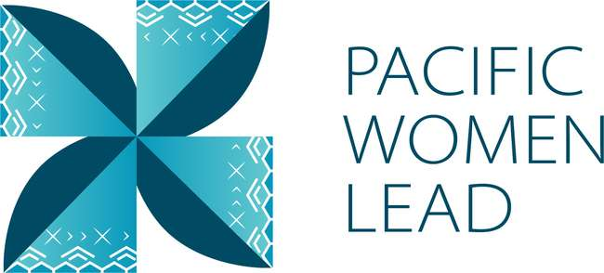

Pacific Women Lead

Republic of Marshall Islands

Program Brief
August 2023

Contents
1 Pacific Women Lead overview 1
2 Program components 2
3 Pacific Women Lead Governance Board 2
4 Brief purpose 3
5 Bilateral activities 3
6 Regional activities 3
6.1 Project and implementing partner count by outcome and sub-outcome areas 3
6.2 Type of implementing partner 5
6.3 Committed funding by outcomes and sub-outcomes 5
7 Pacific Women Lead at SPC activities 5
7.1 Project and implementing partner count by outcomes and sub-outcomes 6
7.2 Type of implementing partner 6
7.3 Committed funding by outcomes and sub-outcomes 6
8 Amplify-Invest-Reach (AIR) Program: Funding to Pacific Feminist Funds 6
9 Pacific Women Lead Enabling Services 7
9.1 Monitoring, Evaluation and Learning Support 7
9.2 Quality Technical Assurance Group (QTAG) 7
9.3 Grant Management 8
Annex 1: Pacific Women Lead Projects in RMI 9
Annex 2: Whole-of-portfolio PWL Indicators 14

Pacific Women Lead overview
Pacific Women Lead (PWL) is a portfolio of regional investments to advance gender equality ($170AUD over five years 2021-2026). PWL is ambitious in its intent to take a Pacific-led, intersectional and transformative approach to promoting gender equality in the region. It is focused on delivering development outcomes for women and girls in all their diversity and bringing new emphasis to strengthening regional action and architecture in support of gender equality.
PWL builds on the strengths and lessons learned through Australia’s 10-year gender equality investment, Pacific Women Shaping Pacific Development. Implementation is through partnerships with the Pacific Community (SPC) as a regional intergovernmental technical agency, Pacific Islands Forum Secretariat (PIFS) through the Pacific Islands Forum Women’s Leaders Meeting, Pacific women-led civil society organisations including Pacific Women’s Funds, United Nations (UN Women, UNFPA and UNICEF) and other non-government organisations and Governance Board. PWL also includes bilateral investments and works to ensure that regional approaches contribute to progress at the national level. In taking this approach, PWL has been designed to address and deliver on both Pacific and Australian Government commitments to progress gender equality in the region.
The goal of PWL is for: Pacific women and girls, in all their diversity, to be safe and equitably share in resources, opportunities and decision-making with men and boys.
The program works across three outcome areas with the following end-of-PWL sub-outcomes:
Table 1 Pacific Women Lead outcomes and sub-outcomes
Outcomes | Sub-outcomes
Women’s Leadership Promoted (WLP) | More women and girls, in all their diversity, are respected, listened to and are influencing decision-making at all levels (Women and girls’ voice)
 | The Pacific feminist movement has grown in depth, is better connected and their expertise is drawn upon by Pacific partners (Pacific feminist civil-society)
Women’s Rights Realised (WRR) | Diverse women and adolescent girls have improved access to quality health services, especially sexual and reproductive health (Women’s health – SRHR)
 | Diverse women have more equitable access to resilient economic opportunities, including increased voice in economic decision-making (Women’s Economic Empowerment)
 | Violence against women and children is reduced and survivors have access to quality support services, including in times of disasters (Women’s safety)
Regional effectiveness and Pacific ownership | Pacific Governments and development partners are implementing programs and policies that support gender equality (Gender mainstreaming)
 | There is robust engagement, cooperation and mutual sharing between regional agencies and intergovernmental organisations to deliver on gender equality commitments (Pacific ownership)

Program components
Implementation of PWL is through complementary partnerships with SPC, targeted Pacific women-led civil society organisations, including Pacific Women’s Funds, Governance Board funds and DFAT bilateral and regional gender projects (including projects with Pacific civil-society, INGOs and UN agencies).
The components of the portfolio include:
The Pacific Community (SPC) as a key implementing partner of PWL. PWL at SPC sits within SPC’s Human Rights and Social Development (HRSD) division and supports the implementation of key regional commitments outlined in the Pacific Leaders’ Gender Equality Declaration, the Pacific Platform for Action on Gender Equality and Women’s Human Rights, and the outcomes of the Triennial Conference of Pacific Women.
Through PWL, SPC provides technical, convening and funding support to government ministries, civil society, and other partners, while also acting as Secretariat for the PWL Governance Board.
Pacific Women’s Funds are supported to expand their work with women’s rights organisations and human rights defenders in the Pacific. This includes funding their advocacy activities to draw more resources for work towards gender equality to the region and funds to support the establishment of the first Pacific Feminist Fund.
DFAT bilateral programs manage and fund country-level gender projects. Importantly, bilateral programs have autonomy in design, delivery and governance, but their gender programming aligns with the PWL goal and outcomes, and they will report results into the Pacific Women Lead Enabling Services (PWLES).
DFAT regional program manages direct funding arrangements for regional gender projects, including (but not limited to) UN Women’s Markets for Change and Pacific Partnership to End Violence Against Women and Girls, and UNFPAs Transformative Agenda program. These projects are also aligned with the PWL goal and outcomes, and report results into the PWLES.
Pacific Women Lead Enabling Services (PWLES) managed by DT Global, provides support to SPC and DFAT to implement PWL. This includes whole-of-portfolio monitoring, evaluation, and learning (MEL), partnership brokering and the delivery of an independent Quality and Technical Assurance Group (QTAG). It is the role of the MEL team within the PWLES to compile a yearly whole-of-portfolio progress report, which brings together all the above components of PWL.

Pacific Women Lead Governance Board
The PWL Governance Board is made up of 13 members, 12 of whom are from the Pacific region. DFAT’s Assist Secretary of the Pacific Development Branch is an ex-officio member of the Board.
The Governance Board has a direct strategy and decision-making role in relation to PWL activities managed by SPC. The Board will receive reporting on outcomes for all other portfolio components through the PWL Annual Progress Report, compiled by the PWLES MEL Team, but does not provide direct strategy advice or have a decision-making role over the DFAT bilateral components or Women’s Funds component of PWL.
Under the SPC-managed component, AUD 5 million has been set aside for activities funded at the discretion of the Governance Board. By making decisions on the allocation of these funds, the Board is more directly engaging in gender equality programming and decision making in the region. These activities may be regional or multi-country in scale including to add value to and build on national activities. As the Secretariat for the Governance Board, SPC has developed seven criteria to guide the use of the Board funds. The seven criteria include: 1) alignment with PWL outcomes; 2) Pacific-led approaches; 3) regional or multi-country in scale; 4) promoting transformational change; 5) development effectiveness; 6) diversity and inclusion; 7) informed by research, evidence and data.
At this point in time, there is no RMI representative on the Pacific Women Lead Governance Board.

Brief purpose
This brief provides information on the gender activities funded under PWL portfolio that are being implemented in Republic of Marshall Islands (RMI). It also serves as a mechanism for the PWLES MEL team and RMI DFAT Post to undertake a review of all project details (i.e., project timeframes and budgets) to ensure all information captured in the database is correct. This will be an ongoing collaborative activity. As such, these briefs will be updated and sent to Post on a six-monthly basis.
The data is drawn from the PWL quantitative database as of 30 August 2023.
This brief provides information on:
- Number of bilateral activities
- Total activities and number and type of implementing partners
- Total number of activities per outcome and sub-outcome area
- Total funding per outcome and sub-outcome area
- Number of regional projects
- Total activities and number and type of implementing partners
- Reach data against PWL quantitative indicators. Reach data refers to the coverage of activities: how many diverse men, women, boys and girls have been reached by an activity or project.

Bilateral activities
This section will present information on gender activities funded by DFAT in RMI when the RMI Country Plan is completed in 2023.

Regional activities
The information presented in this section provides an overview of gender activities implemented in RMI that are managed and funded by DFATs regional program (either at Suva post or Canberra).

Project and implementing partner count by outcome and sub-outcome areas
There are 7 regional projects implemented in RMI and 4 distinct implementing partners (refer to Annex for detailed information), plus one research activity.
Table 6 Regional implementing partners and outcomes/sub-outcomes
Project name | Distinct implementing partner | Outcomes and sub-outcomes
Building Prosperity for Women Producers, Processors and Women-owned Businesses through Organic Value Chains | Pacific Community’s Land Resource Division (LRD) | Women’s rights realised – women’s economic empowerment
Gender responsive Climate Policy and Women’s Climate Leadership in the Pacific | Women Environment and Development Organisation | Women’s leadership promoted – women and girls’ voice
Pacific Partnership to End Violence Against Women and Girls | UN Women | Women’s rights realised – women’s safety
Pacific Partnership to End Violence Against Women and Girls Phase 2 | UN Women | Women’s rights realised – women’s safety
Pacific Community’s Human Rights and Social Development (HRSD) Division Support | Pacific Community’s Human Rights and Social Development (HRSD) Division Support | Pacific ownership and effectiveness – Pacific ownership
Progressing Gender Equality in the Pacific | Pacific Community’s Human Rights and Social Development (HRSD) | Pacific ownership and effectiveness - gender mainstreaming
Pacific Island Forum Secretariat Gender Disability and Social Inclusion | Pacific Islands Forum Secretariat (PIFS) | Pacific ownership and effectiveness - gender mainstreaming
Research activity | Distinct implementing partner
kNOwVAWdata Phase 2 | UNFPA

Of the 7 projects, one projects works in Women’s leadership promoted in women and girl’s voice (1) and three projects work in Women’s rights realised: two in women’s safety (2) and one in women’s economic empowerment (1). Three projects work in Pacific ownership and effectiveness: two projects in gender mainstreaming (2) and one in Pacific ownership (1).
Figure 3 Projects by outcomes and sub-outcomes
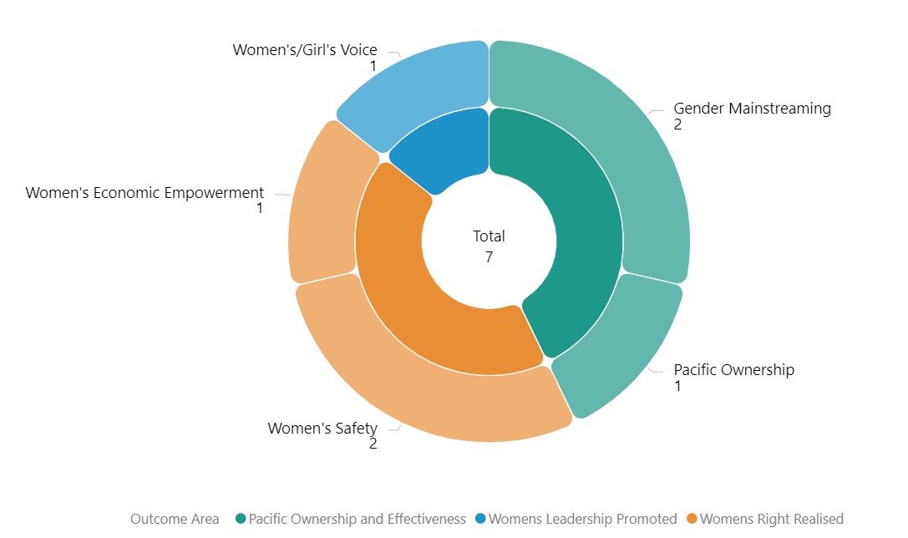

Type of implementing partner
Of the 4 distinct implementing partners, two are inter-governmental organisations, one a regional/multilateral organisation and one are INGOs.
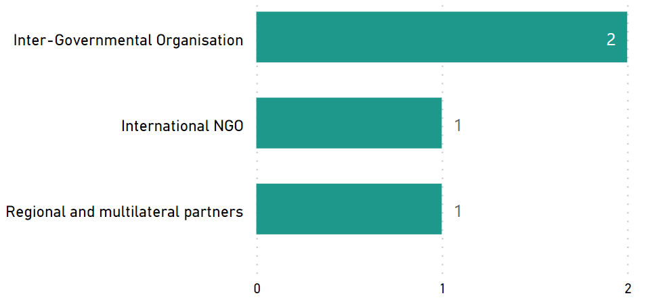
Figure 4 Type of implementing partner

Committed funding by outcomes and sub-outcomes
Table 7 Funding committed for regional projects implemented in RMI
Outcomes | Sub-outcomes | Funding Committed (AUD)
Women’s right realised | Women’s safety | 16,734,693.05
Women’s rights realised | Women’s economic empowerment | 965,600
Women’s leadership promoted | Women and girls’ Voice | 699900
Pacific ownership and effectiveness | Gender mainstreaming | 6059377
Pacific ownership and effectiveness | Pacific ownership | 2,700,000
Total |  | 27,159,570.05
Note: the committed funding is total activity funding and is not broken down by funding allocation for RMI. It is not possible to provide funding amount or spend of regional projects for RMI. This information is not provided to the PWLES.

Pacific Women Lead at SPC activities
This section provides information on projects funded and managed by Pacific Women Lead at SPC (PWL at SPC). SPC has a direct grant agreement with DFAT to implement Pacific Women Lead, valued at AUD57,600,000. PWL at SPC’s grants program is funded out of the total value.
In addition to the 8 projects funded through PWL at SPC’s grants program, SPC has advertised a call for grant proposal. The SPC grants aim to support partners to implement Pacific regional gender equality commitments and contribute to Pacific Women Lead outcomes. The multi-stage grant application process is due for completion in the second half of 2023. This section will be updated when the grants process is completed to include successful grantees in RMI, if any.

Project and implementing partner count by outcomes and sub-outcomes
There is one project funded under PWL at SPC that is being implemented in RMI by one distinct implementing partner (refer to Annex for detailed information). Information on downstream implementing partners will be included, if any, in the next six-monthly program update.
Table 8 PWL at SPC implementing partners, and outcomes/sub-outcomes
Project name | Distinct implementing partner | Downstream implementing partner | Outcomes and sub-outcomes
Weto in Mour: Support Service for Women and Girls that are experiencing violence | Women United Together Marshall Islands |  | Women’s rights realised – women’s safety

Type of implementing partner
Women United Together Marshall Islands is a Pacific NGO.

Committed funding by outcomes and sub-outcomes
Outcomes | Sub-outcomes | Funding Committed (AUD)
Women’s rights realised | Women’s safety | 376,449.65
Total |  | 376,449.65
Note: the committed funding is total activity funding and is not broken down by funding allocation for RMI. It is not possible to provide funding amount or spend of PWL at SPC for RMI. This information is not provided to the PWLES.

Amplify-Invest-Reach (AIR) Program: Funding to Pacific Feminist Funds
The Pacific Feminist Funds consists of funding to three funds, under the program name of the Amplify-Invest-Reach (AIR) program. The AIR contract is managed by the DFAT Gender Equality Branch in Canberra and supports three Pacific Feminist Funds:
Partner organisation | Funding Committed | Funding Source | Outcomes and sub-outcomes
Women’s Fund Fiji | 4,841,659.75 | Bilateral – Fiji | Women leadership promoted – Pacific feminist civil society
Urgent Action Fund Asia and the Pacific | 3,082,500 | Regional | Women leadership promoted – Pacific feminist civil society
Pacific Feminist Fund | 1,170,849 | Regional | Women leadership promoted – Pacific feminist civil society
Total | 9,095,008.75

This section will provide information on grants funded and managed by the two Pacific Feminist Funds (Urgent Action Fund and the Pacific Feminist Fund) once they start funding grantees. The Pacific Feminist Fund was recently launched in May 2023. To date there are no grants funded by the two regional Funds. Additional information will be provided in the next six-monthly update.

Pacific Women Lead Enabling Services
This section provides information on Pacific Women Lead Enabling Services (PWLES) activities and support to DFAT Posts and PWL at SPC and is valued at AUD20 million.

Monitoring, Evaluation and Learning Support
PWL MEL System: The PWLES MEL team holds responsibility for the design, implementation and review of PWL’s whole-of-portfolio MEL system. The MEL system is made up of the following components:
- Quantitative database that tracks progress against PWL indicators. Refer to Annex 2 for a full list of PWL quantitative indicators.
- Qualitative database that allows the PWLES MEL team to code partner narrative reports against qualitative change domains.
The PWL MEL system has the capability to provide Post with data for your DFAT reporting processes (IMR and Tier 2 reporting). The MEL system can also provide qualitative stories or quotes from RMI projects (when implemented) that can be used for DFAT briefing documents or speeches.
Collection of qualitative impact stories: PWLES will collaborate with PWL at SPC collect impact stories from PWL projects in RMI twice per year (July and February). These stories will be used to inform the PWL MEL system but will also be provided to Post and can be used for your communication or public diplomacy needs.

Quarterly DFAT Gender Focal Points (GFPs) meetings: When projects under the RMI Country Plan are implemented, the PWLES MEL team will seek to have a quarterly meeting with the DFAT RMI GFP. At these meetings, the PWLES MEL team confirms if any new gender activities have been funded, shares PWL updates and discusses reporting timelines so Tuvalu project-level data feeds into the PWL MEL system.
Clear Horizon Academy PWL MEL Platform: The PWLES MEL team is developing training modules with Clear Horizon Academy to support PWL partners. Two modules: Using Data for Reporting and Learning and Collecting Impact Stories have been completed. Should you wish provide access to your implementing partners, please reach out to the PWLES MEL team.

Quality Technical Assurance Group (QTAG)
QTAG offers tailored GEDSI support through a panel of consultants.
Gender Focal Point (GFP) mentoring: QTAG provides regular mentoring to GFP in smaller DFAT Posts as a pilot approach to support GFPs to carry out their role with confidence. QTAG’s technical partner CoLAB has been engaged to provide mentoring support to GFPs. The mentoring will also provide a space to support GFPs broader professional development priorities including provide advice and feedback on communication, help with problem solving and to act as a sounding board to troubleshoot issues and ideas with the GFPs without conflicting with other management and supervision support provided by the GFP’s manager/supervisor, and the GFPs existing workload.
GEDSI Analysis and Country Plans/Design: Through its panel of consultants, QTAG provides support to smaller DFAT Posts to carry out GEDSI Analysis and develop their Gender Country Plan/Design. PWL support to the development of country briefs/designs includes PWL whole-of-portfolio MEL briefings to ensure there is alignment to the PWL whole-of-portfolio MEL Framework. Larger Posts can draw on this support to ensure alignment to PWL whole-of-portfolio MEL.

Grant Management
PWLES manages two regional grants, Balance of Power and We Rise Coalition. Funding committed to Balance of Power and We Rise Coalition comes out of the total PWLES AUD20 million.
These two projects are not being implemented in RMI. PWLES can provide updates on these regional grantees at quarterly Gender Focal Point meetings if there is interest.

Annex 1: Pacific Women Lead Projects in RMI
The table provides a list of all bilateral, regional, PWL at SPC projects for RMI that have been entered into the Pacific Women Lead quantitative database. It provides detailed information on each project’s name, implementing partner, project description, end of project outcomes, total funding (AUD) and timeframe.
PWL Components | # Of Projects | Total Funding (AUD)
Bilateral | N/A
Regional | 7 | 27,159,570.05
PWL at SPC | 1 | 376,449.65
AIR Program | N/A
PWLES-managed grants | N/A
Total Combined Funding |  | 27,536,019.70
Total funding provided to grants that are managed under these components and does not reflect the total value of the components.
Note:
- The timeline and budget reflect the start date of Pacific Women Lead i.e. 1 July 2021.
- “Transformative Agenda for Women, Adolescents and Youth in the Pacific: Towards Zero Unmet Need for Planning 2018 – 2022’ Phase 2 is in development. The information presented is for Phase 1, which has been completed in Year 1 of PWL.
- ‘Core Funding for IPPF Global Strategic Framework Funding 2018 – 2022’ was completed in Year 1 of PWL. The ‘Core Funding for IPPF Global Strategic Framework (22-26) and Pacific Strategic Strategy (22-26)’ is the active activity under PWL.

COUNTRY-LEVEL PROJECTS
There are currently no projects funded under this component. A table will be inserted when projects funded by DFAT in RMI are being implemented in RMI.

REGIONAL-LEVEL ACTIVITIES
NO. | AID-WORKS NUMBER | PROJECT NAME AND PARTNER | PROJECT DESCRIPTION | END OF PROJECT OUTCOMES | VALUE (AUD) AND TIMEFRAME
1 |  | Building Prosperity for Women Producers, Processors and Women-owned Businesses through Organic Value Chains  (SPC LRD) | The BPWP project aims to strengthen the recognition of women’s role in organic agriculture. The project uses a combination of inter-linked activities such as trainings to project partners, capacity development of national organic farmer groups, technical assistance to primary actors, and advocating for policy and regulatory standards in countries, to promote organic agriculture and gender equality and social inclusion (GESI). | - Women have increased financial independence and influence in decision-making within the household.  - Women are increasingly participating in organic value chains including decision-making processes.  - Women and men benefit from viable organic value chains that meet market needs and increase food security.  The Pacific organic sector has more gender equitable policies and practices. | $965,600  2021 – 2023
2 | 77520 | Gender responsive Climate Policy and Women’s Climate Leadership in the Pacific  (WEDO) | Advance Pacific women's leadership in climate change decision-making via WEDO's Women Delegates Fund (WDF) program, as well as enhance the implementation of gender-responsive climate policy via capacity strengthening for National Gender and Climate Change Focal Points in the Pacific. | - Strengthen Pacific women’s leadership in climate change diplomacy and policymaking via travel support, training and networking  - Support effective operationalization of the role of National Gender and Climate Change Focal Points across Pacific Island countries | $699,900  2022 – 2024
3 | 74112 | Pacific Partnership to End Violence Against Women and Girls  (UN Women) | The Pacific Partnership seeks to promote Gender Equality, prevent VAWG, and increase access to quality VAWG response services for survivors. The programme engages with over 100 partners across the region, including national governments, CSOs, EVAWG networks, faith-based groups, and sports associations. | - To enhance Pacific youth’s formal in-school and informal education on gender equality and prevention of violence against women and girls.  - To promote gender equitable social norms at individual and community levels to prevent violence against women and girls, and to ensure survivors have access to quality response services.  - To empower national and regional civil society organisations (CSOs) to advocate, monitor and report on regional institutions and governments commitments to enhance gender equality and prevent violence against women and girls. | $800,000  2021 – 2023  Completed.
4 | 77334/8 | Pacific Partnership to End Violence Against Women and Girls Phase 2  (UN Women) | The Pacific Partnership seeks to promote Gender Equality, prevent VAWG, and increase access to quality VAWG response services for survivors. The programme engages with over 100 partners across the region, including national governments, CSOs, EVAWG networks, faith-based groups, and sports associations. | - To enhance Pacific youth’s formal in-school and informal education on gender equality and prevention of violence against women and girls.  - To promote gender equitable social norms at individual and community levels to prevent violence against women and girls, and to ensure survivors have access to quality response services.  - To empower national and regional civil society organisations (CSOs) to advocate, monitor and report on regional institutions and governments commitments to enhance gender equality and prevent violence against women and girls. | $15,934,693.05  2022 - 2027
5 | 69294/46 | Progressing Gender Equality in the Pacific  (HRSD SPC) | PGEP’s overall objective is to strengthen gender mainstreaming, policy design, and implementation, including strategic support to civil society organisations, while supporting country and regional gender data and statistical initiatives. | - Gender Mainstreaming: Public Institutions are implementing policies, practices and programs that support gender equality  - Accountability Mechanisms: Government gender mainstreaming planning budgeting, accountability, monitoring, and reporting systems enhance progress towards achieving gender equality commitments | $2,156,401  2021– 2023 Completed.  Will come under PWL at SPC in 2024
6 | 69294/67 | Pacific Community’s Human Rights and Social Development Division (HRSD) support | HRSD leads SPC’s work in the areas of human rights, gender equality and social development. | HRSD Business Plan  - Objective 1 – Strengthen inclusive, transparent, and responsive governance and institutions for human rights, gender equality and social development.  - Objective 2 – Mobilise, empower, and build conditions for gender equality, equity and social inclusion in society and development  - Objective 3 – Promote, preserve, and protect positive expressions of culture  - Objective 4 – Accelerate impact on human rights, gender equality and social development through knowledge, learning and innovative solutions. | $2,700,000  2022 – 2026
7 | 78400 | Pacific Island Forum Secretariat Gender Disability and Social Inclusion  (Pacific Island Forum Secretariat) | Progressing Pacific Island Forum Secretariat Gender Equality Disability and Social Inclusion priorities | - PIFS Social Policy team to implement priorities on gender equality, disability and social inclusion including in the implementation and monitoring of the 2050 Strategy for the Blue Pacific Continent including gender policy capability and advice  - enhanced strategic engagement and communications  - support to members and actioning outcomes  - progressing disability inclusion  progressing implementation of social policy program | $3,902,976  2023 - 2026

PWL AT SPC ACTIVITIES
NO. | AID-WORKS NUMBER | PROJECT NAME AND PARTNER | PROJECT DESCRIPTION | END OF PROJECT OUTCOMES | VALUE (AUD) AND TIMEFRAME
PWL at SPC Grantee
1 |  | Weto in Mour: Support Service for Women and Girls that are experiencing violence | The Implementation of Weto In Mour Program- Violence Against Women and Girls Support Service Phase 3 – Program Extension in Majuro and Ebeye grant in RMI supports WUTMI to continue to provide customized, quality and effective community-based responses to women and girls who experience domestic violence in Majuro and the GBV counselling program extension in Ebeye. This includes support to have WUTMI’s organizational systems upgraded for improved operations and management so that WUITMI is fit for purpose, women accessing essential lifesaving and targeted comprehensive package of psychosocial support services in Majuro and Ebeye and communities throughout the Marshall Islands having an increased understanding of equal and respectful relationships as a result of being engaged in gender-transformative primary prevention, education and advocacy activities |  | $376,449.65  2022 – 2024

AIR PROGRAM – PACIFIC FEMINIST FUNDS
There are currently no projects funded under this component that is being implemented in RMI. A table will be inserted here for activities implemented in RMI, when projects are funded in RMI.

RESEARCH ACTIVITIES
Total funding for research activities is not included in the combined total funding for bilateral, regional, PWL at SPC, and PWLES-managed grants.
NO. | AID-WORKS NUMBER | PROJECT NAME AND PARTNER | PROJEC DESCRIPTIONS | END OF PROJECT OUTCOMES | VALUE (AUD) AND TIMEFRAME
1 | 72938/47 | kNOwVAWdata Phase 2  (UNFPA) | Works to sustainably strengthen regional and national capacities to measure the prevalence of violence against women in Asia and the Pacific. kNOwVAWdata improves the availability and quality of data to inform more effective policy and programme responses to prevent and end violence against women. | - Data-driven, context-specific decision-making in VAW policy and programme design  - Quality data on what works and what does not work to address VAW effectively  - Effective policies and programmes to address VAW are implemented, monitored and evaluated. | $3,000,000  2021 – 2024

Annex 2: Whole-of-portfolio PWL Indicators
Program Logic key outcome area | Quantitative indicators | Qualitative indicators
Women’s leadership promoted: women and girls’ voice | - # diverse women and girls supported to assume a leadership role  - # diverse women in non-traditional roles and fields of study and/or work  - # of sectoral policies or initiatives clearly addressing diverse women’s needs | - Change in social norms that support diverse women and girls’ leadership  - Successful strategies that have supported diverse women’s influence in decision-making  - Diverse women influencing/shaping national and regional development agenda
Women’s leadership promoted: Pacific feminist civil society | - # diverse women and girls participating in civil society and intergovernmental forums (e.g., Pacific Feminist Forum and Triennial)  - Number of women’s organisations, groups or coalitions actively engaged in the project  - Number of Pacific organisations of people with disability actively engaged in the project | - Evidence of how Pacific women’s organisations and the feminist movement have influenced the national and regional development agenda  - Evidence that the Pacific feminist movement has grown and is better connected  - Evidence that stakeholders have drawn on the Pacific feminist movements expertise and that this has led to outcomes that would otherwise not have happened.
Women’s Rights Realised – women’s health | - # diverse women and girls who received a modern method of contraception  - Number of unintended pregnancies averted  - Total couple-years protection for contraceptives distributed by countries to lower levels including service delivery points (SDPs) (disaggregated by method including emergency contraception and long-acting reversible contraception)  - Percentage of secondary and tertiary SDPs providing quality-assured, adolescents friendly, integrated SRH services | - Change in social norms that limit diverse women and girls’ access to SRHR services  - Improved collaboration within health ministries on SRHR initiatives, and what supported this collaboration  - Diverse women have improved access and use of SRHR services  - Evidence that men are supportive of women’s SRHR
Women’s Rights Realised – women’s economic empowerment | - # diverse women entrepreneurs provided with financial and/or business development services  - # diverse women who have attained formal qualifications | - Change in social norms that limit women’s economic empowerment  - Increased access to resilient economic opportunities for diverse women  - Pacific Governments, civil society, and private sector are implementing gender inclusive economic policies  - Recognition of women’s contribution to household livelihood (related to unpaid care work, financial contribution through food processing, handcraft production, food and water security, etc).
Women’s Rights Realised – women’s safety | - # of counsellors graduating from recognised counselling institutions  - # of services provided to diverse women and children (girls and boys) and other survivors of violence, such as counselling  - # people who participated in sessions on gender issues and women’s equal rights  - # men who have undertaken male advocacy training  - # police, law, and justice officials trained to respond to incidents of violence against women and girls according to an established protocol | - Change in social norms that contribute to women and girls experiencing reduced violence  - Increased capacity of Pacific police to respond to women experiencing violence  - Change in police responsiveness to violence against women and girls in all their diversity  - Evidence of successful strategies for increasing women’s safety  - Evidence of how men’s involvement and advocacy has supported gender equality
Partners supported to increase Pacific ownership and effectiveness of regional gender equality efforts – gender mainstreaming | - # of government staff and development practitioners applying gender mainstreaming tools  - # of mechanisms in place to support gender mainstreaming processes in the government | - Increased resources allocated to address gender issues  - Increased capacity of Pacific Governments and intergovernmental organisations in gender mainstreaming  - Evidence of how technical support mobilised through PWL has led to increased gender equality outcomes for Pacific Governments
Partners supported to increase Pacific ownership and effectiveness of gender and equality efforts – Pacific ownership and regional effectiveness |  | - Increased collaboration and political will between regional partners for stronger gender equality outcomes  - Evidence that the PWL Governance Board, SPC and Women’s Funds are influencing the regional gender equality agenda  - Evidence of increased accountability for gender equality and women’s human rights at regional and national levels
Program Logic strategies  - Grant making in the thematic areas of leadership, health (SRHR), women’s economic empowerment and safety  - Linking and learning and collective action that supports genuine partnerships and strategies for change in social norms and gender equally outcomes  - Technical support, training, coaching, and mentoring to support greater gender mainstreaming and gender equality outcomes for Pacific governments and development partner sector programs  - Collaborative portfolio level monitoring, evaluation and learning sense-making spaces to inform PWL decision-making | - Types of activities delivered (mentoring, training, coaching, campaigning, service delivery, convenings, learning events etc.)  - Number of diverse women and men reached through activities  - Dollar amount of funds released per Program Logic outcome area  - Number of grants supported  - Types of technical support requests from Pacific governments or through the QTAG  - Number of Tasking Notes completed through the QTAG (disaggregated by client)  - Rate of satisfaction with completed Tasking Notes through the QTAG

An ambition outlined in the PWL design was for SPC to progressively take over responsibility for the whole-or-program MEL. This process will need to be incremental and supported over an extended period. Further conversations will be had with SPC’s PWL MEL team and more details about how this could happen will be outlined in future PWL MELF updates.

