,,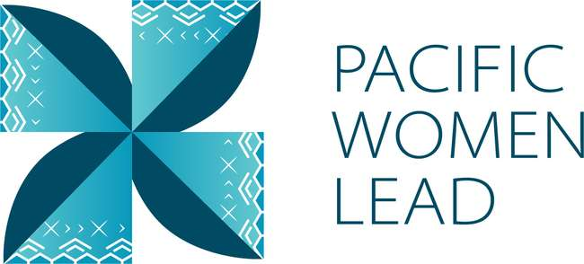

Pacific Women Lead

Samoa

Program Brief
August 2023

Contents
1 Pacific Women Lead overview 1
2 Program components 2
3 Pacific Women Lead Governance Board 2
4 Brief purpose 3
5 Bilateral activities 3
5.1 Project and implementing partner count by outcome and sub-outcome areas. 3
5.2 Type of implementing partner 4
5.3 Committed funding by outcomes and sub-outcomes 5
5.4 Reach data by projects and indicators 5
6 Regional activities 2
6.1 Project and implementing partner count by outcomes and sub-outcomes 2
6.2 Type of implementing partner 4
6.3 Committed funding by outcomes and sub-outcomes 5
7 Pacific Women Lead at SPC activities 5
7.1 Project and implementing partner count by outcomes and sub-outcomes 5
7.2 Type of implementing partner 6
7.3 Committed funding by outcomes and sub-outcomes 6
8 Amplify-Invest-Reach (AIR) Program: Funding to Pacific Feminist Funds 6
9 Pacific Women Lead Enabling Services 6
9.1 Monitoring, Evaluation and Learning Support 6
9.2 Quality Technical Assurance Group (QTAG) 7
9.3 Grant Management 7
Annex 1: Pacific Women Lead Projects Samoa 9
Annex 2: Whole-of-portfolio PWL Indicators 20

Pacific Women Lead overview
Pacific Women Lead (PWL) is a portfolio of regional investments to advance gender equality ($170AUD over five years 2021-2026). PWL is ambitious in its intent to take a Pacific-led, intersectional and transformative approach to promoting gender equality in the region. It is focused on delivering development outcomes for women and girls in all their diversity and bringing new emphasis to strengthening regional action and architecture in support of gender equality.
PWL builds on the strengths and lessons learned through Australia’s 10-year gender equality investment, Pacific Women Shaping Pacific Development. Implementation is through partnerships with the Pacific Community (SPC) as a regional intergovernmental technical agency, Pacific Islands Forum Secretariat (PIFS) through the Pacific Islands Forum Women’s Leaders Meeting, Pacific women-led civil society organisations including Pacific Women’s Funds, United Nations (UN Women, UNFPA and UNICEF) and other non-government organisations and Governance Board. PWL also includes bilateral investments and works to ensure that regional approaches contribute to progress at the national level. In taking this approach, PWL has been designed to address and deliver on both Pacific and Australian Government commitments to progress gender equality in the region.
The goal of PWL is for: Pacific women and girls, in all their diversity, to be safe and equitably share in resources, opportunities and decision-making with men and boys.
The program works across three outcome areas with the following end-of-PWL sub-outcomes:
Table 1 Pacific Women Lead outcomes and sub-outcomes
Outcomes | Sub-outcomes
Women’s Leadership Promoted (WLP) | More women and girls, in all their diversity, are respected, listened to and are influencing decision-making at all levels (Women and girls’ voice)
 | The Pacific feminist movement has grown in depth, is better connected and their expertise is drawn upon by Pacific partners (Pacific feminist civil-society)
Women’s Rights Realised (WRR) | Diverse women and adolescent girls have improved access to quality health services, especially sexual and reproductive health (Women’s health – SRHR)
 | Diverse women have more equitable access to resilient economic opportunities, including increased voice in economic decision-making (Women’s Economic Empowerment)
 | Violence against women and children is reduced and survivors have access to quality support services, including in times of disasters (Women’s safety)
Regional effectiveness and Pacific ownership | Pacific Governments and development partners are implementing programs and policies that support gender equality (Gender mainstreaming)
 | There is robust engagement, cooperation and mutual sharing between regional agencies and intergovernmental organisations to deliver on gender equality commitments (Pacific ownership)

Program components
Implementation of PWL is through complementary partnerships with SPC, targeted Pacific women-led civil society organisations, including Pacific Women’s Funds, Governance Board funds and DFAT bilateral and regional gender projects (including projects with Pacific civil-society, INGOs and UN agencies).
The components of the portfolio include:
The Pacific Community (SPC) as a key implementing partner of PWL. PWL at SPC sits within SPC’s Human Rights and Social Development (HRSD) division and supports the implementation of key regional commitments outlined in the Pacific Leaders’ Gender Equality Declaration, the Pacific Platform for Action on Gender Equality and Women’s Human Rights, and the outcomes of the Triennial Conference of Pacific Women.
Through PWL, SPC provides technical, convening and funding support to government ministries, civil society, and other partners, while also acting as Secretariat for the PWL Governance Board.
Pacific Women’s Funds are supported to expand their work with women’s rights organisations and human rights defenders in the Pacific. This includes funding their advocacy activities to draw more resources for work towards gender equality to the region and funds to support the establishment of the first Pacific Feminist Fund.
DFAT bilateral programs manage and fund country-level gender projects. Importantly, bilateral programs have autonomy in design, delivery and governance, but their gender programming aligns with the PWL goal and outcomes, and they will report results into the Pacific Women Lead Enabling Services (PWLES).
DFAT regional program manages direct funding arrangements for regional gender projects, including (but not limited to) UN Women’s Markets for Change and Pacific Partnership to End Violence Against Women and Girls, and UNFPAs Transformative Agenda program. These projects are also aligned with the PWL goal and outcomes, and report results into the PWLES.
Pacific Women Lead Enabling Services (PWLES) managed by DT Global, provides support to SPC and DFAT to implement PWL. This includes whole-of-portfolio monitoring, evaluation, and learning (MEL), partnership brokering and the delivery of an independent Quality and Technical Assurance Group (QTAG). It is the role of the MEL team within the PWLES to compile a yearly whole-of-portfolio progress report, which brings together all the above components of PWL.

Pacific Women Lead Governance Board
The PWL Governance Board is made up of 13 members, 12 of whom are from the Pacific region. DFAT’s Assist Secretary of the Pacific Development Branch is an ex-officio member of the Board.
The Governance Board has a direct strategy and decision-making role in relation to PWL activities managed by SPC. The Board will receive reporting on outcomes for all other portfolio components through the PWL Annual Progress Report, compiled by the PWLES MEL Team, but does not provide direct strategy advice or have a decision-making role over the DFAT bilateral components or Women’s Funds component of PWL.
Under the SPC-managed component, AUD 5 million has been set aside for activities funded at the discretion of the Governance Board. By making decisions on the allocation of these funds, the Board is more directly engaging in gender equality programming and decision making in the region. These activities may be regional or multi-country in scale including to add value to and build on national activities. As the Secretariate for the Governance Board, SPC has developed seven criteria to guide the use of the Board funds. The seven criteria include: 1) alignment with PWL outcomes; 2) Pacific-led approaches; 3) regional or multi-country in scale; 4) promoting transformational change; 5) development effectiveness; 6) diversity and inclusion; 7) informed by research, evidence and data.
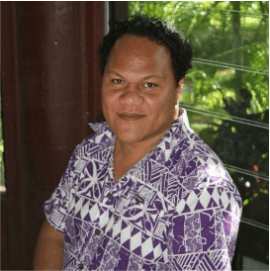
Alex Su’a is the Samoa representative on the PWL Governance Board. Mr. Su’a is a lawyer who has been practising law since 2004 in Apia, Samoa. He is registered as a barrister, solicitor and notary public of the Supreme Court of Samoa. Since 2018, he has been a partner of a small law firm, Stowers & Su’a Lawyers, in Apia and, currently, serves as the President of the Samoa Law Society. Alex is a very proud fa’afafine and is a steadfast advocate in favour of the human rights of the fa’afafine and fa’atama community in Samoa. Since 2005, he has been a founding member of the Samoa Fa’afafine Association, Inc., the only SOGIESC organisation in Samoa, and, since 2018, has served as its President.

Brief purpose
This brief provides information on the gender activities funded under PWL portfolio that are being implemented in Samoa. It also serves as a mechanism for the PWLES MEL team, Samoa DFAT Post and Palladium (managing contractor) to undertake a review of all project details (i.e., project timeframes and budgets) to ensure all information captured in the database is correct. This will be an ongoing collaborative activity. As such, these briefs will be updated and sent to Post on a six-monthly basis.
The data is drawn from the PWL quantitative database as of 30 August 2023.
This brief provides information on:
- Number of bilateral activities
- Total activities and number and type of implementing partners
- Total number of activities per outcome and sub-outcome area
- Total funding per outcome and sub-outcome area
- Number of regional projects
- Total activities and number and type of implementing partners
- Reach data against PWL quantitative indicators. Reach data refers to the coverage of activities: how many diverse men, women, boys and girls have been reached by an activity or project.

Bilateral activities
The information presented in this section provides an overview of the gender activities that are managed and funded by DFAT in Samoa.

Project and implementing partner count by outcome and sub-outcome areas.
There are 2 projects and 3 distinct implementing partners in Samoa (refer to Annex for detailed information). Information on downstream implementing partners will be included, if any, in the next six-monthly program update.
DFAT in Samoa also funds Markets for Change in Samoa – this project funding is captured under the regional Markets for Change program (annex for detailed information).
Table 2 Bilateral implementing partners, and outcomes/sub-outcomes
Project | Distinct implementing partner | Downstream implementing partner | Outcomes and sub-outcomes
Samoa Gender Partnership Program | Tautua/Palladium (Managing Contractor) |  | Women’s leadership promoted – women and girls’ voice
Women in Leadership Samoa | UN Women  UNDP |  | Women’s leadership promoted – women and girls’ voice

The two projects in Samoa work in women’s leadership promoted: both in women and girls’ voice (2).
Figure 1 Projects by outcomes and sub-outcomes
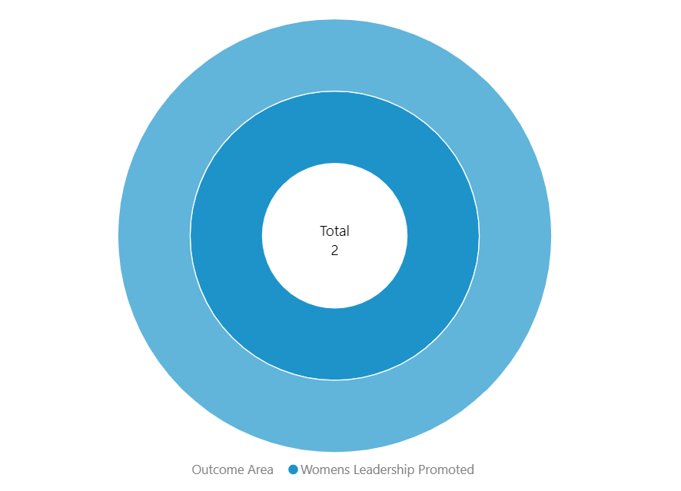

Type of implementing partner
Of the 3 distinct implementing partners, two are regional/multilateral partners and one is a program management facility.
Figure 2 Type of implementing partner
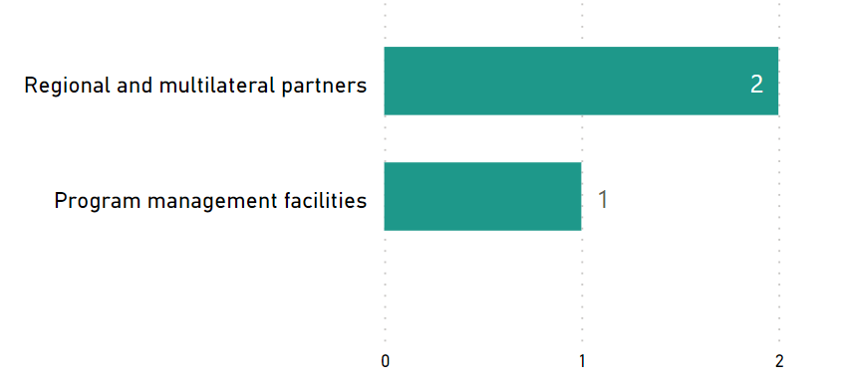

Committed funding by outcomes and sub-outcomes
Table 3 Funding committed for Samoa projects by outcomes and sub-outcomes
Outcomes | Sub-outcomes | Funding Committed (AUD)
Women’s leadership promoted | Women and girls’ voice | 2,900,000
Total |  | 2,900,000
Note: For funding committed for each bilateral activity in Samoa, refer to Annex 1.

Reach data by projects and indicators
Of the two projects, one project provided quantitative data against Pacific Women Lead Indicators on Women’s leadership promoted in women and girls voice and Women’s rights realised in women’s safety. Table 5 provides detailed data against each indicator.
Table 4 Projects providing quantitative data by outcomes and sub-outcomes
Outcomes | Sub-outcomes | Projects
Women’s leadership promoted | Women and girls’ voice | Women in Leadership Samoa
Women’s rights realised | Women’s safety | Women in Leadership Samoa

Table 5 Reach data for Samoa bilateral projects
Outcome Indicators | Sub Outcome Indicators | Project Title | Indicators | Girl | Girls  Disabled | Women | Women  Disabled | Total  Women and Girls | Boys | Boys  Disabled | Men | Men  Disabled | Total  Men and Boys | LGBTQIA | Data not  disaggregated | Total
Women's Leadership Promoted | Women & Girls Voices | Women in Leadership Samoa | Diverse women & girls supported to assume a leadership role at community, provincial & national | 0 | 0 | 1146 | 0 | 1146 | 0 | 0 | 180 | 0 | 180 | 2 | 1046 | 2374
Women's Rights Realised | Women's Safety | Women in Leadership Samoa | Number of people who participated in sessions on gender issues and women’s equal rights | 0 | 0 |  |  | 0 | 0 | 0 | 315 |  | 315 |  | 0 | 315
TOTAL |  |  |  | 0 | 0 | 1146 | 0 | 1146 | 0 | 0 | 495 | 0 | 495 | 2 | 1046 | 2689

Regional activities
The information presented in this section provides an overview of gender activities implemented in Samoa that are managed and funded by DFATs regional program (either at Suva post or Canberra).

Project and implementing partner count by outcomes and sub-outcomes
There are 15 regional projects implemented in Samoa and 10 distinct implementing partners (see annex for detailed information), plus two research activities.
Table 6 Regional implementing partners and outcomes/sub-outcomes
Project name | Distinct implementing partner | Outcomes and sub-outcomes
Core Funding for IPPF Global Strategic Framework Funding 2018 – 2022 | International Planned Parenthood Federation | Women’s rights realised – women’s health (SRHR)
Core funding for the IPPF global strategic framework (22-26) and Pacific Strategy (22-26) | International Planned Parenthood Federation | Women’s rights realised – women’s health (SRHR)
Gender responsive Climate Policy and Women’s Climate Leadership in the Pacific | Women Environment and Development Organisation | Women’s leadership promoted – women and girls’ voice
Markets for Change Phase 2 | UN Women | Women’s rights realised – women’s economic empowerment
Netball Australia (Pilot Pacific Women’s Sports Administration Program | Netball Australia | Women’s leadership promoted – women and girls’ voice
Oceania Rise Rugby Project | Oceania Rugby | Women’s leadership promoted – women and girls’ voice
Pacific Partnership to End Violence Against Women and Girls | UN Women | Women’s rights realised – women’s safety
Pacific Partnership to End Violence Against Women and Girls Phase 2 | UN Women | Women’s rights realised – women’s safety
Progressing Gender Equality in the Pacific | Pacific Community’s Human Rights and Social Development | Pacific ownership and effectiveness - mainstreaming
Pacific Community’s Human Rights and Social Development (HRSD) Division Support | Pacific Community’s Human Rights and Social Development (HRSD) Division Support | Pacific ownership and effectiveness – Pacific ownership
Pacific Island Forum Secretariat Gender Disability and Social Inclusion | Pacific Island Forum Secretariat | Pacific ownership and effectiveness - mainstreaming
RiseUp! Mobilising Young Women's Leadership and Advocacy Phase IV | World YWCA | Women’s leadership promoted – women and girls’ voice
Tennis Australia Women and Girls Pacific Extension – Emerging onto the World Stage | Tennis Australia | Women’s leadership promoted – women and girls’ voice
Transformative Agenda for Women, Adolescents and Youth in the Pacific: Towards Zero Unmet Need for Family Planning (Phase 1) | UNFPA | Women’s rights realised – women’s health (SRHR)
Transformative Agenda for Women, Adolescents and Youth in the Pacific: Towards Zero Unmet Need for Family Planning (Phase 2) | UNFPA | Women’s rights realised – women’s health (SRHR)
Research activities | Distinct implementing partner
Building Back Better: Promoting gender data-driven response to the COVID-19 pandemic in the Pacific and South-east Asia | UN Women | Research activity
kNOwVAWdata Phase 2 | UNFPA | Research activity

Of the 15 projects, five projects work in Women’s leadership promoted in women and girls’ voice (5). Seven work in Women’s rights realised: four in women’s health (4), one in women’s economic empowerment (1), and two in women’s safety (2).
Three projects work in Pacific ownership and effectiveness: two in gender mainstreaming (2) and one in Pacific ownership (1).
Figure 3 Projects by outcomes and sub-outcomes
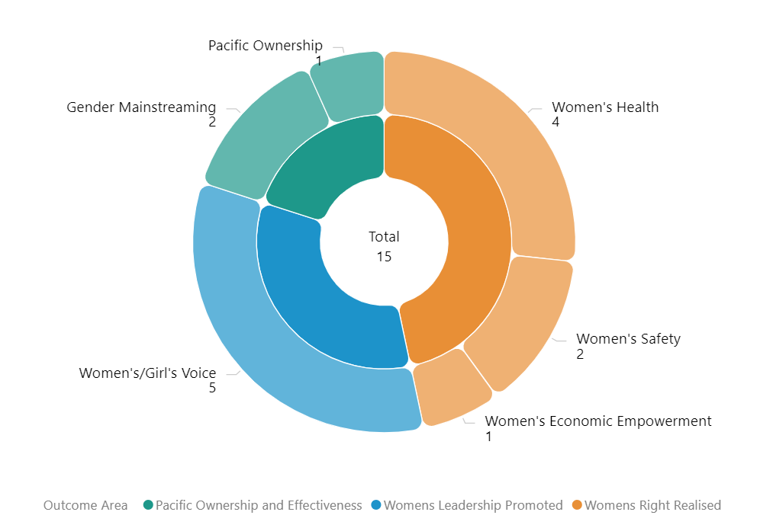

Type of implementing partner
Six of the 10 distinct implementing partners, six are international NGOs, two are regional/multilateral partners and two are inter-governmental organisations.
Figure 4 Type of implementing partner
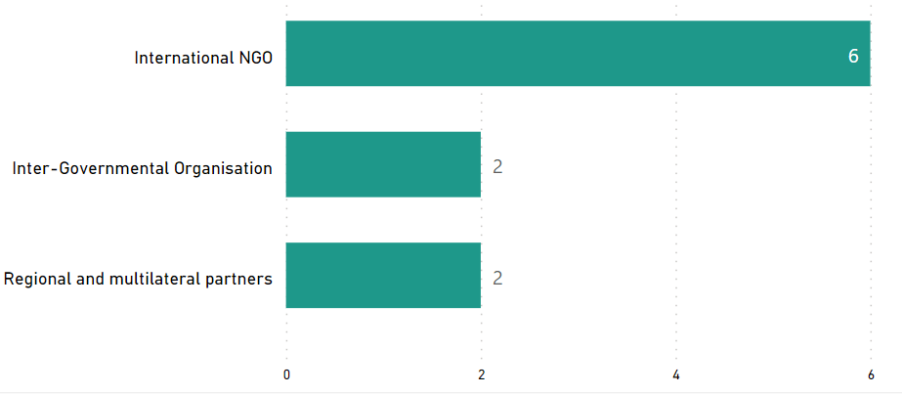

Committed funding by outcomes and sub-outcomes
Table 7 Funding committed for regional projects implemented in Samoa
Outcomes | Sub-outcomes | Funding Committed (AUD)
Women’s rights realised | Women’s economic empowerment | 9,951,871
Women’s rights realised | Women’s health | 47,000,000
Women’s rights realised | Women’s safety | 16,734,693.05
Women’s leadership promoted | Women and girls’ voice | 12,382,500
Pacific ownership and effectiveness | Gender mainstreaming | 6,059,377
Pacific ownership and effectiveness | Pacific ownership | 2,700,000
Total |  | 94,828,441.05
Note: the committed funding is total activity funding and is not broken down by funding allocation for Samoa. It is not possible to provide funding amount or spend of regional projects for Samoa. This information is not provided to the PWLES.

Pacific Women Lead at SPC activities
This section provides information on projects funded and managed by Pacific Women Lead at SPC (PWL at SPC). SPC has a direct grant agreement with DFAT to implement Pacific Women Lead, valued at AUD57,600,000. PWL at SPC’s grants program is funded out of the total value.
In addition to the 8 projects funded through PWL at SPC’s grants program, SPC has advertised a call for grant proposal. The SPC grants aim to support partners to implement Pacific regional gender equality commitments and contribute to Pacific Women Lead outcomes. The multi-stage grant application process is due for completion in the second half of 2023. This section will be updated when the grants process is completed to include successful grantees in Samoa, if any.

Project and implementing partner count by outcomes and sub-outcomes
There is one project funded under PWL at SPC that is being implemented by one distinct implementing partner and one downstream implementing partner in Samoa (refer to Annex for detailed information).
Table 8 PWL at SPC implementing partners, and outcomes/sub-outcomes
Project name | Distinct implementing partner | Downstream implementing partner | Outcomes and sub-outcomes
Shifting the Power Coalition: Strengthening Diverse Women's Leadership in Humanitarian Action | ActionAid Australia | YWCA Samoa | Women’s leadership promoted – feminist civil-society

Type of implementing partner
ActionAid Australia is an international NGO.

Committed funding by outcomes and sub-outcomes
Outcomes | Sub-outcomes | Funding Committed (AUD)
Women’s leadership promoted | Pacific feminist civil society | 532,233.07
Total |  | 532,233.07
Note: the committed funding comes out of PWL at SPC AUD57,600,000 budget.

Amplify-Invest-Reach (AIR) Program: Funding to Pacific Feminist Funds
The Pacific Feminist Funds consists of funding to three funds, under the program name of the Amplify-Invest-Reach (AIR) program. The A-I-R contract is managed by the DFAT Gender Equality Branch in Canberra and supports three Pacific Feminist Funds:
Partner organisation | Funding Committed | Funding Source | Outcomes and sub-outcomes
Women’s Fund Fiji | 4,841,659.75 | Bilateral – Fiji | Women leadership promoted – Pacific feminist civil society
Urgent Action Fund Asia and the Pacific | 3,082,500 | Regional | Women leadership promoted – Pacific feminist civil society
Pacific Feminist Fund | 1,170,849 | Regional | Women leadership promoted – Pacific feminist civil society
Total | 9,095,008.75

This section will provide information on grants funded and managed by the two Pacific Feminist Funds (Urgent Action Fund and the Pacific Feminist Fund) once they start funding grantees. The Pacific Feminist Fund was recently launched in May 2023. To date there are no grants funded by the two regional Funds. Additional information will be provided in the next six-monthly update.

Pacific Women Lead Enabling Services
This section provides information on Pacific Women Lead Enabling Services (PWLES) activities and support to DFAT Posts and PWL at SPC and is valued at AUD20 million.

Monitoring, Evaluation and Learning Support
PWL MEL System: The PWLES MEL team holds responsibility for the design, implementation and review of PWL’s whole-of-portfolio MEL system. The MEL system is made up of the following components:
- Quantitative database that tracks progress against PWL indicators. Refer to Annex 2 for a full list of PWL quantitative indicators.
- Qualitative database that allows the PWLES MEL team to code partner narrative reports against qualitative change domains.
The PWL MEL system has the capability to provide Post with data for your DFAT reporting processes (IMR and Tier 2 reporting). The MEL system can also provide qualitative stories or quotes from Samoa that can be used for DFAT briefing documents or speeches.
Collection of qualitative impact stories: PWLES will collaborate with Tautua/Palladium (managing contractor) to collect impact stories from PWL projects twice per year (July and February). These stories will be used to inform the PWL MEL system but will also be provided to Post and can be used for your communication or public diplomacy needs.
Quarterly DFAT Gender Focal Points (GFPs) meetings: The PWLES MEL team has a standing quarterly meeting with the DFAT Samoa GFP. At these meetings, the PWLES MEL team confirms if any new gender activities have been funded, shares PWL updates and discusses reporting timelines so Samoa project-level data feeds into the PWL MEL system.
Monthly Managing Contractor meetings: The PWLES MEL team has a standing monthly meeting with PNG Women Lead, Tautua Partnership Program (Samoa), Tonga Australia Support Platform Support (TASP). At these meetings, the PWLES MEL team confirms if any new gender activities have been funded, shares PWL updates and discusses reporting timelines so bilateral project-level data feeds into the PWL MEL system. There is also opportunity to share learnings across managing contractors.
Clear Horizon Academy PWL MEL Platform: The PWLES MEL team is developing training modules with Clear Horizon Academy to support PWL partners. Two modules: Using Data for Reporting and Learning and Collecting Impact Stories have been completed. The modules will be piloted with partners at the inaugural PWL Annual Reflection and Analysis workshop in September 2023.

Quality Technical Assurance Group (QTAG)
QTAG offers tailored GEDSI support through a panel of consultants.
Gender Focal Point (GFP) mentoring: QTAG provides regular mentoring to GFP in smaller DFAT Posts as a pilot approach to support GFPs to carry out their role with confidence. QTAG’s technical partner CoLAB has been engaged to provide mentoring support to GFPs. The mentoring will also provide a space to support GFPs broader professional development priorities including provide advice and feedback on communication, help with problem solving and to act as a sounding board to troubleshoot issues and ideas with the GFPs without conflicting with other management and supervision support provided by the GFP’s manager/supervisor, and the GFPs existing workload.
GEDSI Analysis and Country Plans/Design: Through its panel of consultants, QTAG provides support to smaller DFAT Posts to carry out GEDSI Analysis and develop their Gender Country Plan/Design. PWL support to the development of country briefs/designs includes PWL whole-of-portfolio MEL briefings to ensure there is alignment to the PWL whole-of-portfolio MEL Framework. Larger Posts can draw on this support to ensure alignment to PWL whole-of-portfolio MEL.

Grant Management
PWLES manages two regional grants, Balance of Power and We Rise Coalition. Funding committed to Balance of Power and We Rise Coalition comes out of the total PWLES AUD20 million.
Only We Rise Coalition is being implemented in Samoa. PWLES can provide updates on this regional grantees at quarterly Gender Focal Point and Managing Contractor meetings.
We Rise Coalition is being implemented by one distinct implementing partner, and one downstream implementing partner (refer to Annex for detailed information).

9.3.1. Project and implementing partner count by outcomes/sub-outcomes
Project name | Distinct implementing partner | Downstream implementing partner | Outcomes and sub-outcomes
Feminist movements for transformative change: We Rise Coalition Phase 3 | International Women’s Development Agency (IWDA) | Brown Girl Woke (BGW) | Women’s leadership promoted – feminist civil society

9.3.2. Type of implementing partner
IWDA is an international NGO.

9.3.3. Committed funding by outcomes and sub-outcomes
Outcomes | Sub-outcomes | Funding Committed (AUD)
Women’s leadership promoted | Pacific feminist civil society | 3,193,822
Total |  | 3,193,822
Note: the committed funding is total activity funding and is not broken down by funding allocation for Samoa.

Annex 1: Pacific Women Lead Projects Samoa
The table provides a list of all bilateral, regional, PWL at SPC projects and PWLES-managed grants for Samoa that have been entered into the Pacific Women Lead quantitative database. It provides detailed information on each project’s name, implementing partner, project description, end of project outcomes, total funding (AUD) and timeframe.
PWL Components | # Of Projects | Total Funding
Bilateral | 2 | 2,900,000
Regional | 15 | 94,828,441.05
PWL at SPC | 1 | 532,233.07
A-I-R Program | N/A
PWLES-managed grants | 1 | 3,193,822
Total Combined Funding |  | 101,454,496
Total funding provided to grants that are managed under these components and does not reflect the total value of the components.

Note:
- The timeline and budget reflect the start date of Pacific Women Lead i.e. 1 July 2021.
- “Transformative Agenda for Women, Adolescents and Youth in the Pacific: Towards Zero Unmet Need for Planning 2018 – 2022’ Phase 2 is in development. The information presented is for Phase 1 which has been completed in Year 1 of PWL.
- ‘Core Funding for IPPF Global Strategic Framework Funding 2018 – 2022’ was completed in Year 1 of PWL. The ‘Core Funding for IPPF Global Strategic Framework (22-26) and Pacific Strategic Strategy (22-26)’ is the active activity under PWL.

COUNTRY-LEVEL PROJECTS
NO. | AID-WORKS NUMBER PROJECT NAME AND PARTNER PROJECT DESCRIPTION END OF PROJECT OUTCOMES VALUE (AUD) AND TIMEFRAME
1 | 76582 | Samoa Gender Partnership Program  (An initiative of Tautua - Human Development for All Program/Palladium) | Women and vulnerable groups have improved access to services and livelihood opportunities that mitigate the impacts of COVID-19. | - CSOs deliver outcomes for women, including enhanced economic empowerment, reduced gender-based violence, and increased access to services for women experience violence  - GEDSI CSOs have more effective, efficient, and sustainable organizational and grant management systems  - Evidence is available to inform gender planning and decision-making by HDSI and other stakeholders | $2,900,000  2022 - 2024
2 | 74280 | Samoa Women in Leadership (UNDP and UN Women joint program) | Strengthened women’s leadership and gender equality in Samoa. | - Strengthened opportunities for women’s participation in leadership pathways  - Promoting political inclusivity and supporting women’s political participation through a focus on development  - Increased public awareness of and engagement in inclusive and effective political participation  - Sharing knowledge of Samoa’s experience in promoting women’s leadership | Budget expended under Pacific Women Shaping Pacific Development.  2018 – 2022  Completed

REGIONAL-LEVEL ACTIVITIES
NO. | AID-WORKS NUMBER | PROJECT NAME AND PARTNER | PROJECT DESCRIPTION | END OF PROJECT OUTCOMES | VALUE (AUD) AND TIMEFRAME
1 | 74843 | Core Funding for IPPF Global Strategic Framework Funding 2018 – 2022 | The Strategy provides a framework and guidance on a life course approach to SRHR in the Pacific. This entails broadening the focus from family planning to services across the life span from pregnancy and prenatal care and pre-menstruation through menopause. It also looks at critical factors for the Pacific including climate change, gender, disability, non-communicable diseases and sexual and gender-based violence. | - Pacific Island governments increasingly promote, respect, protect and fulfil commitments to SRHR and gender equality.  - People in Pacific countries are able to act freely on their SRHR  - Expanded quality, integrated, gender and rights-based  - Sexual and reproductive health (SRH) services are delivered with a focus on reaching the underserved  - A high performing, accountable and united federation drives sustainable positive change in SRHR in the Pacific | $500,000.00  2021 – 2022  Completed
2 | 77862 | Core Funding for IPPF Global Strategic Framework (22-26) and Pacific Strategic Strategy (22-26) | The strategy aims to come together and break through the barriers that limit sexual and reproductive health and rights (SRHR), thereby enabling quality SRHR to be realised for everyone in the Pacific. It is an ambitious agenda that is informed by the emerging challenges and opportunities in the region | - Centre Care on People: Expand choice and access in coordination with government partners and national civil society and explore digital options and self-care.  - Move the Sexuality Agenda: Shift attitudes and norms in the Pacific through grass roots advocacy to drive gains in SRHR, ensuring the voices of young people and marginalised or excluded groups are heard.  - Solidarity for Change: Create new strategic partnerships and contribute to social movements on SRHR and intersectional areas, and harness opportunities for learning and sharing  - Nurture our Federation: Strengthen IPPF’s Secretariat and Member Associations through improvements in governance, financial and programmatic management, and draw on the Federation’s global expertise and knowledge base. | $2,000,000  2023 - 2026
3 | 77520 | Gender responsive Climate Policy and Women’s Climate Leadership in the Pacific  (WEDO) | Advance Pacific women's leadership in climate change decision-making via WEDO's Women Delegates Fund (WDF) program, as well as enhance the implementation of gender-responsive climate policy via capacity strengthening for National Gender and Climate Change Focal Points in the Pacific. | - Strengthen Pacific women’s leadership in climate change diplomacy and policymaking via travel support, training and networking  - Support effective operationalization of the role of National Gender and Climate Change Focal Points across Pacific Island countries | $699,900  2022 – 2024
4 | 76974  (Aid-works number for Samoa bilateral funding) | Markets for Change (M4C) Phase 2 UN Women | Markets for Change Phase II aims to promote gender equality and the economic empowerment of market vendors, with specific attention to the needs and aspirations of women market vendors. | - Inclusive, effective and representative marketplace groups are created and grow, further enabled and recognised.  - Improved socio-economic security of women market vendors.  - Local governments, market management and other decision-makers are gender-responsive, effective and accountable to women market vendors.  - Physical market structures and operating systems are improved to make markets more gender-responsive, safer, more accessible, sustainable and resilient to disaster risks and climate change | $9,951,871  2022 – 2026  Samoa’s bilateral contribution under PWL is $2,650,000  Total bilateral contribution is AUD5.7 million. 2.65 million has been expended prior to start of PWL. funding under PWL.
5 | 76569 | Netball Australia (Pilot Pacific Women’s Sports Administration Program) | The program focuses on governance and administration support – recognizing that this enables netball associations to advance women in decision-making and leadership roles (and their effectiveness in those roles), as well as enhancing access to safe and inclusive competition for women and girls across the Pacific. | - Improved governance and administration  - Increased women in leadership and decision-making roles  - Increased grassroot participation rates of women and girls in safer and more accessible environments | $1,638,600  2021 – 2023
6 | 77557 | Oceania Rise Rugby Project  (Oceania Rugby) | Strengthen the participation, influence and visibility of women in all parts of the game, both on and off the field. | - 4 new high profile women’s domestic rugby competitions, completing several women’s rugby pathways  - 11 Pacific women in new full-time Senior or Middle Management positions  - 45 emerging Pacific women leaders trained and mentored in governance, leading to more women appointed in decision making roles and improved governance practice  - Over 200 women completing Rugby Accreditations and in leadership roles within the new domestic competitions (as Coaches, Match Officials, Strength & Conditioning coaches, First Aid, Club Administrators)  - Oceania Women in Rugby Network established supporting individuals, peer learning and collective advocacy  - 4000< girls participating in high-quality rugby  - Communities witnessing girls and women play, lead and be celebrated in a formerly ‘men’s’ sport, helping to drive positive change in attitudes and norms gender equality  - Australia and DFAT celebrated as the primary supporter of these successes, opportunities and significant shifts  - Australian dignitaries visible and engaged at high profile, newsworthy announcements, events and competitions  - Direct engagement between Australian government representatives and both profiled and emerging Pacific Island leaders  - Alignment and mutual reinforcement of other significant Oceania Rugby activities driving the participation and empowerment women in Pacific Islands and Australian diplomacy. | $2,933,000  2022 – 2024
7 | 74112 | Pacific Partnership to End Violence Against Women and Girls  (UN Women) | The Pacific Partnership seeks to promote Gender Equality, prevent VAWG, and increase access to quality VAWG response services for survivors. The programme engages with over 100 partners across the region, including national governments, CSOs, EVAWG networks, faith-based groups, and sports associations. | - To enhance Pacific youth’s formal in-school and informal education on gender equality and prevention of violence against women and girls.  - To promote gender equitable social norms at individual and community levels to prevent violence against women and girls, and to ensure survivors have access to quality response services.  - To empower national and regional civil society organisations (CSOs) to advocate, monitor and report on regional institutions and governments commitments to enhance gender equality and prevent violence against women and girls. | $800,000  2021 – 2023  Completed
8 | 77334/8 | Pacific Partnership to End Violence Against Women and Girls Phase 2  (UN Women) | The Pacific Partnership seeks to promote Gender Equality, prevent VAWG, and increase access to quality VAWG response services for survivors. The programme engages with over 100 partners across the region, including national governments, CSOs, EVAWG networks, faith-based groups, and sports associations. | - To enhance Pacific youth’s formal in-school and informal education on gender equality and prevention of violence against women and girls.  - To promote gender equitable social norms at individual and community levels to prevent violence against women and girls, and to ensure survivors have access to quality response services.  - To empower national and regional civil society organisations (CSOs) to advocate, monitor and report on regional institutions and governments commitments to enhance gender equality and prevent violence against women and girls. | $15,934,693.05  2022 - 2027
9 | 69294/46 | Progressing Gender Equality in the Pacific  (HRSD SPC) | PGEP’s overall objective is to strengthen gender mainstreaming, policy design, and implementation, including strategic support to civil society organisations, while supporting country and regional gender data and statistical initiatives. | - Gender Mainstreaming: Public Institutions are implementing policies, practices and programs that support gender equality  - Accountability Mechanisms: Government gender mainstreaming planning budgeting, accountability, monitoring, and reporting systems enhance progress towards achieving gender equality commitments | $2,156,401  2021– 2023 Completed  Will come under PWL at SPC in 2024
10 | 69294/67 | Pacific Community’s Human Rights and Social Development (HRSD) Division Support | HRSD leads SPC’s work in the areas of human rights, gender equality and social development. | HRSD Business Plan  - Objective 1 – Strengthen inclusive, transparent, and responsive governance and institutions for human rights, gender equality and social development.  - Objective 2 – Mobilise, empower, and build conditions for gender equality, equity and social inclusion in society and development  - Objective 3 – Promote, preserve, and protect positive expressions of culture  - Objective 4 – Accelerate impact on human rights, gender equality and social development through knowledge, learning and innovative solutions. | $2,700,000  2022 – 2026
11 | 78400 | Pacific Island Forum Secretariat Gender Disability and Social Inclusion  (Pacific Island Forum Secretariat) | Progressing Pacific Island Forum Secretariat Gender Equality Disability and Social Inclusion priorities | - PIFS Social Policy team to implement priorities on gender equality, disability and social inclusion including in the implementation and monitoring of the 2050 Strategy for the Blue Pacific Continent including gender policy capability and advice  - enhanced strategic engagement and communications  - support to members and actioning outcomes  - progressing disability inclusion  progressing implementation of social policy program | $3,902,976  2023 - 2026
12 | 76453 | RiseUp! Mobilising Young Women's Leadership and Advocacy Phase IV  (World YWCA) | Leadership program developed and led by young women for young women, taking into account local contexts and priorities. RiseUp! provides training, networking and peer support to young women between the ages of 18 and 30 years. It supports young women in contexts where their rights and voices are repressed to know and claim those rights within their peer, family and community networks, and to work collectively to mobilise for change. | - Young women take up informal and formal leadership roles in their peer and family networks, communities, countries, region or globally. | $6,000,000  2020 – 2025
13 | 77821 | Tennis Australia Women and Girls Pacific Extension - Emerging onto the World Stage  (Tennis Australia) | Deliver programs and pathways to create sustainable benefits for women in the Pacific, either as a player, coach or paid administrator/Development Officer. Create economic efficiencies, seeing supporting partners (ITF, ONOC and TA) come together to maximise opportunities for program stakeholders. | Stream 1 – Coaching  - Increase the number of women in decision-making and leadership roles  - Strengthen career and volunteer pathways and opportunities on the court  - Create sustainable networks to influence and advance women  - Inspire and develop women to be a public voice for tennis from grassroots to the world stage  Stream 2 – Community Leadership  - Increase the number of women in decision-making and leadership roles in Tennis organisations  - Develop the governance structures to create safe, welcoming and inclusive environments for women and girls  Stream 3 - Talent  - Improve access to safe inclusive sporting competitions and facilities to encourage higher participation of girls and young women  - Provide pathways for elite players to transition from Juniors to the Professional Tour (ITF and WTA)  - Increase retention of women elite players able to transition to coaches and leaders in the sport | $1,111,000  2022 – 2026
14 | 74352 | Transformative Agenda for Women, Adolescents and Youth in the Pacific: Towards Zero Unmet Need for Planning 2018 – 2022 (Phase 1)  (UNFPA) | The Transformative Agenda outlines action that will increase the demand for, and supply of, SRH services and information (particularly family planning) and create an enabling environment for their progress.  Goal - Transformative change in the lives of women, adolescents and youth across the Pacific by 2022. | - Increased and improved supply of integrated sexual and reproductive health (SRH) information and services, particularly for family planning  - Increased demand for integrated SRH information and services, particularly for family planning  - More conducive and supportive environment for people to access and benefit from quality SRH, especially contraceptive choice. | $7,500,000  2021 – 2023
15 | 77337/9 | Transformative Agenda for Women, Adolescents and Youth in the Pacific: Towards Zero Unmet Need for Planning 2018 – 2022 (Phase 2)  (UNFPA) | The Transformative Agenda outlines action that will increase the demand for, and supply of, SRH services and information (particularly family planning) and create an enabling environment for their progress.  Goal - Transformative change in the lives of women, adolescents and youth across the Pacific by 2022. | - Increased and improved supply of integrated sexual and reproductive health (SRH) information and services, particularly for family planning  - Increased demand for integrated SRH information and services, particularly for family planning  - More conducive and supportive environment for people to access and benefit from quality SRH, especially contraceptive choice. | $37,000,000  2022 – 2028

PWL AT SPC ACTIVITIES
NO. | AID-WORKS NUMBER | PROJECT NAME AND PARTNER | PROJECT DESCRIPTION | END OF PROJECT OUTCOMES | VALUE (AUD) AND TIMEFRAME
PWL at SPC Grantee
1 |  | Shifting the Power Coalition: Strengthening Diverse Women's Leadership in Humanitarian Action (ActionAid Australia) | Works to ensure diverse Pacific women’s voices are included in disaster planning and response at all levels with tangible outcomes around diverse women leaders in six countries.  The Coalition includes ActionAid Vanuatu, FemLink Pacific, Nazareth Centre for Rehabilitation, Pacific Disability Forum, Talitha Project Incorporated, Transcend Oceania, Vanuatu Young Women for Change, Vois Blong Mere, YWCA PNG and YWCA Samoa.  Shifting the Power Coalition partner in Samoa is YWCA Samoa. | - 200 diverse women leaders in six countries will have increased capacity to engage in local and national disaster coordination mechanisms and to organise and influence decision making  - Diverse women’s needs and capacities in times of crises will be documented and contribute to evidence-based disaster planning and response at national and regional level  - Platforms will be established to strengthen diverse Pacific women’s voices in regional humanitarian and disaster resilience forums and their influence on policy and decision making | $532,233.07  2022 – 2024

A-I-R PPROGRAM – PACIFIC FEMINIST FUNDS
There are currently no projects funded under this component that is being implemented in Samoa. A table will be inserted here for activities implemented in Samoa, when projects are funded in Samoa.

PWLES-MANAGED GRANTS
NO. | AID-WORKS NUMBER | PROJECT NAME AND PARTNER | PROJECT DESCRIPTION | END OF PROJECT OUTCOMES | VALUE (AUD) AND TIMEFRAME
1 |  | Feminist movements for transformative change: We Rise Coalition Phase 3 | The goal of the We Rise Coalition is to develop, demonstrate and strengthen feminist coalitions and partnerships in order to grow and uphold inclusive governance, equality, diversity, justice and women’s human rights. | - Coalition and organisational strengthening: Diverse Fiji and Pacific Women are contributing to a coordinated, feminist social movement.  - Movement Building: We Rise partners and the Coalition demonstrate feminist praxis and solidarity.  - Policy, structural and institutional reform: Pacific women influence local, national and regional decision-making to reflect Pacific women's human rights concerns. | $3,193,822  2021 - 2024

RESEARCH ACTIVITIES
Total funding for research activities is not included in the combined total funding for bilateral, regional, PWL at SPC and PWLES-managed grants.
NO. | AID-WORKS NUMBER |  |  | PROJECT NAME AND PARTNER |  | PROJEC DESCRIPTIONS |  | END OF PROJECT OUTCOMES |  | VALUE (AUD) AND TIMEFRAME
1 | 76473 |  |  | Building Back Better: Promoting gender data-driven response to the COVID-19 pandemic in the Pacific and South-east Asia  (UN Women) |  | The Project seeks to increase the production and use of quality timely data to ensure COVID-19 response and recovery efforts are sensitive to gender inequality considerations, provide maximum production from COVID-19 impacts, and enable women’s and girls’ fullest contributions to recovery. |  | - Timely gender-sensitive data on the impact and responses to crisis, most importantly COVID-19, are produced to inform decision-making.  - Gender-responsive COVID-19 policies and recovery plans are in place.  - COVID-19 gender data are accessible and used to inform policies, programmes, advocacy and research. |  | $3,522,558  2021 – 2023
2 |  | 72938/47 | kNOwVAWdata Phase 2  (UNFPA) |  | Works to sustainably strengthen regional and national capacities to measure the prevalence of violence against women in Asia and the Pacific. kNOwVAWdata improves the availability and quality of data to inform more effective policy and programme responses to prevent and end violence against women. |  | - Data-driven, context-specific decision-making in VAW policy and programme design  - Quality data on what works and what does not work to address VAW effectively  - Effective policies and programmes to address VAW are implemented, monitored and evaluated. |  | $3,000,000  2021 – 2024

Annex 2: Whole-of-portfolio PWL Indicators
Program Logic key outcome area | Quantitative indicators | Qualitative indicators
Women’s leadership promoted: women and girls’ voice | - # diverse women and girls supported to assume a leadership role  - # diverse women in non-traditional roles and fields of study and/or work  - # of sectoral policies or initiatives clearly addressing diverse women’s needs | - Change in social norms that support diverse women and girls’ leadership  - Successful strategies that have supported diverse women’s influence in decision-making  - Diverse women influencing/shaping national and regional development agenda
Women’s leadership promoted: Pacific feminist civil society | - # diverse women and girls participating in civil society and intergovernmental forums (e.g., Pacific Feminist Forum and Triennial)  - Number of women’s organisations, groups or coalitions actively engaged in the project  - Number of Pacific organisations of people with disability actively engaged in the project | - Evidence of how Pacific women’s organisations and the feminist movement have influenced the national and regional development agenda  - Evidence that the Pacific feminist movement has grown and is better connected  - Evidence that stakeholders have drawn on the Pacific feminist movements expertise and that this has led to outcomes that would otherwise not have happened.
Women’s Rights Realised – women’s health | - # diverse women and girls who received a modern method of contraception  - Number of unintended pregnancies averted  - Total couple-years protection for contraceptives distributed by countries to lower levels including service delivery points (SDPs) (disaggregated by method including emergency contraception and long-acting reversible contraception)  - Percentage of secondary and tertiary SDPs providing quality-assured, adolescents friendly, integrated SRH services | - Change in social norms that limit diverse women and girls’ access to SRHR services  - Improved collaboration within health ministries on SRHR initiatives, and what supported this collaboration  - Diverse women have improved access and use of SRHR services  - Evidence that men are supportive of women’s SRHR
Women’s Rights Realised – women’s economic empowerment | - # diverse women entrepreneurs provided with financial and/or business development services  - # diverse women who have attained formal qualifications | - Change in social norms that limit women’s economic empowerment  - Increased access to resilient economic opportunities for diverse women  - Pacific Governments, civil society, and private sector are implementing gender inclusive economic policies  - Recognition of women’s contribution to household livelihood (related to unpaid care work, financial contribution through food processing, handcraft production, food and water security, etc).
Women’s Rights Realised – women’s safety | - # of counsellors graduating from recognised counselling institutions  - # of services provided to diverse women and children (girls and boys) and other survivors of violence, such as counselling  - # people who participated in sessions on gender issues and women’s equal rights  - # men who have undertaken male advocacy training  - # police, law, and justice officials trained to respond to incidents of violence against women and girls according to an established protocol | - Change in social norms that contribute to women and girls experiencing reduced violence  - Increased capacity of Pacific police to respond to women experiencing violence  - Change in police responsiveness to violence against women and girls in all their diversity  - Evidence of successful strategies for increasing women’s safety  - Evidence of how men’s involvement and advocacy has supported gender equality
Partners supported to increase Pacific ownership and effectiveness of regional gender equality efforts – gender mainstreaming | - # of government staff and development practitioners applying gender mainstreaming tools  - # of mechanisms in place to support gender mainstreaming processes in the government | - Increased resources allocated to address gender issues  - Increased capacity of Pacific Governments and intergovernmental organisations in gender mainstreaming  - Evidence of how technical support mobilised through PWL has led to increased gender equality outcomes for Pacific Governments
Partners supported to increase Pacific ownership and effectiveness of gender and equality efforts – Pacific ownership and regional effectiveness |  | - Increased collaboration and political will between regional partners for stronger gender equality outcomes  - Evidence that the PWL Governance Board, SPC and Women’s Funds are influencing the regional gender equality agenda  - Evidence of increased accountability for gender equality and women’s human rights at regional and national levels
Program Logic strategies  - Grant making in the thematic areas of leadership, health (SRHR), women’s economic empowerment and safety  - Linking and learning and collective action that supports genuine partnerships and strategies for change in social norms and gender equally outcomes  - Technical support, training, coaching, and mentoring to support greater gender mainstreaming and gender equality outcomes for Pacific governments and development partner sector programs  - Collaborative portfolio level monitoring, evaluation and learning sense-making spaces to inform PWL decision-making | - Types of activities delivered (mentoring, training, coaching, campaigning, service delivery, convenings, learning events etc.)  - Number of diverse women and men reached through activities  - Dollar amount of funds released per Program Logic outcome area  - Number of grants supported  - Types of technical support requests from Pacific governments or through the QTAG  - Number of Tasking Notes completed through the QTAG (disaggregated by client)  - Rate of satisfaction with completed Tasking Notes through the QTAG

An ambition outlined in the PWL design was for SPC to progressively take over responsibility for the whole-or-program MEL. This process will need to be incremental and supported over an extended period. Further conversations will be had with SPC’s PWL MEL team and more details about how this could happen will be outlined in future PWL MELF updates.
Distinct implementing partner is the organisation that holds the contract with DFAT and has ultimate accountability for implementation of project activities.
Downstream implementing partners are organisations that receive funding for activity implementation from the distinct implementing partner. Downstream implementing partners are always Samoa organisations and often support from the distinct implementing partner includes organisational strengthening to ensure downstream partners can meet DFAT’s due diligence requirements.

