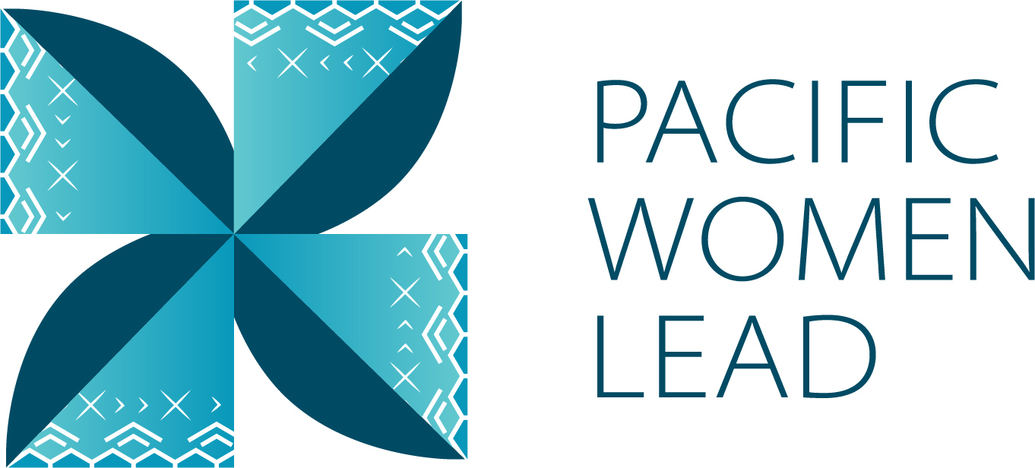

Fiji Country Brief

December 2024

Contents

1 Pacific Women Lead overview 1

2 Program components 1

3 Purpose of the Country Brief 2

**3.1** **Fiji Country Brief** 3

4 Pacific Women Lead at SPC Projects 3

**4.1** **Project and implementing partner count by outcome and sub-outcome** 3

**4.2** **Type of implementing partner** 4

**4.3** **Committed funding by outcome and sub-outcome** 4

5 Pacific Women Lead Governance Board Projects 4

**5.1** **Discretionary Funds** 5

**5.2** **Board Members** 5

6 Pacific Women’s Funds Projects 5

7 Regional activities 6

**7.1** **Project and implementing partner count by outcome and sub-outcome** 6

**7.2** **Type of implementing partner** 7

**7.3** **Committed funding by outcome and sub-outcome** 8

8 Bilateral activities 8

**8.1** **Project and implementing partner count by outcome and sub-outcome** 8

**8.2** **Type of implementing partner** 10

**8.3** **Committed funding by outcome and sub-outcome** 11

**8.4** **Reach data by projects and indicators** 11

9 Pacific Women Lead Enabling Services 2

**9.1** **Monitoring, Evaluation and Learning Support** 2

**9.2** **Quality Technical Assurance Group (QTAG)** 2

**9.3** **Grant Management** 3

Annex 1: Project implemented in Fiji 5

Annex 2: Pacific Women Lead Governance Board Members 30

Annex 3: Cumulative reach data (2021 to present) for DFAT Post in Fiji Projects 34

Annex 4: Whole-of-portfolio PWL Indicators 35

Annex 5: Impact stories 39

# **Pacific Women Lead overview**

Pacific Women Lead (PWL) is a portfolio of regional investments valued at AUD170 million over 5 years (2021 – 2026). PWL aims to advance gender equality and is ambitious in its intent to take a Pacific-led, intersectional and transformative approach to promoting gender equality in the region and bringing new emphasis to strengthening regional action and architecture in support of gender equality. PWL builds on the strengths and lessons learned through Australia’s 10-year gender equality investment, Pacific Women Shaping Pacific Development.

The goal of PWL is for: Pacific women and girls, in all their diversity, to be safe and equitably share in resources, opportunities and decision-making with men and boys.

The program works across three outcome areas with the following end-of-PWL sub-outcomes:

Table 1 Pacific Women Lead outcomes and sub-outcomes

|  |  |
| --- | --- |
| **Outcomes** | **Sub-outcomes** |
| Women’s Leadership Promoted (WLP) | * More women and girls, in all their diversity, are respected, listened to and are influencing decision-making at all levels **(Women and girls’ voice)** * The Pacific feminist movement has grown in depth, is better connected and their expertise is drawn upon by Pacific partners **(Pacific feminist civil society)** |
| Women’s Rights Realised (WRR) | * Diverse women and adolescent girls have improved access to quality health services, especially sexual and reproductive health **(Women’s health – SRHR)** * Diverse women have more equitable access to resilient economic opportunities, including increased voice in economic decision-making **(Women’s Economic Empowerment)** * Violence against women and children is reduced, and survivors have access to quality support services, including in times of disasters **(Women’s safety)** |
| Pacific ownership and regional effectiveness (POE) | * Pacific Governments and development partners are implementing programs and policies that support gender equality **(Gender mainstreaming)** * There is robust engagement, cooperation and mutual sharing between regional agencies and intergovernmental organisations to deliver on gender equality commitments **(Pacific ownership)** |

# **Program components**

PWL is a portfolio of 5 components; each component is a distinct implementing partner [1]of PWL: Through these components, technical support and funding is provided to Pacific women-led civil society organisations, multilateral and regional organisations, government and other stakeholders.

The components of the portfolio include:

**The Pacific Community (SPC) as a key implementing partner of PWL. PWL** at SPC sits within SPC’s Human Rights and Social Development (HRSD) division and supports the implementation of key regional commitments outlined in the Pacific Leaders’ Gender Equality Declaration, the Pacific Platform for Action on Gender Equality and Women’s Human Rights, and the outcomes of the Triennial Conference of Pacific Women. Through PWL, SPC provides technical, convening and funding support to government ministries, civil society, and other partners, while also acting as Secretariat for the PWL Governance Board.

**Pacific Women Lead Governance Board** provides direct strategic oversight on SPC’s PWL related activities and decides the allocation of AUD 5 million of discretionary funds. The Board also provides strategic advisory to DFAT Canberra (Australia) in enhancing regional effectiveness by identifying gaps and opportunities across the Pacific but does not provide direct strategy advice or have a decision-making role over the DFAT Posts or the Pacific Women’s Funds component. The Board receives reporting on outcomes for all other portfolio components through the PWL Annual Progress Report, compiled by the Pacific Women Lead Enabling Services.

**Pacific Women’s Funds** are supported to expand their work with women’s rights organisations and human rights defenders in the Pacific. This includes funding their advocacy activities to draw more resources for work towards gender equality to the region and funds to support the establishment of the first Pacific Feminist Fund.

**DFAT manages bilateral and regional programs. DFAT Canberra (Australia) and Fiji Post** manages direct funding arrangements for regional gender projects, including (but not limited to) UN Women’s Markets for Change and Pacific Partnership to End Violence Against Women and Girls, and UNFPAs Transformative Agenda program. **DFAT Posts** manage and fund country-level gender projects. Importantly, bilateral programs have autonomy in design, delivery and governance, but their gender programming aligns with the PWL goal and outcomes, and they will report results into the Pacific Women Lead Monitoring, Evaluation and Learning (MEL) System.

**Pacific Women Lead Enabling Services** (PWLES) managed by DT Global, provides support to SPC and DFAT to implement PWL. This includes whole-of-portfolio monitoring, evaluation, and learning (MEL), partnership brokering and the delivery of an independent Quality and Technical Assurance Group (QTAG). It is the role of the MEL team within the PWLES to compile a yearly whole-of-portfolio progress report, which brings together all the above components of PWL.[2]

# **Purpose of the Country Brief**

A Country Brief is designed and tailored for each country to serve the following purposes:

* Increase PWL partners and external stakeholders’ visibility of projects and implementing partners that are being funded or come under the PWL portfolio in a country. It is intended to contribute to greater collaboration and coordination by grantors and grantees.
* Serve as a mechanism for PWLES to collaborate with the 5 components of PWL to review project details (i.e. project information, timeframes and budget) to ensure all information captured in the PWL MEL system is correct.
* Support DFAT’s internal reporting, where investments are above 3 million.

Therefore, the Country Brief is designed to cover a calendar year (January to December) and information will be drawn from the PWL quantitative database to show:

1. Gender projects funded by the 5 components of PWL
2. Reach data[3] against PWL quantitative indicators
3. Impact stories collected by partners or PWLES

## **Fiji Country Brief**

This Country Brief update is for Fiji. It provides information on all projects that are being funded by or come under the 5 components of PWL in Fiji and focusses on January to June 2024 period.

# **Pacific Women Lead at SPC Projects**

The Pacific Community (SPC) is a distinct[4] implementing partner of PWL (known as PWL at SPC) and has a grant agreement with DFAT Canberra, valued at AUD57,600,000. From this total value, SPC provides technical support to Pacific governments, hosts and supports regional convenings (such as the Triennial) and a grants program for its government partners and women’s organisations across the Pacific. You can also watch a short explainer video here: [Pacific Women Lead at the Pacific Community (PWL at SPC) explainer video](https://youtu.be/bBOpTVKh8Hs?si=OxeE63PdSKrxVdbT).

This section provides information on projects funded and managed by PWL at SPC that are implemented in Fiji.

## **Project and implementing partner count by outcome and sub-outcome**

PWL at SPC funds 4 downstream[5] implementing partners to implement 4 projects. Table 2 provides an overview of the projects (refer to Annex 1 for detailed project information).

Table 2 Overview of PWL at SPC projects

|  |  |  |
| --- | --- | --- |
| **Project name** | **Downstream implementing partner** | **Outcome and sub-outcome** |
| Economic Empowerment for Rural Remote Pacific Women | Rise Beyond the Reef | Women’s rights realised – women’s economic empowerment |
| Pacific Girl: Girls Arise | Fiji Women’s Rights Movement | Women’s leadership promoted – women and girls’ voice |
| Shifting the Power Coalition: Pacific-owned, Women-led Early Warning and Resilience (POWER) systems | ActionAid Australia | Women’s leadership promoted – Pacific Feminist Civil Society |
| Strengthening Capacity of Women’s Organisations in Pacific Small Island Developing States (PSIDS) on Increasing Women in Leadership and EVAW in the World of Work | Fiji Women’s Rights Movement | Women’s leadership promoted – women and girls’ voice |

Of the 4 projects, three projects work in Women’s leadership promoted: two in women and girls’ voice (2) and one in Pacific Feminist Civil Society (1). One project works in Women’s rights realised in women’s economic empowerment (1).

**Figure 1 Projects by outcome and sub-outcome**

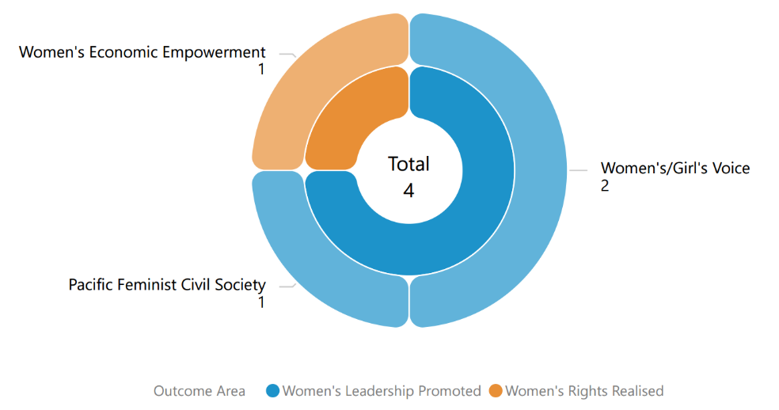

## **Type of implementing partner**

Of the 4 downstream implementing partners, 2 are Civil Society Organisations and 1 is an international NGO.

**Figure 2 Type of implementing partner**

**A diagram of types of implementing partners.
**

## **Committed funding by outcome and sub-outcome**

The committed funding for each of the projects comes out of PWL at SPC AUD57,600,000 budget.

Table 3 Committed funding by outcome and sub-outcome

|  |  |  |
| --- | --- | --- |
| **Outcome** | **Sub-outcome** | **Committed Funding (AUD)** |
| Women’s leadership promoted | Pacific feminist civil society | 532,233.07 |
| Women’s leadership promoted | Women and girls voice | 546,389.27 |
| Women’s rights realised | Women’s economic empowerment | 499,595.35 |
| **Total** |  | **1,578,217.69** |

# **Pacific Women Lead Governance Board Projects**

This section will provide information on projects funded by the PWL Governance Board for Fiji when available and entered into the PWL quantitative database.

## **Discretionary Funds**

Five million has been set aside for activities funded at the discretion of the Governance Board with the aim to add value to and build on existing PWL activities. The Board’s Secretariat (SPC) developed seven criteria to guide the use of the Board funds. The seven criteria include: 1) alignment with PWL outcomes; 2) Pacific-led approaches; 3) regional or multi-country in scale; 4) promoting transformational change; 5) development effectiveness; 6) diversity and inclusion; 7) informed by research, evidence and data.

There are no projects currently being funded by the Board in Fiji.

## **Board Members**

The PWL Governance Board has 13 members, 12 of whom are from the Pacific region (refer to Annex 2 for detailed list of all members). DFAT’s Assistant Secretary of the Pacific Development Branch is an ex-officio member of the Board.

|  |  |
| --- | --- |
| A photo of PWL Governance Board member. | Reverend James Bhagwan is the Fiji representative and co-chair on the PWL Governance Board. Rev. James is married to Maelin (Fiji/Kiribati/Samoa) and has two children. He is an ordained minister of the Methodist Church in Fiji and licensed to preach and celebrate the sacraments in the Anglican Diocese of Polynesia. A descendant of indentured labourers from India, James has roots in the vanua of Noco (Notho) in the province of Rewa and maternal links to the Vanua of Macuata (Mathuata). He holds a Bachelor of Divinity in Ecumenical Studies (Hons.) from the Pacific Theological College in Suva, Fiji and a Master of Theology in Christian Social Ethics from the Methodist Theological University in Seoul, South Korea. He was elected General Secretary of PCC at its 11th General Assembly in Auckland in 2018. He is a passionate advocate for ecological stewardship and climate justice, with particular focus on care for the ocean and self-determination issues and is also an active gender justice advocate. He is a keen Stand-Up-Paddler and long-time volunteer chaplain and crew member and trustee of the Fijian traditional voyaging society, the Uto Ni Yalo Trust and mentors several ocean health collectives. |

# **Pacific Women’s Funds Projects**

The Pacific Women’s Funds is made up of three feminist organisations: Women’s Fund Fiji, Urgent Action Fund Asia and Pacific and Pacific Feminist Fund. Table 4 provides an overview of the Pacific Women’s Fund organisations.

More information about Women’s Fund Fiji and Urgent Action Fund Asia and Pacific can be found on their websites: [Women's Fund Fiji](https://womensfundfiji.org/) and [Urgent Action Fund Asia and Pacific](https://www.uafanp.org/). Pacific Feminist Fund is recently established and does not have a website.

Of the three feminist organisations, Pacific Feminist Fund and Urgent Action Fund Asia and Pacific provides grants to women’s organisations across the Pacific. This component will be updated when projected funded by Pacific Feminist Fund and Urgent Action Fund Asia and Pacific is entered into the PWL database. For Women’s Fund Fiji projects, refer to section 8.

Table 4 Overview of Pacific Women’s Fund organisations

|  |  |  |  |
| --- | --- | --- | --- |
| **Partner organisation** | **Committed Funding** | **Funding Source** | **Outcome and sub-outcome** |
| Women’s Fund Fiji | 4,841,659.75 | Bilateral – Fiji | Women leadership promoted – Pacific feminist civil society |
| Urgent Action Fund Asia and the Pacific | 4,336,500 | Regional | Women leadership promoted – Pacific feminist civil society |
| Pacific Feminist Fund | 1,170,849 | Regional | Women leadership promoted – Pacific feminist civil society |
| **Total** | **10,349,008.75** |  |  |

# **Regional activities**

This section presents information on regional (multi-country) gender activities that are implemented in Fiji. These regional gender activities are managed at either DFAT Post in Fiji or DFAT Canberra (Australia).

## **Project and implementing partner count by outcome and sub-outcome**

There are 13 regional projects implemented by 10 distinct implementing partners, plus one research activity. Table 5 provides an overview of the projects (refer to Annex 1 for detailed information).

Table 5 Overview of regional projects implemented in Fiji

|  |  |  |
| --- | --- | --- |
| **Project name** | **Distinct implementing partner** | **Outcome and sub-outcome** |
| Core funding for the IPPF global strategic framework (22-26) and Pacific Strategy (22-26) Phase 2 | International Planned Parenthood Federation | Women’s rights realised – women’s health (SRHR) |
| Gender-Based Violence Prevention and Response | House of Sarah | Women’s rights realised – women’s safety |
| Gender responsive Climate Policy and Women’s Climate Leadership in the Pacific | Women Environment and Development Organisation | Women’s leadership promoted – women and girls’ voice |
| Markets for Change Phase 2 | UN Women | Women’s rights realised – women’s economic empowerment |
| Net Australia (Pilot Pacific Women’s Sports Administration Program | Netball Australia | Women’s leadership promoted – women and girls’ voice |
| Oceania Rise Rugby Project | Oceania Rugby | Women’s leadership promoted – women and girls’ voice |
| Pacific Partnership to End Violence Against Women and Girls Phase 2 | UN Women | Women’s rights realised – women’s safety |
| Progressing Gender Equality in the Pacific | Pacific Community’s Human Rights and Social Development | Pacific ownership and regional effectiveness - gender mainstreaming |
| Pacific Community’s Human Rights and Social Development (HRSD) Division Support | Pacific Community’s Human Rights and Social Development (HRSD) Division Support | Pacific ownership and regional effectiveness – Pacific ownership |
| Progressing Pacific Islands Forum (PIF) Gender Equality, Disability and Social Inclusion Priorities | Pacific Island Forum Secretariat | Pacific ownership and regional effectiveness - gender mainstreaming |
| Transformative Agenda for Women, Adolescents and Youth in the Pacific: Towards Zero Unmet Need for Family Planning Phase 2 | UNFPA | Women’s rights realised – women’s health (SRHR) |
| Tennis Australia Women and Girls Pacific Extension – Emerging onto the World Stage | Tennis Australia | Women’s leadership promoted – women and girls’ voice |
| Women’s Resilience to Disasters (WRD) Program | UN Women | Women’s leadership promoted – women and girls’ voice |
| **Research activity** | **Distinct implementing partner** |  |
| Strengthening Capacities for Measuring Violence Against Women (nKOwVAWdata) Phase 2 | UNFPA | Research activity |

Figure 3 Projects by outcome and sub-outcome

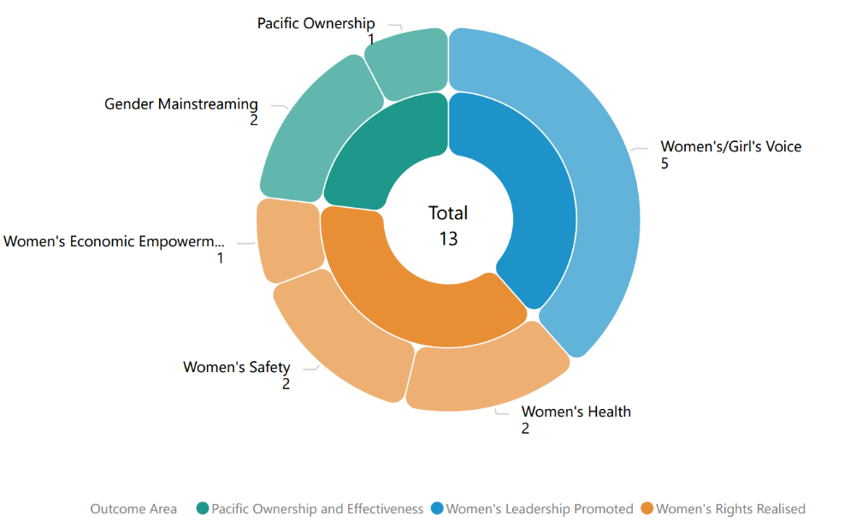

Of the 13 projects, five projects work in Women’s rights realised: two projects in women’s safety (2) and two in women’s health (SRHR) (2) and one in Women’s economic empowerment (1). Five projects work in Women’s leadership promoted: Women’s’ and girls’ voice (5) Three projects work in Pacific ownership and regional effectiveness: two projects in gender mainstreaming (2) and one in Pacific ownership (1).

## **Type of implementing partner**

Of the 10 distinct implementing partners, five are international NGOs, two are inter-governmental organisations, two are regional/multilateral partners and one is a Faith-Based Organisation.

Figure 4 Type of implementing partner

A diagram of types of implementing partners.


## **Committed funding by outcome and sub-outcome**

The committed funding is total grant value and is not broken down by funding allocation for Fiji. It is notpossible to provide specific funding allocation of regional projects for Fiji, nor actual spend. This information is not provided to PWLES.

Table 6 Committed Funding for regional projects implemented in Fiji

|  |  |  |
| --- | --- | --- |
| **Outcome** | **Sub-outcome** | **Committed Funding (AUD)** |
| Women’s rights realised | Women’s economic empowerment | 9,951,871 |
| Women’s rights realised | Women’s health | 52,500,000 |
| Women’s right realised | Women’s safety | 17,069,344.05 |
| Women’s leadership promoted | Women and girls’ voice | 19,882,500 |
| Pacific ownership and regional effectiveness | Gender mainstreaming | 6,059,377 |
| Pacific ownership and regional effectiveness | Pacific ownership | 2,700,000 |
| **Total** |  | **$108,163,092.05** |

# **Bilateral activities**

This section provides an overview of the gender activities that are managed and funded by DFAT Post in Fiji.

## **Project and implementing partner count by outcome and sub-outcome**

There are two projects implemented by two distinct implementing partners in Fiji and 26 downstream projects implemented 18 downstream implementing partners. Table 7 provides an overview of the projects (refer to Annex 1 for detailed information).

Table 7 Overview of DFAT Post in Fiji projects

|  |  |  |  |
| --- | --- | --- | --- |
| **Project** | **Distinct implementing partner** | **Downstream implementing partner** | **Outcome and sub-outcome** |
| Programs to Eliminate Violence against women in Fiji and the Pacific | Fiji Women’s Crisis Centre (FWCC) |  | Women’s rights realised – women’s safety |
| Women’s Fund Fiji | Women’s Fund Fiji | Young Women’s Christian Association  Transcend Oceania  Fiji Women’s Rights Movement  Medical Services Pacific  Pacific Rainbow Advocacy Network  Kioa Women’s Group  Soqosoqo Vakamarama Kadavu (SVM-Kadavu)  Fiji Disabled Peoples Federation  Building Innate Resilience Through Hearts Fiji  Rainbow Pride Foundation  Save the Children Fiji  Rise beyond the Reef  Vanua Levu Arya Mahila Mandal  THEN INDIA MAATHAR SANGAM  Fiji Cancer Society  Udu Point Women’s Initiative Group  FemLINK Pacific  Women’s Entrepreneurs Council | Women’s leadership promoted – feminist civil society |

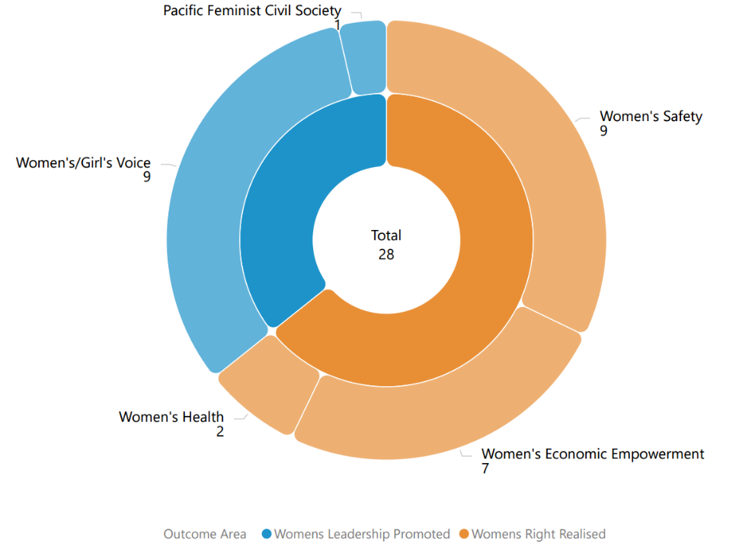Figure 5 Projects by outcome and sub-outcome

The two distinct projects work in Women rights realised in women’s safety (1) and Women in leadership promoted in Pacific feminist civil society (1). Of the 26 downstream projects, 17 projects work in Women’s rights realised: 8 projects work in women’s safety, 7 projects work in women’s economic empowerment and 2 projects work in women’s health. 9 projects work in Women in leadership promoted in women and girls’ voice.

## **Type of implementing partner**

Of the 20 implementing partners, the two distinct implementing partners are Pacific NGOs, and the 18 downstream implementing partners are Pacific NGOs (13), Faith-based Organisations (4), and Organisation for Persons with Disabilities (1).

Figure 6 Type of implementing partner

A diagram of types of implementing partners.


## **Committed funding by outcome and sub-outcome**

Table 8 Committed funding by outcome and sub-outcome

|  |  |  |
| --- | --- | --- |
| **Outcomes** | **Sub-outcomes** | **Funding Committed (AUD)** |
| Women’s rights realised | Women’s economic empowerment | 579,062.27 |
| Women’s rights realised | Women’s health | 315,485.66 |
| Women’s rights realised | Women’s safety | 7,775,725.18 |
| Women’s leadership promoted | Pacific feminist civil society | 2,183,809.58 |
| Women’s leadership promoted | Women and girls voice | 1,072,974.06 |
| **Total** |  | **11,927,056.75** |

## **Reach data by projects and indicators**

From January to June 2024, one project provided quantitative data against PWL indicators (Table 9). Table 10 provides detailed data against each indicator. For cumulative reach data, refer to Annex 3.

Table 9 Projects providing quantitative data by outcome and sub-outcome

|  |  |  |
| --- | --- | --- |
| **Outcome** | **Sub-outcome** | **Projects** |
| Women’s rights realised | Women’s safety | Programs to Eliminate Violence against Women in Fiji and the Pacific – Fiji Women’s Crisis Centre |

**Table 10 January to June 2024 Reach data for DFAT Post in Fiji projects**

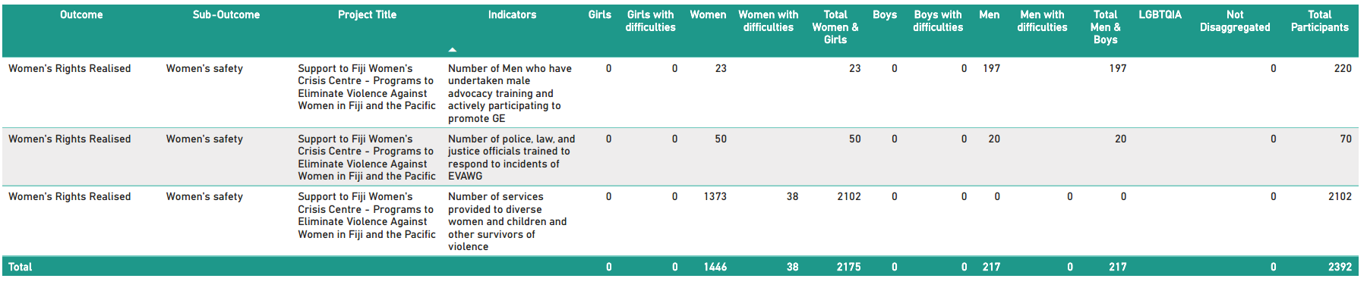

# **Pacific Women Lead Enabling Services**

This section provides information on the PWLES activities and support available for DFAT Posts and PWL at SPC. PWLES is valued at AUD32 million.

## **Monitoring, Evaluation and Learning Support**

**PWL MEL System:** The PWLES manages the PWL portfolio MEL system. The MEL system has two databases:

1. A **Quantitative database** that tracks progress against PWL indicators and can be accessed through a dashboard on the PWL website: [Pacific Women Lead - Our Impact](https://pacificwomen.org/our-impact/). The dashboard is updated six monthly after each reporting cycle.
2. A **Qualitative database** that allows the PWLES MEL team to code partner narrative reports against qualitative change domains (Refer to Annex 4).

The MEL system has the capability to organise and provide data, particularly for DFAT’s reporting processes (IMR and Tier 2 reporting), and qualitative evidence or quotes that can be used for briefing documents or speeches.

**Collection of qualitative impact stories:** PWLES collaborates with distinct and downstream implementing partners in each country to collect impact stories twice a year (February and July). These stories are used to inform the PWL MEL system and can be used by the PWL components for public diplomacy. Additionally, the stories will be published on the PWL website: [Pacific Women Lead - Stories](https://pacificwomen.org/latest-updates/stories/) and annexed to this brief when available.

**Monitoring the rights of people with disabilities Framework:** PWLES developed two guidance notes to support distinct and downstream partners to enhance data collection and reporting on disability inclusion. The guidance notes can be accessed here: [Pacific Women Lead - Resources](https://pacificwomen.org/resources/). PWLES has also facilitated a webinar discussion on these guidance notes which you can watch here: [Monitoring the journey towards the realisation of rights for people with disabilities](https://youtu.be/JCeG_6OmOuE?si=WgwOnXcFATJoiKG7).

**Annual Reflection and Analysis Workshop:** Each year, PWLES co-convenes an Annual Reflection and Analysis Workshop in September that brings together distinct and downstream implementing partners across the PWL portfolio to collaborate and analyse data to understand the program’s progress and make recommendations for the program. A summary of this year’s Annual Reflection and Analysis Workshop can be watched here: [Second Pacific Women Lead Annual Reflection and Analysis Workshop (2024)](https://youtu.be/p5gbcZHlKdg?si=7LXyyJI6AQalYxBT).

**Clear Horizon Academy PWL MEL Platform:** PWLES developed three training modules with Clear Horizon Academy to support PWL partners: Using Data for Reporting and Learning, Collecting Impact Stories and Understanding, monitoring and reporting disability inclusion. These are online and self-paced modules and partners can seek access through the PWLES.

## **Quality Technical Assurance Group (QTAG)**

Through the QTAG, PWLES provides technical support to smaller DFAT Post in Tuvalu, Kiribati, Federated States of Micronesia, Palau, Nauru, Niue, and Republic of Marshall Islands. QTAG currently offers tailored GEDSI support through consultants to smaller DFAT Posts:

**Gender Focal Point (GFP) mentoring:** QTAG continues to provide regular mentoring to GFPs in smaller DFAT Posts to support them to carry out their role with confidence through QTAG’s technical partner Co-LAB. The mentoring provides a space to support GFPs broader professional development priorities including provide advice and feedback on communication, help with problem solving and to act as a sounding board to troubleshoot issues and ideas with the GFPs without conflicting with other management and supervision support provided by the GFP’s manager/supervisor, and the GFPs existing workload.

**GEDSI Analysis and Country Plans/Design:** Through its panel of consultants, QTAG provides support to smaller DFAT Posts to carry out GEDSI Analysis and develop their Gender Country Plan/Design. PWL support to the development of country briefs/designs includes PWL whole-of-portfolio MEL briefings to ensure there is alignment to the PWL whole-of-portfolio MEL Framework. Larger Posts can draw on this support to ensure alignment to PWL whole-of-portfolio MEL.

**Larger DFAT Posts can access the panel of consultants on the QTAG but will have to cover the associated costs.** If Post would like to access the QTAG, Post can reach out to the QTAG Coordinator for initial discussion.

## **Grant Management**

PWLES provides program management support to DFAT Posts in smaller countries and DFAT Canberra. Currently, PWLES provides grant management support to:

1. Two regional programs: Balance of Power and We Rise Coalition Phase 3,
2. Three projects in Tuvalu (funded through the Tuvalu DFAT Post Gender Country Plan), and
3. Management of 3 Gender Advisers in Tuvalu (Gender Equality and Social Inclusion Adviser), FSM (Family Protection Adviser) and Palau (Family Protection Act Adviser).

**Balance of Power and We Rise Coalition Phase 3**

Balance of Power and We Rise Coalition Phase 3 are implemented by 2 distinct implementing partners, and 1 downstream implementing partner for one of the projects in Fiji. Table 11 provides an overview of the projects (refer to Annex 1 for detailed information).

We Rise Coalition Phase 3 is transitioning into Phase 4 which will be managed by DFAT Canberra from March 2025. Table 11 only captures We Rise Phase 3.

**Table 11 Overview of projects managed by PWLES in Fiji**

|  |  |  |  |
| --- | --- | --- | --- |
| **Project Name** | **Distinct implementing partner** | **Downstream implementing partner** | **Outcome and sub-outcome** |
| Balance of Power | Pacific Women Lead Enabling Services (managed by DT Global) |  | Women’s leadership promoted – women and girls voice |
| Feminist movements for transformative change: We Rise Coalition Phase 3 | International Women’s Development Agency (IWDA) | Talitha Project Incorporated | Women’s leadership promoted – feminist civil society |

The two projects work in Women’s leadership promoted in women and girls voice (1) and Pacific Feminist Civil Society (1).

Figure 7 Projects by outcome and sub-outcome

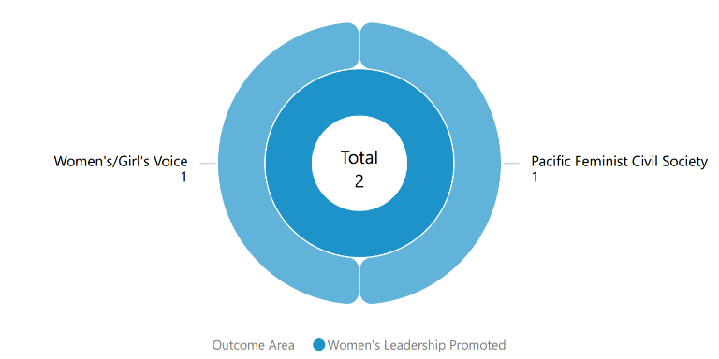

**Type of implementing partner**

Balance of Power is implemented by DT Global, a managing contractor, and We Rise Coalition is implemented by IWDA, an international NGO.

Figure 8 Type of implementing partner

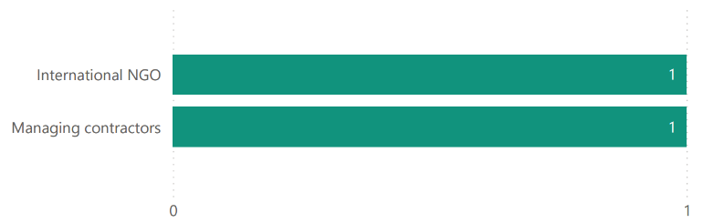

**Committed funding by outcomes and sub-outcomes**

The committed funding is total grant value and is not broken down by funding allocation for Fiji. The committed funding comes out of PWLES AUD32 million.

**Table 12 Committed funding by outcome and sub-outcome**

|  |  |  |
| --- | --- | --- |
| **Outcomes** | **Sub-outcomes** | **Funding Committed (AUD)** |
| Women’s leadership promoted | Women and girls voice | $11,597,674 |
| Women’s leadership promoted | Pacific feminist civil society | $3,240,024 |
| **Total** |  | **$14,837,698** |

# **Annex 1: Project implemented in Fiji**

Annex 1 provides detailed information on each project’s name, implementing partner, project description, end of project outcomes, total funding (AUD) and timeframe of all projects for Fiji under the 5 PWL components that have been entered into the PWL quantitative database.

Table 13 provides a summary of the projects implemented in Fiji by component. Note that total funding only reflects the grants managed under these components and does not reflect the total value of the components.

Table 13 Summary of projects implemented in Fiji

|  |  |  |
| --- | --- | --- |
| PWL Components | # Of Projects | Total Funding (AUD) |
| PWL at SPC Projects | 4 | 1,578,217.69 |
| PWL Governance Board Projects | N/A |  |
| Pacific Women’s Fund Projects | N/A |  |
| DFAT Regional Projects | 13 | 108,163,092.05 |
| DFAT Post in Fiji Projects | 26 | 11,927,056.75 |
| PWLES Projects | 2 | $14,837,698 |
| **Total Combined Funding** |  | **136,506,064.49** |

#### PACIFIC WOMEN LEAD AT SPC PROJECTS

|  |  |  |  |  |  |
| --- | --- | --- | --- | --- | --- |
| NO. | AID-WORKS NUMBER | PROJECT NAME AND PARTNER | PROJECT DESCRIPTION | END OF PROJECT OUTCOMES | VALUE (AUD) AND TIMEFRAME |
| 1 |  | Economic Empowerment for Rural Remote Pacific Women | In the case of Fiji, to build resilient communities through sustainable income generating projects that promote traditional knowledge. For Solomon Islands, work through the established Artisan Cooperative representatives in partnership with local government, village leaders, spouses, to develop a community development strategy that promotes GE and address harmful norms thru GESI outreach trainings and community check-ins. |  | $499,595.35  2024 - 2025 |
| 2 |  | Pacific Girl: Girls Arise  (Fiji Women’s Rights Movement) | The Fiji Women's Rights Movement's (FWRM) Girls Arise program works with girls aged 10-12 to build their life skills and confidence.  Pacific Girl will enable FWRM to extend activities to girls outside of the capital Suva, share the organisation's approach in a toolkit and raise the profile of girls' issues with decision-makers. | * Adolescent girls’ interests and priorities are increasingly visible in decision making. * Adolescent girls have increased agency (knowledge, skills, and voice). * Adolescent girls are increasingly respected and valued by communities and stakeholders. * Adolescent girl programming in the Pacific is connected, strengthened and informed by the interests and priorities of Pacific girls. * Evidence is built and shared on effective gender transformative programming for adolescent girls in the Pacific and incorporated into practice in Pacific Women’s work | $165,159.43  2021 - 2024 |
| 3 |  | Shifting the Power Coalition: Strengthening Diverse Women's Leadership in Humanitarian Action (ActionAid Australia) | Works to ensure diverse Pacific women’s voices are included in disaster planning and response at all levels with tangible outcomes around diverse women leaders in six countries.  The Coalition includes ActionAid Vanuatu, FemLink Pacific, Nazareth Centre for Rehabilitation, Pacific Disability Forum, Talitha Project Incorporated, Transcend Oceania, Vanuatu Young Women for Change, Vois Blong Mere, YWCA PNG and YWCA Samoa. | * 200 diverse women leaders in six countries will have increased capacity to engage in local and national disaster coordination mechanisms and to organise and influence decision making * Diverse women’s needs and capacities in times of crises will be documented and contribute to evidence-based disaster planning and response at national and regional level * Platforms will be established to strengthen diverse Pacific women’s voices in regional humanitarian and disaster resilience forums and their influence on policy and decision making | $532,233.07  2022 – 2024 |
| 4 |  | Strengthening Capacity of Women’s Organisation in Pacific Small Island Developing States (PSIDS) on Increasing Women in Leadership and EVAW in the World of Work | To strengthen, upskill and support the technical capacities of women's rights organisations in the Pacific (PSIDs) on gender analysis tools, evidence based legislative lobbying and advocacy in two key areas 1. Women’s leadership at all levels, of key decision-making spaces, 2. Support womens rights organisations to effectively monitor national, regional and international commitments on ending VAW and advocating for the implementation of ending VAW. |  | $381,229.84  2024 - 2025 |

#### DFAT REGIONAL PROJECTS

|  |  |  |  |  |  |
| --- | --- | --- | --- | --- | --- |
| NO. | AID-WORKS NUMBER | PROJECT NAME AND PARTNER | PROJECT DESCRIPTION | END OF PROJECT OUTCOMES | VALUE (AUD) AND TIMEFRAME |
| 1 | 77862 | Core Funding for IPPF Global Strategic Framework (22-26) and Pacific Strategic Strategy (22-26) | The strategy aims to come together and break through the barriers that limit sexual and reproductive health and rights (SRHR), thereby enabling quality SRHR to be realised for everyone in the Pacific. It is an ambitious agenda that is informed by the emerging challenges and opportunities in the region | * Centre Care on People: Expand choice and access in coordination with government partners and national civil society and explore digital options and self-care. * Move the Sexuality Agenda: Shift attitudes and norms in the Pacific through grass roots advocacy to drive gains in SRHR, ensuring the voices of young people and marginalised or excluded groups are heard. * Solidarity for Change: Create new strategic partnerships and contribute to social movements on SRHR and intersectional areas, and harness opportunities for learning and sharing * Nurture our Federation: Strengthen IPPF’s Secretariat and Member Associations through improvements in governance, financial and programmatic management, and draw on the Federation’s global expertise and knowledge base. | $2,000,000  2021 – 2026  *Phase 1 $500,000.00*  *2021 – 2022*  ***Completed*** |
| 2 | 77520 | Gender responsive Climate Policy and Women’s Climate Leadership in the Pacific  (WEDO) | Advance Pacific women's leadership in climate change decision-making via WEDO's Women Delegates Fund (WDF) program, as well as enhance the implementation of gender-responsive climate policy via capacity strengthening for National Gender and Climate Change Focal Points in the Pacific. | * Strengthen Pacific women’s leadership in climate change diplomacy and policymaking via travel support, training and networking * Support effective operationalization of the role of National Gender and Climate Change Focal Points across Pacific Island countries | $699,900  2022 – 2024 |
| 3 |  | Gender-Based Violence Prevention and Response | The activities under this grant align with the HoS PWL @ SPC grant to establish a ‘Sarah Safe Home (SSH),’ an emergency safe shelter responding to situations in which immediate safety is the primary concern. Supportive programs provided at the shelter will build up the survivors’ opportunities and options for the future thereby reducing incidences of re-abuse for survivors. This also includes improving social support and social outcomes.  The outputs seek to enhance the HoS’ proven approaches, further solidifying their networking capacity and reach, skilled volunteer workforce, advocacy and awareness raising, and internal policy and processes. This proposal will contribute toward a critical mass of faith-based women, youth, men and clergy members changing their attitudes, values and beliefs that perpetuate violence against women and that promote equality between women and men. | * Strengthen HoS’s programming focused on faith-based response to VAWG * Strengthen HoS’s programming focused on faith-based prevention of VAWG * Increase organisational capacity to safely and effectively respond to and prevent VAWG (Institutional Strengthening) | $334,651  2025 – 2025 |
| 4 | 73159/28 | Markets for Change (M4C) Phase 2  (UN Women) | Markets for Change Phase II aims to promote gender equality and the economic empowerment of market vendors, with specific attention to the needs and aspirations of women market vendors. | * Inclusive, effective and representative marketplace groups are created and grow, further enabled and recognised. * Improved socio-economic security of women market vendors. * Local governments, market management and other decision-makers are gender-responsive, effective and accountable to women market vendors. * Physical market structures and operating systems are improved to make markets more gender-responsive, safer, more accessible, sustainable and resilient to disaster risks and climate change | $9,951,871  2022 – 2026  Total regional commitment $6,301,871  Solomon Islands bilateral contribution: $1,000,000  Samoa bilateral contribution: $2,650,000 |
| 5 | 76569 | Netball Australia (Pilot Pacific Women’s Sport Administration Program) | The program focuses on governance and administration support – recognizing that this enables netball associations to advance women in decision-making and leadership roles (and their effectiveness in those roles), as well as enhancing access to safe and inclusive competition for women and girls across the Pacific. | * Improved governance and administration * Increased women in leadership and decision-making roles * Increased grassroot participation rates of women and girls in safer and more accessible environments | $1,638,600  2021 – 2023  **Completed** |
| 6 | 77557 | Oceania Rise Rugby Project  (Oceania Rugby) | Strengthen the participation, influence and visibility of women in all parts of the game, both on and off the field. | * 4 new high profile women’s domestic rugby competitions, completing several women’s rugby pathways * 11 Pacific women in new full-time Senior or Middle Management positions * 45 emerging Pacific women leaders trained and mentored in governance, leading to more women appointed in decision making roles and improved governance practice * Over 200 women completing Rugby Accreditations and in leadership roles within the new domestic competitions (as Coaches, Match Officials, Strength & Conditioning coaches, First Aid, Club Administrators) * Oceania Women in Rugby Network established supporting individuals, peer learning and collective advocacy * 4000< girls participating in high-quality rugby * Communities witnessing girls and women play, lead and be celebrated in a formerly ‘men’s’ sport, helping to drive positive change in attitudes and norms gender equality * Australia and DFAT celebrated as the primary supporter of these successes, opportunities and significant shifts * Australian dignitaries visible and engaged at high profile, newsworthy announcements, events and competitions * Direct engagement between Australian government representatives and both profiled and emerging Pacific Island leaders * Alignment and mutual reinforcement of other significant Oceania Rugby activities driving the participation and empowerment women in Pacific Islands and Australian diplomacy. | $2,933,000  2022 – 2024 |
| 7 | 77334/8 | Pacific Partnership to End Violence Against Women and Girls Phase 2  (UN Women) | The Pacific Partnership seeks to promote Gender Equality, prevent VAWG, and increase access to quality VAWG response services for survivors. The programme engages with over 100 partners across the region, including national governments, CSOs, EVAWG networks, faith-based groups, and sports associations. | * To enhance Pacific youth’s formal in-school and informal education on gender equality and prevention of violence against women and girls. * To promote gender equitable social norms at individual and community levels to prevent violence against women and girls, and to ensure survivors have access to quality response services. * To empower national and regional civil society organisations (CSOs) to advocate, monitor and report on regional institutions and governments commitments to enhance gender equality and prevent violence against women and girls. | $15,934,693.05  2022 – 2027  *Phae 1 $800,000*  *2021 – 2023*  ***Completed*** |
| 8 | 69294/46 | Progressing Gender Equality in the Pacific  (HRSD SPC) | PGEP’s overall objective is to strengthen gender mainstreaming, policy design, and implementation, including strategic support to civil society organisations, while supporting country and regional gender data and statistical initiatives. | * Gender Mainstreaming: Public Institutions are implementing policies, practices and programs that support gender equality * Accountability Mechanisms: Government gender mainstreaming planning budgeting, accountability, monitoring, and reporting systems enhance progress towards achieving gender equality commitments | $2,156,401  2021– 2023  **Completed**  Will come under PWL in 2024. |
| 9 | 69294/67 | Pacific Community’s Human Rights and Social Development (HRSD) Division Support | HRSD leads SPC’s work in the areas of human rights, gender equality and social development. | HRSD Business Plan   * Objective 1 – Strengthen inclusive, transparent, and responsive governance and institutions for human rights, gender equality and social development. * Objective 2 – Mobilise, empower, and build conditions for gender equality, equity and social inclusion in society and development * Objective 3 – Promote, preserve, and protect positive expressions of culture * Objective 4 – Accelerate impact on human rights, gender equality and social development through knowledge, learning and innovative solutions. | $2,700,000  2022 – 2026 |
| 10 | 78400 | Pacific Island Forum Secretariat Gender Disability and Social Inclusion  (Pacific Island Forum Secretariat) | Progressing Pacific Island Forum Secretariat Gender Equality Disability and Social Inclusion priorities | * PIFS Social Policy team to implement priorities on gender equality, disability and social inclusion including in the implementation and monitoring of the 2050 Strategy for the Blue Pacific Continent including gender policy capability and advice * enhanced strategic engagement and communications * support to members and actioning outcomes * progressing disability inclusion * progressing implementation of social policy program | $3,902,976  2023 - 2026 |
| 11 | 77821 | Tennis Australia Women and Girls Pacific Extension - Emerging onto the World Stage  (Tennis Australia) | Deliver programs and pathways to create sustainable benefits for women in the Pacific, either as a player, coach or paid administrator/Development Officer. Create economic efficiencies, seeing supporting partners (ITF, ONOC and TA) come together to maximise opportunities for program stakeholders. | Stream 1 – Coaching   * Increase the number of women in decision-making and leadership roles * Strengthen career and volunteer pathways and opportunities on the court * Create sustainable networks to influence and advance women * Inspire and develop women to be a public voice for tennis from grassroots to the world stage   Stream 2 – Community Leadership   * Increase the number of women in decision-making and leadership roles in Tennis organisations * Develop the governance structures to create safe, welcoming and inclusive environments for women and girls   Stream 3 - Talent   * Improve access to safe inclusive sporting competitions and facilities to encourage higher participation of girls and young women * Provide pathways for elite players to transition from Juniors to the Professional Tour (ITF and WTA) * Increase retention of women elite players able to transition to coaches and leaders in the sport | $1,111,000  2022 – 2026 |
| 12 | 77337/9 | Transformative Agenda for Women, Adolescents and Youth in the Pacific: Towards Zero Unmet Need for Planning 2018 – 2022 (Phase 2)  (UNFPA) | The Transformative Agenda outlines action that will increase the demand for, and supply of, SRH services and information (particularly family planning) and create an enabling environment for their progress.  Goal - Transformative change in the lives of women, adolescents and youth across the Pacific by 2022. | * Increased and improved supply of integrated sexual and reproductive health (SRH) information and services, particularly for family planning * Increased demand for integrated SRH information and services, particularly for family planning * More conducive and supportive environment for people to access and benefit from quality SRH, especially contraceptive choice. | $37,000,000  2022 – 2028  Phase 1 $7,500,000  2021 – 2022  **Completed** |
| 13 |  | Women’s Resilience to Disasters (WRD) Program  (UN Women) | Program Goal: the lives and livelihoods of women and girls are resilient to disasters and climate change; contributing to sustainable, secure and thriving communities.  Support women and girls to increase their adaptive capacity and build resilience in the face of myriad disasters and threats. | * Women and girls have voice and agency to withstand multiple hazards, recover from disasters, and increase their resilience to future disasters and threats. * Prevention, preparedness, and recovery Policy frameworks, systems, processes, and tools are gender-responsive and implemented as a result of local women's and girls' advocacy. | $13,500,000  2021 - 2026 |

#### DFAT IN FIJI PROJECTS

|  |  |  |  |  |  |
| --- | --- | --- | --- | --- | --- |
| NO. | AID-WORKS NUMBER | PROJECT NAME AND PARTNER | PROJECT DESCRIPTION | END OF PROJECT OUTCOMES | VALUE (AUD) AND TIMEFRAME |
| 1 |  | Achieving Economic Empowerment through inclusive, sustainable gender focus approaches Phase 1  (Women’s Entrepreneurs Business Council) | Amidst, the humanitarian grant implementation, WEBC noticed that remote rural women lack access to information on entrepreneurship. To address this there is an urgent need for agencies, gov. ministries, the private sector, the disability sector, and regulatory agencies officers to come together and develop an information booklet. To address challenges by women in business, WEBC through this funding from the Fund (WFF), will implement Achieving Women Economic Empowerment through an inclusive, sustainable, gender focus Approaches Project. The project includes activities such as Women's National Forum, Toastmaster's Program, consultations with stakeholders, Mentoring sessions, Women Entrepreneurs Toolkit and assessing supply chain. |  | $20,339.48  2021  **Completed** |
| 2 |  | Achieving Economic Empowerment through inclusive, sustainable gender focus approaches Phase 2  (Women’s Entrepreneurs Business Council) | Amidst, the humanitarian grant implementation, WEBC noticed that remote rural women lack access to information on entrepreneurship. To address this there is an urgent need for agencies, gov. ministries, the private sector, the disability sector, and regulatory agencies officers to come together and develop an information booklet. To address challenges by women in business, WEBC through this funding from the Fund (WFF), will implement Achieving Women Economic Empowerment through an inclusive, sustainable, gender focus Approaches Project. The project includes activities such as Women's National Forum, Toastmaster's Program, consultations with stakeholders, Mentoring sessions, Women Entrepreneurs Toolkit and assessing supply chain. |  | $81,375.92  2022 – 2023  **Completed** |
| 3 |  | Advancing Sexual Reproductive Health and Rights and Social Services in Fiji through MSP's National Programme  (Medical Services Pacific) | (MSP) plays an important role in the implementation and advocacy of Sexual Reproductive Health Rights in Fiji. Through this grant, MSP will deliver mobile outreach clinics including Sexual Reproductive Health and Rights, Sexual and Gender-Based Violence and post-rape care, psychosocial support, legal advice and critical referral services in central, Western and Northern divisions. MSP will also consult and coordinate with various stakeholders to ensure program fits gaps and to raise awareness about services. |  | $305,092.19  2023 - 2024 |
| 4 |  | Beyond the Rural Women Convenings: Transformative Feminist Media Association of Diverse Fijian Women  (FemLINK Pacific) | The program proposes to centre work in the provinces of Nadroga/Navosa, the informal urban and semi-urban settlements around Lami and the Northern Division and complement these with the current feminist rural women leaders’ network convenings that are conducted in eleven other districts in Fiji. Young women in these localities would be brought into these safe spaces and would also be offered their "Cool Club Collectives" through feminist media training with femLINK and would be introduced to other feminist allies such as the Fiji Women's Rights Movement (FWRM). |  | $305,079.47  2023 - 2025 |
| 5 |  | Building Resilience for Udu Women Project  (Udu Point Women’s Initiative Group) | Udu Point Women's Initiative Group was established in March 2016 by three women of part European, Rotuman, and Tongan descent. Udu Point is a remote island in Fiji/Vanua Levu located on the far northeast point of Vanua Levu. The group includes women who are members of the women's group in the four villages (Udurara, Vunikodi, Nabouono and Nukudamu). The group is made up of part-European, Tongan, Rotuman descent and it also includes Udu women residing in Viti Levu and other islands of Fiji and women that have married to Udu and resides in Udu point. |  | $6,779.83  2021  **Completed** |
| 6 |  | Cancer Education and Awareness  (Fiji Cancer Society) | FCS focuses on health and wellness, early detection, and prevention supported by strategic partnerships to be able to reduce the impact of cancer. FCS acknowledges the fact that Non-Communicable Disease (NCD) is a silent killer, and families are losing their loved ones prematurely to preventable diseases such as cancer and diabetes. The Society, therefore, in the best interest of the people of Fiji, is working towards SDG: Good Health and Wellbeing, and MHMS’s Strategic Priority 1; Outcomes 1.1, 1.2. In addition to the above, FCS will focus on the World Cancer Declaration Targets; specifically, Target 3. The declaration sets out nine targets to be achieved by 2025 with the overarching goal of reducing the number of premature deaths from cancer and improving quality of life and cancer survival rates. The targets are aligned with the global ambition of a 25% reduction in premature mortality from NCDs by 2025 and set out priorities for cancer prevention, early detection, diagnosis, treatment, and care to achieve this mortality reduction in every country. The Fiji Cancer Society through this funding from the Fund, will implement the Cancer Education Workshops, International Women’s Day, and World Cancer Day. The FCS will collaborate with stakeholders such as the Ministry of Medical Services to implement these activities in in Central, Northern, and Western Divisions. |  | $67,798.27  2022 – 2023  **Completed** |
| 7 |  | Community Palliative Care Program (CPCP)  (Fiji Cancer Society) | FCS focuses on health and wellness, early detection, and prevention supported by strategic partnerships to be able to reduce the impact of cancer. Through the funding, FCS will implement Community Palliative Care Program to address the lack of support for female palliative cancer patients. The project includes activities such as procurement of palliative kits and supplies. |  | $61,018.44  2022  **Completed** |
| 8 |  | Economic Empowerment Project - Vanua Levu Arya Mahila Mandal  (Vanua Levu Arya Mahila Mandal) | The Vanua Levu Arya Mandal is the Women’s Wing of Vanua Levu Arya Samaj. It was formed to sustain the religious, cultural, and social heritage and provide a social platform for the upliftment of the living standards of women in Vanua Levu. In 2020, Vanua Levu was severely impacted by Tropical Cyclone Yasa and early this year by Tropical Cyclone Ana. As a result of powerful winds, installations, dwellings, communications systems, and livelihoods were damaged. In some instances, heavy prolonged rains caused loss of life and property. To address the impact of these two cyclones and COVID-19 on women’s groups, the Vanua Levu Arya Mahila Mandal through this funding from the Fund, will implement an Economic Empowerment Project for their members. The project will also include annual conferences and workshops to enhance the knowledge of Vanua Levu Arya Mahila Mandal members on Domestic Violence, Human Rights, Noncommunicable diseases (NCDs), and Human Values. |  | $25,288.75  2022  **Completed** |
| 9 |  | Economic Resilience & Leadership Development Program for Rural & Remote Women in Fiji - Support for initial set up for online market on Amazon platform for rural remote women products  (Rise beyond the  Phase 2 support | The resilience grant will support the initial/start-up costs in the beginning stages (first 12-month cycle) of RBTR (rural & remote women products) online selling of rural women products (RBTR) on the Amazon marketplace. Specifically, the grant will support supplies and materials (bulk fabric, paint, thread), DHL shipping of bulk product shipments to be held at Amazon warehouses in the U.S., and some initial marketing advertisement costs on the Amazon Marketplace website. This will meet the increase in demand and efficient delivery of products maintaining higher returns for RBTR’s customer satisfaction in the USA based markets. This market opportunity and partnership with AMAZON will provide additional market access for more than 150+ women currently in the program and enable RBTR to add approximately 100 new women to their economic leadership & resilience program this year.  Rise Beyond the Reef was established to address rural remote Pacific communities' unique development needs. RBTR program supports rural remote women as they build agency, voice, choice, and resilience women through economic and leadership development. Building trust through economic development partnerships with rural remote women and their communities through the following activities: (1) Online market access- e-Commerce platform (2) e-Commerce strategy development (3) Capacity support for village and district coordinators (4) Leadership opportunities for village-based coordinators |  | $44,068.87  2023  **Completed**  $305,092.19  2022 - 2025 |
| 10 |  | Economic Empowerment of Rural Maathar Sangam Women  (THEN INDIA MAATHAR SANGAM) | The Then India Maathar Sangam was formed in 1939 and is an affiliate of the parent body The Then India Sanmarga Ikya Sangam. The group is governed by the Women’s wing of the parent body. The Maathar Sangam has been very active in the establishment of schools in rural areas around the country as well as managing the Temples and carrying out all preparatory works for the major religious festivals and functions. Through this grant, the Then India Maathar Sangam will implement Economic Empowerment of rural members of the Maathar Sangam. The Maathar Sangam will also partner with local organizations such as Bee Keeping organizations to develop knowledge, skills, and income-generating projects for their members. |  | $54,713.2  2023 - 2024 |
| 11 |  | Ending Violence Against Children in Fiji  (Save the Children Fiji) | Save the Children Fiji is registered as a charitable trust organization in Fiji and was established in 1972 to create sustainable and lasting change in the lives of Children in Fiji. As a Child Rights Organisation, Save the Children Fiji works from the ground level to the policy level and with various stakeholders to ensure Children realize their rights. The Grant will support Save the Children Fiji to implement the project titled “Ending Violence Against Children in Fiji (EVAC)”. The project will focus on building collective action, working with women, men, boys and girls and the community to end violence against children in Fiji. |  | $101,697.4  2023 - 2024 |
| 12 |  | Organisational Strengthening Project BIRTH Fiji  (Building Innate Resilience Through Hearts Fiji) | Between 2020 and 2021, BIRTH Fiji has experienced an increase in number of referral cases of people suffering from mental health, abuse, discrimination and from other forms of crises. With limited resources, BIRTH Fiji continued to provide the holistic support to clients i.e. counselling, home visitation and equipping people with tools to cope and heal from trauma. To address increasing number of referral cases from stakeholders, the BIRTH Fiji through this funding will implement Organisational Strengthening project. The project will enable BIRTH Fiji to develop policies and Standard Operating Procedures to deliver their activities more effectively. |  | $3,058.52  2022  **Completed** |
| 13 |  | Organisational Development & Strengthening for Rainbow Pride Foundation  (Rainbow Pride Foundation) | RPF is one of the few registered organisations that solely focuses on LGBTQIA+ issues in Fiji. However, it has faced problems with core funding, staff capacity and organisational development. Not having proper governance structures, a strategic plan and adequate staff affects RPF ability to deliver impactful initiatives for the LGBTQIA+ community in Fiji. |  | $101,697.4  2023 - 2024 |
| 14 |  | Organisational Strengthening Project for Fiji Disabled Peoples Federation  (Fiji Disabled Peoples Federation) | Fiji Disabled Peoples Federation (FDPF) is an umbrella organization consisting of 4 affiliated organizations namely the Fiji Association of the Deaf (FAD), United Blind Persons of Fiji (UBP), Spinal Injuries Association (SIA), Psychiatric Survivors Association (PSA). Through this project, FDPF aims to build the capacities of women with disabilities as future leaders to help them address the problems and make decisions at various levels. The project will specifically focus on placing more women with disabilities in positions of power within their organizations and communities, so they are meaningfully represented and engaged in leadership bodies. The funding from Women’s Fund Fiji (WFF) will enable FDPF to implement the Organisational Strengthening project to achieve the following: (1) To build capacity and strengthen policies and processes of FDPF affiliates. (2) Enhance the knowledge and skills of FDPF members in areas of leadership and income generation. |  | $122,031.79  2023 - 2026 |
| 15 | 77254 | Programs to Eliminate Violence Against Women in Fiji and the Pacific  (FWCC) | Continuing core funding to the Fiji Women’s Crisis Centre, the leading crisis and support service for women and girls in Fiji.  FWCC's program goal is the elimination of all forms of violence against women and girls in Fiji and the Pacific region using a human rights and development framework. | * Women are asserting their rights and are empowered to make their own choices and decisions. * Service providers, leaders and community members respond sensitively to women survivors and promote equal rights, and duty bearers implement laws and policies. * Women, community leaders and members, and service providers in rural, remote, maritime areas of Fiji are accessing effective prevention and response services. * Government, other policy makers and decision makers develop and review laws and policies that promote women's rights in Fiji and the Pacific region. * Regional Network members and partners use best practice in their prevention and response to violence against women. * Male advocates promote equal decision making and rights for women in family, community, workplace, organisations and society. | $7,085,397  2021 – 2025 |
| 16 |  | Psychological Support and Advocacy for Women and Girls  (Building Innate Resilience Through Hearts Fiji) | Due to Covid19, social and mental problems have escalated to another level requiring more support from service providers in Fiji. As an emerging organisation, BIRTH Fiji needs more resources to provide the holistic support to clients i.e. counselling, home visitation and equipping people with tools to cope and heal from trauma. |  | $94,917.57  2022 - 2024 |
| 17 |  | Revisioning Women living with Disabilities Project  (Fiji Disabled Peoples Federation) | Through this project, FDPF aims to build the capacities of women with disabilities as future leaders to help them address the problems and make decisions at various levels. The project will specifically focus on placing more women with disabilities in positions of power within their organizations and communities, so they are meaningfully represented and engaged in leadership bodies. This grant will enable the Fiji Disabled People’s Federation to achieve the following: (1) Promote and empower the participation of women and girls living with disabilities in leadership and decision-making. (2) Increase awareness of issues affecting women and girls living with disabilities in forums like the (i) Pacific Regional Conference for Women with Disabilities/FDPF Biennial meeting (ii) Advocacy events on International Women's Day (iii) 16 Days of Activism and International Day of Disability (3) Strengthen the FDPF affiliates’ communication and media skills, to advocate for the rights of women and girls living with disabilities. (4) Foster networking and movement building within the FDPF and its affiliates and broader women’s movement in Fiji. |  | $70,259.34  2022  **Completed** |
| 18 |  | Strengthening of PRAN and members access to Sexual Reproductive Health Rights (SRHR)  (Pacific Rainbow Advocacy Network) | PRAN was set up in 2008 and is made up of gender non-confirming groups and focus on the promotion of their member's human rights. The project will support PRAN members in: (1) Project implementation support (2) Sexual Reproductive Health Rights (SRHR) awareness, clinic and members profiling. (3) Life skills training and support for income generation activities. |  | $103,93.47  2022 – 2023  **Completed** |
| 19 |  | Strengthening & building a coalition for change for Seventeen Women's Group in Kadavu  (Soqosoqo Vakamarama Kadavu (SVM-Kadavu)) | The Soqosoqo Vakamarama Kadavu is made up of women from the 17 villages in Kadavu who are members of their village women's group. The project will provide technical support to women's groups with existing income-generating activities. The project focuses on the following key activities for the 17 village women's groups: (1) Organisational Strengthening (2) Income Generation Profiling of Seventeen Women's Groups (3) Life Skills Training & Income Generational Support for Seventeen Women's Groups |  | $21,082.55  2022 - 2024 |
| 20 |  | Strengthening Kioa Women's Organisation Project  Kioa Women's Group | Kioa Women's Organisation has been in existence for 30 years with a total of 100 women members who are of Tuvalu ethnicity and Fijian women. Kioa Women's Group has over the years operated a guest house and has established a Kioa Women's store. The organization's mission is to have a reliable Women's Business venture in Kioa Island, bringing services closer to the community and improving the livelihoods of families and the whole Kioa community. |  | $20,339.48  2022 – 2023  **Completed** |
| 21 |  | Surge Support- Post Pandemic  (Medical Services Pacific) | Through this grant MSP will support the implementation of Surge Support- Post Pandemic. MSP will offer a holistic service ranging from counselling, clinical outreach, legal support, etc. |  | $23,894.82  2022  **Completed** |
| 22 |  | The Fiji National Feminist Forum  (Fiji Women's Rights Movement) | The Fiji National Feminist Forum will be an intergenerational space that will engage the process of strengthening intergenerational feminist learning. From building progress of leadership, advocacy, lobbying tools and skills. The opportunity for feminist women leaders to share knowledge and skills to the younger feminist that is contributing to the strengthening of movement building in Fiji. Most importantly, discussing challenges and ways of working in progressing the achievement towards Gender Equality in Fiji. |  | $67,798.27  2022  **Completed** |
| 23 |  | The Na I Soqosoqo Vakamarama iTaukei Project  (Fiji Women's Rights Movement) | Over the past 32 years, FWRM’s work has been guided by its vision for women of Fiji “to be free from all forms of discrimination, have equal access to opportunities and to live in a healthy environment where the principles of feminist, democracy, good governance, multiculturalism, and human rights prevail”. This vision is implemented through FWRM’s four major pillars of work: democratization, institutional structural and policy transformation, intergenerational leadership, and organizational strengthening. The Fiji Women’s Rights Movement (FWRM) also plays a very important role in the Women’s movement in Fiji. As part of the organization's strengthening, through this grant, FWRM will procure office equipment to support the urgent needs of the Na I Soqosoqo Vakamarama ITaukei (SSV). The SSV is a key partner of the Fiji Women’s Forum program thus this grant will enable them to continue with activities and projects with women leaders in Fiji. |  | $6,779.54  2022  **Completed** |
| 24 |  | The Suva Pop-Up Clinic Project  Medical Services Pacific | MSP plays an important role in implementation and advocacy of Sexual Reproductive Health Rights in Fiji. With the easement of Covid restrictions, opening of school and Fiji's boarders, MSP has experienced an increase in clients seeking their services. Thus, through this grant MSP will support the operation of MSPs Suva Pop Up Clinic. The Suva Pop Up Clinic will offer a holistic service ranging from counselling, clinical outreach, legal support, etc. |  | $32,850.97  2022  **Completed** |
| 25 |  | The Young Feminist Rise Project  (Fiji Women's Rights Movement)  Phase 2 | Through this grant, FWRM will complete the project evaluation and implement the completion of the Emerging Leaders Forum Model (ELF 8) using the new ELF toolkit. FWRM will also partner with local organizations to develop knowledge, skills and a program responsive to the specific needs, issues, and context of a cohort of diverse young women.  FWRM was established in 1986 as a multi-ethnic and multicultural NGO committed to removing all forms of discrimination against women through institutional reform and attitudinal change. FWRM believes that a cornerstone of young women's leadership is inter-generational learning. Through the grant, FWRM will implement Young Feminist Rise Project closely working with two cohorts of diverse young women between the ages of 18-35 from Fiji. By the end of the program, young women will be able to adopt a feminist and human rights lens and individually and collectively work towards dismantling hegemonic power relations and address existing patterns of inequalities and discrimination in their families, communities, networks, workplaces, and the wider local and national socio-political processes and systems. |  | $9,491.76  2022  **Completed**  $305,092.19  2022 - 2025 |
| 26 |  | Trauma Informed and Resilient Communities (TIRC)  Transcend Oceania | "The Transcend Oceania (TO) is a non-governmental peacebuilding organization, committed to advancing sustainable peace and development through justice and non-violence in Fiji. The funding from Women’s Fund Fiji (WFF) will enable Transcend Oceania to implement the Trauma-Informed and Resilient Communities (TIRC) project in Northern, Western, and Central Divisions |  | $305,092.19  2023 - 2025 |
| 27 |  | We Rise! Fiji YWCA: Supporting an Inter-Generation Learning Space for Young Women Leadership and Voice  (Young Women's Christian Association) | The YWCA of Fiji is recognised as a relevant and responsive national women-led organization that is grassroots-driven, linked to the global movement, and rooted in the inter-generational leadership of women and young women. The project activities include: (1) The YWCA of Fiji undertakes a localisation approach of the Young Women's Call to Action through 3 area councils and in consultation with the National Council. (2) Through a strengthened national office that supports national and local activities the YWCA is recognised as a relevant and responsive national women-led organization that is grassroots-driven, linked to the global movement and rooted in the leadership of women, young women, and girls. |  | 84744.3  2022  **Completed** |
| 28 | 77240 | Women’s Fund Fiji | Supporting local women’s groups, organisations and networks in Fiji to expand and enhance their work on women’s empowerment and gender equality. Reaching women living in rural and remote locations and those who are marginalised. | * Feminist and women's rights organisations are empowered through enhanced capacity to contribute to gender justice. * Feminist and women's movements are diverse, vibrant and have critical spaces to enhance their spheres of influence. * The Fund has secured long term and core support from donors, private sector, and philanthropic organisations to advance women's human rights. * The Fund has contributed to influencing support to the larger, global feminist funding ecosystem. * The Women's Fund Fiji is established, empathetic and adaptive in its resources, operations, and programs. | $4,841,659.75  2022 – 2025 |

#### PACIFIC WOMEN’S FUND PROJECTS

There are currently no projects funded under this component that is being implemented in Fiji. A table will be inserted here for activities implemented Fiji, when projects are funded in Fiji.

#### PACIFIC WOMEN LEAD ENABLING SERVICES PROJECT

|  |  |  |  |  |  |
| --- | --- | --- | --- | --- | --- |
| NO. | AID-WORKS NUMBER | PROJECT NAME AND PARTNER | PROJECT DESCRIPTION | END OF PROJECT OUTCOMES | VALUE (AUD) AND TIMEFRAME |
| 1 |  | Balance of Power  (DT Global) | The Balance of Power program aims to initiate dialogue and action around social norms and women’s roles in decision making and leadership in the Pacific region. | * There is a shifting balance of power towards women and men sharing decision-making at all levels. * Women's right to participate in the public sphere, including their right to vote independently, is increasingly understood and accepted by women and men. * Traditional, church, and democratic governance institutions demonstrate action consistent with their commitments on women in leadership and role model gender sensitive practices. | $11,597,674  2021 - 2026 |
| 2 |  | Feminist movements for transformative change: We Rise Coalition Phase 3 | The goal of the We Rise Coalition is to develop, demonstrate and strengthen feminist coalitions and partnerships in order to grow and uphold inclusive governance, equality, diversity, justice and women’s human rights. | * Coalition and organisational strengthening: Diverse Fiji and Pacific Women are contributing to a coordinated, feminist social movement. * Movement Building: We Rise partners, and the Coalition demonstrate feminist praxis and solidarity. * Policy, structural and institutional reform: Pacific women influence local, national and regional decision-making to reflect Pacific women's human rights concerns. | $3,240,024  2021 - 2024 |

#### RESEARCH PROJECTS

Total funding for research activities is not included in the combined total funding for all other components (Table 13).

|  |  |  |  |  |  |
| --- | --- | --- | --- | --- | --- |
| NO. | AID-WORKS NUMBER | PROJECT NAME AND PARTNER | PROJECT DESCRIPTIONS | END OF PROJECT OUTCOMES | VALUE (AUD) AND TIMEFRAME |
| 1 | 72938/47 | Strengthening Capacities for Measuring Violence Against Women (kNOwVAWdata) Phase 2  (UNFPA) | Works to sustainably strengthen regional and national capacities to measure the prevalence of violence against women in Asia and the Pacific. kNOwVAWdata improves the availability and quality of data to inform more effective policy and programme responses to prevent and end violence against women. | * Data-driven, context-specific decision-making in VAW policy and programme design * Quality data on what works and what does not work to address VAW effectively   Effective policies and programmes to address VAW are implemented, monitored and evaluated. | $3,000,000  2021 – 2024 |

# 

# **Annex 2: Pacific Women Lead Governance Board Members**

|  |  |
| --- | --- |
| A photo of PWL Governance Board member. | Dr Audrey Aumua is a co-chair of the PWL Governance Board. Dr Aumua oversees the work of The Fred Hollows Foundation NZ, which has a mission to end avoidable blindness and vision impairment in the Pacific. It achieves this by raising funding to support and partner with Pacific governments and ministries to train local eye care workers and provide the facilities and technology they need to improve access to quality eye care. Previously, Dr Aumua served as Deputy Director General at The Pacific Community’s (SPC) Suva office, where she managed the operations of staff, divisional work and Fiji-based activities, including SPC’s education, maritime, geosciences, land resources, social development and human rights programmes. Dr Aumua has extensive experience in research, policy development and management in the health and education sectors in New Zealand and Australia and has held sustainable development leadership roles across the Pacific. |
| A photo of PWL Governance Board member. | Reverend James Bhagwan is the second co-chair of the PWL Governance Board.   Rev. Bhagwan is married to Maelin (Fiji/Kiribati/Samoa) and has two children. He is an ordained minister of the Methodist Church in Fiji and licensed to preach and celebrate the sacraments in the Anglican Diocese of Polynesia. A descendant of indentured labourers from India, James has roots in the vanua of Noco (Notho) in the province of Rewa and maternal links to the Vanua of Macuata (Mathuata). He holds a Bachelor of Divinity in Ecumenical Studies (Hons.) from the Pacific Theological College in Suva, Fiji and a Master of Theology in Christian Social Ethics from the Methodist Theological University in Seoul, South Korea. He was elected General Secretary of Pacific Council of Churches at its 11th General Assembly in Auckland in 2018. He is a passionate advocate for ecological stewardship and climate justice, with particular focus on care for the ocean and self-determination issues and is also an active gender justice advocate. He is a keen Stand-Up-Paddler and long-time volunteer chaplain and crew member and trustee of the Fijian traditional voyaging society, the Uto Ni Yalo Trust and mentors several ocean health collectives. |
| A photo of PWL Governance Board member. | Mereseini Rakuita is the Pacific Community (SPC) representative on the PWL Governance Board. Ms Rakuita is a visionary champion of gender equality and women’s rights in Fiji and the Asia-Pacific region. She is the Pacific Community (SPC) Principal Strategic Lead – Pacific Women and Girls, driving gender equality and empowerment of women across the Pacific region as part of SPC’s executive team. Dedicated to gender equality, she serves as the chairperson for the FP2030 global movement dedicated to advancing the rights of people everywhere to access family planning services. Mereseini Rakuita is a qualified lawyer and the youngest female politician to be elected to Fiji’s parliament, in 2014, and she was the first female Minister for Lands and Mineral Resources. She has also served as Acting Permanent Secretary for Justice and Anti-corruption with oversight of operations in the Elections Office (2012–2013). Prior to politics, as State Solicitor (2009–2013), she was the highest ranking female legal advisor to the government, and Chairperson of the Telecommunications Authority of Fiji (2008) – the first and youngest Fijian woman in all of these roles during tenure. |
| A photo of PWL Governance Board member. | Honourable Nadine Jalabert is the New Caledonia representative on the PWL Governance Board. Born in New Caledonia in 1965, Hon. Nadine Jalabert studied midwifery in France (1984–1987), served as a midwife in New Caledonia in bush dispensaries (1987–1997), and has worked in a hospital setting in Noumea (since 1998). Since 2014, Hon. Nadine Jalabert has served as Councillor in Mont-Dore city where she helped establish a shelter for female victims of domestic violence and has actively promoted equality between girls and boys, women and men. Since 2019, Hon. Nadine Jalabert has served as the President of the Women’s and Family Rights Committee in the New Caledonia Congress. Hon. Nadine Jalabert is married and has two sons. |
| A photo of PWL Governance Board member. | Ethel Sigimanu is the Solomon Islands representative on the PWL Governance Board. Ms Sigimanu has been instrumental in advancing gender equality and women’s human rights in the Solomon Islands. She is one of the longest-serving permanent secretaries in the Solomon Islands government, having spent 17 years as permanent secretary in various government ministries 10 of which were as Permanent Secretary for the Ministry of Women, Youth, Children and Family Affairs. During this time, she took leadership and was greatly influential in the work towards the passage of the Family Protection Act 2014, which is the first domestic violence legislation in Solomon Islands, as well as the Child and Family Welfare Act 2017. She also developed and reviewed National Gender Equality and Women’s Development policies and conducted a study on Family Health and Safety. In recognition of her courage, strength and leadership in the areas of human rights, social justice, women’s equality and advancement, Ms Sigimanu received the Women of Courage Award in 2019 by the US Secretary of State. Ms Sigimanu also serves on a number of national and regional boards, particularly in the areas of gender and human rights and other areas of the social services sector. Ms Sigimanu is now serving as a freelance consultant, focusing on areas that she is passionate about, particularly the advancement of gender equality and recognition of human rights. |
| A photo of PWL Governance Board member. | Teretia Tokam is the Kiribati representative on the PWL Governance Board. Ms Tokam is the Executive Director of the Kiribati Women and Children Support Centre or KWCSC. Previously, Teretia worked at the Office of the Attorney General in Kiribati, as the country focal officer of the SPC Regional Rights Resource Team, and as the National Coordinator of the Eliminating Sexual and Gender-based Violence project of the Women’s Ministry in Kiribati. Teretia is a feminist and women’s human rights activist, and she is currently a member of the regional network to combat violence against women. |
| A photo of PWL Governance Board member. | ‘Ana Malia Falemaka is one of the Tonga representatives on the Governance Board. Ms Falemaka is a young and passionate advocate from Tonga. At just 19 years old, she currently serves as a board member, mentor and youth ambassador of Talitha Project, Tonga, an NGO that focuses on empowering young women and girls. Ana Malia first became involved with the Talitha Project in 2018, while attending an empowerment camp. Since then, the belief that she can help change our community, society and world has motivated her to continue this journey. She has worked across various Talitha projects, including the Pacific Girl programme. She is also an advisor in the “With and For Girls Fund Advisory Group”, facilitated by Purposeful, as well as a member of the “Pacific Islands Students Fighting Climate Change”, a youth-led organisation comprised of students across the Pacific. ‘Ana Malia is also a student at the University of the South Pacific – Tonga, pursuing a Bachelor of Law. She is humbled and greatly appreciates the various platforms and opportunities that she has been fortunate to have to highlight the issues that girls in Tonga and across the Pacific face and to represent the voices of young Pasifika women and girls in lobbying for change. Her advice to girls in Tonga, as well as in the Pacific, is: If you believe very strongly in something, stand up and fight for it. We cannot always rely on our leaders to continue dictating and shaping the World which we will eventually lead. We are the future generation and so, as future leaders, our opinions must be included, heard and valued. |
| A photo of PWL Governance Board member. | Rhema Misser is the second Tonga representative on the Governance Board. Mr Misser has been a leader in the disability movement for 19 years. He is the President and Founder of the Lavamea Taeiloa Disabled People Association, Inc. and, for four years, served as a board member of the Pacific Disability Forum in Fiji. Rhema looks forward to collaborating with other participants in Pacific Women Lead for the benefit of everyone throughout the Pacific. |
| A photo of PWL Governance Board member. | Alex Su’a is the Samoa representative on the PWL Governance Board. Mr. Su’a is a lawyer who has been practising law since 2004 in Apia, Samoa. He is registered as a barrister, solicitor and notary public of the Supreme Court of Samoa. Since 2018, he has been a partner of a small law firm, Stowers & Su’a Lawyers, in Apia and, currently, serves as the President of the Samoa Law Society. Alex is a very proud fa’afafine and is a steadfast advocate in favour of the human rights of the fa’afafine and fa’atama community in Samoa. Since 2005, he has been a founding member of the Samoa Fa’afafine Association, Inc., the only SOGIESC organisation in Samoa, and, since 2018, has served as its President. |
| A photo of PWL Governance Board member. | Tahina Booth is one of the Papua New Guinea representatives on the PWL Governance Board. Ms. Booth is an accomplished tri-international athlete representing Australia in Olympic weightlifting and powerlifting and in the Rugby League for the Papua New Guinea Orchids. Elite sport has instilled in Tahina discipline and leadership, and the many other skills learnt through sport have transferred into Tahina’s professional life. Tahina founded the Grass Skirt Project (GSP), a Papua New Guinea NGO and social enterprise using sport to prevent gender-based violence through collaborative partnerships and innovative health and wellness events for grassroots communities. |
| A photo of PWL Governance Board member. | Susil Nelson-Kongoi is the second Papua New Guinea representative on the PWL Governance Board. Susil is a senior executive with ExxonMobil PNG with over 15 years’ experience in the development and professional services sector. In addition to her role as ExxonMobil PNG Media and Communications Manager, Ms Nelson-Kongoi is the Chair of Incentive Fund, Vice President (International) of the Business Council of PNG, Chair of the PNG Business Advocacy Network, and Honorary Treasurer on the Board of Coalition for Change. She is actively involved in other non-profit organisations, such as the Business and Professional Women’s Association, advocating for the promotion of women’s participation in the economy, respecting women’s rights and ending violence against women and children. Susil has a Bachelor of Commerce from Canterbury University, New Zealand, and also holds a Master of Business Administration from Divine Word University, Papua New Guinea. |
| A photo of PWL Governance Board member. | Wynetta Dewis has family connections from Boigu island and Horn Island in the Torres Strait. She has over 20 years’ experience in leadership and project management roles. Ms Dewis is Chief Executive Officer for the Queensland Indigenous Family Violence Legal Service, the Chair of the National Family Violence Prevention Legal Service Forum and the Aboriginal and Torres Strait Islander Domestic and Family Violence Prevention Group. Ms Dewis is also a member of the Queensland Legal Assistance Forum Committee, the Coalition of Peaks Committee and the Community Legal Centre Australia Board. |
| No photo available | Virginia Dawson is the Director Policy at the Pacific Islands Forum. She has championed gender equity through policy and programme development during her international career. Her prior roles include Counsellor at the New Zealand High Commission to Fiji (2020-2024) and First Secretary at the New Zealand Embassy in Myanmar (2017-2019). As a development practitioner, Ms Dawson has worked for United Nations Agencies, non-governmental and civil society organisations across the Pacific, Asia, Africa and the Caribbean.  Ms Dawson holds a master’s degree in development studies and Graduate Diploma in Human Resource Management. |
| No photo available | Clemency Oliphant is the Assistant Secretary of the Pacific Development Branch in DFAT Canberra (Australia). Full bio will be included in the next update. |

# **Annex 3: Cumulative reach data (2021 to present) for DFAT Post in Fiji Projects**

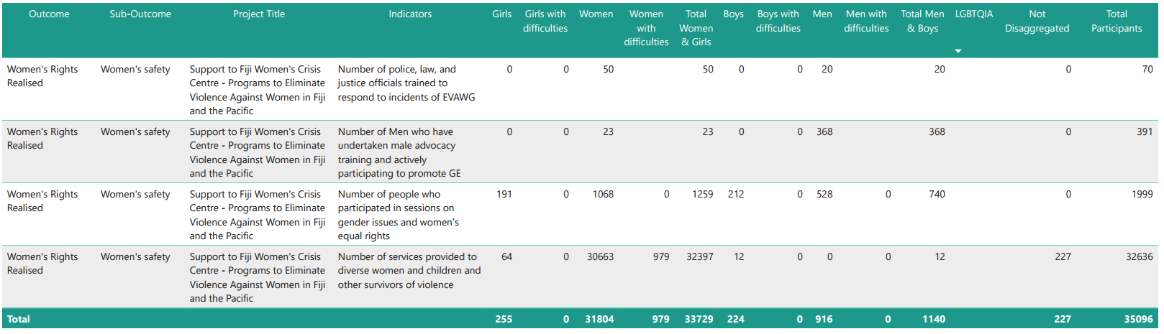

# **Annex 4: Whole-of-portfolio PWL Indicators**

| **Program Logic key outcome area** | **Quantitative indicators** | **Qualitative indicators** | **Domains of inquiry to track change in social norms** |
| --- | --- | --- | --- |
| Women’s leadership promoted: **women and girls’ voice** | * # diverse women and girls supported to assume a leadership role * # of sectoral policies or initiatives clearly addressing diverse women’s leadership needs | * Evidence of more women and girls, in all their diversity, that are respected, listened to and influencing decision-making as a result of PWL grant making * Evidence of change in social norms that limit diverse women and girls’ leadership opportunities as a result of PWL grant making * Evidence of women and girls taking on and practice leadership (at all levels) as a result of PWL grant making * Evidence of how linking and learning between PWL grantees and collaborative MEL has led to better program outcomes in women and girls’ leadership | **Attitudes, beliefs and behaviours** that leadership (both formal and informal) is better suited to men and boys |
| Women’s leadership promoted: **Pacific feminist civil society** | * # diverse women and girls participating in civil society and intergovernmental forums (e.g., Pacific Feminist Forum and Triennial) * Number of women’s organisations, groups or coalitions actively engaged in the project * Number of Pacific organisations of people with disability actively engaged in the project | * Evidence that long-term and flexible funding from Pacific Women’s Funds is contributing to increased recognition and amplification of feminist civil society leadership * Evidence that the Pacific feminist movement has grown in depth, is better connected and their expertise is drawn upon as a result of PWL funding * Evidence of how linking and learning and collective action amongst women’s organisations and the feminist movement has supported better gender equality outcomes |  |
| Women’s Rights Realised – **women’s health** (SRHR) | * # diverse women and girls who received a modern method of contraception * Number of unintended pregnancies averted * Total couple-years protection for contraceptives distributed by countries to lower levels including service delivery points (SDPs) (disaggregated by method including emergency contraception and long-acting reversible contraception) | * Evidence of diverse women and girls’ improved access to comprehensive SRHR services as a result of PWL grant making * Evidence of change in social norms that limit diverse women and girls’ access to SRHR services as a result of PWL grant making * Evidence of the health sector providing comprehensive SRHR services as a result of PWL grant making * Evidence of how linking and learning and collaborative MEL between PWL grantees has led to better program outcome in SRHR | **Taboos and stigma**: cultural taboos surrounding discussion about sex, sexuality and reproductive health  **Gender norms and inequality:** traditional norms that restricts women’s autonomy to make decisions about their bodies  **Religious and moral beliefs**: that influence who should be able to access SRHR services |
| Women’s Rights Realised – **women’s economic empowerment (WEE)** | * # diverse women entrepreneurs provided with financial and/or business development services * # diverse women who have attained formal qualifications | * Evidence that diverse women have increased access to resilient economic opportunities, including increased voice in decision making as a result of PWL grant making * Evidence of change in social norms that prevent diverse women’s entry into the workforce as a result of PWL grant making * Evidence women in all their diversity have increased access to sustainable formal and informal economic opportunities as a result of PWL grant making * Evidence of how linking and learning and collaborative MEL between PWL grantees has led to better program outcome in WEE | **Attitudes and beliefs** that place the main responsibility for the home and care of children, the sick and the elderly on women and girls. |
| Women’s Rights Realised – **women’s safety** | * # of counsellors graduating from recognised counselling institutions * # of services provided to diverse women and children (girls and boys) and other survivors of violence, such as counselling * # people who participated in sessions on gender issues and women’s equal rights * # men who have undertaken male advocacy training * # police, law, and justice officials trained to respond to incidents of violence against women and girls according to an established protocol | * Evidence that violence against women and children has reduced as a result of PWL grant making * Evidence that women and children have improved access to comprehensive support services, including in times of disasters, as a result of PWL grant making * Evidence of increased access to comprehensive support and crisis services for diverse women and children as a result of PWL grant making * Evidence of changed social norms that contribute to diverse women and girls’ experience of violence as a result of PWL grant making * Evidence of how linking and learning and collaborative MEL between PWL grantees has led to better program outcome in safety | **Attitudes, beliefs and behaviours[6]** that condone violence against women  (Refer to footnote 17 for full list of attitudes, beliefs and behaviours. Partners are asked to focus impact story collection on any one (or more) of these attitudes, beliefs and/or behaviours) |
| Partners supportedto increase Pacific ownership and effectiveness of regional gender equality efforts – **gender mainstreaming** | * # of government staff and development practitioners applying gender mainstreaming tools * # of mechanisms in place to support gender mainstreaming processes in the government | * Evidence of how Pacific governments have utilised support to build capacity in gender analysis and mainstreaming * Evidence of how Pacific governments and development partners are mainstreaming gender as a result of PWL grant making, technical support, coaching or mentoring * Evidence of how Pacific government are implementing programs and policies that support national and/or regional gender equality commitments as a result of PWL grant making, technical support, coaching or mentoring |  |
| Partners supportedto increase Pacific ownership and effectiveness of gender and equality efforts – **Pacific ownership and regional effectiveness** |  | * Evidence of effective collaboration between SPC, PIFS and DFAT on regional gender equality commitments * Evidence of how collective action has supported implementation of government commitments to gender equality |  |
| Program Logic strategies   * Grant making in the thematic areas of leadership, health (SRHR), women’s economic empowerment and safety * Linking and learning that supports understanding of change in PWL’s outcome areas * Collective action that supports implementation of government commitment and movement building amongst Pacific feminist and/or women’s organisations * Technical support for gender mainstreaming activities * Collaborative portfolio level monitoring, evaluation and learning sense-making spaces to inform PWL decision-making | * Number of projects funded (by outcome and sub-outcome area) * Number of diverse women and girls reached through activities * Funds committed per outcome and sub-outcome area * Satisfaction with linking and learning events * Satisfaction with technical support for gender mainstreaming | * Evidence of how program logic strategies supported (or undermined) outcomes |  |

# **Annex 5: Impact stories**

|  |
| --- |
| **Project:** Balance of Power  **Tittle:** Fiji’s Great Council of Chief paving the path for women’s participation in traditional leadership |
| Fiji’s Great Council of Chiefs (GCC) was first established in the 1970s and is traditionally dominated by men. While there were a few women serving in the GCC, women’s participation was not institutionalized.    When the Sitiveni Rabuka led Government came into power in late 2022, one of its 100 days policy priorities was the re-establishment of the GCC. Soon after, in early 2023, the Ministry of iTaukei Affairs issued a call for Expressions of Interest to conduct a review of the GCC. When Mereani Rokotuibau, Executive Director of Balance of Power was approached by a predominantly male team to join their bid, she saw this as an opportunity for Balance of Power to influence the traditional leadership space. Interestingly, before Mereani joined, the team of five men and one woman were all aged over sixty but still recognized the need to include women and younger people in their team.    Concurrent to this bidding process, the first meeting of the GCC in over ten years was convened in May of 2023, with only two women representatives amongst the 50+ male representatives. The lack of women’s representation reinforced public concerns, also shared by Mereani, about broader societal challenges on recognizing and validating women’s agency and voice, and in this case the exclusion of women from of traditional decision-making processes.    As one of two Executive Directors for Balance of Power, Mereani works with her colleague Jennnifer Kalpokas Doan to set and implement the strategic direction of a three-country program focused on supporting women exercising leadership as well as women’s pathways into political leadership. She grew up in her village – Nausori, province of Tailevu and is heavily involved in the development of her village and is a part of the Tailevu Provincial Development Think Tank. Over the years, Mereani built her social and political network through the various roles she had, starting out at the Ministry of Agriculture, Pacific Leadership Program, including a role as Monitoring and Evaluation Manager with a development program in the Solomon Islands.    “Two of the members of the GCC review team are part of the Tailevu Think Tank (the strategic group guiding development in her province). They recognized my involvement in the development of my province’s strategic plan in the height of COVID-19. They know I work for Balance of Power. The relationships and the trust were there, more so because of the Think Tank and our context knowledge of working in a male dominated space.”    When the team formed the GCC Review Team after winning the bid, they wanted to ensure that the consultations included diverse voices, and not just of the iTaukei people. The Review Team undertook approaches to increase participation and integrate diverse voices. They designed a standard questionnaire available online, which included seven questions addressing people’s understanding of the GCC and its relevance to the community. This allowed for broader community input beyond the usual privileged circles. The Review Team actively reached out to women of all ages, youth, and various ethnic groups to ensure diverse perspectives were included.    Recognizing that usual consultation approaches will not be enough, the Review Team engaged with provincial councils, district advisory counselors, and even attended church services to reach indigenous communities that were otherwise hard to engage with during the workweek. This approach was crucial in areas where traditional communication channels were not effective. The Review Team alsoconnected with secondary schools to involve young people, the business sector and the Fiji National Council for Persons with Disabilities (NCPD). The Fiji National Council for Persons with Disabilities brought in all their affiliates, including representatives that reflect a variety of impairments: hearing, sight and physical mobility. When the Review Team were traveling to provinces the NCPD supported their members to be included in the consultation. All of these strategies helped build awareness and support for the changes they were advocating for, as well as seek feedback and input from a wide range of stakeholders.    As a result, the recommendations were endorsed by the GCC. The eight recommendations were accepted, which included the introduction of a mandated female representative among the provincial selections. This was a groundbreaking shift, as it institutionalized women's participation in the GCC in a way that had not been achieved before.    “The GCC is now on a path to becoming a standalone institution with its own office and staff within the Ministry of iTaukei. This structural change will enable the GCC to better implement its recommendations and ensure ongoing support for women and youth. For the first time, women will have a guaranteed presence in the GCC, setting a precedent for future representation.” |

|  |
| --- |
| **Project:** We Rise Coalition  **Organisation:** femLINKpacific  **Tittle:** femLINK rural women’s network creates spaces for gender-diverse dialogues |
| These stories were collected during the femLINK’ district convenings in Fiji.  **Member of the Cataliah Trans Group – member of Rainbow Pride Foundation**  “I was introduced to femLINK by a friend. I did not know anything about femLINK but I have always shared my concerns with this friend of mine who then encouraged me to join the femLINK network. She then invited me to attend one of the district convenings. I was reluctant at first but she kept telling me that this is the best place to raise my issues and voice my concerns. I tagged along not knowing that it was going to be the best thing that has ever happened to me. I had a lot of secrets and hidden stories locked away inside me and often weigh me down when I think about the past and its happenings.  In that first meeting, I struggled to gain the confidence to contribute. But the urge in me was too strong to compress. I started unpacking my past and relate my story to the theme of the discussion. That day, I went home feeling lighter and whole lot happier. The best part was knowing that I was in a safe space. A space where I could be myself and have some people in the room who have gone through the same experiences that I had gone through and knowing that others in the room will not judge me for who I am but accept me just as I am. I felt like a new being.  From that single event, I learnt so many things. I learnt I was not alone and that help is always available. I learnt that I do matter in society and that my story needed to be told to motivate others to also share theirs. I learnt to connect with like-minded people and voice our concerns collectively. I also learnt that I do not need to be ashamed of myself or the choices I have made. Instead, to rise up and advocate on issues that I believe are important for humanity.  After that first femLINK attendance, I formed the Cataliah Trans group, so that I could have the opportunity to create awareness amongst people like me. I am thankful to femLINK for the opportunity to be part if this great network. I have always and continue to look forward to all of femLINK’s organised events. I only wish femLINK could expand their reach quickly and hold these convening sessions in every community”.  **We Love and acceptance begins at home**  A pastor's wife was struggling with accepting her gender-diverse child. She believed that throwing out their belongings was an appropriate response to the child’s behavior. This act of rejection and discrimination against her own child was rooted in the misunderstanding of her Christian values and a lack of awareness about human rights.  A femLINK convener, who lived nearby, observed this repeated rejection. Each time the child’s belongings were discarded, the convener would collect the child’s belongings and take them back home. This happened multiple times, demonstrating the convener's patience and quiet support.  Eventually, the convener reached out to the pastor’s wife, inviting her to attend a femLINK rural convening. The pastor's wife accepted the invitation, marking the beginning of a significant transformation.  At the convening, the pastor’s wife shared her story amidst tears. She expressed immense gratitude towards the convener and femLINK for helping her understand the true essence of Christianity— that it begins at home, with love and acceptance. She realized that her actions were discriminatory and harmful to her child.  With newfound awareness, the pastor’s wife ceased her discriminatory behavior. She embraced her child, who in turn started showing more respect for his father’s position. This change fostered a more harmonious family environment.  Moreover, the pastor's wife became an active participant in femLINK’s initiatives. She even secured funding for a seawall project under the UN Women’s Disaster Resilience Program, demonstrating her commitment to community development and resilience. |

|  |
| --- |
| **Organisation:** Fiji Disabled Persons Federation (Women’s Fund Fiji grantee)  **Tittle:** Empowering Women with disabilities through the Fiji Disabled Person Federation |
| The Fiji Disabled Persons Federation (FDPF) is an umbrella organisation that includes the Fiji Association of the Deaf (FAD), United Blind Persons of Fiji (UBP), Spinal Injuries Association (SIA), and Psychiatric Survivors Association (PSA). With support from Women’s Fund Fiji, FDPF is working to build the capacities of women with disabilities, positioning them as future leaders capable of making decisions at various levels. This project specifically focuses on placing more women with disabilities in positions of power within their organisations and communities to ensure meaningful representation and engagement in leadership bodies.    During this reporting period, FDPF conducted a mentoring program for women with diverse disabilities in Tavua, marking a new initiative focused on empowerment. The program identified and trained 20 women from various villages, many of whom had been struggling to embrace their disabilities and engage with their communities.    Through this program, participants gained valuable skills applicable to future employment or entrepreneurial ventures, developed a stronger sense of identity and self-confidence in relation to their disabilities, and built a network of support with other women facing similar challenges.    The mentoring program in Tavua has led to transformations, empowering women with disabilities and fostering self-sufficiency within FDPF branches. Litia Naitanui's success story as a financially independent entrepreneur serves as an example for the participants. Additionally, proactive engagement through executive committee visits to three inactive branches in the West and new board member elections has revitalised these branches, promoted a culture of self-reliance and strengthened their ability to support all members of the disability community.    The training also enabled the women's group to register with the Ministry of Women, Children, and Social Protection. With these new relationships established, the Tavua branch women's group registered for the women's expo for the western division in May. Furthermore, the Ministry of Women, Children and Social Protection Officer has now engaged the women's group in training and workshops organised for women within the district, building their capacity and increasing the visibility of women with disabilities in the area.    For the Rakiraki and Ba branches, the inclusion of District Council of Social Services (DCOSS) representatives within their respective committees has provided necessary assistance and support. DCOSS's reach and human resources help to identify the needs of persons with disabilities and inform the committee for action, enhancing the effectiveness of these branches. |

1. Distinct implementing partner means organisations who have a direct grant agreement with donors or funders.
2. An ambition outlined in the PWL design was for SPC to progressively take over responsibility for the whole-or-program MEL. Further conversations will be had with SPC’s PWL MEL team and more details about how this could happen will be outlined in future PWL MELF updates.
3. Reach data refers to the coverage of activities: how many diverse men, women, boys and girls have been reached by an activity or project.
4. Partners hold a direct grant agreement with a donor or funding organisation.
5. Partners holds a grant agreement with a distinct implementing partner.
6. As found in the Pacific Women Lead baseline, social norms and attitudes that condone violence include: wives and mothers should be submissive to their husbands; husbands and fathers are the head of the household and make the final decisions; there is a certain way women and girls should dress, always modestly and never exposing body parts that could lead to rape or sexual harassment; men can drink and socialise after hours with their friends, but their women should return or remain at home to take care of chores; women and girls should do the household chores (washing, cleaning, cooking, taking care of children, looking after elderly); wives who cannot give birth are devalued; women should be virgins before they get married; girls should aspire to become wives and mothers; there is no such thing as marital rape because husbands have the right to demand sex from their wives; violence against women can be justified, especially if she oversteps the line; sexual harassment is normal and in the Pacific, it is generally accepted

  