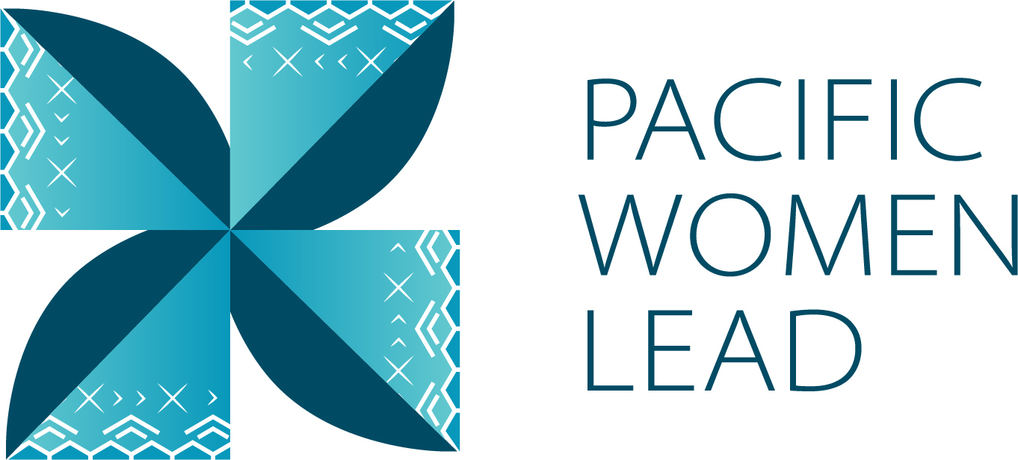

Solomon Islands Country Brief

December 2024

**Contents**

1 Pacific Women Lead overview 1

2 Program components 1

3 Purpose of the Country Brief 2

**3.1** **Solomon Islands Country Brief** 2

4 Pacific Women Lead at SPC Projects 2

**4.1** **Project and implementing partner count by outcome and sub-outcome** 3

**4.2** **Type of implementing partner** 4

**4.3** **Committed funding by outcome and sub-outcome** 4

5 Pacific Women Lead Governance Board Projects 4

**5.1** **Discretionary Funds** 4

**5.2** **Board Members** 4

6 Pacific Women’s Funds Projects 5

7 DFAT Regional Projects 5

**7.1** **Project and implementing partner count by outcome and sub-outcome** 6

**7.2** **Type of implementing partner** 7

**7.3** **Committed funding by outcome and sub-outcome** 8

8 DFAT Post in Solomon Islands Projects 8

**8.1** **Project and implementing partner count by outcome and sub-outcome** 8

**8.2** **Type of implementing partner** 9

**8.3** **Committed funding by outcome and sub-outcome** 10

**8.4** **Reach data by projects and indicators** 10

9 Pacific Women Lead Enabling Services Activities 2

**9.1** **Monitoring, Evaluation and Learning Support** 2

**9.2** **Quality Technical Assurance Group (QTAG)** 2

**9.3** **Grant Management** 3

Annex 1: Projects implemented in Solomon Islands 4

Annex 2: Pacific Women Lead Governance Board Members 17

Annex 3: Cumulative reach data (2021 to present) for DFAT Post in Solomon Islands Projects 21

Annex 4: Whole-of-portfolio PWL Indicators 24

Annex 5: Impact Stories 28

# **Pacific Women Lead overview**

Pacific Women Lead (PWL) is a portfolio of regional investments valued at AUD170 million over 5 years (2021 – 2026). PWL aims to advance gender equality and is ambitious in its intent to take a Pacific-led, intersectional and transformative approach to promoting gender equality in the region and bringing new emphasis to strengthening regional action and architecture in support of gender equality. PWL builds on the strengths and lessons learned through Australia’s 10-year gender equality investment, Pacific Women Shaping Pacific Development.

The goal of PWL is for: Pacific women and girls, in all their diversity, to be safe and equitably share in resources, opportunities and decision-making with men and boys.

The program works across three outcome areas with the following end-of-PWL sub-outcomes:

Table 1 Pacific Women Lead outcomes and sub-outcomes

|  |  |
| --- | --- |
| **Outcomes** | **Sub-outcomes** |
| Women’s Leadership Promoted (WLP) | * More women and girls, in all their diversity, are respected, listened to and are influencing decision-making at all levels **(Women and girls’ voice)** * The Pacific feminist movement has grown in depth, is better connected and their expertise is drawn upon by Pacific partners **(Pacific feminist civil society)** |
| Women’s Rights Realised (WRR) | * Diverse women and adolescent girls have improved access to quality health services, especially sexual and reproductive health **(Women’s health – SRHR)** * Diverse women have more equitable access to resilient economic opportunities, including increased voice in economic decision-making **(Women’s Economic Empowerment)** * Violence against women and children is reduced, and survivors have access to quality support services, including in times of disasters **(Women’s safety)** |
| Pacific ownership and regional effectiveness (POE) | * Pacific Governments and development partners are implementing programs and policies that support gender equality **(Gender mainstreaming)** * There is robust engagement, cooperation and mutual sharing between regional agencies and intergovernmental organisations to deliver on gender equality commitments **(Pacific ownership)** |

# **Program components**

PWL is a portfolio of 5 components; each component is a distinct implementing partner [1]of PWL: Through these components, technical support and funding is provided to Pacific women-led civil society organisations, multilateral and regional organisations, government and other stakeholders.

The components of the portfolio include:

**The Pacific Community (SPC) as a key implementing partner of PWL. PWL** at SPC sits within SPC’s Human Rights and Social Development (HRSD) division and supports the implementation of key regional commitments outlined in the Pacific Leaders’ Gender Equality Declaration, the Pacific Platform for Action on Gender Equality and Women’s Human Rights, and the outcomes of the Triennial Conference of Pacific Women. Through PWL, SPC provides technical, convening and funding support to government ministries, civil society, and other partners, while also acting as Secretariat for the PWL Governance Board.

**Pacific Women Lead Governance Board** provides direct strategic oversight on SPC’s PWL related activities and decides the allocation of AUD 5 million of discretionary funds. The Board also provides strategic advisory to DFAT Canberra (Australia) in enhancing regional effectiveness by identifying gaps and opportunities across the Pacific but does not provide direct strategy advice or have a decision-making role over the DFAT Posts or the Pacific Women’s Funds component. The Board receives reporting on outcomes for all other portfolio components through the PWL Annual Progress Report, compiled by the Pacific Women Lead Enabling Services.

**Pacific Women’s Funds** are supported to expand their work with women’s rights organisations and human rights defenders in the Pacific. This includes funding their advocacy activities to draw more resources for work towards gender equality to the region and funds to support the establishment of the first Pacific Feminist Fund.

**DFAT manages bilateral and regional programs. DFAT Canberra (Australia) and Fiji Post** manages direct funding arrangements for regional gender projects, including (but not limited to) UN Women’s Markets for Change and Pacific Partnership to End Violence Against Women and Girls, and UNFPAs Transformative Agenda program. **DFAT Posts** manage and fund country-level gender projects. Importantly, bilateral programs have autonomy in design, delivery and governance, but their gender programming aligns with the PWL goal and outcomes, and they will report results into the Pacific Women Lead Monitoring, Evaluation and Learning (MEL) System.

**Pacific Women Lead Enabling Services** (PWLES) managed by DT Global, provides support to SPC and DFAT to implement PWL. This includes whole-of-portfolio monitoring, evaluation, and learning (MEL), partnership brokering and the delivery of an independent Quality and Technical Assurance Group (QTAG). It is the role of the MEL team within the PWLES to compile a yearly whole-of-portfolio progress report, which brings together all the above components of PWL.[2]

# **Purpose of the Country Brief**

A Country Brief is designed and tailored for each country to serve the following purposes:

* Increase PWL partners and external stakeholders’ visibility of projects and implementing partners that are being funded or come under the PWL portfolio in a country. It is intended to contribute to greater collaboration and coordination by grantors and grantees.
* Serve as a mechanism for PWLES to collaborate with the 5 components of PWL to review project details (i.e. project information, timeframes and budget) to ensure all information captured in the PWL MEL system is correct.
* Support DFAT’s internal reporting, where investments are above 3 million.

Therefore, the Country Brief is designed to cover a calendar year (January to December) and information will be drawn from the PWL quantative database to show:

1. Gender projects funded by the 5 components of PWL
2. Reach data[3] against PWL quantitative indicators
3. Impact stories collected by partners or PWLES

## **Solomon Islands Country Brief**

This Country Brief update is for Solomon Islands. It provides information on all projects that are being funded by or come under the 5 components of PWL in Solomon Islands and focusses on January to June 2024 period.

# **Pacific Women Lead at SPC Projects**

The Pacific Community (SPC) is a distinct implementing partner of PWL (known as PWL at SPC) and has a grant agreement with DFAT Canberra, valued at AUD57,600,000. From this total value, SPC provides technical support to Pacific governments, hosts and supports regional convenings (such as the Triennial) and a grants program for its government partners and women’s organisations across the Pacific. You can also watch a short explainer video here: [Pacific Women Lead at the Pacific Community (PWL at SPC) explainer video](https://youtu.be/bBOpTVKh8Hs?si=OxeE63PdSKrxVdbT).

This section provides information on projects funded and managed by PWL at SPC that are implemented in Solomon Islands.

## **Project and implementing partner count by outcome and sub-outcome**

PWL at SPC funds 6 downstream[4] implementing partners to implement 5 projects. Table 2 provides an overview of the projects (refer to Annex 1 for detailed project information).

Table 2 Overview of PWL at SPC projects

|  |  |  |
| --- | --- | --- |
| **Project name** | **Downstream implementing partner** | **Outcome and sub-outcome** |
| Barriers to Female Leadership for Staff at Selected Pacific Island Universities, with an emphasis on Science, Technology, Engineering and Mathematics (STEM) | United Nations Development Programme (UNDP) and UN Women | Women’s leadership promoted – women and girls’ voice |
| Implementation of the 2014 Family Protection Act | Ministry of Women, Youth, Children and Family Affairs (MWYCFA) | Pacific ownership and regional effectiveness – gender mainstreaming |
| Shifting the Power Coalition: Pacific-owned, Women-led Early Warning and Resilience (POWER) systems | ActionAid Australia | Women’s leadership promoted – Pacific Feminist Civil Society |
| Strengthening of the women’s movement in Solomon Islands | Women’s Right Action Movement (WRAM) | Women’s leadership promoted – women and girls’ voice |
| Women-led, communities thrive – Women-ledim, komunity-gud | Save the Children, Solomon Islands | Women’s rights realised – women’s safety |

Of the 5 projects, three projects work in Women’s leadership promoted: two in women and girls’ voice (2) and one in Pacific Feminist Civil Society (1). One project works in Pacific ownership and regional effectiveness in gender mainstreaming (1) and one project works in Women’s rights realised in women’s safety (1).

**Figure 1 Projects by outcome and sub-outcomes**

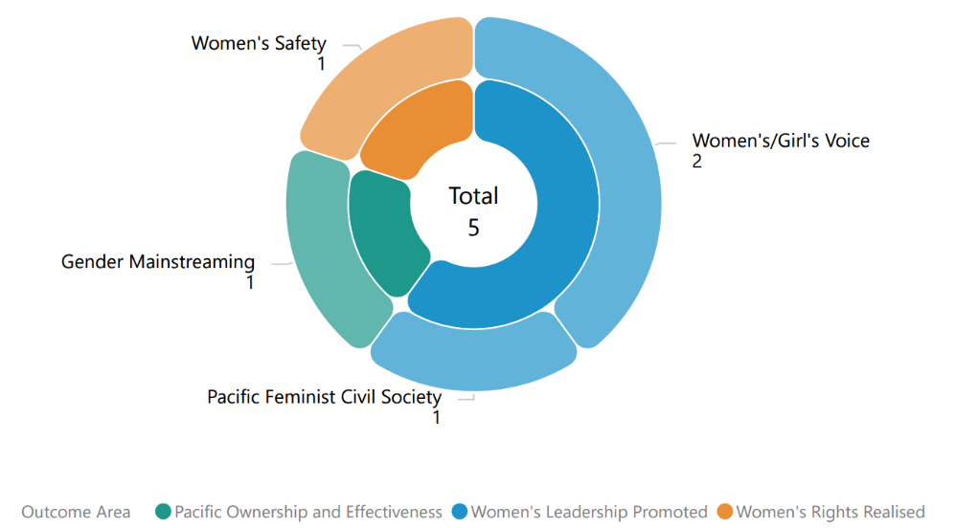

## **Type of implementing partner**

Of the 6 downstream implementing partners, 2 are international NGOs, 2 are regional and multilateral organisations, 1 is a Civil Society Organisation (CSO) and 1 is a government ministry.

**Figure 2 Type of implementing partner**

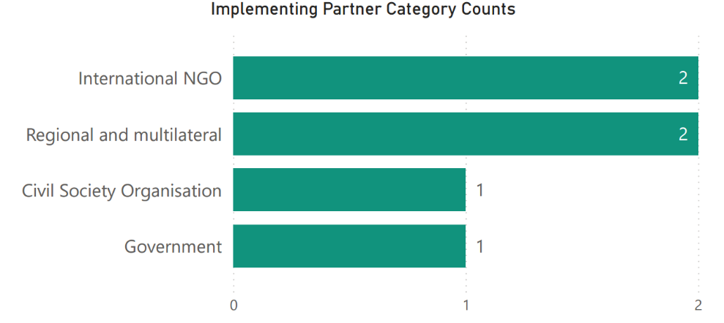

## **Committed funding by outcome and sub-outcome**

The committed funding for each of the projects comes out of PWL at SPC AUD57,600,000 budget.

Table 3 Committed funding by outcome and sub-outcome

|  |  |  |
| --- | --- | --- |
| **Outcome** | **Sub-outcome** | **Committed Funding (AUD)** |
| Women’s leadership promoted | Pacific feminist civil society | 532,233.07 |
| Women’s leadership promoted | Women and girls voice | 915,539.25 |
| Women’s rights realised | Women’s safety | 498,725.97 |
| Pacific ownership and regional effectiveness | Gender mainstreaming | 395,213.63 |
| **Total** |  | **2,341,711.92** |

# **Pacific Women Lead Governance Board Projects**

This section will provide information on projects funded by the PWL Governance Board for Solomon Islands when available and entered into the PWL quantitative database.

## **Discretionary Funds**

Five million has been set aside for activities funded at the discretion of the Governance Board with the aim to add value to and build on existing PWL activities. The Board’s Secretariat (SPC) developed seven criteria to guide the use of the Board funds. The seven criteria include: 1) alignment with PWL outcomes; 2) Pacific-led approaches; 3) regional or multi-country in scale; 4) promoting transformational change; 5) development effectiveness; 6) diversity and inclusion; 7) informed by research, evidence and data.

There are no projects currently being funded by the Board in Solomon Islands.

## **Board Members**

The PWL Governance Board has 13 members, 12 of whom are from the Pacific region (refer to Annex 2 for detailed list of all members). DFAT’s Assistant Secretary of the Pacific Development Branch is an ex-officio member of the Board.

|  |  |
| --- | --- |
| A photo of PWL Governance Board member. | Ethel Sigimanu is the Solomon Islands representative on the PWL Governance Board. Ms Sigimanu has been instrumental in advancing gender equality and women’s human rights in the Solomon Islands. She is one of the longest-serving permanent secretaries in the Solomon Islands government, having spent 17 years as permanent secretary in various government ministries 10 of which were as Permanent Secretary for the Ministry of Women, Youth, Children and Family Affairs. During this time, she took leadership and was greatly influential in the work towards the passage of the Family Protection Act 2014, which is the first domestic violence legislation in Solomon Islands, as well as the Child and Family Welfare Act 2017. She also developed and reviewed National Gender Equality and Women’s Development policies and conducted a study on Family Health and Safety. In recognition of her courage, strength and leadership in the areas of human rights, social justice, women’s equality and advancement, Ms Sigimanu received the Women of Courage Award in 2019 by the US Secretary of State. Ms Sigimanu also serves on a number of national and regional boards, particularly in the areas of gender and human rights and other areas of the social services sector. Ms Sigimanu is now serving as a freelance consultant, focusing on areas that she is passionate about, particularly the advancement of gender equality and recognition of human rights. |

# **Pacific Women’s Funds Projects**

The Pacific Women’s Funds is made up of three feminist organisations: Women’s Fund Fiji, Urgent Action Fund Asia and Pacific and Pacific Feminist Fund. Table 4 provides an overview of the Pacific Women’s Fund organisations.

More information about Women’s Fund Fiji and Urgent Action Fund Asia and Pacific can be found on their websites: [Women's Fund Fiji](https://womensfundfiji.org/) and [Urgent Action Fund Asia and Pacific](https://www.uafanp.org/). Pacific Feminist Fund is recently established and does not have a website.

Of the three feminist organisations, Pacific Feminist Fund and Urgent Action Fund Asia and Pacific provides grants to women’s organisations across the Pacific. Currently, there are no projects funded through this component being implemented in Solomon Islands.

Table 4 Overview of Pacific Women’s Fund organisations

|  |  |  |  |
| --- | --- | --- | --- |
| **Partner organisation** | **Committed Funding** | **Funding Source** | **Outcome and sub-outcome** |
| Women’s Fund Fiji | 4,841,659.75 | Bilateral – Fiji | Women leadership promoted – Pacific feminist civil society |
| Urgent Action Fund Asia and the Pacific | 4,336,500 | Regional | Women leadership promoted – Pacific feminist civil society |
| Pacific Feminist Fund | 1,170,849 | Regional | Women leadership promoted – Pacific feminist civil society |
| **Total** | **10,349,008.75** |  |  |

# **DFAT Regional Projects**

This section presents information on regional (multi-country) gender activities that are implemented in Solomon Islands. These regional gender activities are managed by either DFAT Post in Fiji or DFAT Canberra (Australia).

## **Project and implementing partner count by outcome and sub-outcome**

There are 13 regional projects implemented by 11 distinct implementing partners in Solomon Islands, plus 3 research projects. Table 5 provides an overview of the projects (refer to Annex 1 for detailed information).

Table 5 Overview of regional projects implemented in Solomon Islands

|  |  |  |
| --- | --- | --- |
| **Project name** | **Distinct implementing partner** | **Outcome and sub-outcome** |
| Child Protection Program in Kiribati, Solomon Islands and Vanuatu | UNICEF | Women’s rights realised – women’s safety |
| Core Funding for IPPF Global Strategic Framework Funding 2018 – 2022 | International Planned Parenthood Federation (IPPF) | Women’s rights realised – women’s health (SRHR) |
| Gender responsive Climate Policy and Women’s Climate Leadership in the Pacific | Women Environment and Development Organisation (WEDO) | Women’s leadership promoted – women and girls’ voice |
| Markets for Change Phase 2 | UN Women | Women’s rights realised – women’s economic empowerment |
| Oceania Rise Rugby Project | Oceania Rugby | Women’s leadership promoted – women and girls’ voice |
| Pacific Partnership to End Violence Against Women and Girls Phase 2 | UN Women | Women’s rights realised – women’s safety |
| Progressing Gender Equality in the Pacific | SPC’s Human Rights and Social Development | Pacific ownership and regional effectiveness - gender mainstreaming |
| Progressing Pacific Islands Forum (PIF) Gender Equality, Disability and Social Inclusion Priorities | Pacific Islands Forum Secretariat (PIFS) | Pacific ownership and regional effectiveness – gender mainstreaming |
| RiseUp! Mobilising Young Women's Leadership and Advocacy Phase IV | World YWCA | Women’s leadership promoted – women and girls’ voice |
| SPC’s Human Rights and Social Development (HRSD) Division Support | SPC’s Human Rights and Social Development (HRSD) Division Support | Pacific ownership and regional effectiveness – Pacific ownership |
| Emerging onto the World Stage – Tennis Australia Women and Girls Pacific Extension | Tennis Australia | Women’s leadership promoted – women and girls’ voice |
| A Transformative Agenda for Women, Adolescents and Youth in the Pacific: Towards Zero Unmet Need for Planning 2018 – 2022 Phase 2 | UNFPA | Women’s rights realised – women’s health (SRHR) |
| Women and Girls Accessing Essential, Safe and Secured GBV Services in Solomon Islands | Family Support Centre (UN Trust Fund) | Women’s rights realised – women’s safety |
| **Research activities** | **Distinct implementing partner** |  |
| Building Back Better: Promoting gender data-driven response to the COVID-19 pandemic in the Pacific and South-east Asia | UN Women | Research activity |
| Equality Insights | International Women’s Development Agency (IWDA) | Research activity |
| Strengthening Capacities for Measuring Violence Against Women (nKOwVAWdata) Phase 2 | UNFPA | Research activity |

Of the 13 projects, four projects work in Women’s leadership promoted in women and girl’s voice (4). Six projects work in Women’s rights realised: three projects in women’s safety (3), two projects in women’s health (2) and one project in women’s economic empowerment (1). Three projects work in Pacific ownership and regional effectiveness: two projects in gender mainstreaming (2) and one in Pacific ownership (1).

Figure 3 Projects by outcome and sub-outcome

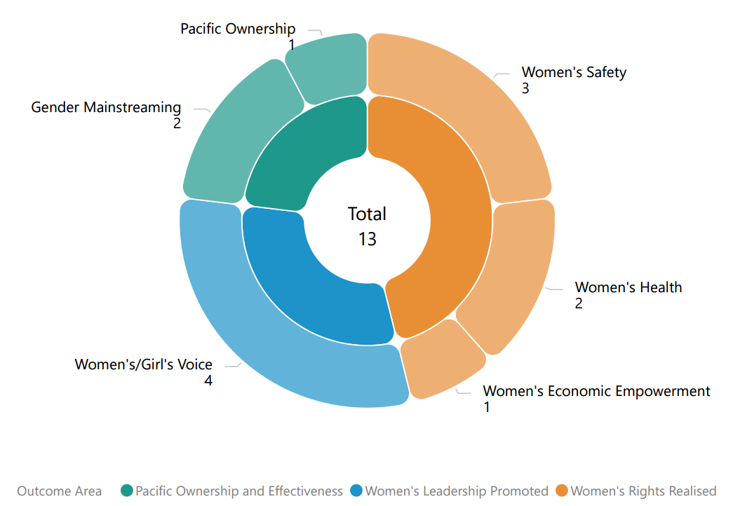

## **Type of implementing partner**

Of the 11 distinct implementing partners, 5 are international NGOs, 3 are regional/multilateral organisations, 2 are inter-governmental organisations and 1 is a Civil Society Organisation.

Figure 4 Type of implementing partner

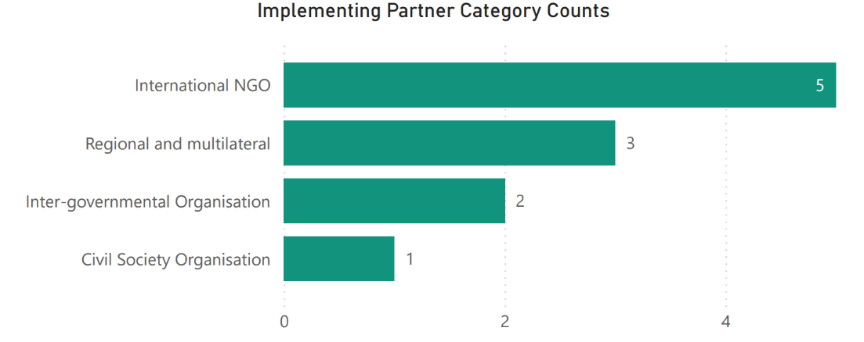

## **Committed funding by outcome and sub-outcome**

The committed funding is total grant value and is not broken down by funding allocation for Solomon Islands. It is notpossible to provide specific funding allocation of regional projects for Solomon Islands, nor actual spend. This information is not provided to PWLES.

Table 6 Committed funding for regional projects implemented in Solomon Islands

|  |  |  |
| --- | --- | --- |
| **Outcome** | **Sub-outcome** | **Committed Funding (AUD)** |
| Women’s rights realised | Women’s economic empowerment | 9,951,871 |
| Women’s rights realised | Women’s health | 52,500,000 |
| Women’s right realised | Women’s safety | 20,276,973.05 |
| Women’s leadership promoted | Women and girls’ voice | 6,699,900 |
| Pacific ownership and regional effectiveness | Gender mainstreaming | 6,059,377 |
| Pacific ownership and regional effectiveness | Pacific ownership | 2,700,000 |
| **Total** |  | **98,188,121.05** |

# **DFAT Post in Solomon Islands Projects**

DFAT Post in Solomon Islands is currently finalising its Gender Design Framework that will inform its gender commitments and priorities from 2025 onwards.

This section provides an overview of the gender activities that are managed and funded by DFAT Post in Solomon Islands and will be updated when the new Gender Design Framework is finalised.

## **Project and implementing partner count by outcome and sub-outcome**

There are 9 projects implemented by 8 distinct implementing partners and 6 downstream implementing partners in Solomon Islands. Table 7 provides an overview of the projects (refer to Annex 1 for detailed information).

Table 7 Overview of DFAT Post in Solomon Islands projects

|  |  |  |  |
| --- | --- | --- | --- |
| **Project** | **Distinct implementing partner** | **Downstream implementing partner** | **Outcome and sub-outcome** |
| Channels of Hope Phase 3 | World Vision Solomon Islands |  | Women’s rights realised – women’s safety |
| Let’s Make Our Families Safe (Safe Families) Project Phase 2 | Oxfam Australia | Malaita, Choiseul and Western Provincial Councils of Women | Women’s rights realised – women’s safety |
| People with Disability Solomon Islands | People with Disability Solomon Islands |  | Women’s leadership promoted – women and girls’ voice |
| Responding to Violence against Women (RVAW) Phase 2 | International Women’s Development Agency | Family Support Centre  Christian Care Centre | Women’s rights realised – women’s safety |
| Supporting the Ministry of Women, Youth, Children and Family Affairs | DT Global, through the Solomon Islands Australia Resource Facility |  | Pacific ownership and regional effectiveness - gender mainstreaming |
| Support to Civil Society Organisations | Australia Solomon Islands Program Support |  | Pacific ownership and regional effectiveness – Pacific ownership |
| Solomon Islands Women in Business | Solomon Islands Women in Business Association |  | Women’s leadership promoted – women and girls’ voice |
| Solomon Islands Professional Driver Training School (SIPDTS) | Young Women Christian Association (YWCA) Solomon Islands |  | Women’s rights realised – women’s economic empowerment |
| Women Ignite Stability and Economic Recovery in Solomon Islands (WISER) | International Women’s Development Agency | Women’s Rights Action Movement (WRAM) | Women’s leadership promoted – feminist civil society |

Of the 9 projects, three work in Women’s leadership promoted: two projects in women’s and girls’ voice (2), and one project in Pacific feminist civil society (1). Four projects work in Women’s rights realised: three projects in women’s safety (3) and one project in women’s economic empowerment (1). Two projects work in Pacific Ownership and regional effectiveness in gender mainstreaming (1) and Pacific ownership (1).

Figure 5 Projects by outcome and sub-outcome

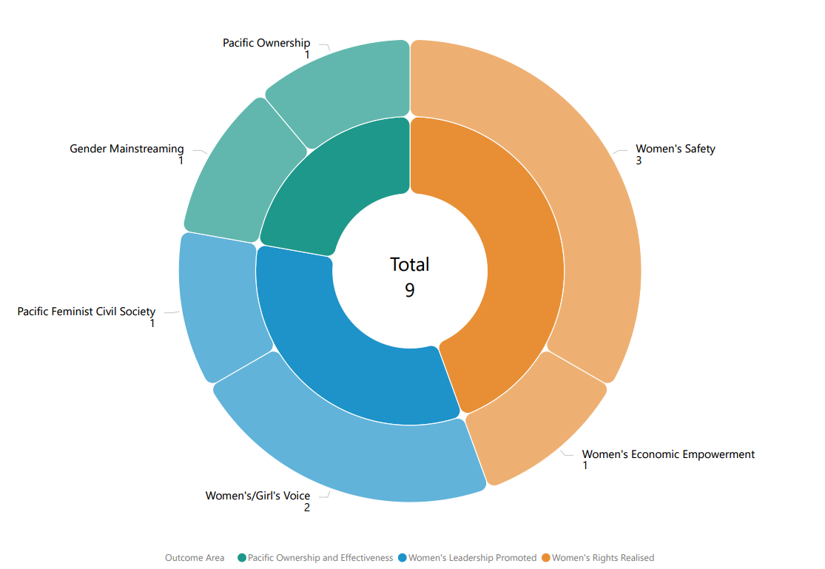

## **Type of implementing partner**

Of the 8 distinct implementing partners, 3 are international NGO, 2 are Civil Society Organisations (of which 1 is an organisation for persons with disabilities), 1 is a Faith-based organisation, 1 is a government ministry, and 1 is a managing contractor.

Figure 6 Type of implementing partner

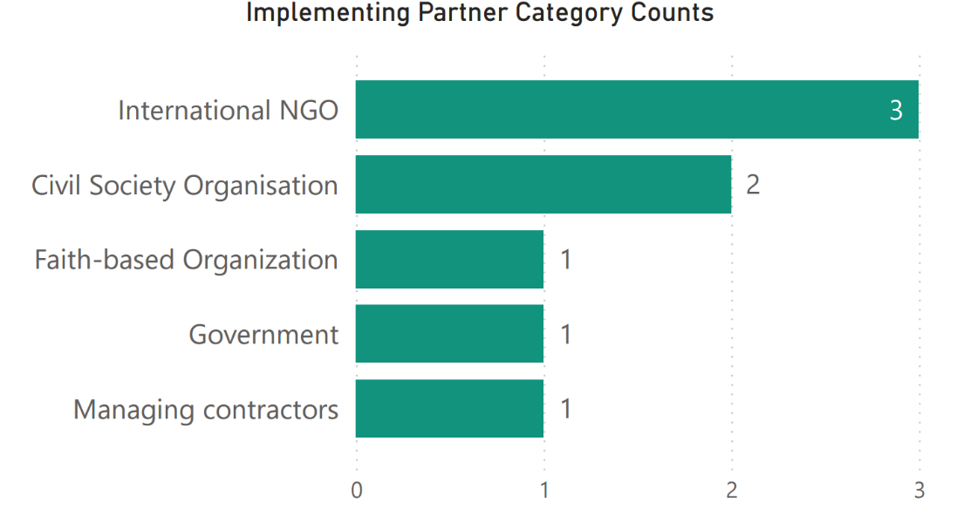

## **Committed funding by outcome and sub-outcome**

Table 8 Committed funding by outcome and sub-outcome

|  |  |  |
| --- | --- | --- |
| **Outcome** | **Sub-outcome** | **Committed Funding (AUD)** |
| Women’s leadership promoted | Women and girls’ voice | 100,000 |
| Women’s leadership promoted | Pacific Feminist Civil Society | 942,207 |
| Women’s rights realised | Women’s safety | 4,337,313 |
| Women’s rights realised | Women’s economic empowerment | 45,054 |
| Pacific ownership and regional effectiveness | Gender mainstreaming | 3,070,645 |
| Pacific ownership and regional effectiveness | Pacific ownership | 500,000 |
| **Total** |  | **8,995,219** |

## **Reach data by projects and indicators**

From January to June 2024, 1 project provided quantitative data against the PWL indicators (Table 9). Table 10 provides detailed data against each indicator. For cumulative reach data, refer to Annex 3.

Table 9 Projects providing quantitative data by outcome and sub-outcome

|  |  |  |
| --- | --- | --- |
| **Outcome** | **Sub-outcome** | **Projects** |
| Women’s leadership promoted | Women and girls Voice | Women Ignite Stability and Economic Recovery in Solomon Islands (WISER) |

Table 10 January to June 2024 Reach data for DFAT Post in Solomon Islands projects

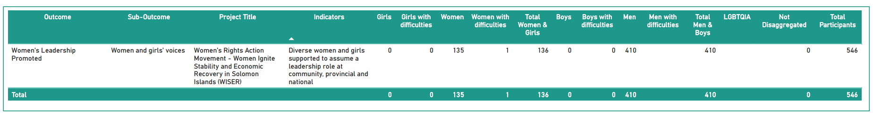

# **Pacific Women Lead Enabling Services Activities**

This section provides information on Pacific Women Lead Enabling Services (PWLES) activities and support available for DFAT Posts and PWL at SPC and is valued at AUD20 million.

## **Monitoring, Evaluation and Learning Support**

**PWL MEL System:** The PWLES manages the PWL portfolio MEL system. The MEL system has two databases:

1. A **Quantitative database** that tracks progress against PWL indicators and can be accessed through a dashboard on the PWL website: [Pacific Women Lead - Our Impact](https://pacificwomen.org/our-impact/). The dashboard is updated six monthly after each reporting cycle.
2. A **Qualitative database** that allows the PWLES MEL team to code partner narrative reports against qualitative change domains (Refer to Annex 4).

The MEL system has the capability to organise and provide data, particularly for DFAT’s reporting processes (IMR and Tier 2 reporting), and qualitative evidence or quotes that can be used for briefing documents or speeches.

**Collection of qualitative impact stories:** PWLES collaborates with distinct and downstream implementing partners in each country to collect impact stories twice a year (February and July). These stories are used to inform the PWL MEL system and can be used by the PWL components for public diplomacy. Additionally, the stories will be published on the PWL website: [Pacific Women Lead - Stories](https://pacificwomen.org/latest-updates/stories/) and will be annexed to this brief when available.

**Monitoring the rights of people with disabilities Framework:** PWLES developed two guidance notes to support distinct and downstream partners to enhance data collection and reporting on disability inclusion. The guidance notes can be accessed here: [Pacific Women Lead - Resources](https://pacificwomen.org/resources/). PWLES has also facilitated a webinar discussion on these guidance notes which you can watch here: [Monitoring the journey towards the realisation of rights for people with disabilities](https://youtu.be/JCeG_6OmOuE?si=WgwOnXcFATJoiKG7).

**Annual Reflection and Analysis Workshop:** Each year, PWLES co-convenes an Annual Reflection and Analysis Workshop in September that brings together distinct and downstream implementing partners across the PWL portfolio to collaborate and analyse data to understand the program’s progress and make recommendations for the program. A summary of this year’s Annual Reflection and Analysis Workshop can be watched here: [Second Pacific Women Lead Annual Reflection and Analysis Workshop (2024)](https://youtu.be/p5gbcZHlKdg?si=7LXyyJI6AQalYxBT).

**Clear Horizon Academy PWL MEL Platform:** PWLES developed three training modules with Clear Horizon Academy to support PWL partners: Using Data for Reporting and Learning, Collecting Impact Stories and Understanding, monitoring and reporting disability inclusion. These are online and self-paced modules and partners can seek access through the PWLES.

## **Quality Technical Assurance Group (QTAG)**

Through the QTAG, PWLES provides technical support to smaller DFAT Post in Tuvalu, Kiribati, Federated States of Micronesia, Palau, Nauru, Niue, and Republic of Marshall Islands. QTAG currently offers tailored GEDSI support through consultants to smaller DFAT Posts:

**Gender Focal Point (GFP) mentoring:** QTAG continues to provide regular mentoring to GFPs in smaller DFAT Posts to support them to carry out their role with confidence through QTAG’s technical partner Co-LAB. The mentoring provides a space to support GFPs broader professional development priorities including provide advice and feedback on communication, help with problem solving and to act as a sounding board to troubleshoot issues and ideas with the GFPs without conflicting with other management and supervision support provided by the GFP’s manager/supervisor, and the GFPs existing workload.

**GEDSI Analysis and Country Plans/Design:** Through its panel of consultants, QTAG provides support to smaller DFAT Posts to carry out GEDSI Analysis and develop their Gender Country Plan/Design. PWL support to the development of country briefs/designs includes PWL whole-of-portfolio MEL briefings to ensure there is alignment to the PWL whole-of-portfolio MEL Framework. Larger DFAT Posts can draw on this support to ensure alignment to PWL whole-of-portfolio MEL.

**Technical support to larger DFAT Posts is provided through their bilateral facilities**. Larger DFAT Posts can access the panel of consultants on the QTAG but will have to cover the associated costs. If Post would like to access the QTAG, Post can reach out to the QTAG Coordinator for initial discussion.

## **Grant Management**

PWLES provides program management support to DFAT. This includes:

1. Two regional programs: Balance of Power and We Rise Coalition. Both these programs are not implemented in Solomon Islands. PWLES can provide updates on these regional grantees to partners upon request.
2. Three implementing partners funded by DFAT Post in Tuvalu
3. Management of a Gender Equality and Social Inclusion Adviser for Tuvalu Gender Affairs Department, a Family Protection Adviser for the FSM Government’s Division of Health and Social Affairs and a Family Protection Act Adviser Ministry of Health and Human Services.

# 

# **Annex 1: Projects implemented in Solomon Islands**

Annex 1 provides detailed information on each project’s name, implementing partner, project description, end of project outcomes, total funding (AUD) and timeframe of all projects for Solomon Islands under the 5 components of PWL that have been entered into the PWL quantitative database.

Table 13 provides a summary of the projects implemented in Solomon Islands by component. Note that total funding only reflects the grants managed under these components and does not reflect the total value of the components.

Table 11 Summary of projects implemented in Solomon Islands

|  |  |  |
| --- | --- | --- |
| PWL Components | # Of Projects | Total Committed Funding (AUD) |
| PWL at SPC Projects | 5 | 2,341,711.92 |
| PWL Governance Board Projects | N/A |  |
| Pacific Women’s Fund Projects | N/A |  |
| DFAT Regional Projects | 13 | 98,188,121.05 |
| DFAT Post in Solomon Islands Projects | 9 | 8,995,219 |
| PWLES Projects | N/A |  |
| **Total Combined Funding** |  | **109,525,051.97** |

.

#### PACIFIC WOMEN LEAD AT SPC PROJECTS

|  |  |  |  |  |
| --- | --- | --- | --- | --- |
| NO. | PROJECT NAME AND PARTNER | PROJECT DESCRIPTION | END OF PROJECT OUTCOMES | VALUE (AUD) AND TIMEFRAME |
| 1 | Barriers to Female Leadership for Staff at Selected Pacific Island Universities, with an emphasis on Science, Technology, Engineering and Mathematics (STEM)  (UNDP and UN Women) | Implement interventions at an institutional level via recommendations for policy changes, action plans and training requirements. To establish baselines and catalyse mechanisms to increase the number of regional women in senior leadership positions in Pacific Island Universities within STEM and beyond. |  | $415,539.25  2024 - 2025 |
| 2 | Shifting the Power Coalition: Pacific Owned, Women-led Early Warning and Resilience (POWER) systems  (ActionAid Australia) | Works to ensure diverse Pacific women’s voices are included in disaster planning and response at all levels with tangible outcomes around diverse women leaders in six countries.  The Coalition includes ActionAid Vanuatu, FemLink Pacific, Nazareth Centre for Rehabilitation, Pacific Disability Forum, Talitha Project Incorporated, Transcend Oceania, Vanuatu Young Women for Change, Vois Blong Mere, YWCA PNG and YWCA Samoa. | * 200 diverse women leaders in six countries will have increased capacity to engage in local and national disaster coordination mechanisms and to organise and influence decision making * Diverse women’s needs and capacities in times of crises will be documented and contribute to evidence-based disaster planning and response at national and regional level * Platforms will be established to strengthen diverse Pacific women’s voices in regional humanitarian and disaster resilience forums and their influence on policy and decision making | $532,233.07  2022 – 2024 |
| 3 | Strengthening of the women’s movement in Solomon Islands  (Women’s Right Action Movement) | Mentoring on gender and the law for young women, strengthening women’s leadership through the community of practice, Study on the link between violence against women and women in leadership. |  | $500,000  2024 – 2025 |
| 4 | Implementation of the 2014 Family Protection Act including the Gender Analysis on the Cyber Crime Bill together with an innovative, transformative and sustainable program to achieve financial literacy and improved business practices of the rural women in the Guadalcanal Province.  (Ministry of Women, Youth, Children and Family Affairs) | 1. Establishment of 1 DV counselling committee in 9 provinces (Regional working group implementation plan/ Family Protection Act  2. Design and roll out of training package of First responders for GBV and SafeNet referral, jointly with SI Police Force  3. Recruitment of national EVAW coordinator |  | $395,213.63  2024 - 2025 |
| 5 | Women-led, communities thrive/Women-ledim, komunity-gud  (Save the Children, Solomon Islands) | The aim of this project is to empower and support survivors of gender-based violence and promote gender equality in Malaita Province by supporting the Malaita Christian Care Centre Safe House for victims of GBV. |  | $498,725,97  2024 - 2025 |

#### PACIFIC WOMEN LEAD GOVERNANCE BOARD PROJECTS

There are currently no projects funded under this component. A table will be included when projects funded by the Board are implemented in Solomon Islands.

#### PACIFIC WOMEN’S FUNDS PROJECTS

There are currently no projects funded under this component. A table will be included when projects funded by the Pacific Women’s Fund are implemented in Solomon Islands.

#### DFAT REGIONAL PROJECTS

|  |  |  |  |  |  |
| --- | --- | --- | --- | --- | --- |
| NO. | AID-WORKS NUMBER | PROJECT NAME AND PARTNER | PROJECT DESCRIPTION | END OF PROJECT OUTCOMES | VALUE (AUD) AND TIMEFRAME |
| 1 | 72410/14 | Child Protection in Kiribati, Solomon Islands and Vanuatu  (UNICEF) | The programme aims to protect children in Kiribati, Solomon Islands, Vanuatu and Samoa from neglect, abuse, and exploitation by strengthening multi-sector multi-stakeholder child protection (CP) systems. It includes three components: establishing a normative framework; strengthening services; and promoting social and behaviour change. | * Governments have strengthened child protection institutional frameworks. * Government and other service providers (non-governmental agencies) have enhanced capacities to provide child protection services which prevent and respond to violence and abuse * Caregivers, families and communities have increased knowledge and skills to eliminate harmful practices and better protect children from violence and abuse | $3,542,280  2021 – 2024 |
| 2 | 77862 | Core Funding for IPPF Global Strategic Framework (22-26) and Pacific Strategic Strategy (22-26) | The strategy aims to come together and break through the barriers that limit sexual and reproductive health and rights (SRHR), thereby enabling quality SRHR to be realised for everyone in the Pacific. It is an ambitious agenda that is informed by the emerging challenges and opportunities in the region | * Centre Care on People: Expand choice and access in coordination with government partners and national civil society and explore digital options and self-care. * Move the Sexuality Agenda: Shift attitudes and norms in the Pacific through grass roots advocacy to drive gains in SRHR, ensuring the voices of young people and marginalised or excluded groups are heard. * Solidarity for Change: Create new strategic partnerships and contribute to social movements on SRHR and intersectional areas, and harness opportunities for learning and sharing * Nurture our Federation: Strengthen IPPF’s Secretariat and Member Associations through improvements in governance, financial and programmatic management, and draw on the Federation’s global expertise and knowledge base. | $2,000,000  2023 – 2026  *Phase 1*  *$500,000*  *2021 – 2022*  ***Completed*** |
| 3 | 77520 | Gender responsive Climate Policy and Women’s Climate Leadership in the Pacific  (WEDO) | Advance Pacific women's leadership in climate change decision-making via WEDO's Women Delegates Fund (WDF) program, as well as enhance the implementation of gender-responsive climate policy via capacity strengthening for National Gender and Climate Change Focal Points in the Pacific. | * Strengthen Pacific women’s leadership in climate change diplomacy and policymaking via travel support, training and networking * Support effective operationalization of the role of National Gender and Climate Change Focal Points across Pacific Island countries | $699,900  2022 – 2024 |
| 4 | 76940  (Bilateral Aid-works number) | Markets for Change (M4C) Phase 2 UN Women | Markets for Change Phase II aims to promote gender equality and the economic empowerment of market vendors, with specific attention to the needs and aspirations of women market vendors. | * Inclusive, effective and representative marketplace groups are created and grow, further enabled and recognised. * Improved socio-economic security of women market vendors. * Local governments, market management and other decision-makers are gender-responsive, effective and accountable to women market vendors.   Physical market structures and operating systems are improved to make markets more gender-responsive, safer, more accessible, sustainable and resilient to disaster risks and climate change | $9,951,871  2022 – 2026  Solomon Islands contributes $1,000,000 from bilateral funding to the total. |
| 5 | 77557 | Oceania Rise Rugby Project  (Oceania Rugby) | Strengthen the participation, influence and visibility of women in all parts of the game, both on and off the field. | * 4 new high profile women’s domestic rugby competitions, completing several women’s rugby pathways * 11 Pacific women in new full-time Senior or Middle Management positions * 45 emerging Pacific women leaders trained and mentored in governance, leading to more women appointed in decision making roles and improved governance practice * Over 200 women completing Rugby Accreditations and in leadership roles within the new domestic competitions (as Coaches, Match Officials, Strength & Conditioning coaches, First Aid, Club Administrators) * Oceania Women in Rugby Network established supporting individuals, peer learning and collective advocacy * 4000< girls participating in high-quality rugby * Communities witnessing girls and women play, lead and be celebrated in a formerly ‘men’s’ sport, helping to drive positive change in attitudes and norms gender equality * Australia and DFAT celebrated as the primary supporter of these successes, opportunities and significant shifts * Australian dignitaries visible and engaged at high profile, newsworthy announcements, events and competitions * Direct engagement between Australian government representatives and both profiled and emerging Pacific Island leaders * Alignment and mutual reinforcement of other significant Oceania Rugby activities driving the participation and empowerment women in Pacific Islands and Australian diplomacy. | $2,933,000  2022 – 2024 |
| 6 | 77334/8 | Pacific Partnership to End Violence Against Women and Girls Phase 2  (UN Women) | The Pacific Partnership seeks to promote Gender Equality, prevent VAWG, and increase access to quality VAWG response services for survivors. The programme engages with over 100 partners across the region, including national governments, CSOs, EVAWG networks, faith-based groups, and sports associations. | * To enhance Pacific youth’s formal in-school and informal education on gender equality and prevention of violence against women and girls. * To promote gender equitable social norms at individual and community levels to prevent violence against women and girls, and to ensure survivors have access to quality response services. * To empower national and regional civil society organisations (CSOs) to advocate, monitor and report on regional institutions and governments commitments to enhance gender equality and prevent violence against women and girls. | $15,934,693.05  2022 - 2027  *Phase 1*  *$800,000*  *2021 – 2023*  ***Completed*** |
| 7 | 69294/46 | Progressing Gender Equality in the Pacific  (HRSD SPC) | PGEP’s overall objective is to strengthen gender mainstreaming, policy design, and implementation, including strategic support to civil society organisations, while supporting country and regional gender data and statistical initiatives. | * Gender Mainstreaming: Public Institutions are implementing policies, practices and programs that support gender equality * Accountability Mechanisms: Government gender mainstreaming planning budgeting, accountability, monitoring, and reporting systems enhance progress towards achieving gender equality commitments | $2,156,401  2021– 2023  **Completed**  *Will come under PWL at SPC in 2024.* |
| 8 | 69294/67 | SPC’s Human Rights and Social Development (HRSD) Division Support  (SPC) | HRSD leads SPC’s work in the areas of human rights, gender equality and social development. | HRSD Business Plan   * Objective 1: Strengthen inclusive, transparent, and responsive governance and institutions for human rights, gender equality and social development. * Objective 2 – Mobilise, empower, and build conditions for gender equality, equity and social inclusion in society and development * Objective 3 – Promote, preserve, and protect positive expressions of culture * Objective 4 – Accelerate impact on human rights, gender equality and social development through knowledge, learning and innovative solutions. | $2,700,000  2022 – 2026 |
| 9 | 78400 | Progressing Pacific Islands Forum (PIF) Gender Equality, Disability and Social Inclusion Priorities  (Pacific Island Forum Secretariat) | Progressing Pacific Island Forum Secretariat Gender Equality Disability and Social Inclusion priorities | PIFS Social Policy team to implement priorities on gender equality, disability and social inclusion including in the implementation and monitoring of the 2050 Strategy for the Blue Pacific Continent including gender policy capability and advice   * Enhanced strategic engagement and communications * Support to members and actioning outcomes * Progressing disability inclusion * Progressing implementation of social policy program | $3,902,976  2023 - 2026 |
| 10 | 76453 | RiseUp! Mobilising Young Women's Leadership and Advocacy Phase IV  (World YWCA) | Leadership program developed and led by young women for young women, taking into account local contexts and priorities. RiseUp! provides training, networking and peer support to young women between the ages of 18 and 30 years. It supports young women in contexts where their rights and voices are repressed to know and claim those rights within their peer, family and community networks, and to work collectively to mobilise for change. | * Young women take up informal and formal leadership roles in their peer and family networks, communities, countries, region or globally. | $6,000,000  2020 – 2025 |
| 11 | 77821 | Emerging onto the World Stage - Tennis Australia Women and Girls Pacific Extension  (Tennis Australia) | Deliver programs and pathways to create sustainable benefits for women in the Pacific, either as a player, coach or paid administrator/Development Officer. Create economic efficiencies, seeing supporting partners (ITF, ONOC and TA) come together to maximise opportunities for program stakeholders. | Stream 1: Coaching   * Increase the number of women in decision-making and leadership roles * Strengthen career and volunteer pathways and opportunities on the court * Create sustainable networks to influence and advance women * Inspire and develop women to be a public voice for tennis from grassroots to the world stage   Stream 2: Community Leadership   * Increase the number of women in decision-making and leadership roles in Tennis organisations * Develop the governance structures to create safe, welcoming and inclusive environments for women and girls   Stream 3: Talent   * Improve access to safe inclusive sporting competitions and facilities to encourage higher participation of girls and young women * Provide pathways for elite players to transition from Juniors to the Professional Tour (ITF and WTA) * Increase retention of women elite players able to transition to coaches and leaders in the sport | $1,111,000  2022 – 2026 |
| 12 | 77337/9 | Transformative Agenda for Women, Adolescents and Youth in the Pacific: Towards Zero Unmet Need for Planning 2018 – 2022 (Phase 2)  (UNFPA) | The Transformative Agenda outlines action that will increase the demand for, and supply of, SRH services and information (particularly family planning) and create an enabling environment for their progress.  Goal - Transformative change in the lives of women, adolescents and youth across the Pacific by 2022. | * Increased and improved supply of integrated sexual and reproductive health (SRH) information and services, particularly for family planning * Increased demand for integrated SRH information and services, particularly for family planning * More conducive and supportive environment for people to access and benefit from quality SRH, especially contraceptive choice. | $37,000,000  2022 – 2028  *Phase 1*  *$7,500,000*  *2021 – 2023*  ***Completed*** |
| 13 |  | Women and Girls Accessing Essential, Safe and Secured GBV Services in Solomon Islands  (Family Support Centre – Funding from UN Women Trust Fund) | This initiative aims to enhance the capacities of GBV Provincial Committees, increase service accessibility for women and girls, raise awareness in educational settings, and foster a supportive network for sharing best practices. Ultimately, it seeks to create a safer environment for women and girls, including women and girls with disabilities, in the Solomon Islands, ensuring they can seek help without barriers. | * Strengthen GBV Provincial Committees through comprehensive training and collaboration with SafeNet partners * Building partnerships with schools to promoted women’s rights and raise awareness about domestic violence * Collaborating to identify and address gaps in the referral system * Developing an impactful communications strategy to inform communities about available GBV services * Establishing a Community of Practitioners for effective knowledge sharing * Training local counsellors to provide trusted and empathetic support to survivors | Budget and timeline not yet available |

#### DFAT POST IN SOLOMON ISLANDS PROJECTS

|  |  |  |  |  |  |
| --- | --- | --- | --- | --- | --- |
| NO. | AID-WORKS NUMBER | PROJECT NAME AND PARTNER | PROJECT DESCRIPTION | END OF PROJECT OUTCOMES | VALUE (AUD) AND TIMEFRAME |
| 1 | 74682 | Channels of Hope Phase 3  (World Vision Solomon Islands) | Channels of Hope is a faith-based approach to dealing with gender-based violence. It focuses on Churches as catalysts of change through a re-exploration of Biblical messages. | * Target communities and churches demonstrate more respectful behaviors that value men, women, boys and girls. * Survivors of GBV have improved community support and improved access to support services. * Target communities better address substance abuse or other triggers for GBV. | $1,256,500  2021 – 2023  **Completed** |
| 2 | 74888 | Let’s Make Our Families Safe Phase 2 (Safe Families) Project  (Oxfam) | Safe Families is a multi-layered approach to violence prevention that aims to influence the social and cultural norm, values, attitudes and beliefs that support family and sexual violence, as well as enabling and resourcing collective action. Oxfam works with the Solomon Islands National Provincial Council of Women to implement the Safe Families Project through Provincial Council of Women in Malaita, Western, Choiseul and Temotu Provinces. | * Women Stakeholders at Provincial and National level have increased institutional capacity to effectively play a key role in the implementation of the FPA and coordination of the EVAW policy to advance gender equality and prevent violence in Solomon Islands. * Increased collaboration between PCW, PA and PG in the establishment of prevention and response support structures / mechanisms such as SAFENET and PTF EVAW Force and in the implementation of provincial EVAW policy to prevent and respond to gender-based violence.   Increased number of PCW and WCW members are empowered to design and implement violence prevention program to facilitate transformational change and lead advocacy and campaign initiatives to ensure women and girls have a life free from violence  Provincial Alliance become an effective platform for holding Provincial Government and service providers accountable through active engagement between civil society and government institutions.   * Increased number of women and girl survivors have awareness of their right to referrals to support services * Increased capacity at community and service providing organisation to provide primary services and facilitate referral for survivors of violence. * There are positive changes among men and women in beliefs, attitudes and social norms relating to family violence, and communities and provinces develop new norms that support gender equality, and * Men, women, girls and boys adopt non-violent conflict resolution methods and respectful behaviour to address gender-based issues at household level. | $1,500,000  2021 – 2023  **Completed** |
| 3 | 76862 | People With Disability Solomon Islands  (PWDSI) | Funding support to PWSI ensures Australia is supporting a suite of women’s group that enable and empower women’s voices in public discourses across the portfolio of activities. |  | $40,000  2021 – 2022  **Completed** |
| 4 | 76873 | Responding to Violence against Women Phase 2 (IWDA with the Family Support Centre and the Christian Care Centre) | Providing core funding, technical support and capacity building to the Christian Care Centre and Family Support Centre, two key organisations providing emergency shelter, first aid, counselling, and legal services to survivors of violence. This includes funding to explore options (including through property construction, purchase or long-term rental) for ensuring that the Family Support Centre have permanent location in Honiara to p5rovide services to survivors of violence. |  | $1,580,813  2021 – 2023  **Completed** |
| 5 |  | Solomon Islands Professional Driver Training School  (YWCA Solomon Islands) | Support to revitalize woman-owned business (driving school) following COVID-19. | * To improve and make sustainable a woman-owned driving school business following COVID-19. | $45,054  2023  **Completed** |
| 6 | 76800 | Solomon Islands Women in Business Association (SWIBA) | Funding support to PWSI ensures Australia is supporting a suite of women’s group that enable and empower women’s voices in public discourses across the portfolio of activities. |  | $60,000  2021 – 2023  **Completed** |
| 7 |  | Supporting the Ministry of Women, Youth, Children and Family Affairs  (Managing Contractor DT Global, through Australia Solomon Islands Resource Facility) | Supporting the MWYCFA with its role of working across the Solomon Islands Government on gender equality policy and implementation, including research, policy development and gendered impacts of COVID-19 and activities arising from the review of the Family Protection Act 2014. This includes through technical support and support for coordinator positions and flexibilities to fund activities identified throughout the year. |  | $3,070,645  2021 – 2023  **Completed** |
| 8 | 78503/22 | Support to Civil Society Organisations  (Australia Solomon Islands Program Support) |  |  | $500,000  2024 - 2025 |
| 9 | 76845 | Women Ignite Stability and Economic Recovery in Solomon Islands (WISER)  (International Women’s Development Agency and Women’s Rights Action Movement) | Core support is provided to WRAM and support for women’s leadership through TSM. |  | $942,207  2021 – 2023  **Completed** |

#### PACIFIC WOMEN LEAD ENABLING SERVICES PROJECTS

There are currently no projects managed under this component for Solomon Islands.

#### RESEARCH PROJECTS

Total funding for research projects is not included in the combined total funding for all the projects.

|  |  |  |  |  |  |
| --- | --- | --- | --- | --- | --- |
| NO. | AID-WORKS NUMBER | PROJECT NAME AND PARTNER | PROJEC DESCRIPTIONS | END OF PROJECT OUTCOMES | VALUE (AUD) AND TIMEFRAME |
| 1 | 76473 | Building Back Better: Promoting gender data-driven response to the COVID-19 pandemic in the Pacific and South-east Asia  (UN Women) | The Project seeks to increase the production and use of quality timely data to ensure COVID-19 response and recovery efforts are sensitive to gender inequality considerations, provide maximum production from COVID-19 impacts, and enable women’s and girls’ fullest contributions to recovery. | * Timely gender-sensitive data on the impact and responses to crisis, most importantly COVID-19, are produced to inform decision-making. * Gender-responsive COVID-19 policies and recovery plans are in place. * COVID-19 gender data are accessible and used to inform policies, programmes, advocacy and research. | $3,522,558  2021 – 2023  **Completed** |
| 2 | 76470 | Equality Insights: Gender data supporting COVID-19 response and recovery in the Pacific  (IWDA) | Program goal is to improve the gender equality outcomes of COVID-19 recovery through use of Equality Insights Rapid data. | * Improved evidence base for implementing COVID-19 recovery that advances gender equality in selected Pacific countries. * Bilateral and other decision-makers and change agents can access and are using Equality Insights Rapid data. * Policy, programming, advocacy and/or resource allocation for COVID recovery is informed by Equality Insights Rapid data in at least two countries.   Regional actors recognize and use Equality Insights data and/or tools. | $2,516,863  2020 – 2022  **Completed** |
| 3 | 72938/47 | Strengthening Capacities for Measuring Violence Against Women (nKOwVAWdata) Phase 2  (UNFPA) | Works to sustainably strengthen regional and national capacities to measure the prevalence of violence against women in Asia and the Pacific. kNOwVAWdata improves the availability and quality of data to inform more effective policy and programme responses to prevent and end violence against women. | * Data-driven, context-specific decision-making in VAW policy and programme design * Quality data on what works and what does not work to address VAW effectively * Effective policies and programmes to address VAW are implemented, monitored and evaluated. | $3,000,000  2021 – 2024 |

# **Annex 2: Pacific Women Lead Governance Board Members**

|  |  |
| --- | --- |
| A photo of PWL Governance Board member. | Dr Audrey Aumua is a co-chair of the PWL Governance Board. Dr Aumua oversees the work of The Fred Hollows Foundation NZ, which has a mission to end avoidable blindness and vision impairment in the Pacific. It achieves this by raising funding to support and partner with Pacific governments and ministries to train local eye care workers and provide the facilities and technology they need to improve access to quality eye care. Previously, Dr Aumua served as Deputy Director General at The Pacific Community’s (SPC) Suva office, where she managed the operations of staff, divisional work and Fiji-based activities, including SPC’s education, maritime, geosciences, land resources, social development and human rights programmes. Dr Aumua has extensive experience in research, policy development and management in the health and education sectors in New Zealand and Australia and has held sustainable development leadership roles across the Pacific. |
| A photo of PWL Governance Board member. | Reverend James Bhagwan is the second co-chair of the PWL Governance Board.   Rev. Bhagwan is married to Maelin (Fiji/Kiribati/Samoa) and has two children. He is an ordained minister of the Methodist Church in Fiji and licensed to preach and celebrate the sacraments in the Anglican Diocese of Polynesia. A descendant of indentured labourers from India, James has roots in the vanua of Noco (Notho) in the province of Rewa and maternal links to the Vanua of Macuata (Mathuata). He holds a Bachelor of Divinity in Ecumenical Studies (Hons.) from the Pacific Theological College in Suva, Fiji and a Master of Theology in Christian Social Ethics from the Methodist Theological University in Seoul, South Korea. He was elected General Secretary of Pacific Council of Churches at its 11th General Assembly in Auckland in 2018. He is a passionate advocate for ecological stewardship and climate justice, with particular focus on care for the ocean and self-determination issues and is also an active gender justice advocate. He is a keen Stand-Up-Paddler and long-time volunteer chaplain and crew member and trustee of the Fijian traditional voyaging society, the Uto Ni Yalo Trust and mentors several ocean health collectives. |
| A photo of PWL Governance Board member. | Mereseini Rakuita is the Pacific Community (SPC) representative on the PWL Governance Board. Ms Rakuita is a visionary champion of gender equality and women’s rights in Fiji and the Asia-Pacific region. She is the Pacific Community (SPC) Principal Strategic Lead – Pacific Women and Girls, driving gender equality and empowerment of women across the Pacific region as part of SPC’s executive team. Dedicated to gender equality, she serves as the chairperson for the FP2030 global movement dedicated to advancing the rights of people everywhere to access family planning services. Mereseini Rakuita is a qualified lawyer and the youngest female politician to be elected to Fiji’s parliament, in 2014, and she was the first female Minister for Lands and Mineral Resources. She has also served as Acting Permanent Secretary for Justice and Anti-corruption with oversight of operations in the Elections Office (2012–2013). Prior to politics, as State Solicitor (2009–2013), she was the highest ranking female legal advisor to the government, and Chairperson of the Telecommunications Authority of Fiji (2008) – the first and youngest Fijian woman in all of these roles during tenure. |
| A photo of PWL Governance Board member. | Honourable Nadine Jalabert is the New Caledonia representative on the PWL Governance Board. Born in New Caledonia in 1965, Hon. Nadine Jalabert studied midwifery in France (1984–1987), served as a midwife in New Caledonia in bush dispensaries (1987–1997), and has worked in a hospital setting in Noumea (since 1998). Since 2014, Hon. Nadine Jalabert has served as Councillor in Mont-Dore city where she helped establish a shelter for female victims of domestic violence and has actively promoted equality between girls and boys, women and men. Since 2019, Hon. Nadine Jalabert has served as the President of the Women’s and Family Rights Committee in the New Caledonia Congress. Hon. Nadine Jalabert is married and has two sons. |
| A photo of PWL Governance Board member. | Ethel Sigimanu is the Solomon Islands representative on the PWL Governance Board. Ms Sigimanu has been instrumental in advancing gender equality and women’s human rights in the Solomon Islands. She is one of the longest-serving permanent secretaries in the Solomon Islands government, having spent 17 years as permanent secretary in various government ministries 10 of which were as Permanent Secretary for the Ministry of Women, Youth, Children and Family Affairs. During this time, she took leadership and was greatly influential in the work towards the passage of the Family Protection Act 2014, which is the first domestic violence legislation in Solomon Islands, as well as the Child and Family Welfare Act 2017. She also developed and reviewed National Gender Equality and Women’s Development policies and conducted a study on Family Health and Safety. In recognition of her courage, strength and leadership in the areas of human rights, social justice, women’s equality and advancement, Ms Sigimanu received the Women of Courage Award in 2019 by the US Secretary of State. Ms Sigimanu also serves on a number of national and regional boards, particularly in the areas of gender and human rights and other areas of the social services sector. Ms Sigimanu is now serving as a freelance consultant, focusing on areas that she is passionate about, particularly the advancement of gender equality and recognition of human rights. |
| A photo of PWL Governance Board member. | Teretia Tokam is the Kiribati representative on the PWL Governance Board. Ms Tokam is the Executive Director of the Kiribati Women and Children Support Centre or KWCSC. Previously, Teretia worked at the Office of the Attorney General in Kiribati, as the country focal officer of the SPC Regional Rights Resource Team, and as the National Coordinator of the Eliminating Sexual and Gender-based Violence project of the Women’s Ministry in Kiribati. Teretia is a feminist and women’s human rights activist, and she is currently a member of the regional network to combat violence against women. |
| A photo of PWL Governance Board member. | ‘Ana Malia Falemaka is one of the Tonga representatives on the Governance Board. Ms Falemaka is a young and passionate advocate from Tonga. At just 19 years old, she currently serves as a board member, mentor and youth ambassador of Talitha Project, Tonga, an NGO that focuses on empowering young women and girls. Ana Malia first became involved with the Talitha Project in 2018, while attending an empowerment camp. Since then, the belief that she can help change our community, society and world has motivated her to continue this journey. She has worked across various Talitha projects, including the Pacific Girl programme. She is also an advisor in the “With and For Girls Fund Advisory Group”, facilitated by Purposeful, as well as a member of the “Pacific Islands Students Fighting Climate Change”, a youth-led organisation comprised of students across the Pacific. ‘Ana Malia is also a student at the University of the South Pacific – Tonga, pursuing a Bachelor of Law. She is humbled and greatly appreciates the various platforms and opportunities that she has been fortunate to have to highlight the issues that girls in Tonga and across the Pacific face and to represent the voices of young Pasifika women and girls in lobbying for change. Her advice to girls in Tonga, as well as in the Pacific, is: If you believe very strongly in something, stand up and fight for it. We cannot always rely on our leaders to continue dictating and shaping the World which we will eventually lead. We are the future generation and so, as future leaders, our opinions must be included, heard and valued. |
| A photo of PWL Governance Board member. | Rhema Misser is the second Tonga representative on the Governance Board. Mr Misser has been a leader in the disability movement for 19 years. He is the President and Founder of the Lavamea Taeiloa Disabled People Association, Inc. and, for four years, served as a board member of the Pacific Disability Forum in Fiji. Rhema looks forward to collaborating with other participants in Pacific Women Lead for the benefit of everyone throughout the Pacific. |
| A photo of PWL Governance Board member. | Alex Su’a is the Samoa representative on the PWL Governance Board. Mr. Su’a is a lawyer who has been practising law since 2004 in Apia, Samoa. He is registered as a barrister, solicitor and notary public of the Supreme Court of Samoa. Since 2018, he has been a partner of a small law firm, Stowers & Su’a Lawyers, in Apia and, currently, serves as the President of the Samoa Law Society. Alex is a very proud fa’afafine and is a steadfast advocate in favour of the human rights of the fa’afafine and fa’atama community in Samoa. Since 2005, he has been a founding member of the Samoa Fa’afafine Association, Inc., the only SOGIESC organisation in Samoa, and, since 2018, has served as its President. |
| A photo of PWL Governance Board member. | Tahina Booth is one of the Papua New Guinea representatives on the PWL Governance Board. Ms. Booth is an accomplished tri-international athlete representing Australia in Olympic weightlifting and powerlifting and in the Rugby League for the Papua New Guinea Orchids. Elite sport has instilled in Tahina discipline and leadership, and the many other skills learnt through sport have transferred into Tahina’s professional life. Tahina founded the Grass Skirt Project (GSP), a Papua New Guinea NGO and social enterprise using sport to prevent gender-based violence through collaborative partnerships and innovative health and wellness events for grassroots communities. |
| A photo of PWL Governance Board member. | Susil Nelson-Kongoi is the second Papua New Guinea representative on the PWL Governance Board. Susil is a senior executive with ExxonMobil PNG with over 15 years’ experience in the development and professional services sector. In addition to her role as ExxonMobil PNG Media and Communications Manager, Ms Nelson-Kongoi is the Chair of Incentive Fund, Vice President (International) of the Business Council of PNG, Chair of the PNG Business Advocacy Network, and Honorary Treasurer on the Board of Coalition for Change. She is actively involved in other non-profit organisations, such as the Business and Professional Women’s Association, advocating for the promotion of women’s participation in the economy, respecting women’s rights and ending violence against women and children. Susil has a Bachelor of Commerce from Canterbury University, New Zealand, and also holds a Master of Business Administration from Divine Word University, Papua New Guinea. |
| A photo of PWL Governance Board member. | Wynetta Dewis has family connections from Boigu island and Horn Island in the Torres Strait. She has over 20 years’ experience in leadership and project management roles. Ms Dewis is Chief Executive Officer for the Queensland Indigenous Family Violence Legal Service, the Chair of the National Family Violence Prevention Legal Service Forum and the Aboriginal and Torres Strait Islander Domestic and Family Violence Prevention Group. Ms Dewis is also a member of the Queensland Legal Assistance Forum Committee, the Coalition of Peaks Committee and the Community Legal Centre Australia Board. |
| No photo available | Virginia Dawson is the Director Policy at the Pacific Islands Forum. She has championed gender equity through policy and programme development during her international career. Her prior roles include Counsellor at the New Zealand High Commission to Fiji (2020-2024) and First Secretary at the New Zealand Embassy in Myanmar (2017-2019). As a development practitioner, Ms Dawson has worked for United Nations Agencies, non-governmental and civil society organisations across the Pacific, Asia, Africa and the Caribbean.  Ms Dawson holds a master’s degree in development studies and Graduate Diploma in Human Resource Management. |
| No photo available | Clemency Oliphant is the Assistant Secretary of the Pacific Development Branch in DFAT Canberra (Australia). Full bio will be included in the next update. |

# **Annex 3: Cumulative reach data (2021 to present) for DFAT Post in Solomon Islands Projects**

|  |  |  |  |  |  |  |  |  |  |  |  |  |  |  |  |  |
| --- | --- | --- | --- | --- | --- | --- | --- | --- | --- | --- | --- | --- | --- | --- | --- | --- |
| **Outcome** | **Sub-Outcome** | **Project Title** | **Indicators** | **Girls** | **Girls with difficulties** | **Women** | **Women with difficulties** | **Total Women & Girls** | **Boys** | **Boys with difficulties** | **Men** | **Men with difficulties** | **Total Men & Boys** | **LGBTQIA** | **Not Disaggregated** | **Total Participants** |
| Pacific Ownership and Effectiveness | Pacific ownership and regional effectiveness | Supporting the Ministry of Women, Youth, Children and Family Affairs | Number of government staff and development practitioners applying gender mainstreaming tools | 0 | 0 | 64 |  | 64 | 0 | 0 | 30 |  | 30 |  | 26 | 120 |
| Pacific Ownership and Effectiveness | Pacific ownership and regional effectiveness | Supporting the Ministry of Women, Youth, Children and Family Affairs | Number of mechanisms in place to support gender mainstreaming processes in the government | 0 | 0 | 252 |  | 252 | 0 | 0 | 33 |  | 33 |  | 0 | 285 |
| Women's Leadership Promoted | Pacific feminist civil society | Women's Rights Action Movement - Women Ignite Stability and Economic Recovery in Solomon Islands (WISER) | Diverse women and girls participating in civil society and intergovernmental forums | 0 | 0 | 110 |  | 110 | 0 | 0 |  |  | 0 |  | 35 | 145 |
| Women's Leadership Promoted | Pacific feminist civil society | Women's Rights Action Movement - Women Ignite Stability and Economic Recovery in Solomon Islands (WISER) | Number of women’s organisations, groups or coalitions actively engaged in the project | 10 | 0 | 98 | 1 | 109 | 0 | 0 | 108 | 0 | 108 |  | 0 | 217 |
| Women's Leadership Promoted | Women and girls' voices | Channels of Hope Phase 3 | Diverse women and girls supported to assume a leadership role at community, provincial and national | 0 | 0 | 53 |  | 53 | 0 | 0 | 88 |  | 88 |  | 0 | 141 |
| Women's Leadership Promoted | Women and girls' voices | People with Disability Solomon Islands | Diverse women and girls supported to assume a leadership role at community, provincial and national | 0 | 0 |  | 9 | 9 | 0 | 0 |  | 7 | 7 |  | 0 | 16 |
| Women's Leadership Promoted | Women and girls' voices | Supporting the Ministry of Women, Youth, Children and Family Affairs | Diverse women and girls supported to assume a leadership role at community, provincial and national | 0 | 0 |  |  | 0 | 0 | 0 |  |  | 0 |  | 16 | 16 |
| Women's Leadership Promoted | Women and girls' voices | Women's Rights Action Movement - Women Ignite Stability and Economic Recovery in Solomon Islands (WISER) | Diverse women and girls supported to assume a leadership role at community, provincial and national | 0 | 0 | 161 | 1 | 162 | 0 | 0 | 410 |  | 410 |  | 0 | 572 |
| Women's Rights Realised | Women's economic empowerment | Channels of Hope Phase 3 | Diverse women entrepreneurs provided with financial and/or business development services | 0 | 0 | 277 |  | 277 | 0 | 0 | 220 |  | 220 |  | 0 | 497 |
| Women's Rights Realised | Women's economic empowerment | People with Disability Solomon Islands | Diverse women entrepreneurs provided with financial and/or business development services | 0 | 0 | 30 |  | 30 | 0 | 0 |  |  | 0 |  | 0 | 30 |
| Women's Rights Realised | Women's economic empowerment | Responding to Violence against Women Phase 2 | Diverse women entrepreneurs provided with financial and/or business development services | 0 | 0 | 69 |  | 69 | 0 | 0 |  |  | 0 |  | 0 | 69 |
| Women's Rights Realised | Women's economic empowerment | Solomon Islands Professional Driver Training School (SIPDTS) | Diverse women entrepreneurs provided with financial and/or business development services | 0 | 0 | 101 |  | 101 | 0 | 0 | 59 |  | 59 |  | 0 | 160 |
| Women's Rights Realised | Women's economic empowerment | Solomon Islands Women in Business | Diverse women entrepreneurs provided with financial and/or business development services | 0 | 0 | 134 |  | 134 | 0 | 0 |  |  | 0 |  | 500 | 634 |
| Women's Rights Realised | Women's economic empowerment | Supporting the Ministry of Women, Youth, Children and Family Affairs | Diverse women entrepreneurs provided with financial and/or business development services | 0 | 0 | 998 | 1 | 999 | 0 | 0 | 24 | 0 | 24 |  | 0 | 1023 |
| Women's Rights Realised | Women's safety | Supporting the Ministry of Women, Youth, Children and Family Affairs | Number of police, law, and justice officials trained to respond to incidents of EVAWG | 0 | 0 | 7 |  | 7 | 0 | 0 | 18 |  | 18 |  | 0 | 25 |
| Women's Rights Realised | Women's safety | Responding to Violence against Women Phase 2 | Number of counsellors graduating from recognized counselling institutions | 0 | 0 | 8 |  | 8 | 0 | 0 |  |  | 0 |  | 0 | 8 |
| Women's Rights Realised | Women's safety | Channels of Hope Phase 3 | Number of Men who have undertaken male advocacy training and actively participating to promote GE | 0 | 0 |  |  | 0 | 0 | 0 | 31 | 10 | 41 |  | 0 | 41 |
| Women's Rights Realised | Women's safety | Let’s Make Our Families Safe Project Phase 2 | Number of Men who have undertaken male advocacy training and actively participating to promote GE | 0 | 0 |  |  | 0 | 0 | 0 | 16 |  | 16 |  | 0 | 16 |
| Women's Rights Realised | Women's safety | Responding to Violence against Women Phase 2 | Number of Men who have undertaken male advocacy training and actively participating to promote GE | 0 | 0 | 25 |  | 25 | 0 | 0 | 58 |  | 58 |  | 15 | 98 |
| Women's Rights Realised | Women's safety | Channels of Hope Phase 3 | Number of people who participated in sessions on gender issues and women’s equal rights | 0 | 0 | 1792 | 28 | 1820 | 0 | 0 | 1868 | 29 | 1897 |  | 95 | 3812 |
| Women's Rights Realised | Women's safety | Let’s Make Our Families Safe Project Phase 2 | Number of people who participated in sessions on gender issues and women’s equal rights | 28 | 0 | 829 | 2 | 859 | 0 | 0 | 757 | 5 | 762 |  | 0 | 1621 |
| Women's Rights Realised | Women's safety | People with Disability Solomon Islands | Number of people who participated in sessions on gender issues and women’s equal rights | 0 | 0 |  | 40 | 40 | 0 | 0 |  | 30 | 30 |  | 16 | 86 |
| Women's Rights Realised | Women's safety | Responding to Violence against Women Phase 2 | Number of people who participated in sessions on gender issues and women’s equal rights | 0 | 0 | 652 | 14 | 666 | 0 | 0 | 729 | 2 | 731 |  | 0 | 1397 |
| Women's Rights Realised | Women's safety | Solomon Islands Women in Business | Number of people who participated in sessions on gender issues and women’s equal rights | 0 | 0 | 25 |  | 25 | 0 | 0 | 17 |  | 17 |  | 0 | 42 |
| Women's Rights Realised | Women's safety | Women's Rights Action Movement - Women Ignite Stability and Economic Recovery in Solomon Islands (WISER) | Number of people who participated in sessions on gender issues and women’s equal rights | 0 | 0 | 1021 | 1 | 1022 | 0 | 0 | 620 | 10 | 630 |  | 20 | 1672 |
| Women's Rights Realised | Women's safety | Let’s Make Our Families Safe Project Phase 2 | Number of services provided to diverse women and children and other survivors of violence | 0 | 0 | 85 |  | 85 | 0 | 0 | 51 |  | 51 |  | 0 | 136 |
| Women's Rights Realised | Women's safety | Responding to Violence against Women Phase 2 | Number of services provided to diverse women and children and other survivors of violence | 60 | 0 | 1453 | 22 | 1535 | 13 | 0 | 130 | 3 | 146 |  | 1017 | 2698 |

# **Annex 4: Whole-of-portfolio PWL Indicators**

| Program Logic key outcome area | Quantitative indicators | Qualitative indicators | Domains of inquiry to track change in social norms |
| --- | --- | --- | --- |
| Women’s leadership promoted: **women and girls’ voice** | * # diverse women and girls supported to assume a leadership role * # of sectoral policies or initiatives clearly addressing diverse women’s leadership needs | * Evidence of more women and girls, in all their diversity, that are respected, listened to and influencing decision-making as a result of PWL grant making * Evidence of change in social norms that limit diverse women and girls’ leadership opportunities as a result of PWL grant making * Evidence of women and girls taking on and practice leadership (at all levels) as a result of PWL grant making * Evidence of how linking and learning between PWL grantees and collaborative MEL has led to better program outcomes in women and girls’ leadership | **Attitudes, beliefs and behaviours** that leadership (both formal and informal) is better suited to men and boys |
| Women’s leadership promoted: **Pacific feminist civil society** | * # diverse women and girls participating in civil society and intergovernmental forums (e.g., Pacific Feminist Forum and Triennial) * Number of women’s organisations, groups or coalitions actively engaged in the project * Number of Pacific organisations of people with disability actively engaged in the project | * Evidence that long-term and flexible funding from Pacific Women’s Funds is contributing to increased recognition and amplification of feminist civil society leadership * Evidence that the Pacific feminist movement has grown in depth, is better connected and their expertise is drawn upon as a result of PWL funding * Evidence of how linking and learning and collective action amongst women’s organisations and the feminist movement has supported better gender equality outcomes |  |
| Women’s Rights Realised – **women’s health** (SRHR) | * # diverse women and girls who received a modern method of contraception * Number of unintended pregnancies averted * Total couple-years protection for contraceptives distributed by countries to lower levels including service delivery points (SDPs) (disaggregated by method including emergency contraception and long-acting reversible contraception) | * Evidence of diverse women and girls’ improved access to comprehensive SRHR services as a result of PWL grant making * Evidence of change in social norms that limit diverse women and girls’ access to SRHR services as a result of PWL grant making * Evidence of the health sector providing comprehensive SRHR services as a result of PWL grant making * Evidence of how linking and learning and collaborative MEL between PWL grantees has led to better program outcome in SRHR | **Taboos and stigma**: cultural taboos surrounding discussion about sex, sexuality and reproductive health  **Gender norms and inequality:** traditional norms that restricts women’s autonomy to make decisions about their bodies  **Religious and moral beliefs**: that influence who should be able to access SRHR services |
| Women’s Rights Realised – **women’s economic empowerment (WEE)** | * # diverse women entrepreneurs provided with financial and/or business development services * # diverse women who have attained formal qualifications | * Evidence that diverse women have increased access to resilient economic opportunities, including increased voice in decision making as a result of PWL grant making * Evidence of change in social norms that prevent diverse women’s entry into the workforce as a result of PWL grant making * Evidence women in all their diversity have increased access to sustainable formal and informal economic opportunities as a result of PWL grant making * Evidence of how linking and learning and collaborative MEL between PWL grantees has led to better program outcome in WEE | **Attitudes and beliefs** that place the main responsibility for the home and care of children, the sick and the elderly on women and girls. |
| Women’s Rights Realised – **women’s safety** | * # of counsellors graduating from recognised counselling institutions * # of services provided to diverse women and children (girls and boys) and other survivors of violence, such as counselling * # people who participated in sessions on gender issues and women’s equal rights * # men who have undertaken male advocacy training * # police, law, and justice officials trained to respond to incidents of violence against women and girls according to an established protocol | * Evidence that violence against women and children has reduced as a result of PWL grant making * Evidence that women and children have improved access to comprehensive support services, including in times of disasters, as a result of PWL grant making * Evidence of increased access to comprehensive support and crisis services for diverse women and children as a result of PWL grant making * Evidence of changed social norms that contribute to diverse women and girls’ experience of violence as a result of PWL grant making * Evidence of how linking and learning and collaborative MEL between PWL grantees has led to better program outcome in safety | **Attitudes, beliefs and behaviours[5]** that condone violence against women  (Refer to footnote 17 for full list of attitudes, beliefs and behaviours. Partners are asked to focus impact story collection on any one (or more) of these attitudes, beliefs and/or behaviours) |
| Partners supportedto increase Pacific ownership and effectiveness of regional gender equality efforts – **gender mainstreaming** | * # of government staff and development practitioners applying gender mainstreaming tools * # of mechanisms in place to support gender mainstreaming processes in the government | * Evidence of how Pacific governments have utilised support to build capacity in gender analysis and mainstreaming * Evidence of how Pacific governments and development partners are mainstreaming gender as a result of PWL grant making, technical support, coaching or mentoring * Evidence of how Pacific government are implementing programs and policies that support national and/or regional gender equality commitments as a result of PWL grant making, technical support, coaching or mentoring |  |
| Partners supportedto increase Pacific ownership and effectiveness of gender and equality efforts – **Pacific ownership and regional effectiveness** |  | * Evidence of effective collaboration between SPC, PIFS and DFAT on regional gender equality commitments * Evidence of how collective action has supported implementation of government commitments to gender equality |  |
| Program Logic strategies   * Grant making in the thematic areas of leadership, health (SRHR), women’s economic empowerment and safety * Linking and learning that supports understanding of change in PWL’s outcome areas * Collective action that supports implementation of government commitment and movement building amongst Pacific feminist and/or women’s organisations * Technical support for gender mainstreaming activities * Collaborative portfolio level monitoring, evaluation and learning sense-making spaces to inform PWL decision-making | * Number of projects funded (by outcome and sub-outcome area) * Number of diverse women and girls reached through activities * Funds committed per outcome and sub-outcome area * Satisfaction with linking and learning events * Satisfaction with technical support for gender mainstreaming | * Evidence of how program logic strategies supported (or undermined) outcomes |  |

**Annex 5: Impact Stories**

|  |
| --- |
| **Project:** Responding to Violence against Women and Girls (RVAWG)  **Organisation:** Family Support Centre  **Tittle:** Shift in mindset leads to improved police responsiveness |
| Since joining the Family Support Centre (FSC) in 2019, Lorio Sisiolo, the Centre Manager has observed changes in Police responsiveness to women experiencing violence. The most notable changes have been in the way police officers handle domestic violence (DV) matters at the station and DV no longer seen as a family matter.  Prior to these changes, FSC found it difficult to get Police to support their clients in an appropriate manner. Cultural and societal norms dictate the mindsets of the Police Officers, and this is evident in their handling of DV cases. *“When a police officer sees a woman (wife) reporting her husband’s domestic violence actions, most times, they will refer the wife to go back to her husband to solve the matter at home and reconcile. Police officers will say that it is a family matter and why do women come to the police station to solve their issues.”*  Because of this mindset, Police Officers are easily influenced by husbands to not act on the report by diminishing the wife’s stories or claims of DV. The practice of paying bride price in Malaita Province is commonly used to justify DV, especially if the Police Officer is from the same province. Some Police Stations have DV units but with limited staff, and officers are not gender sensitised. *“A lot of times, when we refer our clients to the Police stations, the way Officers who are attending to the case looks at our clients makes them not comfortable to share their issues. Sometimes they (Police) talk and don’t mind serving the client. And if they know your husband, it is always unlikely for them to get the help the client needs. That was the attitude we’ve observed before.”*  When the Family Protection Act came into effect in 2014, it criminalised DV. Because of this Act and on-going advocacy by FSC, gender sensitisation workshops, ongoing meetings with Police and Gender Based Violence (GBV) service providers through the SAFENET Referral Network, there is a realisation amongst Police Officers that addressing DV is important. FSC observed a big shift in the way police officers responded to DV cases.  DV Units were established in all Police Stations within Honiara and the number of police officers increased within the Unit. Police Officers were trained in gender. FSC Counsellors noticed the Police officers who are trained in gender and are a part of the SAFENET meetings are always alert and helpful. They would step up to make sure clients are being served even when off duty and would serve clients in an acceptable manner and connecting them to relevant officers who oversee the DV Units. These Police Officers would attend networking meetings, giving opportunity for FSC to share their challenges dealing with police attitude.  Clients have testified that there was less criticism experienced at the stations. In situations where a police officer is questioning a DV client in an unethical manner, gender sensitised police officers would step in and request the officer to talk with the survivor in a private area than standing in front of the counter. The Officers would willing give their names which makes it easier for FSC to follow up with the cases even when the responsible officer is off duty. Some of the work also links to ‘who you know’. For example, FSC councillors know some of the Police Officers, and would usually call them directly to respond and they usually do so positively. *“At one instance, we hosted a former Police Officer who trained to become a lawyer. She did her Postgraduate Diploma in Legal Practice internship with us for four weeks. During those four weeks, she took the lead in working with Police Officers in serving orders or influencing officers to quickly address several cases of DV.”*  But while these changes were seen happening, challenges persist. At the national level, there is no designated vehicle to promptly respond to DV cases, as such, it impacts on Officers serving of orders to perpetrators. Criminal cases are prioritised more than civil cases, and in many instances, FSC must negotiate with police divisions when serving of orders. At the provincial level, one of the challenges is the conflicting views on resourcing a DV case during referral. On one hand, Police Officers are pushing for FSC to transport a client. On the other hand, FSC is an NGO and of the view that Police are mandated to provide transportation in referral cases. *“I think this is due to their mindset that FSC helps by transporting clients in taxis, so, they don’t want to help. This might be due to cultural beliefs and practices or maybe it’s just ignorance of the issue.”* Awareness on DV and the FPA is still needed at the provincial level, and support from the Ministry of Women, Youth, Children and Family Affairs as the custodian of the Act.  In Gizo, Western Province, FSC has a positive working relationship with the Gizo Police Station because of FSC’s presence in Gizo (Branch opened in 2022) and on-going engagement with the Police Officers on DV cases. Despite the close working relationships, challenges also persist in police responsiveness. “*We have few cases where rape reports were submitted but the Criminal Investigation Department (CID) have not carried out investigations on time. So, our Branch staff reported this to me and when I visited Gizo, I spoke with the Provincial Police Commander (PPC) about this case and the PCC addressed it with his Officer. Generally, at the Branch level, the Police Officers are very supportive and work closely with our team. They even partner up to do joint awareness when they go out to communities. With that, I think if we have branches in other provinces, it might also help with relationship building and awareness raising with Police Officers at the provincial level to better support DV cases and survivors in the provinces.”*  For Lorio, all these point to the significant change in mindset and attitude of Police Officers to respond positively to DV cases and FSC clients. While there are still challenges with new recruits, the shift in mindset and attitude is evident. Police officers no longer look at DV cases as just a family matter but see DV as cases governed by law that needs response and actions. |

|  |
| --- |
| **Project:** Markets for Change Phase 2  **Organisation:** UN Women  **Tittle:** Buala Market’s organized through establishment of a new Market Vendors Association |
| Annie Vavaha is a market vendor in Buala Town, the capital of Isabel Province. Formerly a Purchasing Logistics Officer for Kastom Garden Association (KGA), a role she held for 8 years, and a single mother of two children and 5 grandchildren, Annie now sells her produce at Buala Market. Being a market vendor was challenging at first. Annie had to overcome her embarrassment of selling at the market. But that quickly changed when she remembered that she was once an officer at KGA. Annie sells vegetables such as Chinese cabbage, beans, seeds as well as cakes, drinks etc.    In her first year as a market vendor, she observed that vendors, especially women, need training on presentation of their produce. She needed to do something and had a vision to raise the market standards, particularly food hygiene and safety, presentation of products, cleanliness and waste management. Annie approached the Premier, Hon. Rhoda Sikilabu and shared her vision for the market. The Premier supported her idea, but Annie felt she needed to make a stronger case. She called two women vendors – a retired nurse and a retired secondary school teacher to meet the Premier and the Provincial Women’s Desk Officer. They also met the Mother Union’s Executive, and Isabel Women’s Resource Centre. They requested training but were told there was no available funding.    Six months later, the Premier approached Annie and reassured her that she would help look for support and funding to support their training needs. The Premier went on to speak with UN Women, who then came to Buala. Annie was at the market when the Market Master relayed the news of the UN Women team’s arrival and that they want to meet with Annie and the women. By February 2023, the Isabel Provincial Government (IPG) approached the women to select 10 women and 10 men vendors to participate in the consultation for the new market building led by the Solomon Islands Infrastructure Program (SIIP) and were given the opportunity to choose the design. UN Women were also part of the team and used the opportunity to consult with market vendors. An interim executive for the Buala Market Vendors Association (BMVA) was elected with Annie as the interim chairlady. Following the election, Markets for Change Project conducted the ‘Getting started” workshop to draft the constitution. The Executive reviewed and endorsed the final constitution in April and BMVA was formally registered in May 2024.    Since the BMVA’s establishment, the membership has grown and after a year, there are now 115 members and 8 executive committee members - 4 office bearers and 4 ordinary members (all women) and sector leaders (3 women and 3 men). This is also a result of Annie’s advocacy, encouraging the vendors to join. Annie says, *“I always mentioned in our meetings that this association is for our women mainly because there are lots of women market vendors and men market vendors are very supportive of this and worked closely with us.”*  The establishment of the BMVA also resulted in linking the women with the IPG including the Women’s Desk Officer. For example, BMVA’s has been recognized by the IPG were invited to be part of consultations relating to gender-based violence, waste management and clean-up Campaign in Buala. *“Before the M4C project, this was not the case. And now, I am very proud of the connections we’ve established and the recognition that the BMVA has gotten from IPG and other partners at the provincial level. We’ve been invited to workshops and meetings.”* The BMVA and the IPG are now part of the UN Women’s M4C’s working committee. As for the women, their confidence has grown, and this is demonstrated in the way they speak up and communicate.  Food hygiene and safety and waste management has improved. For example, vendors put green coconut husks properly in bags for rubbish collections. Products, especially cooked foods, are covered with clean food covers. Market vendors are encouraged to make themselves presentable. Annie also provides basic training on planting vegetables and gives seeds to the vendors. Now, there is a variety of vegetables sold at the market.  The market is organized into sectors and vendors are more organized and work closely together. Food is cooked in one location of the market. Same goes for coconut, vegetables, root crops, firewood and clothing. Now, Saturdays are a good market day – there is an increase in sales of produce. |

|  |
| --- |
| **Project:** Markets for Change Phase 2  **Organisation:** UN Women  **Tittle:** Diversifying market business and big dreams |
| My name is Dorothy Ngaru and I am a coconut oil and crafts vendor at the Honiara Central Market. I started my marketing at Honiara Central Market in 2016. I started with 20 liters of oil and as I continued, my supply increased to 40 liters and then 60, 100, 200 and now I can get 500 liters of oil. My coconut oil products are now being distributed to almost all the retail shops in town with the label ‘JD Coconut Oil.” This is in addition to our sales on the market.    Before becoming a market vendor, I was a housewife and stayed at home to take care of my children. I made local donuts known in Solomon Islands as ‘ring cake’ and sell them at home. At home, we live together with my sister in-laws, and they are market vendors who sell coconut oils at the market. My interest in being a market vendor was a result of them being in this space. I watched them and told them that once my children are older, I will join them at the market. And that was how I started being a market vendor. As I started, I began to enjoy it, and my interest grew seeing the income earned. I decided to keep doing this and become a fulltime market vendor. In addition to selling coconut oils at the market.    I first heard of the Honiara Market Vendors Association (HCMVA)1 after two years of being in the market. That was in 2018. At that time there was a membership recruitment drive for HCMVA. I heard that if I joined the association, I would have free access to trainings conducted by UN Women through the Markets for Change (M4C) project. These trainings would cost me $500 if I am to attend them on my own through other organizations. So, I was interested in joining and joined the association that time. I joined as a member of the association and two years after, I was elected as the Sector Leader for Coconut Oil sector, a role I currently hold for the past three years. We were supposed to elect new executive members but due to COVID19, we couldn’t convene the Annual General Meeting to elect new executive members.    The training courses I’ve attended as part of the Markets for Change have opened my mind on how I can manage, record and save my earnings from my sale of coconut oil. These training courses were financial literacy and Money Matters, and I found them very useful. I am not well educated so this training helped me to look after my finances. This was not the case before. From all my sales, I will ensure that I have recovered the money that I spent to purchase the coconut oils, crafts. Then I will calculate my expenses and then whatever I have left is my profit. That is how I am keeping track of my earnings.    Through the training I was able to save and build a new home for my family. I also bought a car which I use to distribute my coconut oil to various outlets in Honiara. I plan to build a small warehouse to increase production of my coconut oil business and buy a bus to do oil deliveries. I have also engaged women in my community to do marketing and deliveries for me. The demand for coconut oil is high but my current production is low.    I also decided to diversify my products and decided to sell crafts. I sit at the market with craft vendors and most of them are Seventh Day of Adventist (SDA) women. They only sell their crafts from Mondays to Fridays and usually rest on Saturday. Because of this, during Saturday markets, there are no crafts at the market because it’s the rest day for the craft vendors. We usually get visitors from other countries at the market on Saturdays and most of them would ask for Solomon-made fans and other handicrafts. I would then tell them that we don’t have them on Saturdays because the vendors don’t work on Saturdays. Hence, I decided to use this opportunity to diversify my products and sell crafts. I started by buying crafts from these women market vendors on Fridays to resell them on Saturdays. But now I display and sell crafts throughout the week. This will be my second year as both coconut oil and craft market vendor.    I’ve noticed that by diversifying my products to include crafts, my income also increases. This helps me to be able to save and support my children’s school expenses and needs. Without being a market vendor and the training opportunities I was part of, I don’t think I will be able to financially support my family’s needs and well-being as I am doing now. My husband used to work as a security guard and his earnings alone cannot support all of us. So, by being a market vendor, I can support my family financially. Now, my husband has left his fulltime job and supports me in my business by cooking coconut oils and doing delivery of oils to our clients who are mainly retail shops in town. My elder son also supports my business.    Being part of the association also helped us to voice out market vendors issues with the Market Master and Honiara City Council (HCC). I have attended two meetings where we were able to share our need to refurbish and add tiles to the tables. Before, the tables were just slabs and were not clean to display our products. That was our complaint. We wanted HCC to refurbish the tables. And because of our collective voice, HCC, actioned this and now we have tiled tables which makes the market look cleaner and better for us to display our products.    Additionally, we raised the issue of the need to have security personnel in the market as we don’t feel safe. Now, HCC hires securities for the market, and it made it easier for us to call on them when there is disturbance in the market due to stealing or nuisance under liquor influence in the market space or arguments between vendors over spaces. While having securities makes us feel much safer in the market, it is not 100 percent safe. This is because some of the securities would tend to take sides with people they know and instead of solving issues and remaining neutral, it’s not always the case. I see that the security personnel still need to do more and make market environment safe for all vendors especially us women vendors. Regardless of this, the market environment now is much better than before, when there were no security officers in the market. At least, now the market environment is orderly.    As my business grows, I also want extra support, so currently I have hired three salespersons to help me at the market – two looks after our coconut oils and another one looks after crafts.  Also, being part of the association and the executive committee helped me personally to improve in the way I do my marketing and my family’s standard of living. So, I encouraged other market vendors in my sector on how they should do their marketing. I am proud to be part of the market vendor’s association because the training I went through has opened my eyes to learn new business thinking and hence changed the way I run my business now. |

1. Distinct implementing partner means organisations who have a direct grant agreement with donors or funders.
2. An ambition outlined in the PWL design was for SPC to progressively take over responsibility for the whole-or-program MEL. Further conversations will be had with SPC’s PWL MEL team and more details about how this could happen will be outlined in future PWL MELF updates.
3. Reach data refers to the coverage of activities: how many diverse men, women, boys and girls have been reached by an activity or project.
4. Partners holds a grant agreement with a distinct implementing partner.
5. As found in the Pacific Women Lead baseline, social norms and attitudes that condone violence include: wives and mothers should be submissive to their husbands; husbands and fathers are the head of the household and make the final decisions; there is a certain way women and girls should dress, always modestly and never exposing body parts that could lead to rape or sexual harassment; men can drink and socialise after hours with their friends, but their women should return or remain at home to take care of chores; women and girls should do the household chores (washing, cleaning, cooking, taking care of children, looking after elderly); wives who cannot give birth are devalued; women should be virgins before they get married; girls should aspire to become wives and mothers; there is no such thing as marital rape because husbands have the right to demand sex from their wives; violence against women can be justified, especially if she oversteps the line; sexual harassment is normal and in the Pacific, it is generally accepted

  