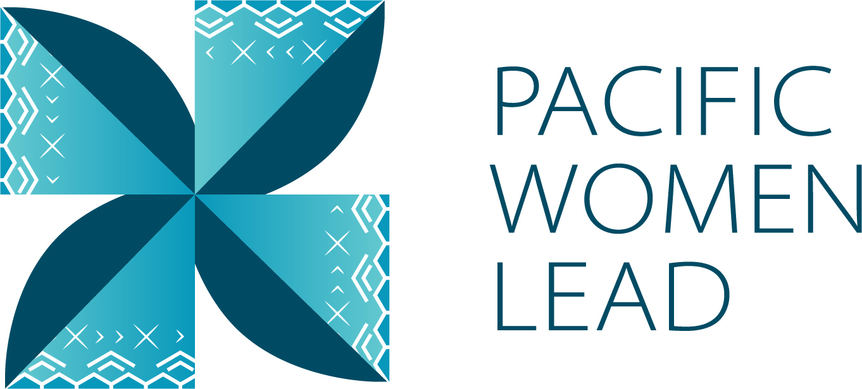

Vanuatu Country Brief

December 2024

**Contents**

1 Pacific Women Lead overview 1

2 Program components 1

3 Purpose of the Country Brief 2

**3.1** **Vanuatu Country Brief** 2

4 Pacific Women Lead at SPC Projects 3

**4.1** **Project and implementing partner count by outcome and sub-outcome** 3

**4.2** **Type of implementing partner** 4

**4.3** **Committed funding by outcome and sub-outcome** 4

5 Pacific Women Lead Governance Board Projects 4

**5.1** **Discretionary Funds** 4

**5.2** **Board Members** 5

6 Pacific Women’s Funds Projects 5

7 DFAT Regional Projects 5

**7.1** **Project and implementing partner count by outcome and sub-outcome** 5

**7.2** **Type of implementing partner** 7

**7.3** **Committed funding by outcome and sub-outcome** 7

8 DFAT Post in Vanuatu Projects 8

**8.1** **Project and implementing partner count by outcome and sub-outcome** 8

**8.2** **Type of implementing partner** 8

**8.3** **Committed funding by outcome and sub-outcome** 9

**8.4** **Reach data by projects and indicators** 9

9 Pacific Women Lead Enabling Services Activities 2

**9.1** **Monitoring, Evaluation and Learning Support** 2

**9.2** **Quality Technical Assurance Group (QTAG)** 2

**9.3** **Grant Management** 3

Annex 1: Projects implemented in Vanuatu 5

Annex 2: Pacific Women Lead Governance Board Members 15

Annex 3: Cumulative reach data (2021 to present) for DFAT Post in Vanuatu Projects 20

Annex 4: Whole-of-portfolio PWL Indicators 21

Annex 5: Impact Stories 25

# **Pacific Women Lead overview**

Pacific Women Lead (PWL) is a portfolio of regional investments valued at AUD170 million over 5 years (2021 – 2026). PWL aims to advance gender equality and is ambitious in its intent to take a Pacific-led, intersectional and transformative approach to promoting gender equality in the region and bringing new emphasis to strengthening regional action and architecture in support of gender equality.

PWL builds on the strengths and lessons learned through Australia’s 10-year gender equality investment, Pacific Women Shaping Pacific Development.

The goal of PWL is for: Pacific women and girls, in all their diversity, to be safe and equitably share in resources, opportunities and decision-making with men and boys.

The program works across three outcome areas with the following end-of-PWL sub-outcomes:

Table 1 Pacific Women Lead outcomes and sub-outcomes

|  |  |
| --- | --- |
| **Outcomes** | **Sub-outcomes** |
| Women’s Leadership Promoted (WLP) | * More women and girls, in all their diversity, are respected, listened to and are influencing decision-making at all levels **(Women and girls’ voice)** * The Pacific feminist movement has grown in depth, is better connected and their expertise is drawn upon by Pacific partners **(Pacific feminist civil society)** |
| Women’s Rights Realised (WRR) | * Diverse women and adolescent girls have improved access to quality health services, especially sexual and reproductive health **(Women’s health – SRHR)** * Diverse women have more equitable access to resilient economic opportunities, including increased voice in economic decision-making **(Women’s Economic Empowerment)** * Violence against women and children is reduced, and survivors have access to quality support services, including in times of disasters **(Women’s safety)** |
| Pacific ownership and regional effectiveness (POE) | * Pacific Governments and development partners are implementing programs and policies that support gender equality **(Gender mainstreaming)** * There is robust engagement, cooperation and mutual sharing between regional agencies and intergovernmental organisations to deliver on gender equality commitments **(Pacific ownership)** |

# **Program components**

PWL is a portfolio of 5 components; each component is a distinct implementing partner [1]of PWL: Through these components, technical support and funding is provided to Pacific women-led civil society organisations, multilateral and regional organisations, government and other stakeholders.

The components of the portfolio include:

**The Pacific Community (SPC) as a key implementing partner of PWL. PWL** at SPC sits within SPC’s Human Rights and Social Development (HRSD) division and supports the implementation of key regional commitments outlined in the Pacific Leaders’ Gender Equality Declaration, the Pacific Platform for Action on Gender Equality and Women’s Human Rights, and the outcomes of the Triennial Conference of Pacific Women. Through PWL, SPC provides technical, convening and funding support to government ministries, civil society, and other partners, while also acting as Secretariat for the PWL Governance Board.

**Pacific Women Lead Governance Board** provides direct strategic oversight on SPC’s PWL related activities and decides the allocation of AUD 5 million of discretionary funds. The Board also provides strategic advisory to DFAT Canberra (Australia) in enhancing regional effectiveness by identifying gaps and opportunities across the Pacific but does not provide direct strategy advice or have a decision-making role over the DFAT Posts or the Pacific Women’s Funds component. The Board receives reporting on outcomes for all other portfolio components through the PWL Annual Progress Report, compiled by the Pacific Women Lead Enabling Services.

**Pacific Women’s Funds** are supported to expand their work with women’s rights organisations and human rights defenders in the Pacific. This includes funding their advocacy activities to draw more resources for work towards gender equality to the region and funds to support the establishment of the first Pacific Feminist Fund.

**DFAT manages bilateral and regional programs. DFAT Canberra (Australia) and Fiji Post** manages direct funding arrangements for regional gender projects, including (but not limited to) UN Women’s Markets for Change and Pacific Partnership to End Violence Against Women and Girls, and UNFPAs Transformative Agenda program. **DFAT Posts** manage and fund country-level gender projects. Importantly, bilateral programs have autonomy in design, delivery and governance, but their gender programming aligns with the PWL goal and outcomes, and they will report results into the Pacific Women Lead Monitoring, Evaluation and Learning (MEL) System.

**Pacific Women Lead Enabling Services** (PWLES) managed by DT Global, provides support to SPC and DFAT to implement PWL. This includes whole-of-portfolio monitoring, evaluation, and learning (MEL), partnership brokering and the delivery of an independent Quality and Technical Assurance Group (QTAG). It is the role of the MEL team within the PWLES to compile a yearly whole-of-portfolio progress report, which brings together all the above components of PWL[2].

# **Purpose of the Country Brief**

A Country Brief is designed and tailored for each country to serve the following purposes:

* Increase PWL partners and external stakeholders’ visibility of projects that are being funded or come under the PWL portfolio in a country. It is intended to contribute to greater collaboration and coordination by grantors and grantees.
* Serve as a mechanism for PWLES to collaborate with the 5 components of PWL to review project details (i.e. project information, timeframes and budget) to ensure all information captured in the PWL MEL system is correct.
* Support DFAT’s internal reporting, where investments are above AUD3 million.

Therefore, the Country Brief is designed to cover a calendar year (January to December) and will be updated six monthly. The information will be drawn from the PWL quantative database to show:

1. Gender projects funded by the 5 components of PWL
2. Reach data[3] against PWL quantitative indicators
3. Impact stories collected by partners or PWLES

## **Vanuatu Country Brief**

This Country Brief update is for Vanuatu. It provides information on all projects that are being funded by or come under the 5 components of PWL in Vanuatu and focusses on January to June 2024 period.

# **Pacific Women Lead at SPC Projects**

The Pacific Community (SPC) is a distinct implementing partner of PWL (known as PWL at SPC) and has a grant agreement with DFAT Canberra, valued at AUD57,600,000. From this total value, SPC provides technical support to Pacific governments, hosts and supports regional convenings (such as the Triennial) and a grants program for its government partners and women’s organisations across the Pacific. You can also watch a short explainer video here: [Pacific Women Lead at the Pacific Community (PWL at SPC) explainer video](https://youtu.be/bBOpTVKh8Hs?si=OxeE63PdSKrxVdbT).

This section provides information on projects funded and managed by PWL at SPC that are implemented in Vanuatu.

## **Project and implementing partner count by outcome and sub-outcome**

PWL at SPC funds 4 downstream[4] implementing partners to implement 5 projects. Table 2 provides an overview of the projects (refer to Annex 1 for detailed project information).

Table 2 Overview of PWL at SPC projects in Vanuatu

|  |  |  |
| --- | --- | --- |
| **Project name** | **Downstream implementing partner** | **Outcome and sub-outcome** |
| Ni Vanuatu Women with Disabilities Leading Resilience to Disasters and Climate Change | ActionAid Vanuatu | Women’s leadership promoted – women and girls’ voice |
| Pacific Girl: Laef Blo Mi, Vois Blo Mi | Care Vanuatu | Women’s leadership promoted – women and girls voice |
| Women’s Leadership and Decision-making in Beef Industry | Department of Industry | Women’s rights realised – women’s economic empowerment |
| Strengthening Women’s Voice in Local Governance | Care Vanuatu | Women’s leadership promoted – women and girls voice |
| Shifting the Power Coalition: Strengthening Diverse Women's Leadership in Humanitarian Action | ActionAid Australia (Vanuatu Young Women for Change) | Women’s leadership promoted – feminist civil society |

Of the 5 projects, four projects work in Women’s leadership promoted in women and girls voice (3) and Pacific Feminist Civil Society (1). One project works in Women’s rights realised in women’s economic empowerment (1).

Figure 1 Projects by outcome and sub-outcome

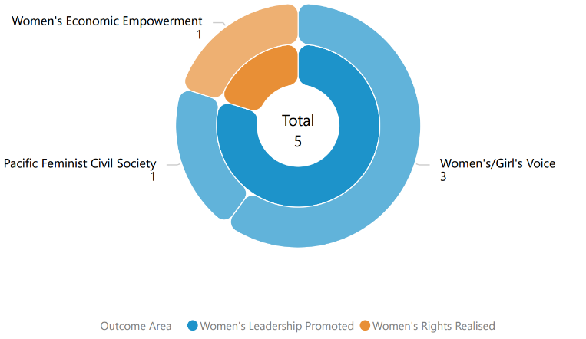

## **Type of implementing partner**

Of the 4 downstream implementing partners, 3 are international NGOs and 1 is a government partner.

Figure 2 Type of implementing partner

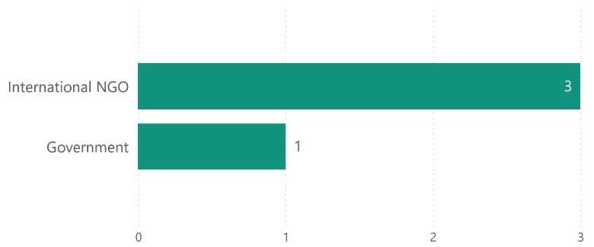

## **Committed funding by outcome and sub-outcome**

The committed funding for each of the projects comes out of PWL at SPC AUD57,600,000 budget.

Table 3 Committed funding by outcome and sub-outcome

|  |  |  |
| --- | --- | --- |
| **Outcome** | **Sub-outcome** | **Funding Committed (AUD)** |
| Women’s leadership promoted | Women and girls Voice | 1,752,702.64 |
| Women’s leadership promoted | Pacific feminist civil society | 532,233.07 |
| Women’s rights realised | Women’s economic empowerment | 312,700 |
| **Total** |  | **2,597,635.71** |

# **Pacific Women Lead Governance Board Projects**

This section will provide information on projects funded by the PWL Governance Board for Vanuatu when available and entered into the PWL quantitative database.

## **Discretionary Funds**

Five million has been set aside for activities to be funded at the discretion of the Governance Board with the aim to add value to and build on existing PWL activities. The Board’s Secretariat (SPC) developed seven criteria to guide the use of the Board funds. The seven criteria include: 1) alignment with PWL outcomes; 2) Pacific-led approaches; 3) regional or multi-country in scale; 4) promoting transformational change; 5) development effectiveness; 6) diversity and inclusion; 7) informed by research, evidence and data.

There are no projects currently being funded by the Board in Vanuatu.

## **Board Members**

The PWL Governance Board has 13 members, 12 of whom are from the Pacific region (refer to Annex 2 for detailed list of all members). DFAT’s Assistant Secretary of the Pacific Development Branch is an ex-officio member of the Board. At this point in time, there is no Vanuatu representative on the Governance Board.

# **Pacific Women’s Funds Projects**

The Pacific Women’s Funds is made up of three feminist organisations: Women’s Fund Fiji, Urgent Action Fund Asia and Pacific and Pacific Feminist Fund. Table 4 provides an overview of the Pacific Women’s Fund organisations.

More information about Women’s Fund Fiji and Urgent Action Fund Asia and Pacific can be found on their websites: [Women's Fund Fiji](https://womensfundfiji.org/) and [Urgent Action Fund Asia and Pacific](https://www.uafanp.org/). Pacific Feminist Fund is recently established and does not have a website.

Of the three feminist organisations, Pacific Feminist Fund and Urgent Action Fund Asia and Pacific provides grants to women’s organisations across the Pacific. Currently, there are no projects funded through this component being implemented in Vanuatu.

Table 4 Overview of Pacific Women’s Fund organisations

|  |  |  |  |
| --- | --- | --- | --- |
| **Partner organisation** | **Committed Funding** | **Funding Source** | **Outcome and sub-outcome** |
| Women’s Fund Fiji | 4,841,659.75 | Bilateral – Fiji | Women leadership promoted – Pacific feminist civil society |
| Urgent Action Fund Asia and the Pacific | 4,336,500 | Regional | Women leadership promoted – Pacific feminist civil society |
| Pacific Feminist Fund | 1,170,849 | Regional | Women leadership promoted – Pacific feminist civil society |
| **Total** | **10,349,008.75** |  |  |

# **DFAT Regional Projects**

This section provides information on regional (multi-country) gender activities that are implemented in Vanuatu. These regional gender activities are managed by either DFAT Post in Fiji or DFAT Canberra (Australia).

## **Project and implementing partner count by outcome and sub-outcome**

There are 11 regional projects implemented by 8 distinct implementing partners in Vanuatu, plus one research project. Table 5 provides an overview of the projects (refer to Annex 1 for detailed information).

Table 5 Overview of regional projects implemented in Vanuatu

|  |  |  |
| --- | --- | --- |
| **Project name** | **Distinct implementing partner** | **Outcome and sub-outcome** |
| Child Protection Program in Kiribati, Solomon Islands and Vanuatu | UNICEF | Women’s rights realised – women’s safety |
| Core funding for the IPPF global strategic framework (22-26) and Pacific Strategy (22-26) | International Planned Parenthood Federation (IPPF) | Women’s rights realised – women’s health (SRHR) |
| Emerging onto the world stage - Tennis Australia Women and Girls Pacific Extension | Tennis Australia | Women’s leadership promoted – women and girls voice |
| Gender responsive Climate Policy and Women's Climate Leadership in the Pacific | Women’s Environment and Development Organisation (WEDO) | Women’s leadership promoted – women and girls voice |
| Markets for Change Project Phase 2 | UN Women | Women’s rights realised – women’s economic empowerment |
| Pacific Partnership to End Violence Against Women and Girls Phase 2 | SPC's Human Rights and Social Development (HRSD) Division Support | Women’s rights realised – women’s safety |
| Progressing Gender Equality in the Pacific | SPC's Human Rights and Social Development (HRSD) Division Support | Pacific ownership and regional effectiveness – gender mainstreaming |
| Progressing Pacific Islands Forum (PIF) Gender Equality, Disability and Social Inclusion Priorities | Pacific Islands Forum Secretariat (PIFS) | Pacific ownership and regional effectiveness – gender mainstreaming |
| SPC’s Human Rights and Social Development (HRSD) Division Support | SPC's Human Rights and Social Development (HRSD) Division Support | Pacific ownership and regional effectiveness – Pacific ownership |
| A Transformative Agenda for Women, Adolescents and Youth in the Pacific: Towards Zero Unmet Need for Planning (Phase 2) | UNFPA | Women’s rights realised – women’s health |
| Women’s Resilience to Disasters (WRD) Program | UN Women | Women’s leadership promoted – women and girls voice |
| **Research activities** | **Distinct implementing partner** |  |
| Strengthening Capacities for Measuring Violence Against Women (nKOwVAWdata)  Phase 2 | UNFPA | Research activity |

Of the 11 projects, five projects work in Women’s rights realised: two projects in women’s safety (2) and two in women’s health (SRHR) (2) and one in women’s economic empowerment (1). Three projects work in Women’s leadership promoted in women and girl’s voice (3) and three projects work in Pacific ownership and regional effectiveness: two projects in gender mainstreaming (2) and one in Pacific ownership (1).

Figure 3 Projects by outcome and sub-outcome

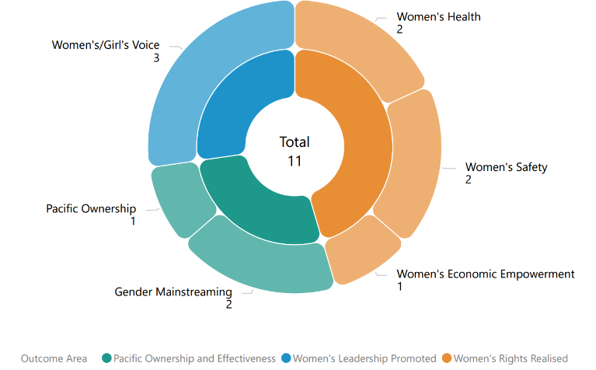

## **Type of implementing partner**

Of the 8 distinct implementing partners, three is an international NGOs (3), three is a regional/multilateral organisation (3), and two inter-governmental organisations (3).

Figure 4 Type of implementing partner

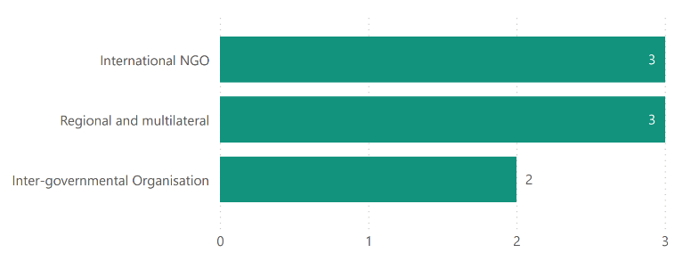

## **Committed funding by outcome and sub-outcome**

The committed funding is total grant value and is not broken down by funding allocation for Vanuatu. It is notpossible to provide specific funding allocation of regional projects for Vanuatu, nor actual spend. This information is not provided to PWLES.

**Table 6 Committed funding by outcome and sub-outcome**

|  |  |  |
| --- | --- | --- |
| **Outcome** | **Sub-outcome** | **Committed Funding (AUD)** |
| Women’s rights realised | Women’s economic empowerment | 9,951,871 |
| Women’s rights realised | Women’s health | 52,500,000 |
| Women’s right realised | Women’s safety | 20,276,973.05 |
| Women’s leadership promoted | Women and girls’ Voice | 15,310,900 |
| Pacific ownership and regional effectiveness | Gender mainstreaming | 6,059,377 |
| Pacific ownership and regional effectiveness | Pacific ownership | 2,700,000 |
| **Total** |  | **106799121.05** |

# **DFAT Post in Vanuatu Projects**

This section provides an overview of gender activities funded and managed by DFAT Post in Vanuatu.

## **Project and implementing partner count by outcome and sub-outcome**

There are 3 projects implemented by 3 distinct implementing partners in Vanuatu, and a research project. Table 7 provides an overview of the projects (refer to Annex 1 for detailed information).

Table 7 Overview of DFAT Post in Vanuatu projects

|  |  |  |
| --- | --- | --- |
| **Project** | **Distinct implementing partner** | **Outcome and sub-outcome** |
| Gender Equality Together! Phase 2: Building a movement for gender equality and freedom from violence in Vanuatu | Care Vanuatu | Women’s rights realised – women’s safety |
| Core support to Sista (We Rise Coalition) | Sista | Women’s leadership promoted – Pacific Feminist Civil Society |
| Vanuatu Gender Equality Program Phase 8 | Vanuatu Women’s Centre | Women’s rights realised – women’s safety |
| **Research activity** | **Distinct implementing partner** |  |
| National Gender-based Violence Prevalence Study | Vanuatu Women’s Centre | Research activity |

Of the 3 projects, two projects work in Women’s rights realised in women’s safety (2) and one project works in Women’s leadership promoted in Pacific Feminist Civil Society (1).

Figure 5 Projects by outcome and sub-outcome

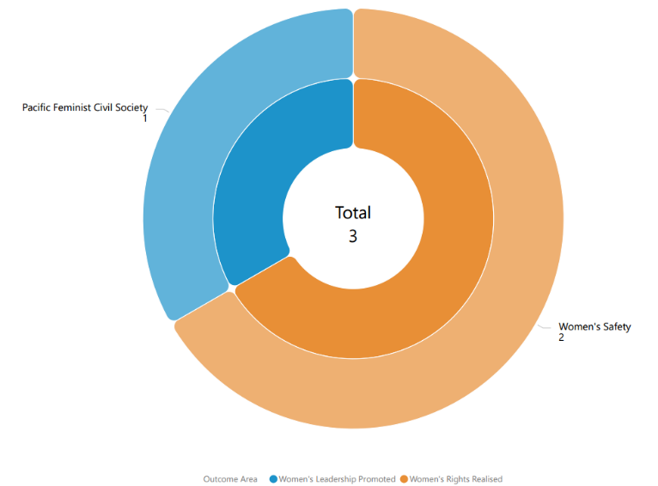

## **Type of implementing partner**

Of the 3 distinct implementing partners, 2 are Civil Society Organisations and 1 is an international NGO.

Figure 6 Type of implementing partner

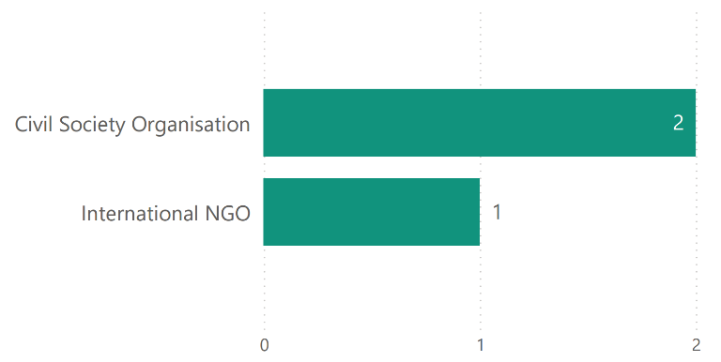

## **Committed funding by outcome and sub-outcome**

Table 8 Committed funding by outcome and sub-outcome

|  |  |  |
| --- | --- | --- |
| **Outcome** | **Sub-outcome** | **Committed Funding (AUD)** |
| Women’s rights realised | Women’s safety | 9,110,000 |
| Women’s leadership promoted | Pacific Feminist Civil Society | 80,000 |
| **Total** |  | **9,190,000** |

## **Reach data by projects and indicators**

From January to June 2024, one project provided quantitative data against PWL indicators (Table 9). Table 10 provides detailed data against each indicator. For cumulative reach data, refer to Annex 2.

Table 9 Projects providing quantitative data by outcome and sub-outcome

|  |  |  |
| --- | --- | --- |
| **Outcome** | **Sub-outcome** | **Projects** |
| Women’s leadership promoted | Pacific Feminist Civil Society | Gender Equality Together! Phase 2 Building a movement for gender equality and freedom from violence in Vanuatu |
| Women’s rights realised | Women’s safety | Gender Equality Together! Phase 2 Building a movement for gender equality and freedom from violence in Vanuatu |

Table 10 January to June 2024 Reach data for DFAT Post in Vanuatu projects

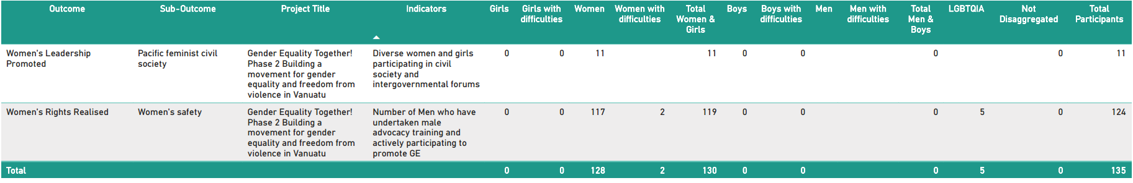

# **Pacific Women Lead Enabling Services Activities**

This section provides information on the PWLES activities and support available for DFAT Posts and PWL at SPC. PWLES is valued at AUD32 million.

## **Monitoring, Evaluation and Learning Support**

**PWL MEL System:** The PWLES manages the PWL portfolio MEL system. The MEL system has two databases:

1. A **Quantitative database** that tracks progress against PWL indicators and can be accessed through a dashboard on the PWL website: [Pacific Women Lead - Our Impact](https://pacificwomen.org/our-impact/). The dashboard is updated six monthly after each reporting cycle.
2. A **Qualitative database** that allows the PWLES MEL team to code partner narrative reports against qualitative change domains (Refer to Annex 2).

The MEL system has the capability to organise and provide data, particularly for DFAT’s reporting processes (IMR and Tier 2 reporting), and qualitative evidence or quotes that can be used for briefing documents or speeches.

**Collection of qualitative impact stories:** PWLES collaborates with distinct and downstream implementing partners in each country to collect impact stories twice a year (February and July). These stories are used to inform the PWL MEL system and can be used by the PWL components for public diplomacy. Additionally, the stories will be published on the PWL website: [Pacific Women Lead - Stories](https://pacificwomen.org/latest-updates/stories/) and will be annexed to this brief when available.

**Monitoring the rights of people with disabilities Framework:** PWLES developed two guidance notes to support distinct and downstream partners to enhance data collection and reporting on disability inclusion. The guidance notes can be accessed here: [Pacific Women Lead - Resources](https://pacificwomen.org/resources/). PWLES has also facilitated a webinar discussion on these guidance notes which you can watch here: [Monitoring the journey towards the realisation of rights for people with disabilities](https://youtu.be/JCeG_6OmOuE?si=WgwOnXcFATJoiKG7).

**Annual Reflection and Analysis Workshop:** Each year, PWLES co-convenes an Annual Reflection and Analysis Workshop in September that brings together distinct and downstream implementing partners across the PWL portfolio to collaborate and analyse data to understand the program’s progress and make recommendations for the program. A summary of this year’s Annual Reflection and Analysis Workshop can be watched here: [Second Pacific Women Lead Annual Reflection and Analysis Workshop (2024)](https://youtu.be/p5gbcZHlKdg?si=7LXyyJI6AQalYxBT).

**Clear Horizon Academy PWL MEL Platform:** PWLES developed three training modules with Clear Horizon Academy to support PWL partners: Using Data for Reporting and Learning, Collecting Impact Stories and Understanding, monitoring and reporting disability inclusion. These are online and self-paced modules and partners can seek access through the PWLES.

## **Quality Technical Assurance Group (QTAG)**

Through the QTAG, PWLES provides technical support to smaller DFAT Post in Tuvalu, Kiribati, Federated States of Micronesia, Palau, Nauru, Niue, and Republic of Marshall Islands. QTAG currently offers tailored GEDSI support through consultants to smaller DFAT Posts:

**Gender Focal Point (GFP) mentoring:** QTAG continues to provide regular mentoring to GFPs in smaller DFAT Posts to support them to carry out their role with confidence through QTAG’s technical partner Co-LAB. The mentoring provides a space to support GFPs broader professional development priorities including provide advice and feedback on communication, help with problem solving and to act as a sounding board to troubleshoot issues and ideas with the GFPs without conflicting with other management and supervision support provided by the GFP’s manager/supervisor, and the GFPs existing workload.

**GEDSI Analysis and Country Plans/Design:** Through its panel of consultants, QTAG provides support to smaller DFAT Posts to carry out GEDSI Analysis and develop their Gender Country Plan/Design. PWL support to the development of country briefs/designs includes PWL whole-of-portfolio MEL briefings to ensure there is alignment to the PWL whole-of-portfolio MEL Framework. Larger Posts can draw on this support to ensure alignment to PWL whole-of-portfolio MEL.

**Larger DFAT Posts can access the panel of consultants on the QTAG but will have to cover the associated costs.** If Post would like to access the QTAG, Post can reach out to the QTAG Coordinator for initial discussion.

## **Grant Management**

PWLES provides program management support to DFAT Posts in smaller countries and DFAT Canberra. Currently, PWLES provides grant management support to:

1. Two regional programs: Balance of Power and We Rise Coalition Phase 3,
2. Three projects in Tuvalu (funded through the Tuvalu DFAT Post Gender Country Plan), and
3. Management of 3 Gender Advisers in Tuvalu (Gender Equality and Social Inclusion Adviser), FSM (Family Protection Adviser) and Palau (Family Protection Act Adviser).

**Balance of Power and We Rise Coalition Phase 3**

Balance of Power and We Rise Coalition Phase 3 are implemented in Vanuatu by 2 distinct implementing partners, and 1 downstream implementing partner for one of the projects. Table 11 provides an overview of the projects (refer to Annex 1 for detailed information).

We Rise Coalition Phase 3 is transitioning into Phase 4 which will be managed by DFAT Canberra from March 2025. Note that DFAT Post in Vanuatu contributes AUD80,000 to We Rise Phase 4 to support Sista. This is captured under section 8 of this country brief. Table 11 only captures We Rise Phase 3.

**Table 11 Overview of projects implemented by PWLES**

|  |  |  |  |
| --- | --- | --- | --- |
| **Project Name** | **Distinct implementing partner** | **Downstream implementing partner** | **Outcome and sub-outcome** |
| Balance of Power | Pacific Women Lead Enabling Services (managed by DT Global) |  | Women’s leadership promoted – women and girls voice |
| Feminist movements for transformative change: We Rise Coalition Phase 3 | International Women’s Development Agency (IWDA) | Sista | Women’s leadership promoted – feminist civil society |

The two projects work in Women’s leadership promoted in women and girls voice (1) and Pacific Feminist Civil Society (1).

Figure 7 Projects by outcome and sub-outcome

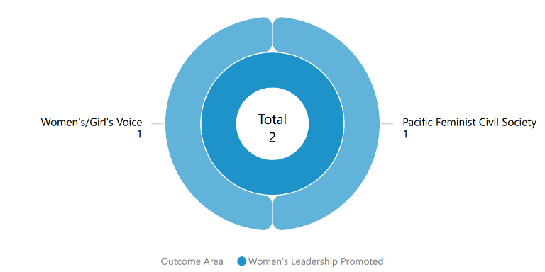

**Type of implementing partner**

One implementing partner is a managing contractor and the other is an international NGO.

Figure 9 Type of implementing partner

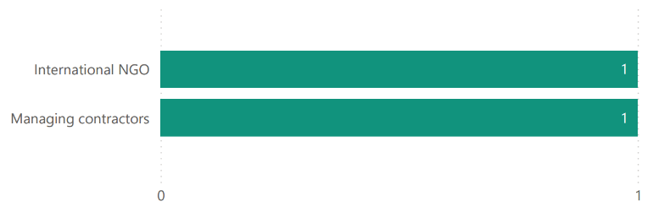

**Committed funding by outcome and sub-outcome**

The committed funding is total grant value and is not broken down by funding allocation for Vanuatu. The committed funding comes out of PWLES AUD32 million.

**Table 12 Committed funding by outcome and sub-outcome**

|  |  |  |
| --- | --- | --- |
| **Outcome** | **Sub-outcome** | **Committed Funding (AUD)** |
| Women’s leadership promoted | Women and girls voice | $11,597,674 |
| Women’s leadership promoted | Pacific feminist civil society | $3,240,024 |
| **Total** |  | **$14,837,698** |

# 

# **Annex 1: Projects implemented in Vanuatu**

Annex 1 provides detailed information on each project’s name, implementing partner, project description, end of project outcomes, total funding (AUD) and timeframe of all projects for Vanuatu under the 5 components of PWL that have been entered into the PWL quantitative database.

Table 13 provides a summary of the projects implemented in Vanuatu by component. Note that total funding only reflects the grants managed under these components and does not reflect the total value of the components.

Table 13 Summary of projects implemented in Vanuatu

|  |  |  |
| --- | --- | --- |
| PWL Components | # Of Projects | Total Committed Funding (AUD) |
| PWL at SPC Projects | 5 | 2,597,635.71 |
| PWL Governance Board Projects | N/A |  |
| Pacific Women’s Fund Projects | N/A |  |
| DFAT Regional Projects | 14 | 106,799,121.05 |
| DFAT Post in Vanuatu Projects | 2 | 9,110,000 |
| PWLES Projects | 2 | $14,837,698 |
| **Total Combined Funding** |  | **133,344,454.76** |

#### PACIFIC WOMEN LEAD AT SPC PROJECTS

|  |  |  |  |  |
| --- | --- | --- | --- | --- |
| NO. | PROJECT NAME AND PARTNER | PROJECT DESCRIPTION | END OF PROJECT OUTCOMES | VALUE (AUD) AND TIMEFRAME |
| 1 | Ni Vanuatu Women with Disabilities Leading Resilience to Disasters and Climate Change  (ActionAid Vanuatu) | To empower women with disabilities to claim their rights and improve their livelihoods. They will be trained as trainers and supported in operating their businesses. provision of small business grants, and support to establish sister savings and loan schemes to enhance their collective savings. Trainings will be provided to support women to establish protection action plans. This will include identifying referral pathways and learning exchanges with relevant services provided through Women’s Affairs. Th project will prepare women with disabilities to participate in emergency preparedness, recovery and response through train the trainer model. (SMS blasts, phone tree networks and sister circles). |  | $500,000  2024 - 2025 |
| 2 | Pacific Girl: Laef Blo Mi, Vois Blo mi | Care's Laef blo mi, vois blo mi program in Vanuatu will work with girls aged 12 - 19 in rural and remote areas of Tafea Province. Pacific Girl will enable CARE to extend life skills and respectful relationships education to younger adolescents in schools, including around 800 adolescent girls. The program includes male peers, teachers and families to ensure girls are safe and respected. | * Adolescent girls’ interests and priorities are increasingly visible in decision making * Adolescent girls have increased agency (knowledge, skills, and voice).   Adolescent girls are increasingly respected and valued by communities and stakeholders.  Adolescent girl programming in the Pacific is connected, strengthened and informed by the interests and priorities of Pacific girls.  Evidence is built and shared on effective gender transformative programming for adolescent girls in the Pacific and incorporated into practice in Pacific Women’s work | $752,702.64  2021 - 2024 |
| 3 | Strengthening Women’s Voice in Local Governance  (CARE Vanuatu) | Support the of Vanuatu's decentralisation policy by working with the Central Tanna Area Council in Tafea Province as a case study to promote diverse women’s leadership in community governance structures. CARE will deliver a five-day workshop and follow up reflection sessions to 256 members of the village and tribal pillar committees (176 women and 80 men). Workshops will then be rolled out to 256 pilar and village committee members. Follow up sessions will be held twice with workshop participants to reinforce key messaging, allow space for reflection, monitor for any negative or unintended impacts, and troubleshoot solutions. Sessions with women will also allow for them to strategize, plan learn and support each other to advance women’s leadership. Finally, workshop materials will be refined and two learning briefs and a video capturing the process and outcomes will be produced for sharing and learning at forums at provincial, national and regional levels. |  | $500,000  2024 – 2025 |
| 4 | Shifting the Power Coalition: Strengthening Diverse Women's Leadership in Humanitarian Action (ActionAid Australia) | Works to ensure diverse Pacific women’s voices are included in disaster planning and response at all levels with tangible outcomes around diverse women leaders in six countries.  The Coalition includes ActionAid Vanuatu, FemLink Pacific, Nazareth Centre for Rehabilitation, Pacific Disability Forum, Talitha Project Incorporated, Transcend Oceania, Vanuatu Young Women for Change, Vois Blong Mere, YWCA PNG and YWCA Samoa.  Shifting the Power Coalition partner in Vanuatu are ActionAid Vanuatu and Vanuatu Young Women for Change. | * 200 diverse women leaders in six countries will have increased capacity to engage in local and national disaster coordination mechanisms and to organise and influence decision making * Diverse women’s needs and capacities in times of crises will be documented and contribute to evidence-based disaster planning and response at national and regional level * Platforms will be established to strengthen diverse Pacific women’s voices in regional humanitarian and disaster resilience forums and their influence on policy and decision making | $532,233.07  2022 – 2024 |
| 5 | Women’s Leadership and Decision-making in the Beef Industry  (Department of Industry) | Women’s Economic Empowerment [Cattle Industry] Initiative in Sanma Province. |  | $312,700  2024 - 2025 |

#### PACIFIC WOMEN LEAD GOVERNANCE BOARD PROJECTS

There are currently no projects funded under this component. A table will be included when projects funded by the Board are implemented in Vanuatu.

#### PACIFIC WOMEN’S FUNDS PROJECTS

There are currently no projects funded under this component. A table will be included when projects funded by the Pacific Women’s Funds are implemented in Vanuatu.

#### DFAT REGIONAL PROJECTS

|  |  |  |  |  |  |
| --- | --- | --- | --- | --- | --- |
| NO. | AID-WORKS NUMBER | PROJECT NAME AND PARTNER | PROJECT DESCRIPTION | END OF PROJECT OUTCOMES | VALUE (AUD) AND TIMEFRAME |
| 1 | 72410/14 | Child Protection in Kiribati, Solomon Islands and Vanuatu  (UNICEF) | The programme aims to protect children in Kiribati, Solomon Islands, Vanuatu and Samoa from neglect, abuse, and exploitation by strengthening multi-sector multi-stakeholder child protection (CP) systems. It includes three components: establishing a normative framework; strengthening services; and promoting social and behaviour change. | * Governments have strengthened child protection institutional frameworks. * Government and other service providers (non-governmental agencies) have enhanced capacities to provide child protection services which prevent and respond to violence and abuse * Caregivers, families and communities have increased knowledge and skills to eliminate harmful practices and better protect children from violence and abuse | $3,542,280  2021 – 2024 |
| 2 | 77862 | Core Funding for IPPF Global Strategic Framework (22-26) and Pacific Strategic Strategy (22-26) (Phase 2) | The strategy aims to come together and break through the barriers that limit sexual and reproductive health and rights (SRHR), thereby enabling quality SRHR to be realised for everyone in the Pacific. It is an ambitious agenda that is informed by the emerging challenges and opportunities in the region | * Centre Care on People: Expand choice and access in coordination with government partners and national civil society and explore digital options and self-care.   Move the Sexuality Agenda: Shift attitudes and norms in the Pacific through grass roots advocacy to drive gains in SRHR, ensuring the voices of young people and marginalised or excluded groups are heard.  Solidarity for Change: Create new strategic partnerships and contribute to social movements on SRHR and intersectional areas, and harness opportunities for learning and sharing  Nurture our Federation: Strengthen IPPF’s Secretariat and Member Associations through improvements in governance, financial and programmatic management, and draw on the Federation’s global expertise and knowledge base. | $2,000,000  2023 – 2026  *Phase 1 Completed*  *$500,000*  *2021 – 2022* |
| 3 | 77821 | Emerging onto the World Stage - Tennis Australia Women and Girls Pacific Extension -  (Tennis Australia) | Deliver programs and pathways to create sustainable benefits for women in the Pacific, either as a player, coach or paid administrator/Development Officer. Create economic efficiencies, seeing supporting partners (ITF, ONOC and TA) come together to maximise opportunities for program stakeholders. | Stream 1: Coaching   * Increase the number of women in decision-making and leadership roles   Strengthen career and volunteer pathways and opportunities on the court  Create sustainable networks to influence and advance women  Inspire and develop women to be a public voice for tennis from grassroots to the world stage  Stream 2: Community Leadership  Increase the number of women in decision-making and leadership roles in Tennis organisations  Develop the governance structures to create safe, welcoming and inclusive environments for women and girls  Stream 3: Talent   * Improve access to safe inclusive sporting competitions and facilities to encourage higher participation of girls and young women * Provide pathways for elite players to transition from Juniors to the Professional Tour (ITF and WTA) * Increase retention of women elite players able to transition to coaches and leaders in the sport | $1,111,000  2022 – 2026 |
| 4 | 77520 | Gender responsive Climate Policy and Women’s Climate Leadership in the Pacific  (WEDO) | Advance Pacific women's leadership in climate change decision-making via WEDO's Women Delegates Fund (WDF) program, as well as enhance the implementation of gender-responsive climate policy via capacity strengthening for National Gender and Climate Change Focal Points in the Pacific. | * Strengthen Pacific women’s leadership in climate change diplomacy and policymaking via travel support, training and networking * Support effective operationalization of the role of National Gender and Climate Change Focal Points across Pacific Island countries | $699,900  2022 – 2024 |
| 5 | 73159/28 | Markets for Change (M4C) Phase 2 UN Women | Markets for Change Phase II aims to promote gender equality and the economic empowerment of market vendors, with specific attention to the needs and aspirations of women market vendors. | * Inclusive, effective and representative marketplace groups are created and grow, further enabled and recognised.   Improved socio-economic security of women market vendors.   * Local governments, market management and other decision-makers are gender-responsive, effective and accountable to women market vendors. * Physical market structures and operating systems are improved to make markets more gender-responsive, safer, more accessible, sustainable and resilient to disaster risks and climate change | $9,951,871  2022 – 2026 |
| 6 | 77334/8 | Pacific Partnership to End Violence Against Women and Girls (Phase 2)  (UN Women) | The Pacific Partnership seeks to promote Gender Equality, prevent VAWG, and increase access to quality VAWG response services for survivors. The programme engages with over 100 partners across the region, including national governments, CSOs, EVAWG networks, faith-based groups, and sports associations. | * To enhance Pacific youth’s formal in-school and informal education on gender equality and prevention of violence against women and girls. * To promote gender equitable social norms at individual and community levels to prevent violence against women and girls, and to ensure survivors have access to quality response services. * To empower national and regional civil society organisations (CSOs) to advocate, monitor and report on regional institutions and governments commitments to enhance gender equality and prevent violence against women and girls. | $15,934,693.05  2022 – 2027  *Phase 1 completed*  *$800,000*  *2021 – 2023* |
| 7 | 69294/46 | Progressing Gender Equality in the Pacific  (HRSD SPC) | PGEP’s overall objective is to strengthen gender mainstreaming, policy design, and implementation, including strategic support to civil society organisations, while supporting country and regional gender data and statistical initiatives. | * Gender Mainstreaming: Public Institutions are implementing policies, practices and programs that support gender equality * Accountability Mechanisms: Government gender mainstreaming planning budgeting, accountability, monitoring, and reporting systems enhance progress towards achieving gender equality commitments | $2,156,401  2021– 2023 **Completed**  Will come under PWL at SPC in 2024 |
| 8 | 78400 | Pacific Island Forum Secretariat Gender Disability and Social Inclusion  (Pacific Island Forum Secretariat) | Progressing Pacific Island Forum Secretariat Gender Equality Disability and Social Inclusion priorities | * PIFS Social Policy team to implement priorities on gender equality, disability and social inclusion including in the implementation and monitoring of the 2050 Strategy for the Blue Pacific Continent including gender policy capability and advice * Enhanced strategic engagement and communications * Support to members and actioning outcomes * Progressing disability inclusion * Progressing implementation of social policy program | $3,902,976  2023 - 2026 |
| 9 | 69294/67 | SPC’s Human Rights and Social Development (HRSD) Division Support | HRSD leads SPC’s work in the areas of human rights, gender equality and social development. | HRSD Business Plan   * Objective 1: Strengthen inclusive, transparent, and responsive governance and institutions for human rights, gender equality and social development. * Objective 2: Mobilise, empower, and build conditions for gender equality, equity and social inclusion in society and development * Objective 3: Promote, preserve, and protect positive expressions of culture * Objective 4: Accelerate impact on human rights, gender equality and social development through knowledge, learning and innovative solutions. | $2,700,000  2022 – 2026 |
| 10 | 77337/9 | Transformative Agenda for Women, Adolescents and Youth in the Pacific: Towards Zero Unmet Need for Planning 2018 – 2022 (Phase 2)  (UNFPA) | The Transformative Agenda outlines action that will increase the demand for, and supply of, SRH services and information (particularly family planning) and create an enabling environment for their progress.  Goal - Transformative change in the lives of women, adolescents and youth across the Pacific by 2022. | * Increased and improved supply of integrated sexual and reproductive health (SRH) information and services, particularly for family planning * Increased demand for integrated SRH information and services, particularly for family planning * More conducive and supportive environment for people to access and benefit from quality SRH, especially contraceptive choice. | $42,500,000  2022 – 2028  *Phase 1 completed*  *$7,500,000*  *2021 – 2023* |
| 11 | 73159/25 | Women’s Resilience to Disasters (WRD) Program  UN Women | Program Goal: the lives and livelihoods of women and girls are resilient to disasters and climate change; contributing to sustainable, secure and thriving communities. Support women and girls to increase their adaptive capacity and build resilience in the face of myriad disasters and threats. | * Prevention, preparedness, and recovery Policy frameworks, systems, processes, and tools are gender-responsive and implemented as a result of local women's and girls' advocacy. * Women and girls have voice and agency to withstand multiple hazards, recover from disasters, and increase their resilience to future disasters and threats. | $13,500,000  2021 – 2026 |

#### DFAT POST IN VANUATU PROJECTS

|  |  |  |  |  |  |
| --- | --- | --- | --- | --- | --- |
| NO. | AID-WORKS NUMBER | PROJECT NAME AND PARTNER | PROJECT DESCRIPTION | END OF PROJECT OUTCOMES | VALUE (AUD) AND TIMEFRAME |
| 1 | 79876 | Core support to Sista  (Sista Vanuatu) | Core funding to help Sista to strengthen their hiring and systems. | * Pacific feminists form a knowledgeable community that actively shares analysis and perspectives on women’s important issues. * Diverse Pacific women are practicing their leadership and contributing to a coordinated, feminist social movement. * Pacific women influence regional and national policy commitments to reflect Pacific women’s human rights concerns. * We Rise Coalition has all the resources needed to fulfill aspirations and objectives through income diversification, capacity strengthening and networking. | $80,000  2024 – 2026  Note: Funding channelled through DFAT Canberra agreement IWDA for We Rise Phase 4 |
| 2 | 77833 | Gender Equality Together! (Phase 2) Building a movement for gender equality and freedom from violence in Vanuatu (CARE Vanuatu) | Project Goal: To strengthen the collective leadership, capacity and coordination of civil society and government actors in Vanuatu to more effectively work towards the promotion of gender equality and the elimination of violence against women and girls with and without disabilities in peacetime and disasters. | * Increased women’s leadership for gender equality and EVAWG * Increased civil society capacity for gender equality and EVAWG * Increased coordination for EVAWG in peacetime and disasters | $1,110,000  2022 - 2025 |
| 3 | 77047 | Vanuatu Women’s Centre Program Against Violence Against Women - Vanuatu Gender Equality Program Phase 8  (Vanuatu Women’s Centre) | Program Goal: The elimination of violence against women and children throughout Vanuatu. Overarching Program Outcome: Effective prevention and response to violence against women and children. | * Survivors are empowered to claim their rights and access justice * Women, children, and community members throughout Vanuatu are accessing effective services for violence against women and children * Increased community acceptance that violence against women and children is a violation of human rights * Government policymakers, legislators and targeted organisations and male advocates reduce discrimination and promote gender equality * VWC and branch staff are effectively managing and coordinating the VWC Network’s prevention and response services | $8,000,000  2021 – 2026 |

#### PACIFIC WOMEN LEAD ENABLING SERVICES PROJECTS

|  |  |  |  |  |
| --- | --- | --- | --- | --- |
| NO. | PROJECT NAME AND PARTNER | PROJECT DESCRIPTION | END OF PROJECT OUTCOMES | VALUE (AUD) AND TIMEFRAME |
| 1 | Balance of Power  (DT Global) | The Balance of Power program aims to initiate dialogue and action around social norms and women’s roles in decision making and leadership in the Pacific region. | * There is a shifting balance of power towards women and men sharing decision-making at all levels. * Women's right to participate in the public sphere, including their right to vote independently, is increasingly understood and accepted by women and men. * Traditional, church, and democratic governance institutions demonstrate action consistent with their commitments on women in leadership and role model gender sensitive practices. | $11,597,674  2021 - 2026 |
| 2 | Feminist movements for transformative change: We Rise Coalition Phase 3 | The goal of the We Rise Coalition is to develop, demonstrate and strengthen feminist coalitions and partnerships in order to grow and uphold inclusive governance, equality, diversity, justice and women’s human rights. We Rise Coalition partner in Vanuatu is Sista Vanuatu | * Coalition and organisational strengthening: Diverse Fiji and Pacific Women are contributing to a coordinated, feminist social movement. * Movement Building: We Rise partners, and the Coalition demonstrate feminist praxis and solidarity. * Policy, structural and institutional reform: Pacific women influence local, national and regional decision-making to reflect Pacific women's human rights concerns. | $3,193,822  2021 - 2024 |

#### RESEARCH PROJECTS

Total funding for research projects is not included in the combined total funding for all the projects.

|  |  |  |  |  |  |
| --- | --- | --- | --- | --- | --- |
| NO. | AID-WORKS NUMBER | PROJECT NAME AND PARTNER | PROJEC DESCRIPTIONS | END OF PROJECT OUTCOMES | VALUE (AUD) AND TIMEFRAME |
| 1 | 72938/47 | Strengthening Capacities for Measuring Violence Against Women (nKOwVAWdata) Phase 2  (UNFPA) | Works to sustainably strengthen regional and national capacities to measure the prevalence of violence against women in Asia and the Pacific. kNOwVAWdata improves the availability and quality of data to inform more effective policy and programme responses to prevent and end violence against women. | * Data-driven, context-specific decision-making in VAW policy and programme design * Quality data on what works and what does not work to address VAW effectively * Effective policies and programmes to address VAW are implemented, monitored and evaluated. | $3,000,000  2021 – 2024 |
| 2 | 76968 | National Gender-based Violence Prevalence Study | Vanuatu Women's Centre will conduct a second national prevalence survey to present updated data on violence against women and children in Vanuatu. |  | $780,000  2021 - 2025 |

# **Annex 2: Pacific Women Lead Governance Board Members**

|  |  |
| --- | --- |
| A photo of PWL Governance Board member. | Dr Audrey Aumua is a co-chair of the PWL Governance Board. Dr Aumua oversees the work of The Fred Hollows Foundation NZ, which has a mission to end avoidable blindness and vision impairment in the Pacific. It achieves this by raising funding to support and partner with Pacific governments and ministries to train local eye care workers and provide the facilities and technology they need to improve access to quality eye care. Previously, Dr Aumua served as Deputy Director General at The Pacific Community’s (SPC) Suva office, where she managed the operations of staff, divisional work and Fiji-based activities, including SPC’s education, maritime, geosciences, land resources, social development and human rights programmes. Dr Aumua has extensive experience in research, policy development and management in the health and education sectors in New Zealand and Australia and has held sustainable development leadership roles across the Pacific. |
| A photo of PWL Governance Board member. | Reverend James Bhagwan is the second co-chair of the PWL Governance Board.   Rev. Bhagwan is married to Maelin (Fiji/Kiribati/Samoa) and has two children. He is an ordained minister of the Methodist Church in Fiji and licensed to preach and celebrate the sacraments in the Anglican Diocese of Polynesia. A descendant of indentured labourers from India, James has roots in the vanua of Noco (Notho) in the province of Rewa and maternal links to the Vanua of Macuata (Mathuata). He holds a Bachelor of Divinity in Ecumenical Studies (Hons.) from the Pacific Theological College in Suva, Fiji and a Master of Theology in Christian Social Ethics from the Methodist Theological University in Seoul, South Korea. He was elected General Secretary of Pacific Council of Churches at its 11th General Assembly in Auckland in 2018. He is a passionate advocate for ecological stewardship and climate justice, with particular focus on care for the ocean and self-determination issues and is also an active gender justice advocate. He is a keen Stand-Up-Paddler and long-time volunteer chaplain and crew member and trustee of the Fijian traditional voyaging society, the Uto Ni Yalo Trust and mentors several ocean health collectives. |
| A photo of PWL Governance Board member. | Mereseini Rakuita is the Pacific Community (SPC) representative on the PWL Governance Board. Ms Rakuita is a visionary champion of gender equality and women’s rights in Fiji and the Asia-Pacific region. She is the Pacific Community (SPC) Principal Strategic Lead – Pacific Women and Girls, driving gender equality and empowerment of women across the Pacific region as part of SPC’s executive team. Dedicated to gender equality, she serves as the chairperson for the FP2030 global movement dedicated to advancing the rights of people everywhere to access family planning services. Mereseini Rakuita is a qualified lawyer and the youngest female politician to be elected to Fiji’s parliament, in 2014, and she was the first female Minister for Lands and Mineral Resources. She has also served as Acting Permanent Secretary for Justice and Anti-corruption with oversight of operations in the Elections Office (2012–2013). Prior to politics, as State Solicitor (2009–2013), she was the highest ranking female legal advisor to the government, and Chairperson of the Telecommunications Authority of Fiji (2008) – the first and youngest Fijian woman in all of these roles during tenure. |
| A photo of PWL Governance Board member. | Honourable Nadine Jalabert is the New Caledonia representative on the PWL Governance Board. Born in New Caledonia in 1965, Hon. Nadine Jalabert studied midwifery in France (1984–1987), served as a midwife in New Caledonia in bush dispensaries (1987–1997), and has worked in a hospital setting in Noumea (since 1998). Since 2014, Hon. Nadine Jalabert has served as Councillor in Mont-Dore city where she helped establish a shelter for female victims of domestic violence and has actively promoted equality between girls and boys, women and men. Since 2019, Hon. Nadine Jalabert has served as the President of the Women’s and Family Rights Committee in the New Caledonia Congress. Hon. Nadine Jalabert is married and has two sons. |
| A photo of PWL Governance Board member. | Ethel Sigimanu is the Solomon Islands representative on the PWL Governance Board. Ms Sigimanu has been instrumental in advancing gender equality and women’s human rights in the Solomon Islands. She is one of the longest-serving permanent secretaries in the Solomon Islands government, having spent 17 years as permanent secretary in various government ministries 10 of which were as Permanent Secretary for the Ministry of Women, Youth, Children and Family Affairs. During this time, she took leadership and was greatly influential in the work towards the passage of the Family Protection Act 2014, which is the first domestic violence legislation in Solomon Islands, as well as the Child and Family Welfare Act 2017. She also developed and reviewed National Gender Equality and Women’s Development policies and conducted a study on Family Health and Safety. In recognition of her courage, strength and leadership in the areas of human rights, social justice, women’s equality and advancement, Ms Sigimanu received the Women of Courage Award in 2019 by the US Secretary of State. Ms Sigimanu also serves on a number of national and regional boards, particularly in the areas of gender and human rights and other areas of the social services sector. Ms Sigimanu is now serving as a freelance consultant, focusing on areas that she is passionate about, particularly the advancement of gender equality and recognition of human rights. |
| A photo of PWL Governance Board member. | Teretia Tokam is the Kiribati representative on the PWL Governance Board. Ms Tokam is the Executive Director of the Kiribati Women and Children Support Centre or KWCSC. Previously, Teretia worked at the Office of the Attorney General in Kiribati, as the country focal officer of the SPC Regional Rights Resource Team, and as the National Coordinator of the Eliminating Sexual and Gender-based Violence project of the Women’s Ministry in Kiribati. Teretia is a feminist and women’s human rights activist, and she is currently a member of the regional network to combat violence against women. |
| A photo of PWL Governance Board member. | ‘Ana Malia Falemaka is one of the Tonga representatives on the Governance Board. Ms Falemaka is a young and passionate advocate from Tonga. At just 19 years old, she currently serves as a board member, mentor and youth ambassador of Talitha Project, Tonga, an NGO that focuses on empowering young women and girls. Ana Malia first became involved with the Talitha Project in 2018, while attending an empowerment camp. Since then, the belief that she can help change our community, society and world has motivated her to continue this journey. She has worked across various Talitha projects, including the Pacific Girl programme. She is also an advisor in the “With and For Girls Fund Advisory Group”, facilitated by Purposeful, as well as a member of the “Pacific Islands Students Fighting Climate Change”, a youth-led organisation comprised of students across the Pacific. ‘Ana Malia is also a student at the University of the South Pacific – Tonga, pursuing a Bachelor of Law. She is humbled and greatly appreciates the various platforms and opportunities that she has been fortunate to have to highlight the issues that girls in Tonga and across the Pacific face and to represent the voices of young Pasifika women and girls in lobbying for change. Her advice to girls in Tonga, as well as in the Pacific, is: If you believe very strongly in something, stand up and fight for it. We cannot always rely on our leaders to continue dictating and shaping the World which we will eventually lead. We are the future generation and so, as future leaders, our opinions must be included, heard and valued. |
| A photo of PWL Governance Board member. | Rhema Misser is the second Tonga representative on the Governance Board. Mr Misser has been a leader in the disability movement for 19 years. He is the President and Founder of the Lavamea Taeiloa Disabled People Association, Inc. and, for four years, served as a board member of the Pacific Disability Forum in Fiji. Rhema looks forward to collaborating with other participants in Pacific Women Lead for the benefit of everyone throughout the Pacific. |
| A photo of PWL Governance Board member. | Alex Su’a is the Samoa representative on the PWL Governance Board. Mr. Su’a is a lawyer who has been practising law since 2004 in Apia, Samoa. He is registered as a barrister, solicitor and notary public of the Supreme Court of Samoa. Since 2018, he has been a partner of a small law firm, Stowers & Su’a Lawyers, in Apia and, currently, serves as the President of the Samoa Law Society. Alex is a very proud fa’afafine and is a steadfast advocate in favour of the human rights of the fa’afafine and fa’atama community in Samoa. Since 2005, he has been a founding member of the Samoa Fa’afafine Association, Inc., the only SOGIESC organisation in Samoa, and, since 2018, has served as its President. |
| A photo of PWL Governance Board member. | Tahina Booth is one of the Papua New Guinea representatives on the PWL Governance Board. Ms. Booth is an accomplished tri-international athlete representing Australia in Olympic weightlifting and powerlifting and in the Rugby League for the Papua New Guinea Orchids. Elite sport has instilled in Tahina discipline and leadership, and the many other skills learnt through sport have transferred into Tahina’s professional life. Tahina founded the Grass Skirt Project (GSP), a Papua New Guinea NGO and social enterprise using sport to prevent gender-based violence through collaborative partnerships and innovative health and wellness events for grassroots communities. |
| A photo of PWL Governance Board member. | Susil Nelson-Kongoi is the second Papua New Guinea representative on the PWL Governance Board. Susil is a senior executive with ExxonMobil PNG with over 15 years’ experience in the development and professional services sector. In addition to her role as ExxonMobil PNG Media and Communications Manager, Ms Nelson-Kongoi is the Chair of Incentive Fund, Vice President (International) of the Business Council of PNG, Chair of the PNG Business Advocacy Network, and Honorary Treasurer on the Board of Coalition for Change. She is actively involved in other non-profit organisations, such as the Business and Professional Women’s Association, advocating for the promotion of women’s participation in the economy, respecting women’s rights and ending violence against women and children. Susil has a Bachelor of Commerce from Canterbury University, New Zealand, and also holds a Master of Business Administration from Divine Word University, Papua New Guinea. |
| A photo of PWL Governance Board member. | Wynetta Dewis has family connections from Boigu island and Horn Island in the Torres Strait. She has over 20 years’ experience in leadership and project management roles. Ms Dewis is Chief Executive Officer for the Queensland Indigenous Family Violence Legal Service, the Chair of the National Family Violence Prevention Legal Service Forum and the Aboriginal and Torres Strait Islander Domestic and Family Violence Prevention Group. Ms Dewis is also a member of the Queensland Legal Assistance Forum Committee, the Coalition of Peaks Committee and the Community Legal Centre Australia Board. |
| No photo available | Virginia Dawson is the Director Policy at the Pacific Islands Forum. She has championed gender equity through policy and programme development during her international career. Her prior roles include Counsellor at the New Zealand High Commission to Fiji (2020-2024) and First Secretary at the New Zealand Embassy in Myanmar (2017-2019). As a development practitioner, Ms Dawson has worked for United Nations Agencies, non-governmental and civil society organisations across the Pacific, Asia, Africa and the Caribbean.  Ms Dawson holds a master’s degree in development studies and Graduate Diploma in Human Resource Management. |
| No photo available | Clemency Oliphant is the Assistant Secretary of the Pacific Development Branch in DFAT Canberra (Australia). Full bio will be included in the next update. |

# **Annex 3: Cumulative reach data (2021 to present) for DFAT Post in Vanuatu Projects**

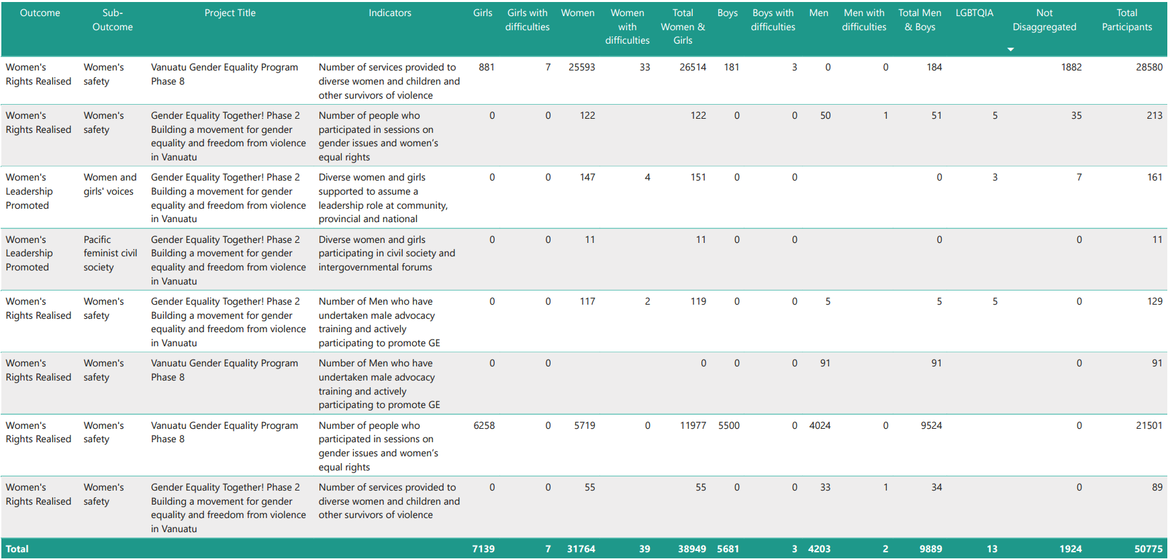

# **Annex 4: Whole-of-portfolio PWL Indicators**

| Program Logic key outcome area | Quantitative indicators | Qualitative indicators | Domains of inquiry to track change in social norms |
| --- | --- | --- | --- |
| Women’s leadership promoted: **women and girls’ voice** | * # diverse women and girls supported to assume a leadership role * # of sectoral policies or initiatives clearly addressing diverse women’s leadership needs | * Evidence of more women and girls, in all their diversity, that are respected, listened to and influencing decision-making as a result of PWL grant making * Evidence of change in social norms that limit diverse women and girls’ leadership opportunities as a result of PWL grant making * Evidence of women and girls taking on and practice leadership (at all levels) as a result of PWL grant making * Evidence of how linking and learning between PWL grantees and collaborative MEL has led to better program outcomes in women and girls’ leadership | **Attitudes, beliefs and behaviours** that leadership (both formal and informal) is better suited to men and boys |
| Women’s leadership promoted: **Pacific feminist civil society** | * # diverse women and girls participating in civil society and intergovernmental forums (e.g., Pacific Feminist Forum and Triennial) * Number of women’s organisations, groups or coalitions actively engaged in the project * Number of Pacific organisations of people with disability actively engaged in the project | * Evidence that long-term and flexible funding from Pacific Women’s Funds is contributing to increased recognition and amplification of feminist civil society leadership * Evidence that the Pacific feminist movement has grown in depth, is better connected and their expertise is drawn upon as a result of PWL funding * Evidence of how linking and learning and collective action amongst women’s organisations and the feminist movement has supported better gender equality outcomes |  |
| Women’s Rights Realised – **women’s health** (SRHR) | * # diverse women and girls who received a modern method of contraception * Number of unintended pregnancies averted * Total couple-years protection for contraceptives distributed by countries to lower levels including service delivery points (SDPs) (disaggregated by method including emergency contraception and long-acting reversible contraception) | * Evidence of diverse women and girls’ improved access to comprehensive SRHR services as a result of PWL grant making * Evidence of change in social norms that limit diverse women and girls’ access to SRHR services as a result of PWL grant making * Evidence of the health sector providing comprehensive SRHR services as a result of PWL grant making * Evidence of how linking and learning and collaborative MEL between PWL grantees has led to better program outcome in SRHR | **Taboos and stigma**: cultural taboos surrounding discussion about sex, sexuality and reproductive health  **Gender norms and inequality:** traditional norms that restricts women’s autonomy to make decisions about their bodies  **Religious and moral beliefs**: that influence who should be able to access SRHR services |
| Women’s Rights Realised – **women’s economic empowerment (WEE)** | * # diverse women entrepreneurs provided with financial and/or business development services * # diverse women who have attained formal qualifications | * Evidence that diverse women have increased access to resilient economic opportunities, including increased voice in decision making as a result of PWL grant making * Evidence of change in social norms that prevent diverse women’s entry into the workforce as a result of PWL grant making * Evidence women in all their diversity have increased access to sustainable formal and informal economic opportunities as a result of PWL grant making * Evidence of how linking and learning and collaborative MEL between PWL grantees has led to better program outcome in WEE | **Attitudes and beliefs** that place the main responsibility for the home and care of children, the sick and the elderly on women and girls. |
| Women’s Rights Realised – **women’s safety** | * # of counsellors graduating from recognised counselling institutions * # of services provided to diverse women and children (girls and boys) and other survivors of violence, such as counselling * # people who participated in sessions on gender issues and women’s equal rights * # men who have undertaken male advocacy training * # police, law, and justice officials trained to respond to incidents of violence against women and girls according to an established protocol | * Evidence that violence against women and children has reduced as a result of PWL grant making * Evidence that women and children have improved access to comprehensive support services, including in times of disasters, as a result of PWL grant making * Evidence of increased access to comprehensive support and crisis services for diverse women and children as a result of PWL grant making * Evidence of changed social norms that contribute to diverse women and girls’ experience of violence as a result of PWL grant making * Evidence of how linking and learning and collaborative MEL between PWL grantees has led to better program outcome in safety | **Attitudes, beliefs and behaviours[5]** that condone violence against women  Refer to footnote 17 for full list of attitudes, beliefs and behaviours. Partners are asked to focus impact story collection on any one (or more) of these attitudes, beliefs and/or behaviours) |
| Partners supportedto increase Pacific ownership and effectiveness of regional gender equality efforts – **gender mainstreaming** | * # of government staff and development practitioners applying gender mainstreaming tools * # of mechanisms in place to support gender mainstreaming processes in the government | * Evidence of how Pacific governments have utilised support to build capacity in gender analysis and mainstreaming * Evidence of how Pacific governments and development partners are mainstreaming gender as a result of PWL grant making, technical support, coaching or mentoring * Evidence of how Pacific government are implementing programs and policies that support national and/or regional gender equality commitments as a result of PWL grant making, technical support, coaching or mentoring |  |
| Partners supportedto increase Pacific ownership and effectiveness of gender and equality efforts – **Pacific ownership and regional effectiveness** |  | * Evidence of effective collaboration between SPC, PIFS and DFAT on regional gender equality commitments * Evidence of how collective action has supported implementation of government commitments to gender equality |  |
| Program Logic strategies   * Grant making in the thematic areas of leadership, health (SRHR), women’s economic empowerment and safety * Linking and learning that supports understanding of change in PWL’s outcome areas * Collective action that supports implementation of government commitment and movement building amongst Pacific feminist and/or women’s organisations * Technical support for gender mainstreaming activities * Collaborative portfolio level monitoring, evaluation and learning sense-making spaces to inform PWL decision-making | * Number of projects funded (by outcome and sub-outcome area) * Number of diverse women and girls reached through activities * Funds committed per outcome and sub-outcome area * Satisfaction with linking and learning events * Satisfaction with technical support for gender mainstreaming | * Evidence of how program logic strategies supported (or undermined) outcomes |  |

# **Annex 5: Impact Stories**

|  |
| --- |
| **Project:**Balance of Power  **Tittle:** *Tru the Lens* Vanuatu – a multi-faceted initiative generating unexpected results |
| *Tru the Lens*, the ten-part documentary series portraying the lives and experiences of ni-Vanuatu women in a range of fields, progressed strongly in 2022-23. There are now four completed films, launched and being actively used, profiling:   * Katura Tom and Stephanie Tarileo, the first two pilots of ATR planes in Air Vanuatu * Shirley Tokon, first female Manager of premier league football club North Efate Limited, and Director of Vanuatu Health Program * Adela Issachar Aru, CEO of Vanuatu Tourism Office * Olivia Keith, Principal, Baldwin Lonsdale Memorial School, TORBA Province   The approach to *Tru the Lens* is characterised by several important and interconnected features which are proving to be central to its effectiveness: subject selection, film-making process, the film itself, launch events and follow-up dissemination.  Observational data collected by BOP, and media monitoring, shows that the films and the launch events are reaching people outside the usual audience for a gender program. For example, Tatie Tawaia, a star player for North Efate, shared a BOP Facebook post on her personal page, with a comment about the need to have more women leaders in Vanuatu. As a top player in the country’s premier football league, his high public profile means he has great influence. His amplifying of the BOP message further validates BOP’s strategy of ‘influencing the influencers’, even beyond those with whom BOP works directly.  BOP’s strategy of working with male filmmakers has continued to generate tangible influence, which will feed into wider influence as those content creators do other work. There are signs that their attitudes have been shifted through their involvement with the project: *“There are many women in Vanuatu who have not received the level of recognition that they deserve. They ring a different element of leadership and change, and a lot of these women have many amazing stories that need to be told so they can inspire the next group of young leaders. (Markson Taiki, Matakambu Productions).”*  The men involved are also seeing how their work is linked with wider signs of shifting attitudes to women leaders in Vanuatu, including in the political sphere: *“I believe the screening of these films has inspired and influenced communities across Vanuatu. Today we have the biggest village of Vanuatu, Mele, put aside their differences and elect Julia King to Parliament How cool is that? (Moses Cakau, Senior TV producer, VBTC).”*  BOP is utilising the *Tru the Lens* films in a range of contexts and events, including with ni-Vanuatu university students in Fiji, with schools around Vanuatu, and with other development partners such as ADRA, through their Family Life education program. That last example, where one film was screened to a group of men and women in a community setting generated some powerful responses, especially amongst men in the audience. For example: *“I regret that I have mistreated my wife. Now I have seen this film, I will go home and do my best to support her in anything she wants to be. (viewer of Tru the Lens film 4: Olivia Keith).”*  The investment in the *Tru the Lens* series is paying dividends for BOP, and for Vanuatu, even as it is still being expanded. The next film will profile new MP Julia King, and the launch event is likely to be hosted by the Prime Minister, which will generate even greater audience and reach for this centrepiece of BOP in Vanuatu.  BOP will conduct a mid-term evaluation of *Tru the Lens* in late 2023, at the half-way point of the series, and focusing on capturing added evidence of how the series is contributing to BOP’s intended outcomes. |

|  |
| --- |
| **Project:** Balance of Power  **Tittle:** Working with the Anglican Diocese of Banks and Torres, Vanuatu |
| In November 2022, the Vanuatu BOP team travelled to TORBA Province, to do preliminary work for the filming of the *Tru the Lens* film profiling Olivia Keith, school principal of Baldwin Lonsdale School, and to discuss the subsequent launch of her film on Rah Island. BOP was working with the chiefs of that island, and in addition engaging with the Anglican Diocese of Banks and Torres (DOBT) to arrange the launch event, so that BOP could remain in the ‘back seat’, and ensure that the film, and the event, was perceived as very much local.  BOP Program Administrator, Telstar Jimmy, had asked her mother’s sister, Jean, who lives in Sola, to assist with logistical arrangements for the team’s visit, especially arrangements for their travel by land and sea to Rah Island, where the launch event would take place.  Jean sits with the Women’s Desk of the DOBT, responsible for outreach and activities of the Women’s Union groups across the Banks and Torres islands, and her husband, Father Maurice Vaes, is the Mission Secretary/Vicar General for the Bishop of DOBT. They were both excited to hear about BOP’s work with men and women to target the social norms around women’s leadership, because – unbeknownst to Telstar and the rest of the BOP team – they were both already active on these issues within the Anglican Church. Jean had studied alongside her husband in Solomon Islands and gained the same degree in theological studies as the men who were ordained. However, this formal recognition and ordination was not an option for Jean, and her potential roles within the Church are limited. So, she and Father Maurice have been advocating for a change within the Anglican Church in Vanuatu, so women could be given equal leadership status, and opportunities. To achieve this, they were advocating for the necessary votes from 9 dioceses from Vanuatu & Solomon during their annual church gatherings called the Synod.  The Bishop responsible for their Diocese supports women’s leadership and had created a theme for ‘Women in the Frontline’ that Jean could use in her outreach to women’s groups across the islands. This was a call to encourage women to raise in leadership, drawing from women in the Bible who were leaders and instigators of change. However, this was proving difficult to progress in practice, with almost no resources to travel across the islands of TORBA Province. The conversations between Father Maurice and Jean, and the BOP team, have led to a number of strong opportunities to collaborate in pursuit of the shared aims of advancing women’s leadership.  First, BOP delivered a two-day inclusive leadership workshop on Motalava Island for the Diocese of Banks and Torres. District Priest of Motolava, Father Tione Ling, opened the event and encouraged participants to embrace the compatibility of women’s leadership and the Christian faith. This workshop took place in tandem with the *Tru the Lens* film launch and was attended by around 35 women, mostly from the Anglican Church in Banks and Torres, but also from other denominations, such as Seventh Day Adventist, Assemblies of God and Pillar of Fire Ministry.    After that first workshop, and the film launch, the BOP team was approached by the Secretary of the Anglican Diocese, requesting an ongoing relationship and further activities together. This is a very significant development for BOP. There have been several attempts in the past to find entry points into church organisations, given their enormous influence in Vanuatu. However, these past attempts have not come to fruition. Amplifying the voices of faith leaders to advocate for women’s leadership has huge potential to advance social norm change, so BOP will continue to invest in this link with the Anglican Diocese of Banks and Torres, where there is great potential. |

|  |
| --- |
| **Project:** Gender Equality Together – Young Women Leadership Program  **Implementing Partner:** CARE Vanuatu  **Tittle:** The Empowerment Journey |
| My name is Guilaine Nauni from Ambae part Futuna Island. I am proud of my life journey which started through challenges that were thrown at me and gave me very low self-esteem, but my drive and motivation resulted in who I have become today. Each step from where I started till now is a milestone and a blessing. In 2005 we relocated from Santo to Vila so my dad could take up his missionary work in our church. Our family had everything from our own home to the life that any child would have wanted in Santo, but in Vila we started from scratch where we had no electricity and was just using candles. We lived in a tinned house with very low financial stability. To make things worse, I could not complete university due to the student environment where boys on campus had no respect for girls. I was not used to being on campus for my 6-8pm classes. Despite my good grades in two courses, I decided to leave school. Everything that happened during these years kept pushing my self-esteem lower and building on through each challenge. As I kept falling back, I shut myself out even further. In 2013 when my life seemed lost to me, I was requested to take care of my sister’s business and administered the office. I was enjoying the experience doing administrative roles when an arranged friendship was facilitated. There was pressure from this arrangement and so I had to accept it despite my desire to want to know him better. I was trying to slow this relationship and get to understand who he is, instead he was rushing the arranged friendship. He respected his parents and so when things were not working how he wanted, he almost committed suicide. With my experience in the administration, my parents moved me back to Santo to support the Christian Church school with years 7 - 11. I was in Santo from 2014 till 2016 until the situation cooled down, and I moved back to Vila. World Vision requested me to volunteer, and I agreed. I was involved in a Child Fund training around child protection work for 7 months in a series of workshops.  My involvement with CARE started in 2018. I learned about the Young Women Leadership Program (YWLP) through a World Vision staff, who was also a close friend, who encouraged me to consider filling an application form. Since my self-esteem was low, I made the attempt to fill in the form for submission without giving it much thought. I applied because someone else was encouraging me to do it. Then I received a call to confirm that I made it through for the program. Other girls would have screamed and shouted with excitement. To me, the call felt like I was given notice. Before the program started, I was trying to understand all the bits and pieces of information and my journey. Where is this taking me? I was trying to understand what the impact would be on my life.  During the program induction, I felt the topics were new to me and I thought to myself that I must complete all training sessions and put the pieces together like a puzzle. My confidence was still low, I was too shy to talk in front of others easily, but my self-esteem was somehow adapting to new information from the induction sessions and slowly changing. I started to realize that if I grasp this opportunity and really focus on what the training will offer then things might change.  Topics around life skills, leadership, Gender Based Violence (GBV) including other important sessions were facilitated with the young girls including a mentorship component. Young women were matched with women leaders who were interested to support us through mentoring and coaching. Different women leaders attended a session and shared their leadership pathway and how they battled different challenges. One of the women leaders shared her experience and stated, “*you can be who you want to become or think you want to be like”.* I admired her strength right there and wished she would be my mentor. To my surprise, my wish came true when she mentored me through the program. She advised me to embrace all learnings effectively and walk with it. Another component is the small group project which is a success as young women leaders were allowed the opportunity to choose a topic on issues and challenges that they know and see happening in their communities, and plan awareness activities for their peers and communities. When engaging through the small group project, I felt the importance of working with women who have faced the same challenges that I had been through. When asked about my plans, I decided to work with a group of single mothers who have gone through similar challenges.  Internships were not included in the YWLP program during this time. My short-term goal to find a job pushed me to request an internship. I learnt a lot with World Vision as a volunteer and so I wanted a similar opportunity. I shared this with my mentor who agreed to find a placement for me. But before my mentor could find one, I approached the YWLP Coordinator who agreed I could intern as Gender Equality Together (GET)’s Assistant. Two months later when my internship ended, I was placed in 4 different roles that were not part of Care Vanuatu’s organizational structure up to the point of negotiating my current role as a part time and working on my consultancy role. My colleagues and friends are asking how things have worked out for me like that, and all I can say is it is really God’s favor over my life.  For me it was my blessing in disguise all along, realizing the missing pieces of puzzle I was trying to put together at the beginning through the program period till the end of the program. I realized that when I did what my YWLP program mentor encouraged me to, with my heart and passion, other things were just falling into place. My life has changed dramatically where I am now a financially strong and very confident young women. I am empowered and believe that I can be the change. I can demonstrate and show other women that I am working with and those around me that they can reach their dreams if they put their heart and passion to turn their thoughts to reality.  With this growth and change in my life, I am respected and recognized as a decision maker in my workplace, home, in church and the wider community too. Before my participation in the program, I feel that I was not allowed to effectively participate, to talk about issues, discuss alternatives and recommend actions that can be taken to address these issues. This has changed where I am more respected, get asked for my feedback, feel that my concerns and recommendations are valid and that actions were taken accordingly. This just made me want to do more, not just for myself, but also for others around me and to continue the trend that if I can do it then others can be empowered through my situation and soar beyond to achieve their dreams and just be who they are.  I wanted to showcase my life story to others because I lived it and if someone started their life journey just like me and or faced more challenges, my story demonstrates the power of linking your passion to your heart and put focus into what you feel will make change to your life. This is my living testimony that anything can happen, and I am a changed and happy young woman. |

|  |
| --- |
| **Project:** Pacific Girl – Vois Blong Mi  **Implementing Partner:** CARE Vanuatu  **Tittle:** Menstrual Health Management in Vanuatu |
| It’s a part of life, but many women and girls in Vanuatu continue to face challenges in accessing the information and resources they need to safely and hygienically manage their menstruation. The flow on effects is multifaceted and combine to further disadvantage girls growing up in a highly patriarchal community where gender inequality is prevalent.  In many of Vanuatu’s remote communities, access to water remains a significant challenge and many schools are not equipped with sanitary, secure toilet and handwashing facilities. Many households also have limited access to financial resources, putting buying menstrual hygiene products out of reach. At the same time, [harmful menstrual beliefs are still prevalent in communities](https://reliefweb.int/report/vanuatu/water-women-and-disability-study-menstrual-hygiene-management), and people commonly consider women and girls unclean during menstruation, leading to isolation during menstruation and monthly disruption of women and girls’ day to day lives.  These factors can result in a multitude of problems for women and girls, including health risks, interruptions to their attendance at school that also increases the likelihood of school dropout, and subsequent disadvantage in work, life and economic opportunities. That’s why CARE in Vanuatu is working to help make sure girls in Tafea have everything they need for good menstrual hygiene.  With the support of the Australian Government through the Pacific Girl Program, CARE’s Vois Blong Mi team has been giving girls in 15 schools and communities across Tafea Menstrual Hygiene Management (MHM) kits, which include a bucket with a lid, bathing and washing soap, deodorant, reusable sanitary pads and panties. Girls who received the kits say the reusable pads help them feel more confident to attend class instead of skipping it when they are on their periods, and they are happy not to have to ask their parents for money each month to buy menstrual hygiene products. CARE partners with local organisation Mamma's Laef Vanuatu to supply the reusable sanitary pads, which are produced in Vanuatu’s capital Port Vila by a local women’s collective.  “I truly adore and appreciated using the kit,” said Jerielle Japana, a Year 8 student in Aneityum in southern Vanuatu. “It has everything I need to take care of myself during my period, including a bucket with a lid, reusable sanitary pads, underwear, and deodorant. It is a self- contained kit for myself, and nobody is allowed to use my bucket. Sanitary pads protect me throughout my period.”  Jerielle says she also learned useful information in the sessions. “It helped me to have clear understanding of what it means to stay hygienic during menstruation.” Jerielle says the financial benefits of the kits are also important. “I'm a boarder, so the reusable pads really helped me out financially. I no longer ask my parents for money each month to purchase disposal Stayfree/Cortex.” |

|  |
| --- |
| **Project:** Shifting the Power Coalition  **Implementing Partner:** ActionAid Vanuatu  **Tittle:** We will flourish like no other - Flora Spearheading Women-led Disaster Response in Vanuatu |
| The Secretariat of the Pacific Community (SPC), through the Pacific Women Lead at SPC programme (PWL at SPC), supports ActionAid Vanuatu through the Shifting the Power Coalition. The coalition aims to ensure diverse Pacific women’s voices are included in disaster planning and response at all levels. This includes assisting people like Flora, the Country Program Manager of ActionAid Vanuatu in assisting the tourism industry to support women-led recovery from Tropical Cyclone Pam.  Flora has played critical roles in establishing the Women I Tok Tok Tugeta (WITTT) network in 2018. Through WITTT, diverse Ni-Vanuatu women organise, strategise and drive disaster response. She was also involved in establishing Women Wetem Weta (WWW) – a network of young women that monitor the weather and use mobile phones to share weather warnings and climate messaging to communities across the country. *“I mobilise and work with 5000 women on the ground. In times of disaster, I link up all these women from the National Emergency Operations Centre. The information from the community flows up to government, then goes back to the women in their villages.”*  This progress did not come easy. The work to establish WITTT and WWW required significant effort to ensure women had a firm grasp on their individual and collective voice and agency. *“Women are taught to wash dishes, clean the house and make sure there is food on the table. To say a sentence in front of others is a big step for them. It has taken courage and confidence to even use a pen. They have been silent for too long. But now the room is bubbling… you have to shout because the women are full of confidence.”*  By developing early warning systems that are contextualised and strengthen women’s leadership at all levels, both disaster response and community resilience are enhanced. Women's involvement in decision making reaps benefits for all members of the community, iteratively enhancing disaster resilience and – as a result – sustainable development at the local level.  For example, as disaster relief can be slow to reach communities owing to limited transport and other challenges, the women’s response networks prepare and distribute local fruit, vegetables, and other resources most needed during a crisis. *“If the pandanus trees are affected, the community can’t do much anymore to sell and earn money. So, they get pandanus shoots to replant. It’s a different response because it’s led by women, for women; they know exactly what has been lost.”*  The coalition continues to share lessons learned from its work, taking a deliberately feminist approach to finding solutions that work for communities. *“There’s our sisters we have within the Shifting the Power Coalition, the safe space we have created. We know we have to join hands together. The work… if we are growing it, we are growing it together. We are not growing it for me, Flora. When I talk, I talk as WITTT. I’m talking as the network of women and the power of women.”*  *“This is how I want to see myself progressing to help saving lives of women… to live freely and happily as a woman in Vanuatu as well as any other woman in the Pacific. If they have that right, we will flourish like no other.”* |

|  |
| --- |
| **Project:** Markets for Change  **Implementing Partner:** UN Women – Vanuatu  **Tittle:** Iata’s Journey |
| Iata, a resilient female vendor from Rantapao village sells her banana chips, manioc chips, and kumala chips, at the bustling Port Vila central market. Her specialisation in chip-making makes Iata rely heavily on local produce.  Iata’s first job was in the tourism sector as a chips maker after completing year 10 in Ambae. She sold chips for her employer around the Chinese shops including in a minivan around town. Iata loved her job as a chip maker and was inspired by her employer. *‘I loved the smell of chips being cooked in oil’.* But she had to quit her job and stay at home to take care of her children after her second child was born. During the hiatus, her previous employer was deported from Vanuatu.  Iata grew up in a business-oriented home where her father started the business of roadside stalls in Port Vila selling cooked food. She grew up with a passion to start her own business. For the love of chip-making, she decided to get into the chip-making business. *‘I had a discussion with my partner about it, he was interested and supported my idea. That’s how it all began’.*  She started her business and was encouraged by her father to start selling at least 10 packets of chips each day. Iata managed to sell 7 packets in two days when she started and then for the third sale, she was selling 20 packets and then 75 packets of chips per day. But just when her business seemed stable, she was evicted from the land she was selling from and had to move to a new place further away from town. Despite this challenge Iata’s family continued to support her. Their support included building up her resilience to disasters and coping mechanisms to be strong and continue to keep her business flourishing during cyclone season and COVID.  2023 proved to be a challenging year for Iata and her fellow vendors, as three tropical cyclones wreaked havoc on farms and market activities. Her business had to stop operating for a few weeks as her selling space was damaged, including the local produce that she bought from other vendors in the market to make her chips. Iata found solace in the support provided by the Market for Change project, which equipped her with invaluable training on resilience-building during disasters. Armed with newfound knowledge and skills, particularly in financial management and savings, Iata understood the importance of setting aside funds for unforeseen circumstances. This foresight proved invaluable when the cyclones ravaged local crops and vegetables, as Iata could rely on her savings to sustain her market activities.  Empowered by the support she received, she paid it forward by sharing her expertise with four single mothers in her community, enabling them to embark on a similar entrepreneurial journey. Witnessing their success at the market brought Iata immense joy, knowing that she had made a positive impact on their lives and their families' well-being. Iata acknowledges the pivotal role played by the comprehensive training programs by Markets for Change. Not only did they impart practical skills but also instilled a sense of responsibility and adherence to market rules among vendors. *‘I increased my business knowledge during the M4C training on the importance of keeping my business space separated from my family home, how to keep the chips in a safe and secure environment, and the importance of using utensils, packaging, and keeping to the health and safety food requirements. Quality is always my business priority hence my passion for sharing with other women in my community so that we are all progressing with our business ideas’.* |

|  |
| --- |
| **Project:** Core support to International Planned Parenthood Association  **Implementing Partner:** IPPF – Vanuatu Family Health Association (VFHA)  **Tittle:** Building a Strong Foundation - Communication, Infrastructure, and Staff Support for Vanuatu Family Health Association |
| The Vanuatu Family Health Association (VFHA) is currently implementing a culture of teamwork, where the organization collaborates and coordinates to effectively handle its day-to-day tasks, whether it be in governance, management, or programming. Despite existing challenges, VFHA continues to excel in its delivery of sexual and reproductive health services in the country.  The team has reorganized its organizational structure and has communicated these changes to VFHA members. Doing so has clarified communication channels and individual roles to avoid overlapping duties. This has strengthened team collaboration and therefore improved program delivery. Further, to strengthen MA governance, VFHA holds quarterly general staff meetings, department meetings, Senior Management Team meetings, and Board meetings to share reports on their areas of work, discuss any issues, and get updated on operational issues.  VFHA has repositioned its office seating arrangement to encourage daily interaction and easy staff monitoring. Furthermore, the team holds annual retreats for staff and members to engage, celebrate achievements, and reflect on work changes. The success of this initiative is evident in the improvement of VFHA's team performance in the region. To address high staff turnover, VFHA has planned to bolster staff morale by introducing a recognition reward system for staff performance.  As shared by the Executive Director for VFHA, Julius Ssenabulya, *“We are a different office now compared to previous years. Staff are more open to discussing issues and challenges with the Senior Management Team and there is a sense of pride and renewed energy in the organization. Our Board and members have been very supportive of the arrangements and new initiatives.”* |

1. Distinct implementing partner means organisations who have a direct grant agreement with donors or funders.
2. An ambition outlined in the PWL design was for SPC to progressively take over responsibility for the whole-or-program MEL. Further conversations will be had with SPC’s PWL MEL team and more details about how this could happen will be outlined in future PWL MELF updates.
3. Reach data refers to the coverage of activities: how many diverse men, women, boys and girls have been reached by an activity or project.
4. Partners holds a grant agreement with a distinct implementing partner.
5. As found in the Pacific Women Lead baseline, social norms and attitudes that condone violence include: wives and mothers should be submissive to their husbands; husbands and fathers are the head of the household and make the final decisions; there is a certain way women and girls should dress, always modestly and never exposing body parts that could lead to rape or sexual harassment; men can drink and socialise after hours with their friends, but their women should return or remain at home to take care of chores; women and girls should do the household chores (washing, cleaning, cooking, taking care of children, looking after elderly); wives who cannot give birth are devalued; women should be virgins before they get married; girls should aspire to become wives and mothers; there is no such thing as marital rape because husbands have the right to demand sex from their wives; violence against women can be justified, especially if she oversteps the line; sexual harassment is normal and in the Pacific, it is generally accepted

  